E-learning satisfaction: investigating gender differenceS

Choi-Meng Leong
UCSI University
mandyleongcm@gmail.com

Chin-Fei Goh
Universiti Teknologi Malaysia
gcfei@utm.my

Fadillah Ismail
Universiti Tun Hussein Onn Malaysia
fadillah@uthm.edu.my

Owee-Kowang Tan
Universiti Teknologi Malaysia
oktan@utm.my

Choon-Hee Ong
Universiti Teknologi Malaysia
ongchoonhee@ibs.utm.my

ABSTRACT

The purpose of this study is to evaluate the impact of learner–content interaction, learner-learner interaction, learner–instructor interaction, self-regulated learning, and Internet self-efficacy is present on e-learning satisfaction. The gender effect is also included in the investigation of the impact. Many studies have been conducted to reveal learners’ satisfaction with e-learning, however, limited research has emphasized the gender effect in explaining learner satisfaction. A review of the existing literature was used to develop a conceptual model which was further tested using data collected from undergraduate students. The data collection used a self-administered questionnaire and 742 valid responses were acquired. Partial least square-structural equation modeling was used to analyze the model while multigroup analysis was used to assess the gender differences for the predictors. The results showed that learner–instructor interaction, learner-learner interaction, self-regulated learning, and Internet self-efficacy were predictors for learning satisfaction based on the overall sample. The university may use these factors as a reference to achieve learning satisfaction among students. Gender was found significantly different in the relationship between Internet self-efficacy and satisfaction. The finding suggests that the university administrators need to undertake strategic change to assist female learners in overcoming the barrier of Internet self-efficacy skills.
Keywords: e-Learning Satisfaction, Gender, Internet Self-efficacy, Interaction, Self-regulation

1. INTRODUCTION
The adoption of e-learning alongside traditional teaching in higher education has started to gain traction globally [1]. The rapid development of Information, Communications, and Technologies (ICTs) and the Internet have enabled many learners to be more wired. Many higher education institutions have adopted instructional approaches by integrating ICTs into traditional courses to enhance the effectiveness of teaching and learning [1-2]. This combination of computers and traditional teaching is known as hybrid learning[3].
The successful integration of e-learning into traditional teaching relies on various factors. These include prerequisite initiatives, such as the selection of technology, instructor characteristics, and organizational support[1]. Furthermore, learners and instructors need to change their learning and teaching methods to enhance learning performance, respectively[4]. The main reason is that the use of ICTs in teaching may alter the relationship between instructors and learners. An instructor who utilizes e-learning in teaching activities tends to assume a constructivism approach and becomes an instructor to facilitate active learning among learners [5]. A constructivism approach contradicts objectivism, which assumes learners are passive recipients of information from teachers who own the information. Consequently, the integration of e-learning into traditional teaching changes the learning styles of learners and the way that instructors teach [6]. In particular, the e-learning promotes learner-directed learning through the use of an e-learning environment.
Due to the changes in learning instructions, the learners’ satisfaction levels remain unknown for e-learning. Scholars have voiced concern over the extent to which the integration of e-learning into traditional teaching enhances learning and teaching outcomes [1,4,7]. Therefore, it is essential to measure learner satisfaction in courses that integrate e-learning into traditional teaching to gauge the effectiveness of learning [7]. A high level of learner satisfaction is a positive indicator for university administrators to improve program planning and continuously strengthen the policy of e-learning in traditional teaching. On the contrary, a low level of student satisfaction would indicate that some strategic decisions or changes are required, for example, program planning, workplace reward systems, and training for instructors to address the issue. The understanding of learner satisfaction is a vital strategic driver affecting the success of integrating e-learning into traditional teaching in higher education [6].
Multifaceted predictors for learning satisfaction are available for the investigation of e-learning. The e-learning instructions include course content design, interactions, self-regulated learning, and course outcomes [8]. Several studies have confirmed that interactivity in the learning environment and individual differences in self-regulation and Internet self-efficacy are the predictors of learning satisfaction in an environment that combines e-learning and traditional teaching[2,4,9,10].
Nevertheless, Luarn, Kuo, Chiu, and Chang [11] acknowledged the presence of social support in online relationships, which could be different from tie strength and gender differences perspectives. Gender differences were also found to moderate human-technology relationships[12]. A closely related study by González-Gómez, Guardiola, Martín Rodríguez, and Montero Alonso[13] discovered that female students had a higher level of satisfaction than male students in e-learning courses. Another study by Ramírez-Correa, Arenas-Gaitán, and Rondán-Cataluña [14] used a technology acceptance model to examine gender differences to explain the adoption of e-learning. Their study confirmed that the gender effect exists in adopting an e-learning platform. Different behavior and information processing across gender groups lead to such findings, which influences the learning process and satisfaction [13-15]. Given the variations in e-learning satisfaction due to the gender gap, identifying the gender effect on satisfaction in an environment that combines e-learning and traditional teaching is an insufficiently investigated topic. Differently from many other studies[16-18], this study includes multi-group analysis of the gender effect to predict learners’ satisfaction using interaction-based predictors that combine the transactional distance theory of Moore[19] and the social cognitive theory of Bandura[20].

2. background literature
2.1 Learning Satisfaction
A pedagogy that mixes traditional education with an online learning aims to maximize the benefits of both learning environments to enhance the teaching-learning experience [2,21]. Prior studies have largely confirmed that successful integration of e-learning into traditional teaching can lead to better learning outcomes and reduce attrition rates [21-22]. Several ways can elucidate such outcomes. First, e-learning serves to accentuate access and schedule flexibility, which can be related to learners with diverse learning styles and knowledge levels [6,23]. Second, the socialization aspect of face-to-face interactions can provide learning guidance to students [21]. Furthermore, the combination of e-learning and traditional teaching is a cost-effective pedagogy for instructors because the e-learning aspect reduces traveling time, lecturing hours, and other economic costs.
Learner satisfaction outlines the degree to which learners regard their learning experiences as positive [24]. As the traditional learning instructions integrate e-learning instructions, the learners’ satisfaction level is still the main concern as it is closely related to academic achievement or success. Besides, the integration of e-learning into traditional teaching is viewed as providing the transformative potential to achieve higher levels of learner satisfaction and learning outcomes compared to conventional face-to-face and pure e-learning courses [7,25]. Previous studies regarding e-learning or the integration of e-learning into traditional teaching [17,26-27] have been conducted to identify learners’ performance and experience. For learner satisfaction, Dang et al. [16] found indirect relationships between learning satisfaction predictors and satisfaction. [28] related learning satisfaction predictors to course satisfaction. Instead of performance, experience, or course satisfaction, this study emphasizes the learners’ satisfaction as contrary to these former studies. Besides, this study also examines the direct relationship between learning satisfaction predictors and the learners’ satisfaction. Consequently, this study applies the predictors of learning satisfaction to identify the learners’ satisfaction with e-learning.
2.2 Predictors of Learning Satisfaction
As e-learning implies a distance between instructors and learners, one of the important theoretical constructs for e-learning is interaction. The theory of transactional distance argues that the separation between instructors and learners contributes to communication gaps [29]. Therefore, the transaction needs to cover dialogue, structure, and learner autonomy [30]. Specifically, the dialogue comprises two-way communication as well as all types of interaction [31]. The previous research by Moore [19] distinguished three types of interaction in distance education, which are; learner–content interaction, learner-learner interaction, and learner–instructor interaction. Such interactivity is a precondition to establishing positive learning environments and student satisfaction [6]. The effect of interaction in an e-learning environment has been greatly investigated [32]. Similarly, learner–content interaction, learner–instructor interaction, and learner-learner interaction are known as the critical drivers of student satisfaction in learning environments that combine e-learning and traditional teaching [2].
Learner–content interaction is a significant characteristic of education, encompassing traditional and distance education [19]. It refers to the interaction between learners and course materials, for example, doing assignments and readings. Learners intellectually interact with the contents of the study to learn and develop their cognitive structures and perspectives. Learner–content interaction is very similar to internal didactic conversations in which learners talk to themselves, in their minds, about the information and ideas that they learn through any educational process. As course materials are available in a learning management system, a system that is easy to use increases the level of learning satisfaction [33]. Therefore, this study posits that:
H1: Learner-content interaction has a positive effect on e-learning satisfaction.
Learner–instructor interaction refers to the interaction between learners and expert instructors, who prepared the instructional materials [19]. When e-learning is adopted, the interaction can take place, either formally, or informally [19] as well as synchronously (e.g., telephone, online chat, and video-conferencing) and asynchronously (e.g., discussion boards and emails) in various channels [34]. Such interaction is vital to stimulate student curiosity, which is a potent motivator, to accomplish the learning goals [19]. During learner–instructor interaction, instructors provide adequate guidance to learners who have difficulty in correctly applying the knowledge and skills learned through learner–content interaction. Learner–instructor interaction also facilitates the establishment of a social relationship through exchanging socioemotional benefits and, thus, an emotional learning climate and social interaction [35-36]. Subsequently, students will be more satisfied, which leads to lower attrition rates. This study proposes the following hypothesis:
H2: Learner-instructor interaction has a positive effect on e-learning satisfaction.
Learner-learner interaction represents the interaction among learners working in small groups [19]. After learner–content interaction, learners can learn from one another to achieve learning objectives. Peer interaction can address any misunderstandings and misconceptions that may occur during self-learning. The impact of learner-learner interaction plays a vital role in stimulating learners’ motivation, especially for those learners who lack self-motivation [19,37]. Learner-learner interaction also facilitates the student learning process to enhance learning outcomes [2]. This interaction refers to the discursive communication processes in which the exchanging of content knowledge and socioemotional information occur among learners [36]. Learner-learner interaction establishes mutual socioemotional support and group cohesiveness to enable students to construct cognitive understanding within a positive learning climate. In short, learner-learner interaction promotes more profound cognitive development, as well as strengthening learning motivation and improving learning outcomes. Therefore, the next hypothesis for this study is:
H3: Learner-learner interaction has a positive effect on e-learning satisfaction.
Besides the interaction predictors derived from the theory of transactional distance, this study also combines the predictors initiated from the social cognitive theory of Bandura [20]. The social cognitive model of self-regulation introduced by Zimmerman [38] is grounded on the social cognitive theory of Bandura [20], in which learning transpires in a social contexts via the interaction of covert personal, behavioral, and environmental events. Self-regulated learning delineates as the extent to which learners are active in their learning metacognitively, motivationally, and behaviourally [24,38]. Self-regulated learners are self-motivated and accept self-responsibility in the learning process. Self-regulated learners are active in formulating strategies and action plans as well as monitoring to accomplish their own learning goals. Learning behavior utilizing a strategy to optimize the learning process is a salient characteristic of self-regulated learners. Prior studies have primarily confirmed that self-regulated learners tend to achieve better academic performance in e-learning as well as in mixed e-learning and traditional teaching modes [10,24]. Thus, this paper hypothesizes that:
H4: Self-regulated learning has a positive effect on e-learning satisfaction.
Founded on social cognitive theory, Bandura [39] further enhanced the theory of self-efficacy. Self-efficacy expands from the self-regulation and self-reflection aspects of the social cognitive theory of Bandura [20]. In other words, self-efficacy is the belief or confidence regarding one’s capability to tie motivation, cognitive resources, and actions together to enable the execution of a prearranged context successfully [39]. An online element combines with self-efficacy to investigate e-learning satisfaction and, thus, is called Internet self-efficacy. Recent studies have included Internet self-efficacy to investigate learner’s behavior [18,40], teacher behavior [41], and Internet anxiety [42]. However, none of these studies relates Internet self-efficacy to learners’ satisfaction. Consequently, this study includes Internet self-efficacy to expand the current framework of interaction approaches to learners’ satisfaction.
Internet self-efficacy, therefore, refers to one person’s belief, confidence, and expectations in his or her ability to accomplish Internet-related activities and to achieve desired results [24]. In e-learning, Internet self-efficacy can reflect one’s Internet experiences and capabilities and, thus, can affect one’s confidence to engage with an information system. Internet self-efficacy is an essential factor that can influence academic attainment in a technology-mediated learning environment. Prior studies have confirmed that learners have diverse Internet self-efficacy profiles, which influence their Internet-related learning activities [24,43]. Learners with a high level of Internet self-efficacy tend to demonstrate adaptive behavior in Internet-related activities, including e-learning [43]. These learners are more likely to accept challenges and adapt their strategies to accomplish e-learning activities. Thus, Internet self-efficacy will influence learners’ satisfaction within an e-learning environment. The fifth hypothesis for this study is:
H5: Internet self-efficacy has a positive effect on e-learning satisfaction.
Former work, such as Best and Conceição [44] considered the theory of transactional distance, in which the predictors included learner-learner interaction, learner–teacher interaction, and learner–content interaction. Contrary to Best and Conceição [44], this study combines the theory of transactional distance of Moore [19], as well as the social cognitive theory of Bandura [20] in explaining interaction phenomena in e-learning. Therefore, under social cognitive theory, self-regulated learning is incorporated as one of the predictors of learners’ satisfaction. Specifically, this study includes Internet self-efficacy as another predictor due to the advancement of the social cognitive theory. The incorporation of self-regulated learning and Internet self-efficacy means that this study different from other recent studies of learner satisfaction, such as Chen and Yao [45]; Kurucay and Inan [46]; and Li [47]. To further analyze learner satisfaction, this study also includes gender effect analysis in the prediction.
2.3 The Gender Effect on Learning Satisfaction
Variations in satisfaction levels can be due to gender differences. Other studies have found that gender differences exist in perceived playfulness regarding the level of technology acceptance of a blended learning system among student users [48]. Descriptive studies have also reported that gender differences exist in terms of communication patterns among students in mixed e-learning and traditional teaching environments [6,49,50,51]. In general, scholars agree that male students tend to be more autonomous and independent, however, female students tend to seek relationships and connectedness. Females show more involvement in communication as they tend to treat computers as social media [52]. The levels of involvement may affect the process of information integration, and, thus, gender behavioral differences in interaction may have different impacts on learning satisfaction.
Furthermore, self-efficacy can also vary between males and females. For instance, Kayany and Yelsma [53] revealed that men possess a higher tendency to use new media. Besides, the gender gap also exists in technology evaluation and capitalization [54]. Bolívar-Cruz and Verano-Tacoronte [55] found that the factors affecting the competency of males and females were diverse in the self-assessment oral presentation, which is an assessment to develop self-regulation skills. Due to the variations that exist between males and females, this study uses the interaction-based predictors, such as learner–content interaction, learner-learner interaction, learner–instructor interaction, Internet self-efficacy, and self-regulated learning. The use of interaction-based predictors from the theory of transactional distance and the social cognitive theory is different from past studies of gender difference effects in e-learning, such as [16-17]; [18]; and [40]. This study, therefore, formulates the following hypotheses:
H6a: There are significant gender differences in the relationship between learner-content interaction and e-learning satisfaction.
H6b: There are significant gender differences in the relationship between learner-instructor interaction and e-learning satisfaction.
H6c: There are significant gender differences in the relationship between learner-learner interaction and e-learning satisfaction.
H6d: There are significant gender differences in the relationship between self-regulated learning and e-learning satisfaction.
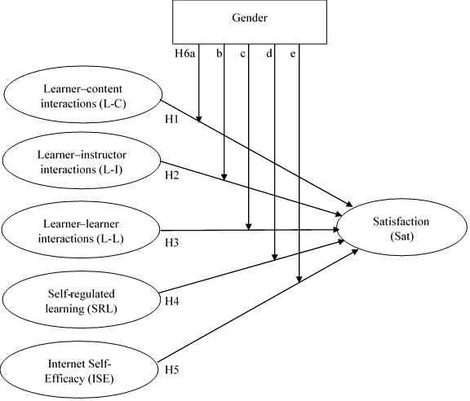
H6e: There are significant gender differences in the relationship between Internet self-efficacy and e-learning satisfaction.
Figure 1. Research framework
Figure 1 illustrates the research framework proposed in this study. Table 1 also presents the synthesis of the selected recent literature review for e-learning. The findings of these studies ground the research gaps for this study.

Table 1. Literature review summary
No | Author(s) | Predictor(s) | Findings | Gender Analysis | Setting
1. | [45] | - Learning  - Instructor  - Course  - Technology  - Design  - Environment | - The design dimension critically affected the satisfaction. | - | Integration of E-learning into Traditional Teaching

Table 1. Literature review summary (cont.)
No | Author(s) | Predictor(s) | Findings | Gender Analysis | Setting
2. | [28] | - Information Access  - Interactive Learning  - Networked Learning  - Materials Development | - Networked learning and materials development were significantly related to learning achievement and course satisfaction.  - Learning styles were significant in determining information access, interactive learning, networked learning, and materials development. | - | Integration of E-learning into Traditional Teaching
3. | [16] | - Computer Self-Efficacy  - Instructor Characteristics  - Facilitating Conditions | - All attributes were significantly related to perceived accomplishment and perceived enjoyment for females  - Only instructor characteristics and facilitating conditions were significantly related to perceived accomplishment and perceived enjoyment for males.  - Perceived accomplishment and perceived enjoyment significantly influenced satisfaction. | - Descriptive  - Structural Equation Modeling | Integration of E-learning into Traditional Teaching
4. | [27] | - Forecasting | - Students showed better performance in modified E-Learning System. | - | E-learning
5. | [40] | - Internet self-efficacy  - Anti-phishing Self-efficacy  - Anti-phishing Behavior | - Males and females were significantly different in terms of anti-phishing self-efficacy and anti-phishing behavior.  - Anti-phishing self-efficacy mediated the relationship between Internet self-efficacy and anti-phishing behavior. | Structural Equation Modeling | Online Experience

Table 1. Literature review summary (cont.)
No | Author(s) | Predictor(s) | Findings | Gender Analysis | Setting
6. | [44] | - Learner-learner Interaction  - Learner-teacher Interaction  - Learner-content Interaction | - Learner-content interaction was found significant to satisfaction. | - | Integration of E-learning into Traditional Teaching
7. | [46] | - Learner-learner Interaction | - Learner-learner interaction affected perceived learning and satisfaction.  - Frequency of interaction was positively correlated with perceived learning, achievement, and satisfaction. | - | Online course
8. | [42] | - Search Self-efficacy  - Communication Self-efficacy  - Organization Self-efficacy  - Differentiation Self-efficacy  - Reactive/ Generative Self-efficacy | - Reactive/ generative self-efficacy contributed to Internet anxiety. | - | Integration of E-learning into Traditional Teaching
9. | [41] | - Teachers’ Internet Self-efficacy | - Teachers showed high Internet self-efficacy. | Descriptive | E-Learning
10. | [17] | - Technology Infrastructure Quality  - Learner Engagement  - Faculty Technology Competence  - Learner Interaction  - Course Design Quality | - All attributes affected student learning experience for both males and females. | Logistic Regression | Integration of E-learning into Traditional Teaching

Table 1. Literature review summary(cont.)
No | Author(s) | Predictor(s) | Findings | Gender Analysis | Setting
11. | [18] | - Internet Facilities  - Internet Usage Purposes  - Internet Self-efficacy | - Females owned Internet facilities, had more frequent Internet usage for academic purposes.  - The perception of females was positive on the benefits of the Internet. | Descriptive | Integration of E-learning into Traditional Teaching
12. | [26] | - General Internet Use  - Professional Internet Use  - Hours per Week | - The relationship between use of the Internet and learning performance was mediated by academic self-efficacy.  - Professional Internet use stands out as the predictor of learning performance. | - | E-learning
13. | [47] | - Perceived Learning  - Number of Previous Online Courses  - Gender  - Degree  - Self-regulated Learning Strategy Usage  - Culture | - All attributes affected learner’s satisfaction, except gender and culture. | - | - Massive Open Online Courses (MOOCs)

3. RESEARCH METHOD
3.1 Participants and Data Collection
Due to changes in learning instructions by integrating e-learning into traditional teaching, the learners’ satisfaction level is still the main concern of higher education providers, as satisfaction is closely related to academic achievement or success. Consequently, this study investigates learners’ satisfaction by employing the predictors of learning satisfaction, as well as by considering the impact of gender differences. The study was carried out at a medium-sized private college in Malaysia. The college consisted of 1316 undergraduate students, and it offers courses that integrate e-learning into traditional teaching every semester. The duration of the study in each semester is four months. Such courses cover management and accounting disciplines, such as operation management, human resource management, technology management, accounting information systems, financial accounting, and management accounting, among others.
We used a purposive sampling technique to collect the data, as the selected samples were limited to the on-campus students, excluding students who were undergoing internships. Also, the respondents had gone through three-months of study, in which the students should have experienced a certain level of exposure in using e-learning systems before the data collection exercise commenced. Thus, the data collection process started at the fourth month of the ongoing semester when this study was carried out, and the data collection process lasted for two weeks. Before the commencement of data collection, the students notified that their participation in the research was voluntary. The college approved the procedure of data collection in this study.
We used SPSS software to perform descriptive analysis. Furthermore, the data were analyzed using partial least square-structural equation modeling (PLS-SEM) with the SmartPLS software. We constructed a questionnaire which included demographic information, student perceptions of interactivity in the learning environment (i.e., learner–content interaction, learner–instructor interaction and learner-learner interaction), self-regulated learning, Internet self-efficacy, and learning satisfaction. Table 2 summarizes the instruments and the sources of the measurement items for all of the constructs. A 5-point Likert scale ranging from strongly disagree (1) to strongly agree (5) was used to measure the six constructs.

Table 2. Questionnaire sources and measurement items
Constructs | Items |  | Sources
Learner–content interactions (L-C) | LC1 | Online course material helped me to understand better the class content | [2]
Learner–content interactions (L-C) | LC2 | Online course materials stimulated my interest for this course | [2]
Learner–content interactions (L-C) | LC3 | Online course materials helped relate my personal experience to new concepts or new knowledge | [2]
Learner–content interactions (L-C) | LC4 | It was easy for me to access the online course materials | [2]
Learner–instructor interactions (L-I) | SI1 | I had numerous interactions with the instructor during the class | [2]
Learner–instructor interactions (L-I) | SI2 | I asked the instructor my questions through different electronic means, such as emails, discussion board, instant messaging tools, etc. | [2]
Learner–instructor interactions (L-I) | SI3 | The instructor regularly posted some questions for students to discuss on the discussion board | [2]
Learner–instructor interactions (L-I) | SI4 | The instructor replied my questions in a timely fashion | [2]
Learner–instructor interactions (L-I) | SI5 | I replied to messages from the instructors | [2]
Learner–instructor interactions (L-I) | SI6 | I received enough feedback from my instructor when I needed it | [2]
Table 2. Questionnaire sources and measurement items (cont.)
Constructs | Items |  | Sources
Learner–learner interactions (L-L) | SS1 | Overall, I had numerous interactions related to the course content with fellow students | [2]
Learner–learner interactions (L-L) | SS2 | I got lots of feedback from my classmates | [2]
Learner–learner interactions (L-L) | SS3 | I communicated with my classmates about the course content through different electronic means, such as emails, discussion boards, instant messaging tools, etc. | [2]
Learner–learner interactions (L-L) | SS4 | I answered questions of my classmates about the content through different electronic means, such as email, discussion board, instant messaging tools, etc. | [2]
Learner–learner interactions (L-L) | SS5 | I shared my thought or ideas about the lectures and its application with other students during this class. | [2]
Learner–learner interactions (L-L) | SS6 | I comment on other students’ thought and ideas. | [2]
Learner–learner interactions (L-L) | SS7 | Group activities during class gave me chances to interact with my classmates. | [2]
Learner–learner interactions (L-L) | SS8 | Class projects led to interactions with my classmates. | [2]
Self-regulated learning (SRL) | LP1 | During class time, I often miss important points because I’m thinking of other things. | [24]
Self-regulated learning (SRL) | LP2 | When reading for this course, I make up questions to help focus my reading. | [24]
Self-regulated learning (SRL) | LP3 | When I become confused about something I’m reading for this class, I go back and try to figure it out. | [24]
Self-regulated learning (SRL) | LP4 | If course materials are difficult to understand, I change the way I read the material. | [24]
Self-regulated learning (SRL) | LP5 | Before I study new course material thoroughly, I often skim it to see how it is organized. | [24]
Self-regulated learning (SRL) | LP6 | I ask myself questions to make sure I understand the material I have been studying in this class. | [24]
Self-regulated learning (SRL) | LP7 | I try to change the way I study in order to fit the course requirements and instructor’s teaching style. | [24]
Self-regulated learning (SRL) | LP8 | I often find that I have been reading for class but don’t know what it was all about. | [24]
Self-regulated learning (SRL) | LP9 | I try to think through a topic and decide what I am supposed to learn from it rather than just reading it over when studying, | [24]
Self-regulated learning (SRL) | LP10 | When studying for this course I try to determine which concepts I don’t understand well. | [24]

Table 2. Questionnaire sources and measurement items (cont.)
Constructs | Items |  | Sources
Internet Self-Efficacy (ISE) | SE1 | Understanding terms/words relating to Internet hardware | [24]
Internet Self-Efficacy (ISE) | SE2 | Understanding terms/words relating to Internet software. | [24]
Internet Self-Efficacy (ISE) | SE3 | Describing functions of Internet hardware | [24]
Internet Self-Efficacy (ISE) | SE4 | Trouble shooting Internet hardware. | [24]
Internet Self-Efficacy (ISE) | SE5 | Explaining why a task will not run on the Internet | [24]
Internet Self-Efficacy (ISE) | SE6 | Using the internet to gather data | [24]
Internet Self-Efficacy (ISE) | SE7 | Confident learning advanced skills within a specific Internet program. | [24]
Internet Self-Efficacy (ISE) | SE8 | Turning to an on-line discussion group when help is needed. | [24]
Satisfaction (Sat) | S1 | Overall, I am satisfied with this class. | [24]
Satisfaction (Sat) | S2 | This course contributed to my educational development. | [24]
Satisfaction (Sat) | S3 | This course contributed to my professional development. | [24]
Satisfaction (Sat) | S4 | I am satisfied with the level of interaction that happened in this course. | [24]
Satisfaction (Sat) | S5 | In the future, I would be willing to take a fully online course again. | [24]

4. data analysis
In total, we had disseminated 800 questionnaires, and 742 completed questionnaires were returned, indicating a 92.7% valid response rate. The administrative support of the college contributed to obtaining such a high response rate. Table 3 depicts the profile of the respondents. 209 males and 533 females responded to the survey. The age for most of the respondents were between 19 years and 21 years. In terms of online duration, 73.2 percent of the respondents spent more than 5 hours per week online.

Table 3. Profile of respondents
Variable | Category | Frequency | Percent
Gender | Male | 209 | 28.20
Gender | Female | 533 | 71.80
Age | 18 or less than 18 years old | 7 | 0.90
Age | 19-21 years old | 580 | 78.20
Age | 22-24 years old | 136 | 18.30
Age | More than 25 years old | 18 | 2.40
Age | Unknown | 1 | 0.10
Hours Spent Online per Week | 5 or less than 5 hours | 199 | 26.80
Hours Spent Online per Week | 6-10 hours | 172 | 23.20
Hours Spent Online per Week | 11-15 hours | 132 | 17.80
Hours Spent Online per Week | 16-20 hours | 77 | 10.40
Hours Spent Online per Week | More than 20 hours | 162 | 21.80
Table 4 presents the descriptive statistics for all of the constructs. The means of all of the variables ranged between 3.62 and 3.80. The Cronbach’s alpha and composite reliability for all of the constructs exceeded the 0.70 threshold level, suggesting sufficient internal consistency. The Average Variance Extracted (AVE) for all of the constructs was greater than 0.5, which confirmed the validity of all of the constructs.

Table 4. Descriptive statistics among the constructs
Variable | Items | Mean | S. D. | Sample | Cronbach’s alpha | Composite Reliability | AVE
Learner–content interactions (L-C) | 4 | 3.77 | 0.66 | All | 0.88 | 0.92 | 0.74
 |  |  |  | Males | 0.88 | 0.92 | 0.74
 |  |  |  | Females | 0.88 | 0.92 | 0.74
Learner–instructor interactions (L-I) | 6 | 3.62 | 0.62 | All | 0.88 | 0.91 | 0.64
 |  |  |  | Males | 0.89 | 0.92 | 0.65
 |  |  |  | Females | 0.88 | 0.91 | 0.63
Learner–learner interactions (L-L) | 8 | 3.75 | 0.59 | All | 0.91 | 0.92 | 0.60
 |  |  |  | Males | 0.92 | 0.94 | 0.65
 |  |  |  | Females | 0.89 | 0.65 | 0.58
Self-regulated learning (SRL) | 10 | 3.71 | 0.56 | All | 0.90 | 0.92 | 0.54
 |  |  |  | Males | 0.92 | 0.93 | 0.59
 |  |  |  | Females | 0.89 | 0.91 | 0.51
Internet Self-Efficacy (ISE) | 8 | 3.71 | 0.58 | All | 0.91 | 0.93 | 0.61
 |  |  |  | Males | 0.92 | 0.94 | 0.65
 |  |  |  | Females | 0.90 | 0.92 | 0.59
Satisfaction (Sat) | 5 | 3.80 | 0.63 | All | 0.89 | 0.92 | 0.69
 |  |  |  | Males | 0.88 | 0.92 | 0.69
 |  |  |  | Females | 0.89 | 0.92 | 0.69

Table 5 shows the results of the indicator loadings. Based on the results, all of the constructs achieved reliability. All of the indicator loadings exceeded or were equal to 0.70, which substantiated the reliability of all of the indicators. The Heterotrait-Monotrait Ratio (HTMT) analysis indicated that all of the indicators achieved discriminant validity because all of the values were less than the threshold value of 0.85 (see, Table 6).

Table 5. Indicator loadings
Construct | Items | All | Males | Females
Learner–content interactions (L-C) | LC1 | 0.85 | 0.86 | 0.85
 | LC2 | 0.89 | 0.90 | 0.88
 | LC3 | 0.88 | 0.88 | 0.88
 | LC4 | 0.82 | 0.78 | 0.84
Learner–instructor interactions (L-I) | SI1 | 0.74 | 0.70 | 0.76
 | SI2 | 0.76 | 0.79 | 0.75
 | SI3 | 0.80 | 0.83 | 0.79
 | SI4 | 0.83 | 0.84 | 0.82
 | SI5 | 0.83 | 0.85 | 0.81
 | SI6 | 0.82 | 0.81 | 0.83
Learner–learner interactions (L-L) | SS1 | 0.80 | 0.86 | 0.76
 | SS2 | 0.76 | 0.80 | 0.74
 | SS3 | 0.80 | 0.84 | 0.79
 | SS4 | 0.79 | 0.81 | 0.79
 | SS5 | 0.78 | 0.80 | 0.76
 | SS6 | 0.73 | 0.74 | 0.72
 | SS7 | 0.77 | 0.78 | 0.77
 | SS8 | 0.77 | 0.82 | 0.73
Self-regulated learning (SRL) | LP1 | 0.73 | 0.78 | 0.68
 | LP2 | 0.72 | 0.74 | 0.71
 | LP3 | 0.73 | 0.78 | 0.70
 | LP4 | 0.68 | 0.79 | 0.61
 | LP5 | 0.77 | 0.78 | 0.77
 | LP6 | 0.78 | 0.84 | 0.74
 | LP7 | 0.71 | 0.71 | 0.71
 | LP8 | 0.74 | 0.76 | 0.72
 | LP9 | 0.75 | 0.78 | 0.74
 | LP10 | 0.72 | 0.70 | 0.73
Internet Self-Efficacy (ISE) | SE1 | 0.81 | 0.84 | 0.80
 | SE2 | 0.84 | 0.87 | 0.82
 | SE3 | 0.83 | 0.87 | 0.81
 | SE4 | 0.76 | 0.74 | 0.77
 | SE5 | 0.75 | 0.76 | 0.74
 | SE6 | 0.75 | 0.81 | 0.72
 | SE7 | 0.78 | 0.83 | 0.76
 | SE8 | 0.72 | 0.75 | 0.71
Satisfaction (Sat) | S1 | 0.84 | 0.85 | 0.83
 | S2 | 0.86 | 0.86 | 0.86
 | S3 | 0.85 | 0.83 | 0.86
 | S4 | 0.85 | 0.83 | 0.86
 | S5 | 0.74 | 0.77 | 0.72

Table 6. Heterotrait-Monotrait ratio (HTMT)
 | L-C | SRL | L-I | L-L | ISE | Sat
L-C | 0.86
SRL | 0.58 | 0.73
L-I | 0.59 | 0.75 | 0.80
L-L | 0.56 | 0.80 | 0.72 | 0.77
ISE | 0.62 | 0.71 | 0.59 | 0.71 | 0.78
Sat | 0.45 | 0.70 | 0.65 | 0.67 | 0.62 | 0.83
Note: The bold is the square root of the AVE.

We then estimated the relationship among the interactions in the learning environment (i.e., learner–content interaction, learner–instructor interaction and learner-learner interaction), self-regulated learning, Internet self-efficacy and learning satisfaction using the whole sample, followed by the male sample and the female sample. We performed a multi-group analysis (MGA) to differentiate the impact of the predictor variables across the gender groups.
In the first step, a bootstrapping of 5000-sub samples was carried out for the structural model estimation (see, Table 7). The overall explanatory power (R²) shows that the whole sample, the male sample, and the female sample accounted for 48.5%, 71.7%, and 39.3% in their respective structural models. The values of all of the Q² for these three samples were more than zero, suggesting the predictive relevance of all of the structural models in this study. In short, the analysis confirmed the predictive validity of all of the structural models [56]. Furthermore, the model showed an adequate model fit for all of the models because all of the standardized root mean squared residual (SRMR) values were less than 0.08.
The results show that learner–instructor interaction and self-regulated learning positively affected learning satisfaction for all of the structural models. On the contrary, learner–content interaction did not influence satisfaction for all of the models. The assessment results of the whole sample showed that learner–instructor interaction (β = 0.22, t = 3.49), learner-learner interaction (β = 0.17, t = 3.41), self-regulated learning (β = 0.27, t = 5.38), and Internet self-efficacy (β = 0.19, t = 3.41) were significant and positively related to satisfaction, while the effect of learner-content interaction (β = -0.04, t = 1.02) was insignificant on satisfaction. Therefore, hypotheses H2, H3, H4, and H5 were supported, whereas, hypothesis H1 was rejected. Figures 2 to 4 summarized the findings. The impact of learner-learner interaction and Internet self-efficacy on satisfaction were inconsistent between males and females, suggesting potential gender effects.

Table 7. Estimation of the structural model
 | All | Males |  | Females |  | All | Males | Females
Endogenous construct | R-Square |  |  |  |  | Q-Square
Sat | 0.485 | 0.717 |  | 0.393 |  | 0.326 | 0.484 | 0.267
Model Fit | Saturated Model |  |  |  |  | Estimated Model
SRMR | 0.05*** | 0.06*** |  | 0.05*** |  | 0.05*** | 0.06*** | 0.05***
 | All |  | Males |  |  |  | Females
Relation | Path Coefficient (t-value)
L-C Sat | -0.04^{n.s.} (1.02) |  |  | -0.01^{n.s.} (0.22) |  |  | -0.04 ^{n.s.} (0.68)
L-I Sat | 0.22*** (3.49) |  |  | 0.13** (2.36) |  |  | 0.26*** (3.28)
L-L Sat | 0.17*** (3.41) |  |  | 0.13 ^{n.s.} (1.63) |  |  | 0.17 *** (2.86)
SRL Sat | 0.27*** (5.38) |  |  | 0.30*** (3.88) |  |  | 0.21*** (3.37)
ISE Sat | 0.19*** (3.41) |  |  | 0.39*** (5.79) |  |  | 0.12 ^{n.s.} (1.70)
Notes: Statistical significance ^{n.s.}= non-significant; **p<0.05; ***p<0.01
L-C = learner–content interaction; L-I = learner–instructor interaction, L-L= learner–learner interaction, SRL= Self-regulated learning, ISE = Internet self-efficacy, Sat = satisfaction

In the second step, we examined whether the impact of learner–content interaction, learner–instructor interaction, learner-learner interaction, self-regulated learning, and Internet self-efficacy on satisfaction differed across gender groups. Specifically, we used the PLS-MGA, parametric, and Welch-Satterthwait tests to examine the gender effect. In this study, our multi-group analysis indicated a statistically significant difference between males and females in the relationship between Internet self-efficacy and learning satisfaction (see, Table 8). The PLS-MGA, parametric, and Welch-Satterthwait tests constantly confirmed the result. Consequently, hypothesis H6e was supported. In contrast, the impact of learner–content interaction, learner–instructor interaction, learner-learner interaction, and self-regulated learning on satisfaction did not differ across gender groups, and, thus, hypotheses H6a, H6b, H6c, and H6d were rejected. Figure 5 demonstrates the results.

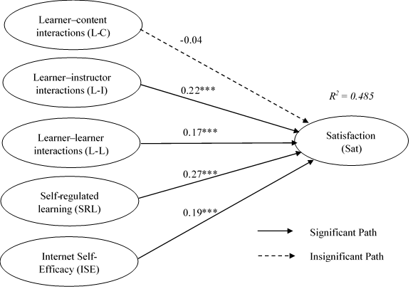

Figure 2. Path coefficients for the whole sample

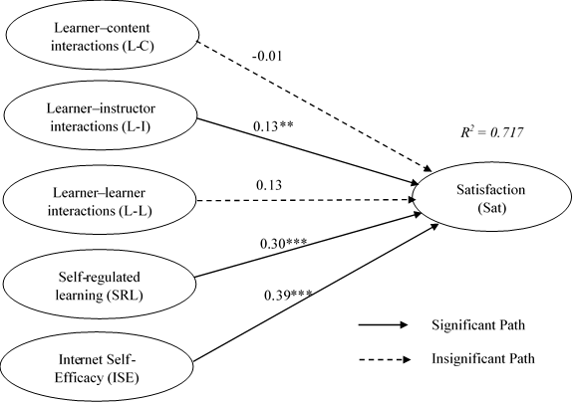

Figure 3. Path coefficients for the male group

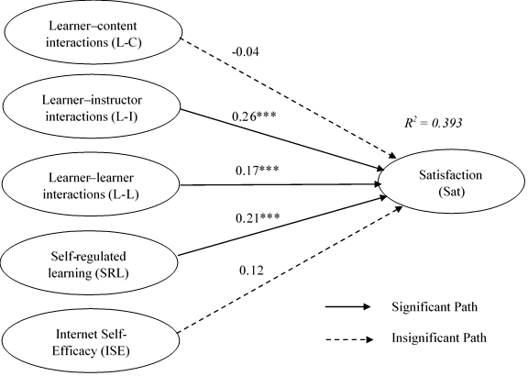

Figure 4. Path coefficients for the female group

Table 8. Multi-group analysis
Relation | Path Coefficient-diff (p-value) for Females vs Males
Relation | PLS-MGA | Parametric | Welch-Satterthwait Test
L-C Sat | 0.02 ^{n.s.} (0.61) | 0.02 ^{n.s.} (0.80) | 0.02 ^{n.s.} (0.77)
L-I Sat | 0.13 ^{n.s.} (0.10) | 0.13 ^{n.s.} (0.34) | 0.13 ^{n.s.} (0.20)
L-L Sat | 0.04 ^{n.s.} (0.34) | 0.04 ^{n.s.} (0.71) | 0.04 ^{n.s.} (0.69)
SRL Sat | 0.08 ^{n.s.} (0.80) | 0.09 ^{n.s.} (0.45) | 0.09 ^{n.s.} (0.40)
ISE Sat | 0.27*** (0.99) | 0.28** (0.02) | 0.27*** (0.01)
Notes: Statistical significance ^{n.s.}= non-significant; **p<0.05; ***p<0.01

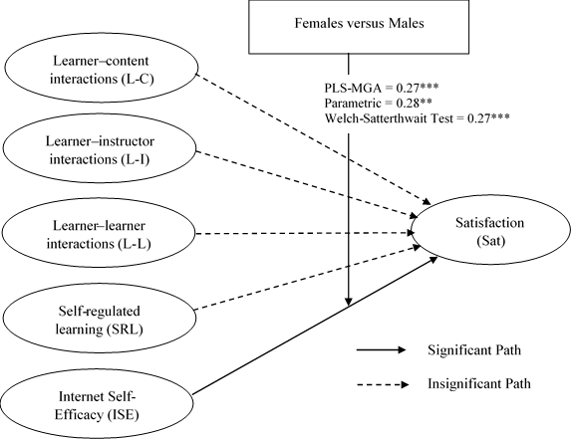

Figure 5. Multi-group analysis results

An Importance Performance Matrix Analysis (IPMA) was performed to assess the importance and relative performance of the perceived attributes by respondents in evaluating the comparative advantage of the determinants of learning satisfaction. Figures 6, 7, and 8 show the IPMA for the whole sample, and the male and the female groups, respectively. The Importance-performance map presents the importance (x-axis) and performance (y-axis) in the matrix. In all of the groups, learner–content interaction shows an above-average performance value but a below-average importance value in predicting learning satisfaction. On the other hand, self-regulated learning, Internet self-efficacy, learner-learner interaction, and learner–instructor interaction have both above-average performance, and importance values in all of the groups, except for learner-learner interaction and learner–instructor interaction which were found less vital for the male group.

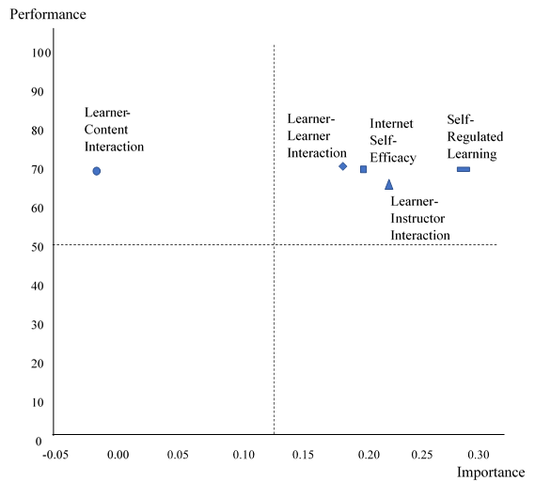
Figure 6. Importance-performance map for predicting learning satisfaction in the whole sample
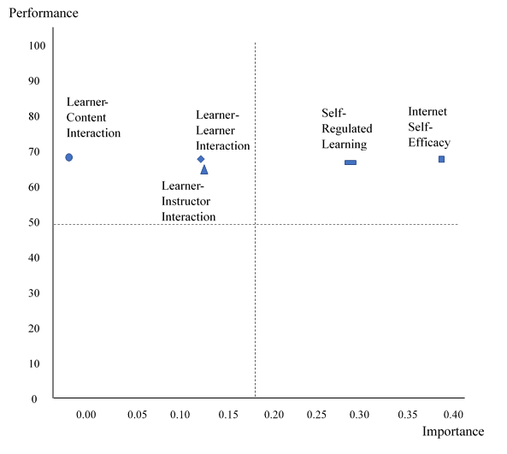

Figure 7. Importance-performance map for predicting learning satisfaction in the male group

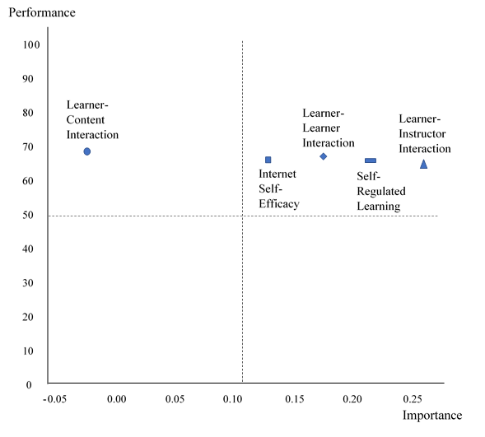
Figure 8. Importance-performance map for predicting learning satisfaction in the female group

In short, we summarize the results into (1) the relationship between learning satisfaction predictors and e-learning satisfaction; and (2) the gender effects on e-learning satisfaction. For the relationship between learning satisfaction predictors and e-learning satisfaction, the whole sample analysis results show that learner–instructor interaction, learner-learner interaction, self-regulated learning, and Internet self-efficacy are positively associated with satisfaction. As different predictors are significant for male and female groups, gender differences may exist. For the gender effects on e-learning satisfaction, gender difference exists between Internet self-efficacy and e-learning satisfaction.

5. discussion
The present study was conducted to investigate the impact of learner–content interaction, learner-learner interaction, learner–instructor interaction, Internet self-efficacy, and self-regulated learning on learning satisfaction with the presence of the gender effect. The sample was separated into three groups (i.e., the whole sample, males and females) to identify the gender effect. We first performed the PLS-SEM on the whole sample, and subsequently on the male sample and the female sample. The whole sample analysis results showed that learner–instructor interaction and learner-learner interaction were positively associated with satisfaction. In line with the study of [57], recurrent interaction contributes to satisfaction. Instructors should consider identifying measures to promote successful interactions in the classroom and online platforms to enable students to engage in the learning process more effectively. Additionally, university administrators should consider providing adequate training to enhance university instructors’ skills in designing lessons and structuring classrooms to enable learners to take an active role in their learning through learner–instructor interaction. Furthermore, self-regulated learning was positively associated with satisfaction in the whole sample group. Self-regulated learning can improve learning satisfaction through the use of interactive learning materials [58]. University instructors should continue to design appropriate learning strategies and activities to help learners to develop their self-regulated learning. Such an approach may help students to accept self-responsibility in the learning process instead of focusing on direct instruction and teacher-centered learning. Furthermore, the whole sample evidence suggests that Internet self-efficacy is positively related to satisfaction. This finding is consistent with Shen, Cho, Tsai, and Marra [59] who demonstrated that online self-efficacy predicts learning satisfaction. Courses can be provided to shape the ability to use the Internet. In contrast, the inconsistency of the predictors’ results among the male and the female groups directed further investigation to test for presence of the gender effect further.
Multigroup analysis was performed to identify the gender effect between the male and the female samples. The analysis shows that a gender difference exists for Internet self-efficacy, but not for other relationships. In other words, the traditional gap in Internet self-efficacy happens between males and females [60-62]. The causation analysis of the PLS-SEM also supports this finding, i.e., Internet self-efficacy is not related to learning satisfaction in the female sample. The university administrators need to undertake strategic changes to assist female learners in overcoming the barrier of Internet self-efficacy skills. For example, the university should strive to conduct more Internet-related activities for female learners to develop their Internet self-efficacy. Because the gender gap in technology self-efficacy is an international phenomenon, our study renders significant findings to motivate university administrators and instructors to consider implementing gender-neutral interventions to ensure that learners can enhance learning effectiveness and satisfaction in combination e-learning and traditional teaching environments [63].
The importance-performance map analysis provides areas where there is the room for enhancement. Self-regulated learning and self-efficacy have a high impact on learning satisfaction across all of the groups. Therefore, these planned learning activities are directed to maintain or to increase the satisfaction level. The learner–content interaction is positioned at the dimension of high performance but is yet important, which entails special attention from university administrators. Education can enhance comparative advantage [64]. Thus, the action is essential to create awareness among learners to benefit from learning resources. The predictors of learner-learner interaction and learner–instructor interaction show low importance though high performance among male learners to achieve satisfaction. Males prefer higher-order interactions, which involve idea discussions and research participation [65]. Thus, awareness needs to be imparted by university instructors when conducting discussions or research-related activities.

6. conclusion
In contemplating obtaining a better understanding of the satisfaction level of e-learning, this study assesses the impact of gender differences in learning satisfaction using different e-learning predictors and analyses areas for enhancement in e-learning.
Learning satisfaction predictors and e-learning satisfaction. The predictors for e-learning satisfaction identified in the whole sample include learner–instructor interaction, learner-learner interaction, self-regulated learning, and Internet self-efficacy on satisfaction. These areas can be considered by the university administrators to increase the satisfaction of learners. Learner–content interaction is one of the areas for enhancement, where awareness regarding the importance of the interaction between learner and content in the integration of e-learning into the traditional teaching context needs to be enhanced. To create value for the interaction, more higher-order thinking skills discussion can be conducted to enhance the learner-learner interaction of males. On the other hand, university administrators can conduct more workshops or exposure to increase confidence levels for female learners.
Gender effects and e-learning satisfaction. The gender effects are present in the relationship between Internet self-efficacy and learning satisfaction. As Internet self-efficacy is not significant for females, the university’s administrators need to assist female learners in overcoming the barrier of Internet self-efficacy skills to enhance their satisfaction.
As for recommendations for further study, investigating gender effects on the impact of interactivity in the learning environment, as well as Internet self-efficacy and self-regulated learning on learning outcomes that bases on Bloom’s Taxonomy [66], are promising future research avenues.

7. acknowledgEment
The authors acknowledge the generous support from Ministry of Education Malaysia and Universiti Teknologi Malaysia (FRGS/1/2018/SS03/UTM/02/3, Vot No.5F104).

8. REFERENCES
- H. M. S. Ahmed, Hybrid e-Learning acceptance model: Learner perceptions. Decision Sciences Journal of Innovative Education, 8(2), 313-346, 2010.
- Y.-C. Kuo, B. R. Belland, K. E. E. Schroder, and A. E. Walker, K-12 teachers’ perceptions of and their satisfaction with interaction type in blended learning environments. Distance Education, 35(3), 360-381, 2014.
- C. J. Bonk and C. R. Graham, The handbook of blended learning: Global perspectives, local designs. California: John Wiley & Sons, 2012.
- J.-H. Wu, R. D. Tennyson, and T.-L. Hsia, A study of student satisfaction in a blended e-learning system environment. Computers & Education, 55(1), 155-164, 2010.
- J.-K. Lee and W.-K. Lee, The relationship of e-Learner’s self-regulatory efficacy and perception of e-Learning environmental quality. Computers in Human Behavior, 24(1), 32-47, 2008.
- M. A. Naaj, M. Nachouki, and A. Ankit, Evaluating student satisfaction with blended learning in a gender-segregated environment. Journal of Information Technology Education: Research, 11(1), 185-200, 2012.
- P. Moskal, C. Dziuban, and J. Hartman, Blended learning: A dangerous idea? The Internet and Higher Education, 18, 15-23, 2013.
- U. Ehlers, Quality in e-learning. The learner as a key quality assurance category. European Journal of Vocational Training, 29, 3-15, 2004.
- M. Kerres and C. D. Witt, A didactical framework for the design of blended learning arrangements. Journal of Educational Media, 28(2-3), 101-113, 2003.
- S. Van Laer and J. Elen, In search of attributes that support self-regulation in blended learning environments. Education and Information Technologies, 1-60, 2016.
- P. Luarn, H.-C. Kuo, Y.-P. Chiu, and S.-C. Chang, Social support on Facebook: The influence of tie strength and gender differences. International Journal of Electronic Commerce Studies, 6(1), 37-50, 2015.
- J.-M. Lee and J.-Y. Rha, Ambivalence toward personalized technology and intention to use location-based mobile commerce: The moderating role of gender. International Journal of Electronic Commerce Studies, 8(2), 197-218, 2017.
- F. González-Gómez, J. Guardiola, Ó. Martín Rodríguez, and M. Á. Montero Alonso, Gender differences in e-learning satisfaction. Computers & Education, 58(1), 283-290, 2012.
- P. E. Ramírez-Correa, J. Arenas-Gaitán, and F. J. Rondán-Cataluña, Gender and Acceptance of E-Learning: A Multi-Group Analysis Based on a Structural Equation Model among College Students in Chile and Spain. PloS one, 10(10), e0140460, 2015.
- A. Wallace and N. Panteli, Bringing relevance to eLearning – a gender perspective. Studies in Higher Education, 1-13, 2016.
- Y. Dang, Y. Zhang, S. Ravindran, and T. Osmonbekov, Examining student satisfaction and gender differences in technology-supported, blended learning. Journal of Information Systems Education, 27, 119-130, 2016.
- V. Savara, Unraveling determinants of quality in blended learning: Are there gender-based differences? International Journal of Quality & Reliability Management, 35(9), 2035-2051, 2018.
- W. Suana, Students’ internet access, internet self-efficacy, and internet for learning physics: Gender and grade differences. Journal of Technology and Science Education, 8, 281, 2018.
- M. G. Moore, Editorial: Three types of interaction. American Journal of Distance Education, 3(2), 1-7, 1989.
- A. Bandura, Social foundations of thought and action: A social cognitive theory. Englewood Cliffs, NJ, US: Prentice-Hall, Inc, 1986.
- O. Deperlioglu and U. Kose, The effectiveness and experiences of blended learning approaches to computer programming education. Computer Applications in Engineering Education, 21(2), 328-342, 2013.
- A. Hirumi, The design and sequencing of online and blended learning interactions: A framework for grounded design. Canadian Learning Journal, 16(2), 21-25, 2011.
- D. Holley and C. Dobson, Encouraging student engagement in a blended learning environment: the use of contemporary learning spaces. Learning, Media and Technology, 33(2), 139-150, 2008.
- Y.-C. Kuo, A. E. Walker, K. E. E. Schroder, and B. R. Belland, Interaction, Internet self-efficacy, and self-regulated learning as predictors of student satisfaction in online education courses. The Internet and Higher Education, 20, 35-50, 2014.
- K. Schweizer, M. Paechter, and B. Weidenmann, Blended learning as a strategy to improve collaborative task performance. Journal of Educational Media, 28(2-3), 211-224, 2003.
- M. S. Islam, From ICT adoption to ICT addiction: What really matters between the use of ICT and learning performance? International Journal of Electronic Commerce Studies, 9(2), 133-159, 2019.
- T. Kaewkiriya, Design of a mobile e-learning forecasting system based on a case study using multiple intelligence analysis. International Journal of Electronic Commerce Studies, 7(2), 189-200, 2016.
- G. Cheng and J. Chau, Exploring the relationships between learning styles, online participation, learning achievement and course satisfaction: An empirical study of a blended learning course. British Journal of Educational Technology, 47(2), 257-278, 2016.
- M. Moore and G. Kearsley, Distance education: A systems review. Belmont: Wadsworth Publishing Company, 1996.
- M. Moore, Theory of transactional distance. In D. Keegan (Ed.), Theoretical principles of distance education (pp. 22-38). New York: Routledge, 1997.
- G. Falloon, Making the connection. Journal of Research on Technology in Education, 43(3), 187-209, 2011.
- C. Chou, H. Peng, and C.-Y. Chang, The technical framework of interactive functions for course-management systems: Students’ perceptions, uses, and evaluations. Computers & Education, 55(3), 1004-1017, 2010.
- M. Cheng and A. H. K. Yuen, Student continuance of learning management system use: A longitudinal exploration. Computers & Education, 120, 241-253, 2018.
- C.-H. Lin, B. Zheng, and Y. Zhang, Interactions and learning outcomes in online language courses. British Journal of Educational Technology, 48(3), 730-748, 2016.
- Y.-M. Cheng, Exploring the roles of interaction and flow in explaining nurses' e-learning acceptance. Nurse Education Today, 33(1), 73-80, 2013.
- M. Paechter and B. Maier, Online or face-to-face? Students' experiences and preferences in e-learning. The Internet and Higher Education, 13(4), 292-297, 2010.
- D. U. Bolliger, F. A. Inan, and O. Wasilik, Development and validation of the online instructor satisfaction measure (OISM). Educational Technology & Society, 17(2), 183-195, 2014.
- B. J. Zimmerman, A social cognitive view of self-regulated academic learning. Journal of Educational Psychology, 81(3), 329, 1989.
- A. Bandura, Self-efficacy: The exercise of control. New York, NY, US: W H Freeman/Times Books/ Henry Holt & Co, 1997.
- J. C.-Y. Sun, S.-J. Yu, S. S. J. Lin, and S.-S. Tseng, The mediating effect of anti-phishing self-efficacy between college students’ internet self-efficacy and anti-phishing behavior and gender difference. Computers in Human Behavior, 59, 249-257, 2016.
- S. Kahraman and Z. Yilmaz, In-service teachers’ Internet self-efficacy: A re-examination of gender differences. Turkish Online Journal of Distance Education, 19, 72-85, 2018.
- N. Paul and M. Glassman, Relationship between internet self-efficacy and internet anxiety: A nuanced approach to understanding the connection. Australasian Journal of Educational Technology, 33, 147-165, 2017.
- S. Sukanlaya, N. Cameron, and J. Kieren, Increasing learners’ satisfaction/intention to adopt more e‐learning. Education + Training, 55(1), 83-105, 2013.
- B. Best and S. Conceição, Transactional distance dialogic interactions and student satisfaction in a multi-institutional blended learning environment. European Journal of Open, Distance and E-Learning, 20, 138-152, 2017.
- W. Chen and A. Yao, An empirical evaluation of critical factors influencing learner satisfaction in blended learning: A pilot study. Universal Journal of Educational Research, 4, 1667-1671, 2016.
- M. Kurucay and F. A. Inan, Examining the effects of learner-learner interactions on satisfaction and learning in an online undergraduate course. Computers & Education, 115, 20-37, 2017.
- K. Li, MOOC learners’ demographics, self-regulated learning strategy, perceived learning and satisfaction: A structural equation modeling approach. Computers & Education, 132, 16-30, 2019.
- A. Padilla-Meléndez, A. R. del Aguila-Obra, and A. Garrido-Moreno, Perceived playfulness, gender differences and technology acceptance model in a blended learning scenario. Computers & Education, 63, 306-317, 2013.
- C. Dziuban, P. Moskal, and J. Hartman, Higher education, blended learning and the generations: Knowledge is power-no more. In J. C. M. J. Bourne (Ed.), Elements of quality online education: Engaging communities, Sloan Center for online education (pp. 85-100). Needham, MA: Sloan Center for Online Education, 2005.
- M. Graff, Individual differences in sense of classroom community in a blended learning environment. Journal of Educational Media, 28(2-3), 203-210, 2003.
- Y. Gulbahar and R. O. Madran, Communication and collaboration, satisfaction, equity, and autonomy in blended learning environments: A Case from Turkey. International Review of Research in Open and Distance Learning, 10(2), n2, 1-22, 2009.
- M. Cuadrado-García, M.-E. Ruiz-Molina, and J. D. Montoro-Pons, Are there gender differences in e-learning use and assessment? Evidence from an interuniversity online project in Europe. Procedia - Social and Behavioral Sciences, 2(2), 367-371, 2010.
- J. M. Kayany and P. Yelsma, Displacement effects of online media in the socio-technical contexts of households. Journal of Broadcasting & Electronic Media, 44(2), 215-229, 2000.
- V. Venkatesh and M. G. Morris, Why don't men ever stop to ask for directions? Gender, social influence, and their role in technology acceptance and usage behavior. MIS Quarterly, 24(1), 115-139, 2000.
- A. Bolívar-Cruz and D. Verano-Tacoronte, Self-assessment of the oral presentation competence: Effects of gender and student’s performance. Studies in Educational Evaluation, 59, 94-101, 2018.
- J. F. Hair, G. T. M. Hult, C. M. Ringle, and M. Sarstedt, A primer on partial least squares structural equation modeling (PLS-SEM). Thousand Oaks: Sage, 2013.
- H. N. Folz, T. L. Sprunger, A. H. Sheehan, J. Aranda, K. M. Bozymski, D. C. Ramsey, and J. D. Gonzalvo, Factors associated with mentor satisfaction among teaching and learning curriculum program participants. Currents in Pharmacy Teaching and Learning, 10(4), 427-432, 2018.
- S. Li, S. Yamaguchi, and J.-I. Takada, The influence of interactive learning materials on self-regulated learning and learning satisfaction of primary school teachers in Mongolia. Sustainability, 10(1093), 1-19, 2018.
- D. Shen, M.-H. Cho, C.-L. Tsai, and R. Marra, Unpacking online learning experiences: Online learning self-efficacy and learning satisfaction. The Internet and Higher Education, 19, 10-17, 2013.
- R. J.-c. Chu, How family support and Internet self-efficacy influence the effects of e-learning among higher aged adults – Analyses of gender and age differences. Computers & Education, 55(1), 255-264, 2010.
- S.-C. Chuang, F.-M. Lin, and C.-C. Tsai, An exploration of the relationship between Internet self-efficacy and sources of Internet self-efficacy among Taiwanese university students. Computers in Human Behavior, 48, 147-155, 2015.
- M.-J. Tsai and C.-C. Tsai, Junior high school students’ Internet usage and self-efficacy: A re-examination of the gender gap. Computers & Education, 54(4), 1182-1192, 2010.
- A. H. Huffman, J. Whetten, and W. H. Huffman, Using technology in higher education: The influence of gender roles on technology self-efficacy. Computers in Human Behavior, 29(4), 1779-1786, 2013.
- S. H. Hsu, Developing an index for online customer satisfaction: Adaptation of American customer satisfaction index. Expert Systems with Applications, 34(4), 3033-3042, 2008.
- E. D. Cohen, Gendered styles of student-faculty interaction among college students. Social Science Research, 75, 117-129, 2018.
- V. Balakrishnan and C. L. Gan, Students’ learning styles and their effects on the use of social media technology for learning. Telematics and Informatics, 33(3), 808-821, 2016.

