Research on the Status of E-Commerce Development Based on Big Data and Internet Technology

Chung-Lien Pan
Guangzhou Nanfang College
peter5612@gmail.com

Ya Liu*
Guangzhou Nanfang College
liuyahnu@163.com

Yu-Chun Pan
National Taiwan University of Science and Technology
alice719tw@gmail.com

ABSTRACT
Cross-border cooperation in big data, Internet technology, and e-commerce plays an important role in guiding the people-oriented development of technology applications. In order to provide the latest research fronts of e-commerce development in the new era, this study used the VOSviewer to systematically review the development status of e-commerce supported by big data and Internet technology on the basis of mapping 265 kinds of literature retrieved from The Web of Science database from 1989 to 2020. This paper produces a concise research cluster map based on the co-occurrence network of key phrase data. The clusters cover keyword overview, major countries, organizations, top-level sources, co-citation networks, and bibliographical coupling networks. The analysis of the key phrases map shows that there is still a big gap in the research of e-commerce. With the progress and popularization of the Internet, the public has become more and more interested in electronic transactions, and e-commerce has become more popular. The research on country and organization cluster shows that, with China, the United States, and the United Kingdom as the typical examples, countries with dominant data resources have a greater influence on the organization cluster and source cluster, and are more closely related to each other. To source coupled-cluster analysis and bibliography from a total of two aspects has carried on the more in-depth research, studies have shown that e-commerce topics focused on production and economic research subject, "international journal of production research", "the mis quarterly" and "sustainability Basel " are thought to be the highest rate in publications, in e-commerce and the network technology research field, the "sustainability" is the dominant top journals. At the same time, publications with high co-citation rates have a high degree of bibliographic coupling.
Keywords: Internet, Big Data, technology, E-commerce, co-occurrence network
1. INTRODUCTION

Research fronts are the focus of many researchers in recent years. Research fronts are usually represented by a set of articles that discuss the same or similar issues [1]. Research fronts can reveal theoretical trends and the emergence of new topics[2]. In recent years, the development of Internet technology, the Internet of Things, big data and e-commerce has become research fronts, attracting wide attention and exerting a wide and far-reaching impact on society, economy, and politics.
Internet technology is a base for electronic marketing expansion, especial in the developed countries. Internet technology is an information technology (IT) that diffuses at exponential rates among business-to-business organizations[3]. Big Data has captured a lot of interest in the industry, with anticipation of better decisions, efficient organizations, and many new jobs. Much of the emphasis is on the challenges of the four V's of Big Data: Volume, Variety, Velocity, and Veracity, and technologies that handle the volume, including storage and computational techniques to support analysis. However, the most important feature of Big Data, the raison d'etre, is none of these 4 V's-but values[4]. One possible definition of electronic commerce (E-commerce) is "business transactions done electronically rather than by physical means, this includes not only transactions related to trading in goods and services but also interchanges between trading partners, such as sales support, logistics and customer services"[5]. Industry 4.0 is the fourth industrial revolution. It is formed on the building blocks of the Industrial Internet of Things, real-time data collection, and predictive analytics using big data analytics, artificial intelligence, and cloud manufacturing[6].By using Internet platforms, information and communication technologies, "Internet Plus" combines the concept of "Internet Plus" with modern information technology applications such as the Internet of Things, cloud computing, big data, and mobile Internet to create a new ecosystem for modern industries. With the gradual development of national industry policy, electronic commerce in China officially entered the "Internet plus" era[7]. Based on the analysis results in the customer data, it became the direction of electronic commerce to pay attention to different features of customers and carry out accurate personalized marketing with big data technology[8]. The term "big intelligence moving cloud" is a combination of big data, intelligence, mobile Internet, and cloud computing. It is a revolution of new technologies that cross-fuse various technologies and form a new technology supported by multiple information technologies. The interaction of the four can build an accounting big data platform integrating finance, management, and business, and improve the timeliness and efficiency of logistics cost management of e-commerce enterprises[9]. The Industry 4.0 phenomenon offers opportunities and challenges to all business models. Despite the literature advances in this field, little attention has been paid to the interplay of smart production systems (SPSs), big data analytics (BDA), cyber-physical systems (CPS), the internet of things (IoT), and the potential business process management (BPM) improvements[10]. When the country attaches great importance to the development of the "big intelligence moving cloud ", how sustainable is the development of its related technologies? Are there any new directions and areas for development? With the support of Internet technology and big data, what breakthroughs have e-commerce made? What new sparks have erupted from the collision of Internet technology, big data, and e-commerce? These are the current trend of development in the era of attention and research issues.
The study of electronic commerce in the world began in the late 1970s. The implementation of e-commerce can be divided into two steps, EDI business started in the mid-1980s, Internet business began in the early 1990s. The 1990s is an information age and an era of the knowledge economy. The Internet began to popularize and gradually change people's way of life. Since 1991, commerce and trade activities that had been excluded from the Internet have officially entered the kingdom, thus making e-commerce the biggest hotspot of Internet applications. Dell, an American company known for its direct-to-consumer online direct sales model, had online sales of up to $5 million in May 1998. The revenues of Amazon's online bookstore, another Internet upstart, soared from $15.8m in 1996 to $400m in 1998. After decades of development of the Internet, big data, as a new term, began to attract the attention of the theoretical circle in 2010. Its concepts and characteristics were further enriched, and relevant data processing technologies emerged one after another. Big data began to show the vitality and maintained its peak development from 2011. The successful integration of e-commerce, the Internet, and big data has injected fresh vitality into the development of the social economy in continuous collision and integration. Exploring the frontier of its development is very necessary to summarize its glorious history and reveal its future innovation trend.
Under the above background, the purpose of this scientometric review is to summarize the research status from 1989 to 2020, conduct statistical and visual processing of the results and data searched through The Web of Science (WoS) to make them easier to understand, and comprehensively capture the development of this field through the scientific cartography system. To achieve a systematic review of the development status of e-commerce with the support of big data and Internet technology, we used the scientific mapping tool VOSviewer to carry out interactive visualization and multiple bibliometric analysis of literature. Therefore, this paper provides a deep and broad perspective for the academic and practical circles to understand the basic knowledge structure and evolution process of the interdisciplinary field of e-commerce.
Section 2 of this paper describes the theoretical basis and literature basis of this study. In section 3, the methodology of applied literature retrieval and analysis techniques is described, and the knowledge domain is scientifically mapped. Section 4 includes co-occurrence analysis, keyword analysis, co-citation analysis, and bibliographic coupling analysis of all relevant bibliographic records collected from the Web of Science (WoS), and summarizes hot research issues in this field. Finally, the fifth part summarizes the research results and guides future research and practice.
2. LITERATURE REVIEW

Internet of Things (IoT), Cyber-Physical System (CPS), Cloud Computing (CC), Artificial Intelligence (AI), Big Data Analytics (BDA), Digital Twin (DT), etc, which have greatly advanced the development of sustainable smart manufacturing throughout the lifecycle[11]. The internet of things, the blockchain, and big data technologies are potential enablers of sustainable agriculture supply chains, smart agriculture is transforming the agricultural sector in terms of economic, social, and environmental sustainability[12], [13]. Big data analytics (BDA) and the Internet of Things (IoT) tools are considered crucial investments for firms to distinguish themselves among competitors. Drawing on a strategic management perspective, BDA and IoT capabilities can create significant value in business processes if supported by a good level of data quality, which will lead to better competitive advantage[14]. Smart Manufacturing, which is the fourth revolution in the manufacturing industry and is also considered as a new paradigm[15]. At present, the Internet of things is still in its initial stage of development, achieve more intelligent life still faces many problems and challenges, this also attracted many scholars to research, the research on scientific measurement of Internet of Things shows that the hot research topics include application, communication protocols, operating systems and so on [16]. Some scholars have studied the coexistence of Bluetooth, wireless multi-domain network, WIFI, and other communication technologies, as well as the identification of things, integration, and management of big data[17], [18].
Several challenges exist in IoT, such as security, bandwidth management, interfacing interoperability, connectivity, packet loss, and data processing[19]. Industry 4.0 is not only a new industrial revolution, but also a crucial integration challenge that involves several actors from the IoE, which are people, data, services, and things. Moving to Industry 4.0 involves the collection of massive amounts of data and the development of big data applications that can ensure a quick data flow between different systems, including massive amounts of data and information collected from smart sensors, and sending them to cloud applications that allow real-time data monitoring and processing. Securing and protecting the transmitted data represents a big issue to be discussed and resolved[20], [21]. The positive impact of the Internet of things on human life is profound, and its derivative value chain will improve the sustainable development of the economy[22]. A balance must be struck between the identity and access control required by the Internet of things and the user's right to privacy and identity[23]. More research is needed to understand the differences between benefits and risks and how individuals and organizations interact in different Internet of things systems[24].
As more and more devices are connected to Internet products, when they reach a certain level, they will create value for individual consumers and companies, driving the development of all walks of life. For example, in the e-commerce industry, e-retailers can use the Internet of things to select the most suitable product delivery service provider for customers or provide accurate positioning of services to achieve synergies and improve customer satisfaction and better shopping experience[25, 26]. In the Internet era of information sharing, users' word of mouth plays an important role in e-commerce websites[27]. The research trend of Internet technology mainly focuses on artificial intelligence, big data and other aspects[28, 29].
The manufacturing industry has recently been focusing on improving energy efficiency to reduce greenhouse gas emissions and achieve sustainable growth. The focus is on combining existing energy technologies with new information and communication technologies as the Fourth Industrial Revolution approaches[30].Manufacturing industries can only be achieved by combining the physical manufacturing world and digital world, to realize a series of smart manufacturing activities, such as active perception, real-time interaction, automatic processing, intelligent control, and real-time optimization, etc.[31].With the rapid development of the Internet of Things, Cyber-Physical Systems, and Big Data, sustainable smart manufacturing provides a new strategy for energy management by applying advanced information technologies[32].The emergence of the Internet of Things (IoT) as the new paradigm of Information and Communication Technology (ICT) and rapid changes in technology and urban needs urge cities around the world to formulating smart city policies[33].The Internet of things enhanced the effectiveness of response operations in terms of resource accountability, specialized actions, situation assessment, resource allocation, and multi-organization coordination[34]. The Internet of things can be used to collect more and more data, these data can be used by decision-makers to obtain the necessary information of ATI Mely Fashion[35]. IoT and Data Analytics, which will change the entire supply chain process, and this has the potential to revolutionize management[36]. In an empirical application, the Internet of things can help asset managers make the right decisions at the right time by providing sufficient quality data to generate the required information, thus benefiting asset management organizations[37].
The Internet of things is not only a valuable technology for remote and networked control of devices and data sources, but also comes with considerations for other internet-connected devices: potential security and privacy issues associated with the use of these devices[38-41]. Therefore, in terms of the Internet of things and remote network control, there is huge development potential, but also a security and privacy problem that cannot be ignored[42]. The fact that data related to the Internet of things devices are sent over the Internet and stored in the cloud makes them vulnerable to attacks and it may expose the Internet of things devices to hackers[43]. When the Internet of things devices are used with sensitive personal data related to medical treatment, their security and privacy are particularly important[44]. Scientists call for a new regulatory approach that can intercept attacks, validate data, control access, and guarantee customer privacy[45].
The impact of the Internet on the acceptance of the Internet of things, since the 2000s, the Internet age has become a global population phenomenon. In the continuous development of all walks of life are facing different challenges [46, 47]. However, in the process of human development, it is not difficult to find that people have technical literacy to adopt new innovative solutions [48–50]. With the increasing popularity of Wi-Fi and 4g-LTE Internet connection, the use of IoT devices is becoming more and more common in our daily life[51]. In terms of the use of the Internet, some scholars have found from 2014 to 2017 that house buyers and tenants aged between 18 and 49 are highly involved in Internet activities, so they are most willing to use the Internet of things in their daily consumption[52, 53].By using the scientometrics method, some scholars grouped the overall terms that appear frequently from the Scopus paper database according to keywords, titles, and abstracts. Their study found a remarkable increase in the number of articles on IoT in each category of the paper. The use of the scientometrics method makes the analysis able to focus on the movement of characteristics and IoT themes to researcher's direction that has not found at this time, as a comprehensive guide to further research and industry strategy that is more directed on concepts that support the 4th industrial revolution[54]. Some scholars have analyzed the research output data on ‘Big Data’ during 2010-2014 indexed in both, the Web of Knowledge and Scopus. The analysis maps comprehensively the parameters of total output, growth of output, authorship and country-level collaboration patterns, major contributors (countries, institutions, and individuals), top publication sources, thematic trends, and emerging themes in the field[55]. Researcher reviewed papers published in the ten top journals to investigate the contributions of the Information Systems & MIS articles in the electronic commerce literature. The bibliometric study examines the extant literature on Information Systems & MIS and international business, and the results provide a global perspective of the field, identifying the works that have had the greatest impact, the intellectual interconnections among authors and published papers, and the main research traditions or themes that have been explored in Information Systems & MIS studies. Structural and longitudinal analyses reveal changes in the intellectual structure of the field over time [56]. Some researchers used scientometric data extracted from Scopus, explored how the Internet has become a powerful knowledge machine which forms part of the scientific infrastructure across not just technology fields, but also right across the social sciences, sciences, and humanities[57].
To sum up, the development of Internet technology, the Internet of Things, big data, and e-commerce has become a hot topic in recent years. Although there are a lot of articles in some fields, there are few discussions on combining the three for comprehensive research, and it is impossible to have a complete picture of seeing trees and forests. On the other hand, visualization research on the hotspots and trends of E-commerce with the support of Big Data and Internet technology through scientometric is still lacking. This paper makes up for the lack of comprehensive research in these three areas by mapping key phrases, including major country, organization, and source clusters, based on the WoS database. These maps will help to track and explore interdisciplinary cooperation over the years, laying the foundation for the application of Internet technology and big data in the field of e-commerce.
3. DATA AND METHODS

The concept of the research fronts was first proposed by Price to describe the dynamic nature and ideological status of the research field[58]. Research fronts are the focus of many researchers in recent years[1]. They are usually represented by a set of articles that discuss the same or similar issues. Typically, the research fronts consist of about 40 or 50 recently published articles; the study of changes in a relatively small literary network can help to track the trajectory of an uncounted number of documents[58]. Research fronts can reveal theoretical trends and the emergence of new topics[59].
To obtain literature related to e-commerce, Internet technology, and big data, scientometrics analysis in this paper uses the tool scientific Network (WoS) to carry out "advanced search" query, take the subject to be studied as the core keywords (including their similar meaning phrases), and search within the scope of the main work area of the research subject. Finally, keywords and research fields are set as follows:
TS= ("Electronic Commerce" OR "Internet Technology" OR "Big Data") AND TS= ("Digital Technology" OR " Virtual Technology" OR "Online Communication" OR "Mobile Technology" OR "Internet of Things" OR "New Media") AND SU= ("Business & Economics" OR "Government & Law" OR "Social Sciences" OR "Management" OR "Communication" OR "Technology"). Various literacy terms have been selected from the Oxford Bibliography. After removing samples with too narrow search results and too little data for discussion, in February 2020, 265 articles (including SCI-expanded and SSCI) were retrieved as samples of this study. Then, the VOSviewer and Python visual package are used to map, and the keyword overview, major countries, organizations, top-level sources, co-citation networks, and bibliographical coupling networks cluster diagrams are drawn, by creating various clusters, checking sizes of the nodes, and checking the relationships and proximity of the nodes, a thorough analysis is carried out one by one.
4. RESEARCH MAPPING RESULTS

This section will make a comprehensive analysis of the research results from the aspects of literature release and citation trends, top research institutions, and keyword clusters by using graphs and tables.
4.1 Annual trends
As showed in figure 1 and figure 2, the number of publications on this topic began to appear in 2006, increased rapidly and exponentially since 2015, and reached its peak in 2019 (The data for 2020 is not comprehensive, so the comparison is not included). The increasing trend of the number of citations is consistent with the increasing trend of publications.
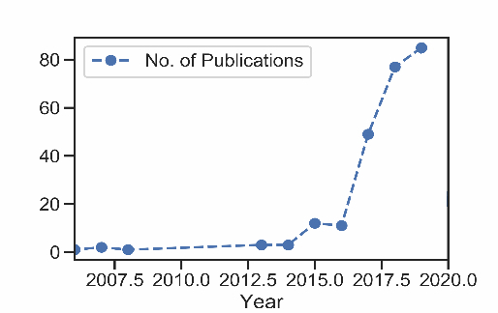
Figure 1. Trends in publications from 2000 to 2020
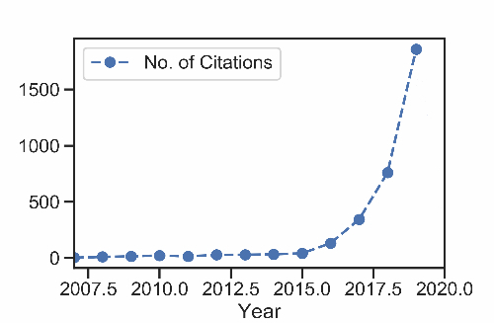
Figure 2. Variation trend of citations from 2000 to 2020
4.2 Keyword graphs and clusters
To build a keyword network, this paper uses VOSviewer software to build the author's keyword co-occurrence network graph. There are 954 keywords in the author. After screening, 56 more important keywords were selected and analyzed, and the so-called "more important" keywords appeared at least 3 times. According to the co-occurrence relationship, the 56 keywords studied in this paper were divided into 6 clusters, each cluster corresponding to a different color. Each circular node in the figure represents a keyword. The larger the area of the node is, the more critical the keyword is in the study.
According to Figure3, the green cluster includes 11 keywords such as the Internet of things, big data analysis, cloud computing, and the fourth industrial revolution. The Internet of things (IoT) is an information carrier based on the Internet, traditional telecommunication network, etc., which enables all objects to form an interconnected network. Through observation, it is found that the keyword Internet of things is most closely related to other clusters. Therefore, we can see that in the era of big data, people are more inclined to infiltrate the Internet of things into various industries and use cloud computing and industry 4.0 to create new business models. There are 9 keywords in the dark bule cluster, the main keywords are privacy, data protection, deep learning, security. Among them, the keywords of privacy and security in this cluster are correlated with those of service and commodity. The focus of this cluster is on the privacy and security problems brought by the application of big data and how to effectively utilize the deep learning of big data for data protection in the commodity and service industry. The red cluster has 16 keywords, dominated by smart city, data mining, energy efficiency, and sustainability. This cluster is less related to other clusters, among which smart cities are most closely related to sustainability. The keywords of the whole group focus on energy efficiency and the sustainable development of each industry system.
There are 7 keywords in the yellow cluster. Blockchain, Internet of things, digitization, e-commerce, and innovation are the most influential keywords in the cluster. The focus of this cluster is the relatively emerging digital science. As shown in the figure, although the yellow cluster is not mature and large, each node has begun to communicate with other fields in the figure. This shows that the scientific application of emerging data has begun, and has full development potential. The light blue cluster involves a few nodes, but the big data node is one of the most important central nodes in the whole picture. The association emanating from this central node radiates almost to the main node of each population, connecting the areas of interest in this paper. In addition to big data, the nodes represented by artificial intelligence and digital transformation are more significant than other keywords in the cluster, and they are related to blockchain, digitalization, and other fields by themselves. However, compared with other keywords in the same cluster, the relationship with e-commerce in the yellow cluster is weak. By comparison, it can be found that the application of big data and other related technologies in the field of e-commerce is highly feasible, and there is a large development space, which is worthy of further study by scholars in this region. In the purple cluster, the nodes of data analysis, intelligent manufacturing, cybersecurity, and risk management occupy a prominent position. The purple nodes shown in the figure do not have a relatively concentrated distribution like other clusters. However, in a relatively dispersed form, based on the interrelation among the purple clusters, there are negligible correlation influences on the Internet of things, big data analysis, privacy, data protection, deep learning, and other fields.
Combined with the overall view, the largest nodes "Internet of things" and "big data" in the diagram are closely related to smart cities, data analysis, and the fourth industrial revolution, but all of them are sparsely linked to e-commerce. Although technologies such as big data and the Internet of things have been well developed in various fields, it is obvious that there is still a big gap in the research of e-commerce in this aspect. With the progress and popularity of the Internet, the public is more and more interested in electronic transactions, and e-commerce is more and more popular. As a direct result of the development of the Internet, e-commerce is a new development direction for the application of big data technology. Therefore, it is an important task to explore the use of Internet technology and big data analysis to promote the systematic transformation of e-commerce.
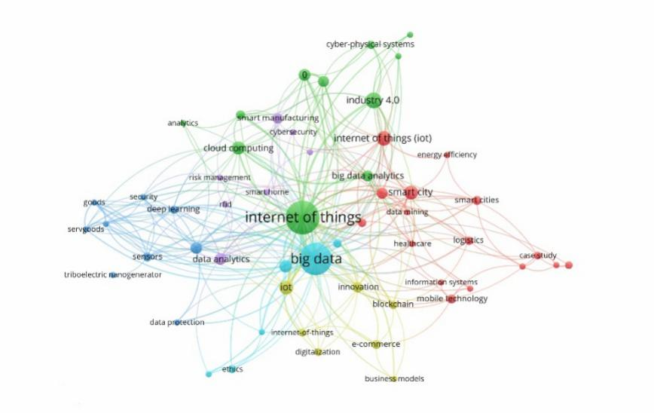
Figure 3. Keyword cluster overview
4.3 Top organizations
In this study, the author's mechanism distribution was tested to determine its geographical distribution. Table 1 lists all organizations accounting for more than 5%. The top three are in China, the US, and the UK, accounting for 60.4 percent of the total. China overtook the United States to assume the top spot. The booming development of the Internet has driven the rapid development of e-commerce in China. The annual "double eleven" event, ranging from tens of millions to hundreds of billions RMB, is a great epitome of the development of the B2C model in China. No matter in terms of user scale or market scale, China's e-commerce is undoubtedly the fastest growing up in the world.
Table1. Main geographical distribution of authors
Country | Number of articles | %
China | 59 | 22.30%
America | 58 | 21.90%
Britain | 43 | 16.20%
Korea | 20 | 7.60%
Australia | 18 | 6.80%
India | 17 | 6.40%
Spain | 16 | 6.00%
Others | 34 | 12.80%
Figure 4 shows the status of collaborating on a topic. As shown in figure (a), China, the United States, and the United Kingdom dominate the national network and become the three main parts of the research. Figure (b) clearly shows that six major organizational clusters, namely the Chinese academy of sciences in China, northwestern polytechnical university, Zhejiang university, Pennsylvania state university in the United States, the University of Oxford in the United Kingdom, and the University of Melbourne in Australia, are closely related to each other. In the distribution channels of figure (c), the main central clusters include journals on sustainability, international production research, technology forecasting and social change, business vision, production planning and control, and sustainable cities and society, and are closely related to each other. Through the comparative analysis of the three clusters, it can be found that the countries that occupy the dominant position in data resources have a greater influence on the organization cluster and source cluster, and have closer connections with each other. China, the United States, and the United Kingdom are notable cases.
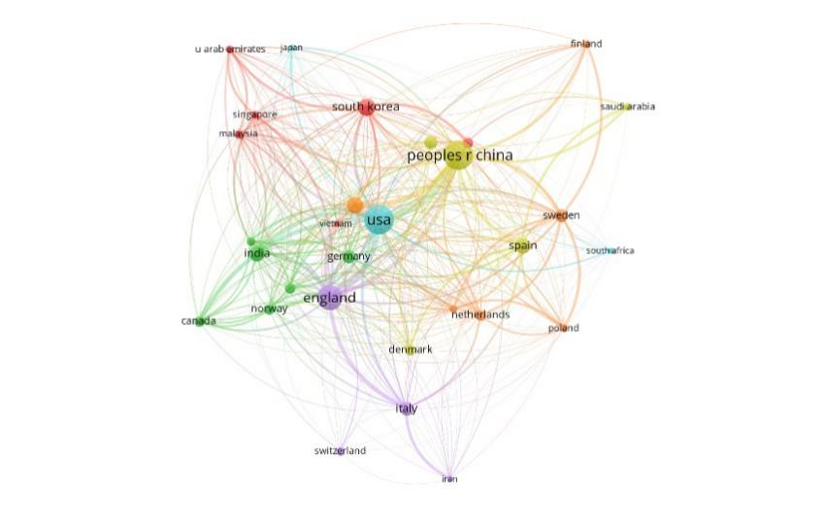
Figure 4. (a) Collaboration between states and institutions
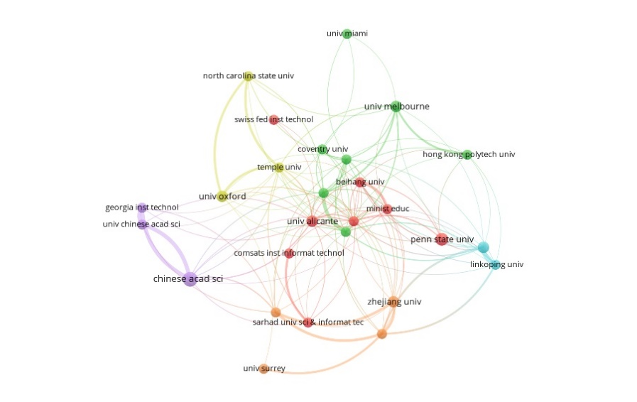
Figure 4. (b) Organization cluster
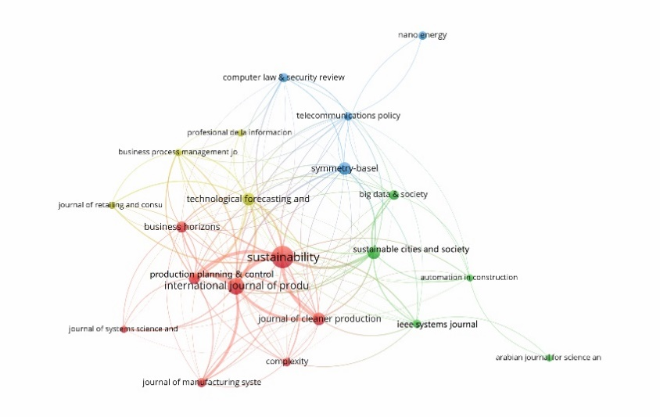
Figure 4. (c) Source cluster
In order to explore the bibliographic coupling between publications and the co-citation between cited sources, VOSviewer software was used to construct the co-occurrence network graph. Table 2 lists the major journals related to e-commerce under big data and Internet technology, with 4 clusters. The "Discipline" section lists the areas of WoS research, and the "Journal" section lists the rankings based on the number of articles published. Through the data sorted out in Table 2, the corresponding display diagram is drawn. And the visualization results were shown in figure 5.

Table2. Top - level publication source details based on the bibliographic coupling relationship network
Cluster | Journal | Discipline
#1 | (3-1) Symmetry-Basel, (3-3) Sustainable Cities and Society, (5) Big Data & Society, (6-1) Computer Law & Security Review, (7-3) Nano Energy, (7-2) Telecommunications Policy, (7-1) IEEE Systems Journal, (8-7) Automation in Construction, (8-4) Arabian Journal for Science and Engineering | Multidisciplinary Sciences; Green & Sustainable Science & Technology; Construction & Building Technology; Energy & Fuels; Social Sciences, Interdisciplinary; Law; Nanoscience & Nanotechnology; Physics, Applied; Chemistry, Physical; Materials Science, Multidisciplinary; Communication; Information Science & Library Science; Telecommunications; Operations Research & Management Science; Computer Science, Information Systems; Engineering, Electrical & Electronic; Engineering, Civil
#2 | (3-4) Technological Forecasting and Social Change, (4-1) Business Horizons, (7-4) Complexity, (8-8) Journal of Systems Science and Systems Engineering, (8-2) Journal of Retailing and Consumer Services, (8-6) Professional De La Information, (8-1) Business Process Management Journal | Regional & Urban Planning; Business; Multidisciplinary Sciences; Mathematics, Interdisciplinary Applications; Operations Research & Management Science; Communication; Information Science & Library Science; Management
#3 | (2) International Journal of Production Research, (4-2) Production Planning & Control, (6-2) Journal of Manufacturing Systems, (8-3) International Journal of Production Economics | Operations Research & Management Science; Engineering, Manufacturing; Engineering, Industrial
#4 | (1) Sustainability, (3-2) Journal of Cleaner Production | Green & Sustainable Science & Technology; Environmental Sciences; Environmental Studies; Engineering, Environmental

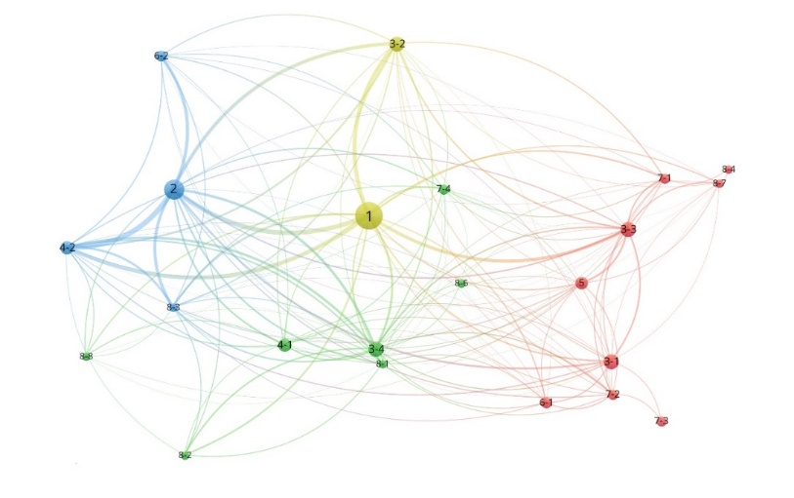
Figure 5. Top-level publication source details
Since the publication "Journal of cleaner production" contains most of the papers, it is omitted in this study to ensure the rationality of the results. In figure 6, it can be found that the references cited by the author are co-cited. According to the co-citation relationship, 34 clusters are mainly divided into three clusters, namely cluster (a), (b), and (c). The larger the node, the greater the strength of the links between its citations or the number of citations. These three clusters are the most prominent ones of "international journal of production research", "mis quarterly" and "sustainability Basel". Among them, the "international journal of production research" of the cluster (a) has the strongest co-citation relationship, followed by the "international journal of production economics" which is also located in the cluster (a). It can be found that topics such as e-commerce to mainly focus on the production and economic research disciplines. "Technological forecasting and social change", "Harvard business review", "production planning & control" and so on are also at the top of the list, indicating that these sources have been cited by more scholars, with a high citation rate, a large range of applicable research fields and more influence.
Figure 7 shows the co-occurrence network, or bibliographic coupling, of the first 22 publications. It can be found from the figure that the bibliography in this study with a high degree of coupling and citation quantity is mainly located in the cluster (c). Among the research on the integration of e-commerce and Internet technologies, the publication "sustainability" publishes most articles and occupies a dominant position in the top-level publications. Also, this publication has a high link strength with "international journal of production research" and "production planning & control", and they are all in the cluster (c). It can be found that they refer to multiple public publications together, with a high degree of cross-referencing, mainly focusing on the intersection of sustainability, production, business, and engineering. This is roughly the same as the result of figure 5. Publications with high co-citation rates also have a high degree of bibliographic coupling. Another cluster (d) centered on "sustainable cities and society" focuses on social science, big data, architecture, and engineering. The symmetry-base cluster (a) focuses on areas such as the digital economy, mathematics, and computer law. In the cluster (b) centered on "technological forecasting and social change", the research fields are mainly related to business management, retail services, and information science. It can be found that the purpose and scope of the journals of these four clusters are similar, and they all focus on multidisciplinary comprehensive research concentrating on the business economy, data, and science.
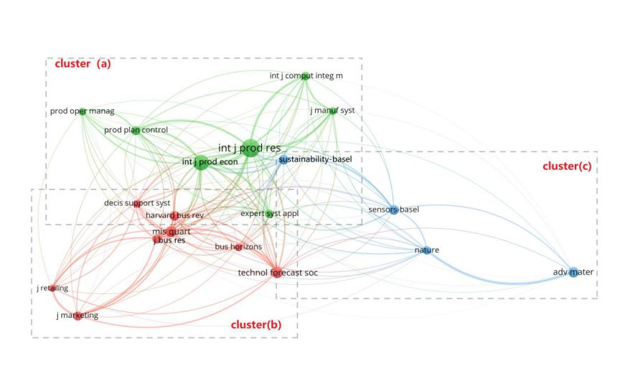
Figure 6. Top cited sources: a co-citation relationship network visualization
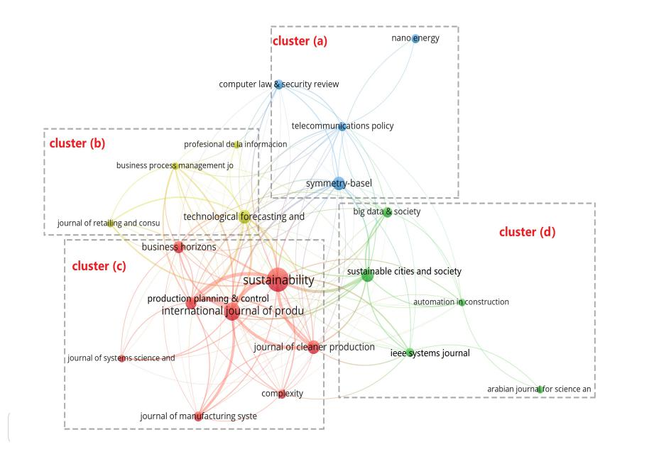
Figure 7. Top publication sources: a bibliographic coupling relationship network visualization

5. CONCLUSIONS
5.1 Findings and Contributions
Based on the co-occurrence data network, it can be found that :(1) since 2015, China, the United States, and the United Kingdom have occupied an important position in the rapidly growing publications. As a developing country, China's ranking among the top three is closely related to its booming development in e-commerce. The birth and popularity of "Double 11", "Double 12" and other new "festivals" have provided strong support for China to occupy the core position in publications; (2) the current study power is given priority to with institutions from China, the United States, the United Kingdom, the lack of researchers from other industries at the core of enterprise, community, which related to the industry attribute, nature of work, to a certain extent, this phenomenon caused the disconnection between theory and practice, which suggests that further research should focus on collaboration between industry, theory, and practice of cross-border joint; (3) cluster analysis of major publications reflects the interdisciplinary nature of this research subject, and the research mode of "Internet +", "big data +" and "e-commerce +" will become a new research direction and hot field. The citation rate of the paper is positively correlated with the coupling degree of the literature. These classic journals and researches, such as "International Journal of Production Research "," Production Planning & Control "and "Sustainability", have been generally recognized with wide application scope and great influence; (4) from the point of keywords cluster analysis, the biggest node in figure "Internet of things" and "Big data" are closely related to wisdom city, data analysis, the fourth industrial revolution, but they have less to do with e-commerce, this shows that with the support of Big data and Internet technology, there is still a lot of space for the development of e-commerce. With the popularization of the Internet, the public's adaptability to and enthusiasm for electronic transactions becoming increasingly sophisticated, e-commerce will usher in a new round of blowout development. These findings will provide guidance and assistance to researchers in e-commerce, big data, and related technologies.
5.2 Limitations and Further Research Direction
This research, however, is subject to several limitations. On the one hand, data for 2020 are incomplete, so the number of articles published and cited must not be comparable with other years. On the other hand, this paper analyzes the frontier of e-commerce development under the support of big data and Internet technology, explores the current development trend and key issues of concern. However, there is still a lack of research on what measures e-commerce should take under the current development trend and how to realize faster and more stable development with the help of big data, the Internet of Things, artificial intelligence, and other technologies. This is also the focus of future research.

6.CITATIONS
[1] J. S. Liu, L. Y. Y. Lu, W. M. Lu., “Research fronts in data envelopment analysis,” Omega, Vol. 58, pp. 33-45, 2016.
[2] X. W. Su, X. Li, Y. X. Kang., “A bibliometric analysis of research on intangible cultural heritage using citespace,” SAGE Open, Vol. 9, No. 2, pp. 1-15, 2019.
[3] G. J. Avlonitis and D. A. Karayanni., “The impact of internet use on business-to-business marketing,” Industrial Marketing Management, Vol. 29, No. 5, pp. 441-459, 2000.
[4] A. Sheth., “Transforming big data into smart data: Deriving value via harnessing volume, variety, and velocity using semantic techniques and technologies,” in Conf. 2014 IEEE 30th International Conference on Data Engineering, Chicago, IL, USA, 2014, pp. 2-2.
[5] G. Oosthuizen., “Security issues related to E-commerce,” Network Security, Vol. 1998, No. 5, pp. 10-11, 1998.
[6] K. Tiwari and M. S. Khan., “Sustainability accounting and reporting in the industry 4.0,” Journal of Cleaner Production, Vol. 258, pp. 1-12, 2020.
[7] J. Li, C. Ma, M. R. Guo, L. L. Gao, G. Q. Gu., “Development status and technical framework of internet-plus modern agriculture,” in Proc. 2018 the 10th International Conference on Computer and Automation Engineering, Brisbane, Australia, 2019, pp. 1-7.
[8] C. Lu, W. H. Qiu, X. L. Cheng., “Research on aviation big data and e-commerce applications,” in Proc. 2017 International Conference on Electronic, Control, Automation and Mechanical Engineering, Sanya, China, 2018, pp.446-450.
[9] C. Zhang and X. Pei., “Research on logistics cost control of e-commerce enterprises under the background of ‘Dazhi Yiyun’—Taking Jingdong mall as an example,” Modern Management, Vol. 9, No. 3, pp. 408-413, 2019.
[10] M. M. Queiroz, S. Fosso Wamba, M. C. Machado, R. Telles., “Smart production systems drivers for business process management improvement: An integrative framework,” Business Process Management Journal, Vol. 26, No. 5, pp. 1075-1092, 2020.
[11] Y. Liu, Y. F. Zhang, S. Ren, M. Y. Yang, Y. T. Wang, D. Huisingh., “How can smart technologies contribute to sustainable product lifecycle management?” Journal of Cleaner Production, Vol. 249, pp. 1-4, 2020.
[12] S. S. Kamble, A. Gunasekaran, S. A. Gawankar., “Achieving sustainable performance in a data-driven agriculture supply chain: A review for research and applications,” International Journal of Production Economics, Vol. 219, pp. 179-194, 2020.
[13] A. M. Ciruela-Lorenzo, A. R. Del-Aguila-Obra, A. Padilla-Meléndez, J. J. Plaza-Angulo., “Digitalization of agri-cooperatives in the smart agriculture context. proposal of a digital diagnosis tool,” Sustainability, Vol. 12, No. 4, pp. 1325, 2020.
[14] N. Côrte-Real, P. Ruivo, T. Oliveira., “Leveraging internet of things and big data analytics initiatives in European and American firms: Is data quality a way to extract business value?” Information & Management, Vol. 57, No. 1, pp. 48-51, 2020.
[15] H. S. Kang, J. Y. Lee, S. S. Choi, H. Kim, J. H. Park, J. Y. Son, B. H. Kim, S. D. Noh., “Smart manufacturing: Past research, present findings, and future directions,” International Journal of Precision Engineering and Manufacturing-Green Technology, Vol. 3, No. 1, pp. 111-128, 2016.
[16] J. Ruiz-Rosero, G. Ramirez-Gonzalez, J. Williams, H. Liu, R. Khanna, G. Pisharody., “Internet of things: a scientometric review,” Symmetry, Vol. 9, No. 12, pp. 301, 2017.
[17] J. Iqbal, M. Khan, M. Talha, H. Farman, B. Jan, A. Muhammad, H. A. Khattak., “A generic internet of things architecture for controlling electrical energy consumption in smart homes,” Sustainable Cities and Society, Vol. 43, pp. 443-450, 2018.
[18] L. Uden and W. He., “How the internet of things can help knowledge management: a case study from the automotive domain,” Journal of Knowledge Management, Vol. 21, No. 1, pp. 57-70, 2017.
[19] P. K. Khatua, V. K. Ramachandaramurthy, P. Kasinathan, J. Y. Yong, J. Pasupuleti, A. Rajagopalan., “Application and assessment of internet of things toward the sustainability of energy systems: Challenges and issues,” Sustainable Cities and Society, Vol. 53, pp. 2-10, 2020.
[20] M. Sanchez, E. Exposito, J. Aguilar., “Industry 4.0: survey from a system integration perspective,” International Journal of Computer Integrated Manufacturing, Vol. 33, No. 10-11, pp. 1017-1041, 2020.
[21] C. E. Cotet, G. C. Deac, C. N. Deac, C. L. Popa., “An innovative industry 4.0 cloud data transfer method for an automated waste collection system,” Sustainability, Vol. 12, No. 5, pp. 1839, 2020.
[22] J. Nagy, J. Oláh, E. Erdei, D. Máté, J. Popp., “The role and impact of industry 4.0 and the internet of things on the business strategy of the value chain—the case of hungary,” Sustainability, Vol. 10, No. 10, pp. 3491, 2018.
[23] S. Wachter., “Normative challenges of identification in the internet of things: Privacy, profiling, discrimination, and the GDPR,” Computer Law & Security Review, Vol. 34, No. 3, pp. 436-449, 2018.
[24] A. J. A. M. van Deursen and K. Mossberger., “Any thing for anyone? a new digital divide in internet-of-things skills: a new digital divide in internet-of-things skills,” policy & internet, Vol. 10, No. 2, pp. 122-140, 2018.
[25] J. Yu, N. Subramanian, K. Ning, D. Edwards., “Product delivery service provider selection and customer satisfaction in the era of internet of things: A Chinese e-retailers’ perspective,” International Journal of Production Economics, Vol. 159, pp. 104-116, 2015.
[26] Y. T. Tsai, S. C. Wang, K. Q. Yan, C. M. Chang., “Precise positioning of marketing and behavior intentions of location-based mobile commerce in the internet of things,” Symmetry, Vol. 9, No. 8, pp. 139, 2017.
[27] X. Y. Yu, S. K. Roy, A. Quazi, B. Nguyen, Y. Q. Han., “Internet entrepreneurship and ‘the sharing of information’ in an internet-of-things context: The role of interactivity, stickiness, e-satisfaction and word-of-mouth in online SMEs’ websites,” Internet Research, Vol. 27, No. 1, pp. 74-96, 2017.
[28] T. Saarikko, U. H. Westergren, T. Blomquist., “The internet of things: Are you ready for what’s coming?” Business Horizons, Vol. 60, No. 5, pp. 667-676, 2017.
[29] J. Serrano-Cobos, “Tendencias tecnológicas en internet: hacia un cambio de paradigma,” El Profesional de la Información, Vol. 25, No. 6, pp. 843-850, 2016.
[30] K. T. Park, Y. T. Kang, S. G. Yang, W. B. Zhao, Y. S. Kang, S. J. Im, D. H. Kim, S. Y. Choi, S. Do Noh., “Cyber physical energy system for saving energy of the dyeing process with industrial internet of things and manufacturing big data,” International Journal of Precision Engineering and Manufacturing-Green Technology, Vol. 7, No. 1, pp. 219-238, 2020.
[31] A. Vatankhah Barenji, X. L. Liu, H. Y. Guo, Z. Li., “A digital twin-driven approach towards smart manufacturing: reduced energy consumption for a robotic cellular,” International Journal of Computer Integrated Manufacturing, Vol. 34, No. 7-8, pp. 1-16, 2020.
[32] S. Y. Ma, Y. F. Zhang, S. Ren, H. D. Yang, Z. F. Zhu., “A case-practice-theory-based method of implementing energy management in a manufacturing factory,” International Journal of Computer Integrated Manufacturing, Vol. 34, No. 7-8, pp. 1-15, 2020.
[33] N. Noori, T. Hoppe, M. de Jong., “Classifying pathways for smart city development: comparing design, governance and implementation in Amsterdam, Barcelona, Dubai, and Abu Dhabi,” Sustainability, Vol. 12, No. 10, pp. 4030, 2020.
[34] L. Yang, S. H. Yang, L. Plotnick., “How the internet of things technology enhances emergency response operations,” Technological Forecasting and Social Change, Vol. 80, No. 9, pp. 1854-1867, 2013.
[35] M. Kumar, G. Graham, P. Hennelly, J. Srai., “How will smart city production systems transform supply chain design: a product-level investigation,” International Journal of Production Research, Vol. 54, No. 23, pp. 7181-7192, 2016.
[36] S. Fosso Wamba, S. Akter, A. Edwards, G. Chopin, D. Gnanzou., “How ‘big data’ can make big impact: Findings from a systematic review and a longitudinal case study,” International Journal of Production Economics, Vol. 165, pp. 234-246, 2015.
[37] P. Brous and M. Janssen., “Advancing e-government using the Internet of things: A systematic review of benefits,” in Electronic Government, E. Tambouris, M. Janssen, H. J. Scholl, M. A. Wimmer, K. Tarabanis, M. Gascó, B. Klievink, I. Lindgren, P. Parycek, Eds. Cham: Springer International Publishing, 2015, pp. 156-169.
[38] T. Xu, J. B. Wendt, M. Potkonjak., “Security of IoT systems: Design challenges and opportunities,” in Conf. International Conference on Computer-Aided Design, San Jose, CA, USA, 2014, pp. 417-423.
[39] M. U. Farooq, M. Waseem, A. Khairi, S. Mazhar., “A critical analysis on the security concerns of internet of things (iot),” International Journal of Computer Applications, Vol. 111, No. 7, pp. 1-6, 2015.
[40] Y. H. Hwang., “IoT Security & Privacy: Threats and Challenges,” in Proc. The 1st ACM Workshop on IoT Privacy, Trust, and Security - IoTPTS ’15, Singapore, Republic of Singapore, 2015, pp. 1-1.
[41] K. Zhao and L. Ge., “A survey on the internet of things security,” in Conf. 2013 Ninth International Conference on Computational Intelligence and Security, Emeishan, China, 2013, pp. 663-667.
[42] M. Tellez, S. El-Tawab, H. M. Heydari., “Improving the security of wireless sensor networks in an IoT environmental monitoring system,” in Conf. 2016 IEEE Systems and Information Engineering Design Symposium, Charlottesville, VA, USA, 2016, pp. 72-77.
[43] M. Stanislav and T. Beardsley., “Hacking iot: a case study on baby monitor exposures and vulnerabilities,” Rapid, Vol. 7, pp. 17, 2015.
[44] S. M. Riazul Islam, Daehan Kwak, M. Humaun Kabir, M. Hossain, Kyung-Sup Kwak., “The internet of things for health care: a comprehensive survey,” IEEE Access, Vol. 3, pp. 678-708, 2015.
[45] R. H. Weber., “Internet of Things – New security and privacy challenges,” Computer Law & Security Review, Vol. 26, No. 1, pp. 23-30, 2010.
[46] T. Correa., “Digital skills and social media use: How Internet skills are related to different types of Facebook use among ‘digital natives’,” Information, Communication & Society, Vol. 19, No. 8, pp. 1095-1107, 2016.
[47] A. Šorgo, T. Bartol, D. Dolničar, B. Boh Podgornik., “Attributes of digital natives as predictors of information literacy in higher education: Digital natives and information literacy,” British Journal of Educational Technology, Vol. 48, No. 3, pp. 749-767, 2017.
[48] J. Andersson, H. Hellsmark, B. A. Sandén., “Shaping factors in the emergence of technological innovations: The case of tidal kite technology,” Technological Forecasting and Social Change, Vol. 132, pp. 191-208, 2018.
[49] F. Caputo, V. Scuotto, E. Carayannis, V. Cillo., “Intertwining the internet of things and consumers’ behaviour science: Future promises for businesses,” Technological Forecasting and Social Change, Vol. 136, pp. 277-284, 2018.
[50] I. K. Wang and R. Seidle., “The degree of technological innovation: A demand heterogeneity perspective,” Technological Forecasting and Social Change, Vol. 125, pp. 166-177, 2017.
[51] J. Gubbi, R. Buyya, S. Marusic, M. Palaniswami., “Internet of Things (IoT): A vision, architectural elements, and future directions,” Future Generation Computer Systems, vol. 29, No.7, pp. 1645-1660,2013.
[52] S. Gurtner, R. Reinhardt, K. Soyez., “Designing mobile business applications for different age groups,” Technological Forecasting and Social Change, Vol. 88, pp. 177-188, 2014.
[53] E. C. Tzavela, C. Karakitsou, E. Halapi, A. K. Tsitsika., “Adolescent digital profiles: A process-based typology of highly engaged internet users,” Computers in Human Behavior, Vol. 69, pp. 246-255, 2017.
[54] M. Dachyar, T. Y. M. Zagloel, L. R. Saragih., “Knowledge growth and development: internet of things (IoT) research, 2006–2018,” Heliyon, Vol. 5, No. 8, pp. 1-12, 2019.
[55] V. K. Singh, S. K. Banshal, K. Singhal, A. Uddin., “Scientometric mapping of research on ‘Big Data’,” Scientometrics, Vol. 105, No. 2, pp. 727-741, 2015.
[56] W. Glänzel., “Expression of concern: Bibliometric study of electronic commerce research in information systems & mis journals,” Scientometrics, Vol. 114, No. 3, pp. 1423, 2018.
[57] E. T. Meyer and R. Schroeder., “The net as a knowledge machine: How the Internet became embedded in research,” New Media & Society, Vol. 18, No. 7, pp. 1159-1189, 2016.
[58] D. J. de Solla Price., “Networks of scientific papers,” Science, Vol. 149, No. 3683, pp. 510-515, 1965.
[59] C. Chen., “CiteSpace II: Detecting and visualizing emerging trends and transient patterns in scientific literature,” Journal of the American Society for Information Science & Technology, Vol. 57, No. 3, pp. 359-377, 2005.

