Bibliometrics Analysis of Social Media And Entrepreneurship Research Using Scopus Database
Lian Yang
Universiti Teknologi Malaysia
Zuraidah Sulaiman
Universiti Teknologi Malaysia

ABSTRACT
This paper analyzes the changing trend of international cooperation and research topics on social media and entrepreneurship in the past decade. Through the bibliometric analysis of 569 academic publications selected from Scopus from 2007 to 2020, it can be found that the importance of Asian countries in social media and entrepreneurship research is increasing. Except for several countries with the most extensive international cooperation, the international cooperation of other countries is mainly limited to the continent to which the country belongs. The change of research objects in this field is accompanied by the emergence of new social media platforms. It is worth noting that combining research topics with other industries has become a trend. This paper reveals the development trend of social media and entrepreneurship research through keyword co-occurrence analysis and cluster analysis and provides some suggestions for future research.
Keywords: Social media, Entrepreneurship, Bibliometric, Scopus, E-commerce

1. INTRODUCTION
The rapid development of social media has gradually participated in most aspects of people's life (i.e. social life, business life, education sector, and political life)[1] . Rich types of social media, such as Facebook and LinkedIn; Microblogs, such as Twitter and Tumblr; Blogs, such as Blogger and WordPress; Video/photo-sharing platforms such as YouTube, Instagram, Tiktok, and Flickr; Social bookmarking websites, such as Pinterest, Snapchat, etc. Social media have become one of the most discussed topics in today's business field. They have led to the reshaping of the business environment. More companies recognize that social media change the business model and create new opportunities[2] [3] . Social media platforms provide enterprises with new opportunities to improve their competitive position through new and interactive ways, which makes social media widely used as a business tool in the twenty-first century[4] .
Social media technology enables more stakeholders to participate in the identification of entrepreneurial opportunities and provides entrepreneurs with more sources of entrepreneurial opportunities. Social media has been identified as a source of entrepreneurial opportunities, an indispensable part of entrepreneurial practice and a helpful platform for business growth[5] . Entrepreneurs often seek advice from altruistic information providers on social media platforms[6] [7] . Many entrepreneurs use social media platforms for marketing. Social media is recognized as an important platform for brands and advertise and promote their products and services. Social media allows these companies to design their advertising materials with rich, dynamic, and interactive media at the lowest cost [8] ; realizing a cost advantage over traditional advertising and marketing processes[9] [10] . Social media has been regarded as an effective mechanism to help the company's marketing objectives and strategies, especially in customer participation, customer relationship management, and communication [11] [12] .
At present, the adoption of social media in entrepreneurship has become a common phenomenon, and the research on social media and entrepreneurship has attracted more and more attention. The number of research literature in this field has increased year by year, but the research on the characteristics of international cooperation of social media and entrepreneurship is almost nonexistent. The bibliometric analysis of social media and entrepreneurship research is rare, in particular, there is a lack of in-depth research on the characteristics and evolution of international cooperation in social media and entrepreneurship study in the past ten years, as well as the changes of research trends. To fill this gap, we conducted a bibliometric analysis on social media and entrepreneurship research. To reveal the changing characteristics of international cooperation in social media and entrepreneurship research and the research trends in this field, we reviewed 569 publications included by Scopus from 2007 to 2020 and we comprehensively conducted a bibliometric analysis on the publications in three sub-periods (2007-2010, 2011-2015 and 2016-2020). The paper's purpose is to show the changing characteristics and research trends of international cooperation in social media and entrepreneurship research and to provide guidance for future research.
- Methodology
This study uses bibliometrics as a quantitative research method to sort out and analyze the research development and change process of social media and entrepreneurship, and the characteristics of international cooperation and the future research trend in this field.
2.1 Bibliometrics
Bibliometrics is a statistical analysis method of publications, which has been used since the 1920s[13] . The use of bibliometric methods, indicators, and tools has increased sharply, mainly due to the improvement of bibliographic database suppliers[14] . The Bibliometric analysis uses statistical techniques to evaluate academic publications from a quantitatively perspective in a certain field[15] . It enables researchers to organize information in specific fields[16] , assess the scientific development of particular subject knowledge[17] and compare research performance in different countries[18] , determine emerging research priorities, and predict future research directions[19] . Bibliometric analysis has been widely used in various fields to measure the quality of academic output and productivity.
2.2 Designing the Keyword Search Strings
The data source of our study is the Scopus publishing database. Scopus is one of the largest databases of peer-reviewed research papers in science, medicine, technology, engineering, art, social sciences and humanities. To retrieve the research related to social media and entrepreneurship, we adopted the following steps to conduct this bibliometric research:
Step 1:The query string used for the search was:(TITLE-ABS-KEY ( ( "social media" OR "social network* site" OR "Facebook" OR "Twitter" OR "blog" OR "blogs" OR "Pinterest" OR "Snapchat" OR "Instagram" OR "LinkedIn" OR "Weibo" OR "YouTube" OR "video sharing site" OR "WeChat" OR "Tiktok" OR "douyin" OR "kuaishou" ) AND ( "Entrepreneur*" OR "start-up" OR "new venture" ) ) )AND ( LIMIT-TO ( SRCTYPE , "j" ) ) AND ( LIMIT-TO ( DOCTYPE , "ar" ) ), which is used to collected all publications containing these terms in titles, abstracts and keywords, and determine the scope of the search in journal and article. This querystring resulted in 796 articles.。
Step 2:The query string used for the search was:( TITLE-ABS-KEY( ( "social media" OR "social network* site" OR "facebook" OR "twitter" OR "blog" OR "blogs" OR "Pinterest" OR "Snapchat" OR "Instagram" OR "LinkedIn" OR "Weibo" OR "YouTube" OR "video sharing site" OR "WeChat" OR "Tiktok" OR "douyin" OR "kuaishou" ) AND ( "Entrepreneur*" OR "start-up" OR "new venture" ) ) ) AND ( TITLE ( "recent" OR progress OR review OR critical OR revisit OR advance* OR highlight OR perspective OR prospect OR trends OR bibliometric OR scientometric OR insights OR overview OR "state of the art" OR challenges OR updates ) OR ( ABS ( progress OR review OR bibliometric OR scientometric ) ) ) AND ( LIMIT-TO ( SRCTYPE,"j" ) ) AND ( LIMIT-TO ( DOCTYPE,"ar" ) ), which is used to find potentially review articles. This querystring resulted in 107 articles collect the EID of these review papers.
Step 3: The first article appeared in 2007. Considering that 2021 is not over, we limit the time to 2007-2020 and exclude the articles in 2021. We exclude the review articles obtained in step 2 from the search results in step 1, and finally get a query string , as shown below:
(TITLE-ABS-KEY ( ( "social media" OR "social network* site" OR "facebook" OR "twitter" OR "blog" OR "blogs" OR "Pinterest" OR "Snapchat" OR "Instagram" OR "LinkedIn" OR "Weibo" OR "YouTube" OR "video sharing site" OR "WeChat" OR "Tiktok" OR "douyin" OR "kuaishou" ) AND ( "Entrepreneur*" OR "start-up" OR "new venture" ) ) )AND NOT EID (EID of review articles) AND ( LIMIT-TO ( SRCTYPE,"j" ) ) AND ( LIMIT-TO ( DOCTYPE,"ar" ) ) AND ( EXCLUDE ( PUBYEAR,2021) ). This querystring resulted in 569 articles.
Step 4: All collected articles are divided into three sub-periods: 2007-2010, 2011-2015 and 2016-2020 and are analyzed and drawn according to the following characteristics: year of publication, number of publications, productive journals, top authors, institutions, predominant countries/regions, international cooperation, highly cited publications and author keyword co-occurrence.
2.3 Data Analysis Strategies
VOSviewer is a bibliometric software tool that is extensively used by researchers to examine bibliographic coupling[20][21]and build and view bibliometric maps[22]. We use VOSviewer v.1.6.17 software to analyze the retrieved data, identify the relationship between countries, institutions, and author keywords through the visualization of each main cluster, and show the development process of social media and entrepreneurship research around the number of publications, source journals, institutions, countries/regions and keywords in different sub-periods, in-depth analysis of the changing characteristics of international cooperation. Finally, the change and trend of research topics are revealed by co-occurrence analysis and cluster analysis based on author keywords.

3. Result analysis
3.1 Publication Distribution Analysis
Through the statistical calculation of the retrieved data, the number of publications increased continuously from 2007 to 2020. As shown in Figure 1, it can be observed that the change in the number of publications can be divided into three stages. From 2007 to 2010, the number of publications in this period was less, and 1, 4, 7, and 6 articles were retrieved respectively. The number of publications increased from 2011 to 2015, and the number of publications from 2011 to 2015 were 10, 19, 15, 32, and 31 respectively. From 2016 to 2020, the number of publications increased rapidly. From 2016 to 2020, the number of publications were 51, 69, 73, 105, and 146 respectively, and exceeded 100 to 105 for the first time in 2019.
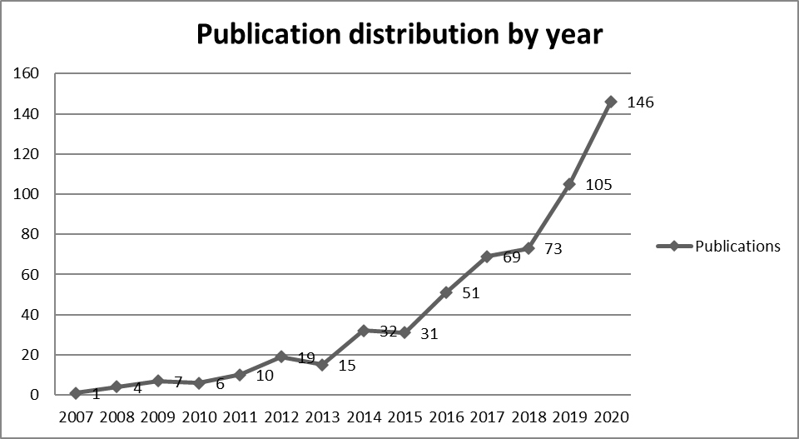
Figure 1.Publication distribution by year
3.2 Productive Publication Source
Analyze the source journals in the three sub-periods, bibliometric indicators such as total publications, total citations, and CiteScore (2020 report) were used for ranking purposes. The top ten productive publication sources are shown in Table 1., it can be observed that the sources journal with the total publications from 2007 to 2010 is Entrepreneurial Executive and Journal Of Research In Marketing And Entrepreneurship, with two publications respectively and one publication in other journals. The most total citations are the International Journal Of Cultural Studies, the highest CiteScore journal is the Journal Of Internet Commerce, with a value of 4.3.

Table 1. Productive Publication Source
Rank | 2007-2010 |  |  |  | 2011-2015 |  |  |  | 2016-2020
Rank | Journal/periodical | TP | TC | CiteScore  2020 | Journal/periodical | TP | TC | CiteScore  2020 | Journal/periodical | TP | TC | CiteScore  2020
1 | Entrepreneurial Executive | 2 | 49 | - | Emerald Emerging Markets Case Studies | 6 | 2 | 0.1 | Social Media And Society | 11 | 123 | 4.8
2 | Journal Of Research In Marketing And Entrepreneurship | 2 | 48 | 2.4 | Journal Of The International Academy For Case Studies | 4 | 32 | - | Journal Of Small Business And Enterprise Development | 8 | 137 | 4.5
3 | International Journal Of Cultural Studies | 1 | 63 | 2 | Business Horizons | 3 | 92 | 11.3 | Emerald Emerging Markets Case Studies | 7 | 0 | 0.1
4 | Review Of Policy Research | 1 | 30 | 3.5 | Entrepreneurial Executive | 3 | 30 | - | Journal Of Business Research | 7 | 76 | 9.2
5 | Cartographica | 1 | 21 | 1.3 | Journal Of Business Venturing | 2 | 431 | 13.3 | Journal Of Business Venturing Insights | 7 | 103 | 4.4
6 | Communications Of The ACM | 1 | 15 | - | Social Media And Society | 2 | 198 | 4.8 | Sustainability Switzerland | 7 | 35 | 3.9
7 | Journal Of Internet Commerce | 1 | 10 | 4.3 | Feminist Media Studies | 2 | 40 | 2.1 | International Journal Of Communication | 6 | 56 | 2.4
8 | European Journal Of Social Sciences | 1 | 9 | - | First Monday | 2 | 39 | 3.2 | International Journal Of Entrepreneurial Behaviour And Research | 6 | 69 | 6.2

Table 1. Productive Publication Source
Rank | 2007-2010 |  |  |  | 2011-2015 |  |  |  | 2016-2020
Rank | Journal/periodical | TP | TC | CiteScore  2020 | Journal/periodical | TP | TC | CiteScore  2020 | Journal/periodical | TP | TC | CiteScore  2020
9 | International Journal Of Entrepreneurship And Small Business | 1 | 5 | 1.7 | International Journal Of Technology Management | 2 | 25 | 2 | International Journal Of Innovative Technology And Exploring Engineering | 6 | 0 | -
10 | International Journal Of E Collaboration | 1 | 4 | 0.9 | Triplec | 2 | 15 | 2.1 | Small Business Economics | 5 | 97 | 8.8
TP: Total Publications; TC: Total Citations

From 2011 to 2015, Emerald Emerging Markets Case Studies had six publications, but its citations and CiteScore were the least, 2 and 0.1 respectively. The Journal Of Business Venturing has the highest total citations, with 431 sources, and its CiteScore value of 13.3 is also the highest. It is worth noting that Social Media And Society, a professional journal in social media appeared in 2015, with 198 citations and a CiteScore of 4.8, which reflects that research in this field has become more concerned than ever before.
From 2016 to 2020, Social Media And Society developed into one of the most critical journals in this field as they published the most publications, with full publications of 11 and a CiteScore of 4.8. The most cited journal is the Journal Of Small Business And Enterprise Development, and the CiteScore is 4.5. The highest CiteScore is Journal Of Business Research, and the CiteScore is 9.2. From the data of these three sub-periods, it can be found that professional social media journals have gradually become the core journals in this field.
3.3 Highly Cited Publications
For the publications in these three sub-periods, by using the indicator of total citations, sort out the top 10 highly cited publications. From 2007 to 2010, by analyzing the 10 highly cited publications, as shown in Table 2, we can find that YouTube, Blog, and Twitter are the leading social media platform. The marketing role of social media is the focus of research, such as focusing on entrepreneurial marketing[25] , using social media to increase advertising, improve marketing[26] and enhance marketing efforts[27] .

Table 2. Top 10 Highly Cited Publications from 2007 to 2010
Rank | Title | Author | Year | Journal | TC
1 | YouTube as archive: Who will curate this digital Wunderkammer? | Gehl, R. | 2009 | International Journal of Cultural Studies | 63
2 | Using social media to increase advertising and improve marketing | Hensel, K., Deis, M.H. | 2010 | Entrepreneurial Executive | 33
3 | Entrepreneurial marketing and the Web 2.0 interface | Jones, B. | 2010 | Journal of Research in Marketing and Entrepreneurship | 30
4 | "Getting the word out": Policy bloggers use their soap box to make change | Mckenna, L. | 2007 | Review of Policy Research | 30
5 | Keyhole, Google Earth, and 3D worlds: An interview with Avi Bar-Zeev | Crampton, J.W. | 2008 | Cartographica | 21
6 | Entrepreneurship education and Web 2.0 | Jones, B., Iredale, N. | 2009 | Journal of Research in Marketing and Entrepreneurship | 18
7 | Is twitter a viable commercial use platform for small businesses? an empirical study targeting two audiences in the small business community | Geho, P.R., Smith, S., Lewis, S.D. | 2010 | Entrepreneurial Executive | 16
8 | Ballot box communication in online communities | Xia, M., Huang, Y., Duan, W., Whinston, A.B. | 2009 | Communications of the ACM | 15
9 | Blogs: Emerging knowledge management tools for entrepreneurs to enhance marketing efforts | Singh, R.P., Singh, L.O. | 2008 | Journal of Internet Commerce | 10
10 | Developing agriculture in Malaysia: Internet utilization among Malaysian youth agro-businessman | Hassan, M.S., Shaffril, H.A.M., Hassan, M.A., D'Silva, J.L. | 2009 | European Journal of Social Sciences | 9
TC: Total Citations
The highest highly cited publication from 2011 to 2016 in Table 3 is "Social research 2.0: virtual snowball sampling method using Facebook"[28] , which shows that Facebook is the most concerning social media platform at this stage. In addition, Twitter[29] is also a popular social media platform. The research on crowdfunding [30] appeared for the first time, indicating that the research on social media and entrepreneurship has extended to the financial industry.
Table 3. Top 10 Highly Cited Publications from 2011 to 2015
Rank | Title | Author | Year | Journal | TC
1 | Social research 2.0: Virtual snowball sampling method using Facebook | Baltar, F., Brunet, I. | 2012 | Internet Research | 386
2 | Social interaction via new social media: (How) can interactions on Twitter affect effectual thinking and behavior? | Fischer, E., Reuber, A.R. | 2011 | Journal of Business Venturing | 358
3 | Overcoming the "Ideology of Openness": Probing the affordances of social media for organizational knowledge sharing. | Gibbs, J.L., Rozaidi, N.A., Eisenberg, J. | 2013 | Journal of Computer-Mediated Communication | 180
4 | "Having it All" on Social Media: Entrepreneurial Femininity and Self-Branding Among Fashion Bloggers. | Duffy, B.E., Hund, E. | 2015 | Social Media and Society | 166
5 | What do we know about software development in startups? | Giardino, C., Unterkalmsteiner, M., Paternoster, N., Gorschek, T., Abrahamsson, P. | 2014 | IEEE Software | 97
6 | Online entrepreneurial communication: Mitigating uncertainty and increasing differentiation via Twitter | Fischer, E., Rebecca Reuber, A. | 2014 | Journal of Business Venturing | 73
7 | Investor communication in equity-based crowdfunding: a qualitative-empirical study | Moritz, A., Block, J., Lutz, E. | 2015 | Qualitative Research in Financial Markets | 68

Table 3. Top 10 Highly Cited Publications from 2011 to 2015
Rank | Title | Author | Year | Journal | TC
8 | Creative Destruction: An Exploratory Study of How Digitally Native News Nonprofits Are Innovating Online Journalism Practices | Nee, R.C. | 2013 | JMM International Journal on Media Management | 61
9 | Mr. Gates returns: Curation, community management and other new roles for journalists. | Bakker, P. | 2014 | Journalism Studies | 57
10 | Counseling customers: Emerging roles for genetic counselors in the direct-to-consumer genetic testing market | Harris, A., Kelly, S.E., Wyatt, S. | 2013 | Journal of Genetic Counseling | 46
From 2016 to 2020, as shown in Table 4, the most cited articles were "On the Fintech Revolution: Interpreting the Forces of Innovation, Disruption, and Transformation in Financial Services"[31] , and more and more research related to the financial field during this period, indicating that the research on social media and entrepreneurship is further combined with the financial industry. Research on the new social platform Instagram[32] has emerged. In addition, the impact of social media on organizational performance[33] and innovation performance[34] has also attracted attention.

Table 4. Top 10 Highly Cited Publications from 2016 to 2020
Rank | Title | Author | Year | Journal | TC
1 | On the Fintech Revolution: Interpreting the Forces of Innovation, Disruption, and Transformation in Financial Services | Gomber, P., Kauffman, R.J., Parker, C., Weber, B.W. | 2018 | Journal of Management Information Systems | 199
2 | The romance of work: Gender and aspirational labr in the digital culture industries | Duffy, B.E. | 2016 | International Journal of Cultural Studies | 137
3 | The effect of social networking sites and absorptive capacity on SMES’ innovation performance | Scuotto, V., Del Giudice, M., Carayannis, E.G. | 2017 | Journal of Technology Transfer | 105
4 | The empty rhetoric of the smart city: from digital inclusion to economic promotion in Philadelphia | Wiig, A. | 2016 | Urban Geography | 92
5 | Digital work: Self-branding and social capital in the freelance knowledge economy | Gandini, A. | 2016 | Marketing Theory | 84
6 | Embracing digital networks: Entrepreneurs’ social capital online | Smith, C., Smith, J.B., Shaw, E. | 2017 | Journal of Business Venturing | 75
7 | Social identity and signaling success factors in online crowdfunding | Kromidha, E., Robson, P. | 2016 | Entrepreneurship and Regional Development | 73
8 | Playing the visibility game: How digital influencers and algorithms negotiate influence on Instagram. | Cotter, K. | 2019 | New Media and Society | 69
9 | Social media’s impact on organizational performance and entrepreneurial orientation in organizations | Parveen, F., Jaafar, N.I., Ainin, S. | 2016 | Management Decision | 69
10 | Catching fire and spreading it: A glimpse into displayed entrepreneurial passion in crowdfunding campaigns | Li, J.J., Chen, X.-P., Kotha, S., Fisher, G. | 2017 | Journal of Applied Psychology | 66

3.4 Predominant Countries
Bibliometric indicators such as total publications and total citations were used to rank predominant Countries, as shown in table5.
Table 5. Predominant countries of social media and entrepreneurship research
 | 2007-2010 |  |  | 2011-2015 |  |  | 2016-2020
Rank | Country | TP | TC | Country | TP | TC | Country | TP | TC
1 | United States | 8 | 148 | United States | 37 | 794 | United States | 101 | 1664
2 | United Kingdom | 4 | 54 | Spain | 7 | 464 | United Kingdom | 51 | 805
3 | Malaysia | 1 | 9 | Sweden | 7 | 167 | India | 32 | 139
4 |  |  |  | United Kingdom | 7 | 165 | Malaysia | 28 | 131
5 |  |  |  | Australia | 6 | 104 | Australia | 21 | 388
6 |  |  |  | India | 6 | 12 | Indonesia | 20 | 27
7 |  |  |  | Canada | 4 | 439 | Germany | 19 | 328
8 |  |  |  | France | 4 | 83 | China | 19 | 153
9 |  |  |  | China | 4 | 25 | Spain | 17 | 112
10 |  |  |  | Netherlands | 3 | 123 | Italy | 16 | 247
11 |  |  |  | Israel | 3 | 98 | Canada | 16 | 226
12 |  |  |  | Germany | 3 | 79 | Thailand | 14 | 101
TP: Total Publications; TC: Total Citations
From 2007 to 2010, there were three major research countries in this field, namely the United States, with eight publications and 148 citations; the United Kingdom, with four publications and 54 citations; Malaysia, with one publication and 9 citations.
From 2011 to 2015, the United States had the most significant number of publications in 12 countries, with 37 publications and 794 citations. Spain and Sweden ranked second with seven publications respectively, and Australia and India ranked third with six publications respectively. It is noteworthy that Canada, China, and France also began to pay attention to research in this field, with four publications respectively, and three articles respectively in Germany, Israel, and the Netherlands.
From 2016 to 2020, the United States continued to maintain the largest number of publications and citations, 101 and 1664 respectively; The number of United Kingdom publications is still second, with 51 and 805 citations; third in India has 32 articles, with 139 citations; Malaysia's research on this area has rapidly developed to 28, ranking No. 4, followed by Australia, Indonesia, China, and Germany, with 21, 20, 19, 19 and 17 respectively. The number of publications in Canada and Italy is 16, and the number of publications in Thailand is 14. We can find that the research on social media and entrepreneurship in Asian countries has developed rapidly, accounting for 5 of the 12 countries, which can also reflect the vast popularity of social media in Asia at this stage. It can be found that the predominant countries have gradually expanded from the original United States and the United Kingdom to other European countries. At present, the importance of Asian countries in this field is increasing.
3.5 International Cooperation
We use VOSviewer to visualize the cooperation between countries. In the co-authorship analysis, the link strength between countries represents the number of publications that two affiliated countries have co-authored, and the full link strength represents the full strength of the co-authorship links between a given country and other countries. The higher the full strength, the more co-authored publications in that country. The distribution of national cooperation is shown in Figure 2. It can be observed that from 2007 to 2010, the main research countries, the United States, the United Kingdom, and Malaysia, did not cooperate in this field.
Figure 2. International cooperation from 2007-2010
We can observe that from 2011 to 2015 in Figure 3, Spain was the country with the most international cooperation and its link was nine, which means that it has carried out international cooperation with nine different countries; Britain is followed by eight Italy is the third with seven, and Portugal, Belgium, Serbia and Slovenia of six. The cooperation between countries during this period was mainly carried out in European countries. From 2016 to 2020, as shown in Figure 4, the United Kingdom was the country with the most cooperation, with 25 links. The most cooperative country with the United Kingdom is the United States, with five links, which means that the number of cooperation between the United Kingdom and the United States is five; Next is China, with four links. The cooperation between Britain and Canada ranks third, with three links. The United States ranked second, with total links of 21. The countries that cooperate most with the United States are China and Germany, with six links respectively; Followed by the United Kingdom, Australia, and Italy, with five links respectively. Australia ranks third, with 12 links. China and Germany ranked fourth and fifth, with links of ten and seven respectively. In addition to several countries with the most international cooperation, the international cooperation of other countries is mainly limited to continents. Usually, European nations mainly cooperate with European nations, and Asian nations cooperate with Asian nations.
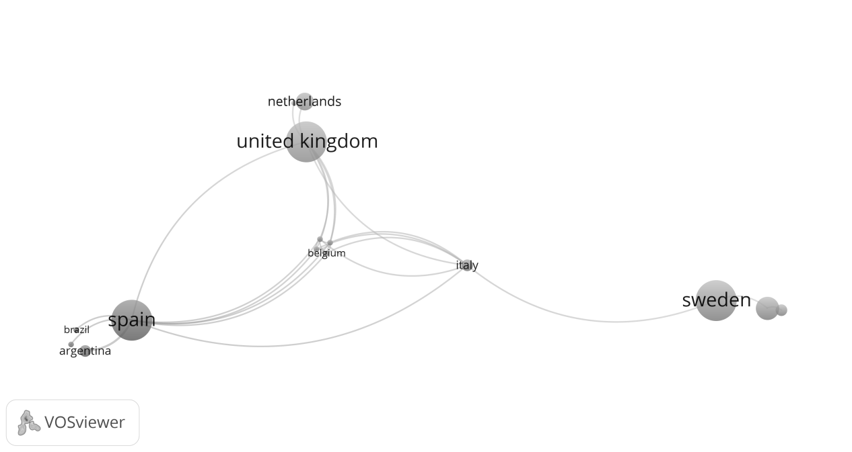 Figure 3. International cooperation from 2011-2015
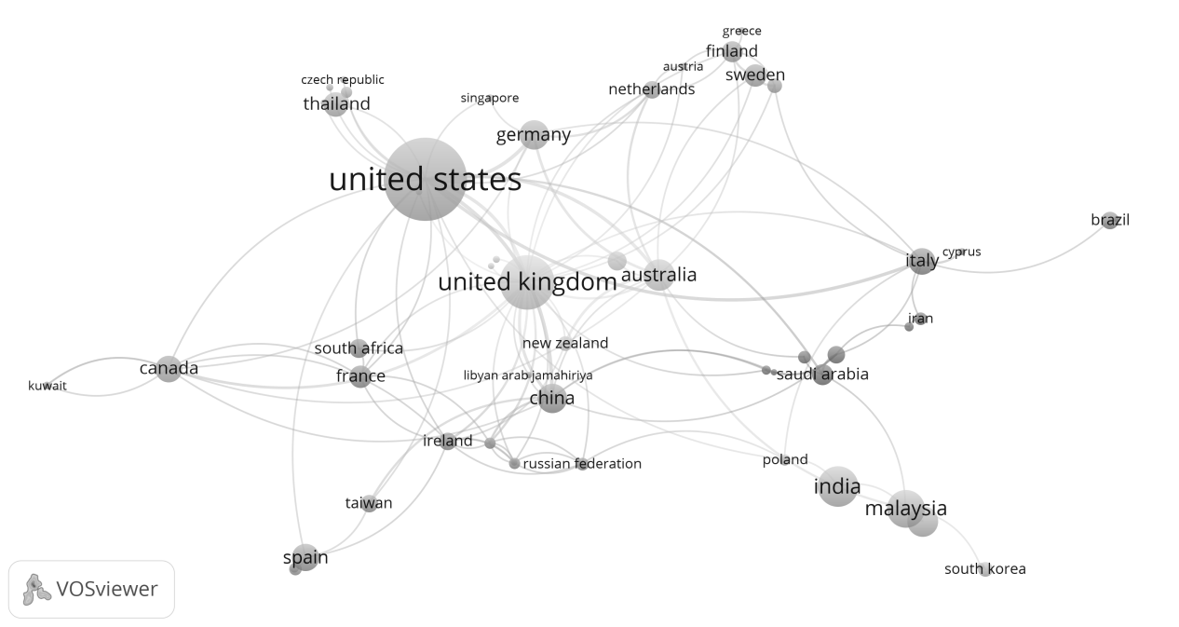 Figure 4. International cooperation from 2016-2020
It can be observed that the countries with the most cooperation from 2016 to 2020 have significantly changed compared with 2011 to 2015. At this stage, the countries with the most cooperation are no longer only European countries; still, non-European countries such as the United States, Australia, and China have begun extensive national cooperation, reflecting the more extensive international cooperation in this field.
3.6 Productive Institutions
We analyzed the research institutions in the three sub-periods using the three indicators of entire publications, total cities, and countries of affiliation and obtained the top 10 productive institutions, as shown in Table 6.

Table 6. Top Ten Productive Institutions
 | 2007-2010 |  |  |  | 2011-2015 |  |  |  | 2016-2020
Rank | Institutions | Country | TP | TC | Institutions | Country | TP | TC | Institutions | Country | TP | TC
1 | Leeds Metropolitan University | United Kingdom | 2 | 48 | The University of Texas at Austin | United States | 3 | 22 | Michigan State University | United States | 6 | 157
2 | George Mason University | United States | 1 | 63 | Ono Academic College | Israel | 3 | 98 | Queensland University of Technology | Australia | 6 | 106
3 | Clayton State University | United States | 1 | 33 | University of Toronto | Canada | 2 | 431 | University of Southern California | United States | 5 | 81
4 | Ramapo College of New Jersey | United States | 1 | 30 | York University | Canada | 2 | 431 | Universiti Malaysia Kelantan | Malaysia | 5 | 23
5 | Georgia State University | United States | 1 | 21 | Universidad Nacional de Mar del Plata | Argentina | 2 | 403 | Universiti Kebangsaan Malaysia | Malaysia | 4 | 2
6 | Middle Tennessee State University | United States | 1 | 16 | Universitat Rovira i Virgili | Spain | 2 | 403 | Universiti Utara Malaysia | Malaysia | 4 | 6
7 | University of Illinois Urbana-Champaign | United States | 1 | 15 | Temple University | United States | 2 | 187 | Norwegian University of Science and Technology | Norway | 4 | 25

Table 6. Top Ten Productive Institutions
 | 2007-2010 |  |  |  |  |  |  |  |  | 2011-2015 |  |  |  |  |  |  | 2016-2020
Rank | Institutions |  |  | Country |  | TP |  | TC |  | Institutions | Country |  | TP |  |  | TC | Institutions |  |  | Country |  | TP | TC
8 |  | The George Washington University | United States |  | 1 |  | 15 |  | San Diego State University |  |  | United States |  | 2 | 67 |  |  | Taylor's University Malaysia | Malaysia |  | 4 |  |  | 6
9 |  | Northwestern University | United States |  | 1 |  | 15 |  | The University of North Carolina at Chapel Hill |  |  | United States |  | 2 | 29 |  |  | Pennsylvania State University | United States |  | 3 |  |  | 216
10 |  | The University of Texas at Austin | United States |  | 1 |  | 15 |  | Barry University |  |  | United States |  | 2 | 28 |  |  | Temple University | United States |  | 3 |  |  | 179
TP: Total Publications; TC: Total Citations

From 2007 to 2010, Leeds Metropolitan University in the UK had the most significant total publications, with two publications and a full citation of 48. The other nine research institutions had one publication each. The total citation research institution is George Mason University in the United States, with a total citation of 63. During this period, for Leeds Metropolitan University in the UK, the other nine research institutions were all from the United States, indicating that almost all the leading research institutions in this field were in the United States.
From 2011 to 2015, the University of Texas at Austin in the United States and Ono academic college in Israel were the research institutions with the largest total publications, with several 3 and citations of 22 and 98, respectively. Although the number of publications of research institutions in Canada is 2, ranking third, the number of citations is the highest among these countries, reaching 431. At this stage, we can find that half of the research institutions are non-U.S, which are from Israel, Canada, Argentina, and Spain, indicating that research institutions outside the United States have also begun to pay attention to research in this field.
From 2016 to 2020, Michigan State University in the United States and Queensland University of Technology in Australia were the research institutions with the largest total publications, with six publications each and 157 and 106 citations, respectively. The research institutions in the United States are still the most important in this field. It is worth noting that research institutions in Malaysia have developed rapidly in this field. A total of four research institutions were selected, namely, Universiti Malaysia Kelantan, Universiti Kebangsaan Malaysia, Universiti Utara Malaysia, Taylor's University, and 5, 4, 4, and 4 publications, respectively. However, the overall citation is 23, 2, 6, and 6, respectively. During this period, the number of non-U.S. research institutions further increased to 6, reflecting the attention paid to research in this field in non-U.S. countries.
3.7 Productive Authors
According to the three indicators of full publications of authors, total citations, and h-index, table 7 shows the top 10 productive authors who have contributed to this field in three sub-periods.

Table 7. Top Ten Productive Authors
Rank | Author(s) | SA-ID | TP | TC | h-index | Affiliation | Country
2007-2010
1 | Jones, B. | 56071408100 | 2 | 48 | 11 | Leeds Metropolitan University | United Kingdom
2 | Gehl, R. | 25957999800 | 1 | 63 | 10 | George Mason University | United States
3 | Deis, M.H. | 22952833800 | 1 | 33 | 3 | Clayton State University | United States
4 | Hensel, K. | 36696434900 | 1 | 33 | 1 | Clayton State University | United States
5 | Mckenna, L. | 23019448300 | 1 | 30 | 2 | Ramapo College of New Jersey | United States
6 | Crampton, J.W. | 7005574653 | 1 | 21 | 23 | Georgio State University | United States
7 | Geho, P.R. | 36682096400 | 1 | 16 | 5 | Middle Tennessee State University | United States
8 | Lewis, S.D. | 36682579200 | 1 | 16 | 2 | Middle Tennessee State University | United States
9 | Smith, S. | 56120604900 | 1 | 16 | 1 | Middle Tennessee State University | United States
10 | Whinston, A.B. | 7005286020 | 1 | 15 | 54 | University of Texas-Austin | United States
2011-2015
1 | Avnimelech, G. | 6508156712 | 3 | 98 | 14 | Ono Academic College | Israel
2 | Baltar, F. | 36681792600 | 2 | 403 | 4 | University of Mar del Plata | Argentina
3 | Fischer, E. | 7402015680 | 2 | 431 | 31 | York University | Canada
4 | Zelekha, Y. | 33467982600 | 2 | 84 | 6 | Ono Academic College | Israel
5 | Sharabi, E. | 54390112900 | 2 | 84 | 3 | Ono Academic College | Israel
6 | Kleban, J. | 55599749300 | 2 | 28 | 2 | Barry University | United States
7 | Nickerson, I. | 36057326400 | 2 | 28 | 3 | Barry University | United States
8 | Slabbert, A.D. | 24177582500 | 2 | 9 | 6 | Cape Peninsula University of Technology | South Africa
9 | Ukpere, C.L. | 56094956700 | 2 | 9 | 2 | Cape Peninsula University of Technology | South Africa
10 | Rolston, C. | 38162854600 | 2 | 4 | 2 | Belmont University | United States

Table 7. Top Ten Productive Authors
Rank | Author(s) | SA-ID | TP | TC | h-index | Affiliation | Country
2016-2020
1 | Duffy, B.E. | 55799606900 | 4 | 251 | 15 | Temple University | United States
2 | McGrath, H. | 35337099200 | 3 | 64 | 8 | University College Cork | Ireland
3 | O'Toole, T. | 7006733254 | 3 | 64 | 12 | Waterford Institute of Technology | Ireland
4 | Charoensukmongkol, P. | 44861028200 | 3 | 60 | 17 | National Institute of Development Administration | Thailand
5 | Obschonka, M. | 35848937800 | 3 | 56 | 27 | Queensland University of Technology | Australia
6 | Ahmad, S.Z. | 36503484500 | 3 | 54 | 17 | Abu Dhabi University | United Arab Emirates
7 | Mamun, A.A. | 36782596500 | 3 | 21 | 13 | Universiti Malaysia Kelantan | Malaysia
8 | Fazal, S.A. | 57191227941 | 3 | 20 | 8 | Universiti Malaysia Kelantan | Malaysia
9 | Nasir, N.A.B.M. | 57193955201 | 3 | 20 | 5 | Universiti Malaysia Kelantan | Malaysia
10 | Thorpe, H. | 12143371300 | 2 | 62 | 19 | University of Waikato | New Zealand
SA-ID: Scopus Author ID ;TP: Total Publications; TC: Total Citations

Jones, with two publications from Leeds Metropolitan University in the UK, was the researcher with the total publications from 2007 to 2010, while the other researchers all had one. The highest total citations are Gehl, R., from George Mason University in the United States, with 63 total citations. It can be observed that all the top 10 authors, except Jones, are from the United States.
From 2011 to 2015, Avnimelech, G. from Ono academic college in Israel had three publications, and the other nine had two. The first and second total citations are Fischer from York University in Canada and Baltar, F., from the University on Mar del Plata in Argentina, respectively, 431 and 403. Meanwhile, Fischer is also the highest author on the h-index, reaching 31. Avnimelech, G., with the most publications, ranked second in the h-index, at 14. Only three of the top 10 authors came from the United States, reflecting that non-American researchers played a more critical role in this field. Duffy, B.E. has four publications from 2016 to 2020 and is also the author with the most citations of 251; the other eight authors have three publications, and another is two. The highest h-index is Obschonka, M., with 27. It can be found that half of the top 10 productive authors are from Asia, including three authors from Malaysia, one from Thailand, and one from the United Arab Emirates, reflecting that Asian researchers are playing an increasingly important role in this field. The changing trend of productive authors in these three sub-periods is similar to that of our previous predominant countries and effective institutions, which supports our last analysis.
3.8 Author Keyword Co-occurrence
The researchers' choice of keywords points out the research direction. Keyword analysis also shows the trend of research topics. We use VOSviewer to visualize the occurrence of author keywords. Figures 5, 6, and 7 show the co-occurrence of author keywords in three sub-periods, indicating the relevance of keywords. The tag size indicates the higher weight or occurrence times, and the similar color of the tag means the cluster of keywords. Lines between tags represent links between keywords.
3.8.1 Analysis within clusters from 2007 to 2010
Figure 5 shows the co-occurrence of authors' keywords from 2007 to 2010. After re-labeling synonymic single words and con-generic phrases, a total of 81 author keywords were recorded. Five keywords met the threshold of a minimum of five occurrences for the mapping in VOSviewer, and two clusters can be observed:
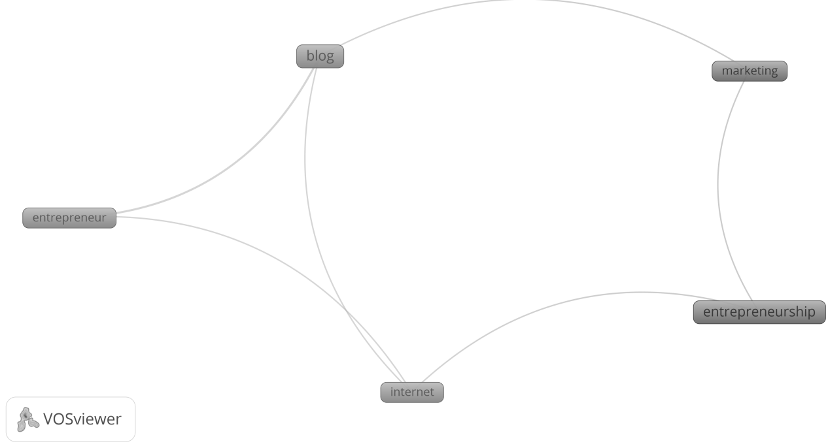 Figure 5. Author keywords co-occurrence from 2007-2010
Cluster1: The keywords are blog, entrepreneur, and internet. As a widely used social media at that time, the importance of the blog to entrepreneurs began to attract scholars' attention. Robert and Lisa[27] investigated the rapid growth of blog network traffic and discussed how blogs could improve performance by improving the marketing function of enterprises.
Cluster2: The keywords are entrepreneurship and marketing, which indicates that the main focus on social media and entrepreneurship in this period is marketing. The traditional marketing model is being challenged. How to generate potential customers, improve popularity, and communication methods are also developing. Entrepreneurs must understand how to use social media to increase advertising and improve marketing[26] . Jones [25] found that social media is essential in marketing and entrepreneurship and can be regarded as a tool to increase entrepreneurial freedom. Hensel and Deis [26] claim that social media can increase advertising and improve marketing. The marketing role of different social media platforms has also been confirmed by Robert and Lisa [27] , who found that blogs improve performance by improving the marketing function of enterprises, and the usefulness of Twitter as a marketing tool has also been confirmed [24] . In addition to focusing on marketing, social media has created opportunities for education management and business reputation. Social media can provide opportunities for new forms of stakeholder participation and become an efficient and effective communication tool within and across business and education departments [35] . Burke and Calton [36] proposed that combining the social technology infrastructure with the social capital requirements of entrepreneurial communities will help the formation of e-learning networks, thus promoting the success of entrepreneurial communities.

3.8.2 Analysis within clusters from 2011 to 2015
Figure 6 shows the co-occurrence of author keywords from 2011 to 2015; a total of 422 author keywords were recorded: five keywords met the threshold of a minimum of five occurrences for the mapping in VOSviewer, and two clusters can be observed:
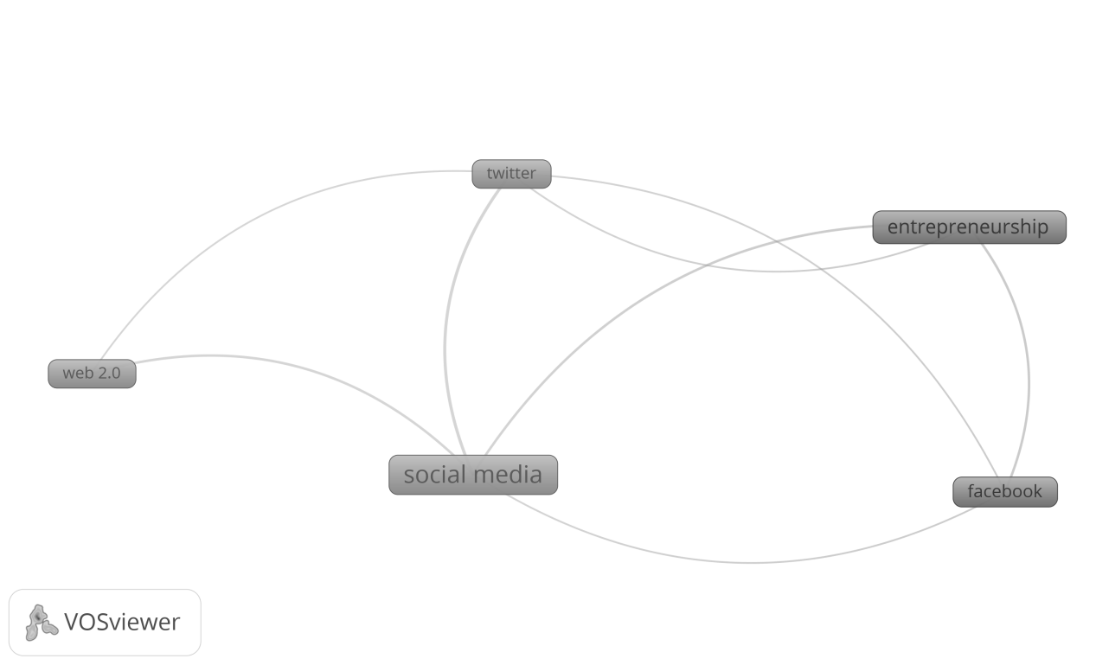 Figure 6. Author keywords co-occurrence from 2011 to 2015
Cluster1: The keywords are social media, Twitter, and Web 2.0. The research on social media has attracted more attention, especially on Twitter, as a rapidly developing social platform. Fischer and Reuber [29] used social interaction theory to study social media and found that perceived time affordability can predict the social interaction level of entrepreneurs through Twitter. Social media can serve as a marketing tool and use data to optimize social media marketing activities [37] . In addition, social media promotes entrepreneurship among Kenyan women [38] . Stimulate response theory and balance theory are also used in social media research. Based on this theory, Zhu and Chang [39] found that the unethical behavior of the founders of enterprises on social media will negatively impact the corporate image, and the initial impression of consumers on the founders of enterprises will positively impact the positive corporate image.
Cluster2: The keywords are enterprise and Facebook. The development of Internet technology and smartphones has increased significantly with the development of social media. Through smartphones, you can access Facebook, Twitter, and other popular social media platforms anytime and anywhere. It can be said that the role of social media in providing information flow for start-ups, small and medium-sized enterprises, and large companies is more important than ever [40] . Social media self-efficacy can be used to predict perceived behavior control in entrepreneurial intention [41] .
3.8.3 Analysis within clusters from 2016 to 2020
Figure 7 shows the co-occurrence of author keywords from 2016 to 2020. A total of 1584 author keywords were recorded; 37 keywords met the threshold of a minimum of five occurrences for the mapping in VOSviewer, and eight clusters can be observed:
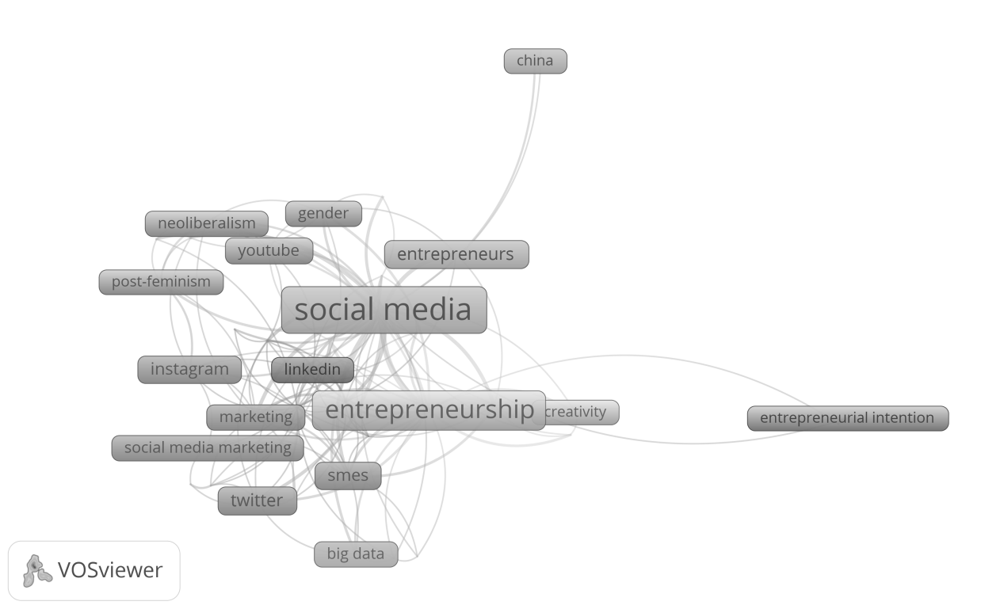 Figure 7. Author keywords co-occurrence from 2016-2020
Cluster1: The keywords are Instagram, machine learning, marketing, SMEs, social entrepreneurship, social innovation, social media marketing, and Twitter. As a photo-sharing platform, Instagram plays a vital role in daily life. Many entrepreneurs and enterprises began to promote their brands and products on social media platforms like Instagram. Bakar et al.[40] proposed a technical method to summarize the popular keywords or tags on Instagram through some simple visual displays. This provides help for enterprises to use social media marketing. Social media still plays an essential role in marketing, especially digital marketing.
Researchers began to focus on artificial intelligence and big data (such as data generated through social media) to help understand the potential of financial results. Social media big data and artificial intelligence methods may provide comparable information about regional personality and culture, which has preliminary significance for the research and practice of entrepreneurship regions and ecosystems, as well as regional economic achievements [42] .
The application of artificial intelligence can predict the social media marketing level of start-ups, which has a positive significance for improving social media marketing activities [43] . Basri [44] found that artificial intelligence-assisted social media marketing (AISMM) improved effective enterprise management and small and medium-sized enterprise performance (SMEP) through research on Saudi Arabia's small and medium-sized enterprises (SMEs) and improved performance by using AISMM to reduce various marketing problems.
The marketing role of social media has always been the focus of researchers. The researchers suggest that small enterprises and start-ups should incorporate digital marketing into their business plans and implement it as a strategy, which will be conducive to market competitiveness [45] . For social media marketing, only providing content cannot bring sales. More importantly, they should participate in Q & A sessions. This will help to enhance the value of the brand [46] . In some cases, the content category, release time, and media type will significantly impact the online participation of customers [47] . The research conducted by Mokhtar [48] in small and medium-sized enterprises(SMEs) in Kelantan, Malaysia, found that technical organization and environmental factors can significantly affect the adoption of social media marketing. In addition, the education level of entrepreneurs can also affect the adoption of social media marketing [49] . It is worth noting that when some organizations of specific activities (such as business plan competitions) use social media to conduct marketing activities for SMEs, a large number of respondents (55%) do not know that social media tools are used to promote competitions. This may be because the organizations using social media either do not properly plan or are careless in using these tools [50] .
Cluster2: The keywords are Facebook, digital marketing, social networks, start-ups, women entrepreneurship, and LinkedIn. We can see that the impact of Facebook and LinkedIn on entrepreneurship and marketing has been studied a lot. Sajilan et al. [51] developed a conceptual model based on strategic contingency theory and diffusion of innovations theory to study the impact of Facebook on the performance of retail companies, and found that the use of Facebook has a statistically positive impact on retailers' perceived financial performance, perceived non-financial performance, perceived business growth and perceived performance relative to competitors. For entrepreneurs, perceived risk and personal characteristics are the main factors that prevent them from entering Facebook commerce [52] . The study also found that product information such as product quality and economic value can significantly affect Facebook users' "like clicking" on Facebook ads, and "like clicking" and comments will also affect millennials' willingness to buy products [53] .
LinkedIn is an important platform. Many companies use LinkedIn to promote their businesses and services, including start-ups to large organizations. Start-ups use LinkedIn as a social network and as a way to identify the factors affecting the audience. Female entrepreneurs are using social media and chat applications to promote their businesses. Social networks affect entrepreneurs' online connection with social capital [54] , consciously using social networks can help start-ups' financing [55] , and social networks can affect the amount of financing. Banerji and Reimer [56] found that the average number of followers of enterprise founders on LinkedIn is the most powerful indicator to predict the amount of enterprise financing. In addition, through research using social capital theory, it is found that social interaction improves the probability of achieving crowdfunding goals [57] .
Cluster3: Women, gender, post-feminism, YouTube, and neoliberalism are identities. Women entrepreneurs are a research group that attracts the attention of scholars. Cordero-Gutiérrez and Santos-Requejo [58] found that women and young people are the groups that most want to conduct business experiments through social networks. A study in the United Arab Emirates also confirmed this, immigrant women entrepreneurs in the United Arab Emirates are using social media and chat applications to promote their businesses. Digital tools play a major role in their business promotion [59] . Social media provides convenience for women's Entrepreneurship [60] , and social networks provide an inclusive platform through which women can establish and operate small businesses [61] and contact potential customers [62] . Even female migrant workers of marginal groups can create social networks through social media to develop social entrepreneurship [63] . Therefore, Women entrepreneurs must adapt to the use of ICT and social media to improve the sustainability of their enterprises and attract the younger generation [64] . However, it cannot be ignored that the romantic ideal of empowering women economically in the digital space may mask the long-term existence of systematic and structural oppression [65] . The double bondage of numbers proves the persistent structural inequality, which makes women's entrepreneurship a second-class entrepreneurial type [66] . With the development of social media, much content about women's rights is transmitted on YouTube [67] . Naudin and Patel [68] address issues of identity and professionalism for women cultural entrepreneurs by focusing on their use of Twitter. In addition, the research on social media and entrepreneurs has also been extended to the fields of post-feminism [69] , neoliberalism [70] , etc.
Cluster4: The keywords are social media, China, digital entrepreneurship and entrepreneurs. The widespread use of social media in China has also attracted the attention of scholars. Chen et al.[71] investigated the strategic use of social media in stakeholder participation of Chinese start-ups. Ideological leadership building, Co-branding and influence endorsement were identified as the new social media participation strategies of start-ups. The research on entrepreneurs is also growing. Turan and Kara [72] found that a large part of the change in the intention of entrepreneurs to use social media is due to the entrepreneurs' views on the required efforts, performance expectations and various social impacts. Previous entrepreneurial experience is the most important factor affecting the use of social media because the cognitive difference between novice and experienced entrepreneurs will affect their ability to identify opportunities and cope with technological changes [73] . The expanded research model positively impacts academic entrepreneurs' intention to use digital technology media platforms [74] . Social media is becoming a platform for students' entrepreneurship in China. The use of social media indirectly affects students' entrepreneurial intention through self-efficacy [75] . Students need to improve their technical preparation to become entrepreneurs who are good at digital marketing after graduation [76] . Gender studies of entrepreneurs have found that start-ups founded by male entrepreneurs generally perform better, which can be attributed to their more diversified online social networks than female entrepreneurs [77] .
Cluster5: The keywords are creativity, innovation, technology and entrepreneurs. For entrepreneurs, social media can not only be used for marketing work, but also have a positive impact on innovation and creativity. Crammond et al.[78] conceptualized Social Media Use (SMU) as a knowledge management tool that helps Small and Medium-sized Enterprises (SMEs) start businesses. As a management tool for small and medium-sized enterprises, innovative SMU has brought great benefits. Social media brings innovation and technology and brings more help to entrepreneurs.
Social media has a significant positive impact on the innovation achievements of start-ups [79] . In addition, customer co-creation on social media platforms will also positively impact the provision of innovative services [80] . According to the organizational ecology theory, innovation ability and social media ability play a moderate role in the relationship between brand orientation and brand performance of SMEs [81] . Open innovation also plays a moderate role in the relationship between social media and entrepreneurship orientation, thus improving the innovation performance of SMEs [82] .
As an emerging technology, social media has two most commonly used theoretical models: The Technology Acceptance Model (TAM) and the Unified Theory of Acceptance and Use of Technology (UTAUT). Through the research using TAM, we not only found that technology, organizational structure and environmental background have a significant impact on the adoption of social media [83] , but also found that strengthening the ability of Latino/Hispanic entrepreneurs in social media can improve their ability to establish customer relations, brand development and equity financing [84] . UTAUT is a good model to prove that performance expectation, effort expectation, social impact and convenience positively impact behavior intention and user behavior [85] . Performance expectation, perceived risk, perceived trust and perceived happiness significantly affect the depth of social media adoption and thus significantly affect consumer participation [86] .
Cluster6: The keywords are crowdfunding, institutions, self-branding, and social capital. As a new way of raising funds, crowdfunding is more and more used in the fund-raising of start-ups and Internet companies. Social media has a positive impact on crowdfunding [87] . Many theories have been applied to research in this field. Through the use of social capital theory, it is found that social interaction improves the probability of achieving crowdfunding goals [88] . According to the ability theory, innovation orientation improves enterprises' ability to succeed in crowdfunding activities, and social media plays a moderate role [89] . Kaminski et al. [90] believe that crowdfunding activities need to treat their social media activities with a certain degree of sensitivity to achieve the goal of successfully achieving their activity objectives. According to social identity theory and Signaling theory, the sponsors and supporters of identity projects in entrepreneurs' own social networks are related to a larger commitment/supporter ratio [87] . In this process, social media can provide investors with an opportunity to verify less reliable information [91] . However, it is worth noting that Laurell et al. [92] believe that social media plays a seemingly insignificant role in the interaction between crowdfunding and sustainable development. Social capital obtained through social media interaction contributes to the entrepreneurial behavior of IT freelancers [93] , and social media can also be used as a work tool for self-branding [94] .
Cluster7: The keywords are big data, e-commerce and Internet. In developed and developing countries, the adoption of e-commerce by small and medium-sized enterprises is a subject of much research. The application of mobile devices and social media networks has wholly changed the e-commerce adoption process of small and medium-sized enterprises. E-commerce applications using social media networks expand the range of tools that small and medium-sized enterprises may use [95] . The combination of e-commerce and social media has developed a new business model of social commerce. Guzmán-Duque et al.[96] found that the most used social networks in s-commerce are Facebook, Twitter, Instagram, WhatsApp and YouTube as well as e-bay, Mercado Libre, Amazon, and Tmall. The use of big data in social media can be used to improve the sales and operating profits of online businesses. The use of big data in social commerce can gain competitive advantages, which may win opportunities for enterprises and customers [97] .
Cluster8: The keywords are entrepreneurial intention and Saudi Arabia. More and more attention has been paid to the research on entrepreneurship in Saudi Arabia. Alayis et al. [98] confirmed the impact of social networks on students' perceived feasibility; social media use indirectly affects students' entrepreneurial intention through self-efficacy [75] . Social networking sites have affected the entrepreneurial intention of Saudi Arabian Business School undergraduates [98] . Saudi Arabian students' overall entrepreneurial intention is high [99] .
4. Discussion and Conclusion
This study conducted a bibliometric analysis of 569 academic publications selected from social media and entrepreneurship research from 2007 to 2020. To better analyze the changing trend of international cooperation and research topics, we comprehensively analyzed the number of publications, source journals, highly cited articles, countries, institutions, international cooperation, top authors and author keyword co-occurrence analysis and cluster analysis in the three sub-periods (2007-2010, 2011-2015 and 2016-2020). It has obtained a clear path and changed the trend of international cooperation and research topics of social media and entrepreneurship in recent ten years.
Firstly, the research on social media and entrepreneurship has attracted much attention. The number of publications is increasing rapidly every year and professional journals in the field of social media have appeared. The main countries of social media and entrepreneurship research have gradually expanded from the early United States and the United Kingdom to other countries. Currently, Asian countries occupy an essential position in this field. The leading research institutions and top authors in this field also have the exact change trend, reflecting that Asian countries are increasing the importance of research in this field with economic development. Especially in India, China, Southeast Asia and the Middle East, these hot economic growth countries and regions, the research in this field has developed rapidly.
Second, at the level of international cooperation, the United States and the United Kingdom are the countries with the most international cooperation. China in Asia and Australia in Oceania are also developing rapidly in international cooperation, and these countries are also the core countries for research in this field. Except for a few countries with the most significant international cooperation, the international cooperation of other countries is mainly limited to their continents. In general, European countries mainly cooperate with European countries, and Asian countries cooperate with Asian countries.
Third, the change of research objects is accompanied by the emergence of new social media platforms. The research target platforms have gradually expanded from the initial Blog, Twitter and Facebook to Instagram, LinkedIn and YouTube and so on, which have attracted extensive attention in recent years.
Fourthly, from the co-occurrence analysis and cluster analysis, it can be found that the research topics in this field have developed from the initial focus on the marketing function to innovation, customer management, knowledge management and entrepreneurial purpose, and the research topics have become more extensive. At the same time, the combination of this field with other industries has become a trend, such as the research on crowdfunding in combination with the financial industry and the research on social commerce in combination with e-commerce. In addition, more and more studies are focusing on women's research, including feminism, female entrepreneurship, etc. Finally, with the wide application of new technologies, social media and entrepreneurship research also pay attention to the latest technologies, such as big data, machine learning and artificial intelligence.
More comprehensive international cooperation leads to faster research and development. Cooperation will produce more knowledge, new ideas, and academic achievements[100] . Research cooperation between remote authors can promote the progress of research results and methods in relevant fields and bring more effective development results[101] . In addition, academic cooperation can improve research quality, scientific production efficiency and promote breakthroughs in a shorter time[102] [103] . Future research suggests that cooperation should not be limited to their continents, whether European countries, Asian countries or countries on other continents, but should actively cooperate with countries on other continents to bring more innovative achievements and promote more diversification of research in this field. Secondly, the target platform of the study usually changes with the emergence of new social media platforms. Therefore, the latest popular social media platforms will be the focus of future research, such as the current rapidly developing social media platforms in the field of short videos, such as TikTok, Instagram reels, Facebook's lasso et al. Third, the research trend in this field is to combine with other industries or new technologies. It is suggested that future research can focus on industries or fields, such as financial technology, artificial intelligence, big data, etc. Fourth, with the growth of global feminism, future research can focus on topics related to gender or women. Fifth, considering the rapid development of the economy and the Internet in Asia, future research can focus on Asian countries and regions, such as India, China, Southeast Asia, the Middle East, etc.
5. Limitations
Although our data source Scopus is a widely used academic database globally, essential articles and information may not be included. Secondly, there are inevitably some deviations in the retrieval process and statistics of literature data, or all effective keywords are not considered. These problems need to be improved in future research.
6. References
- A. A. Alalwan, N. P. Rana, Y. K. Dwivedi, R. Algharabat, "Social media in marketing: A review and analysis of the existing literature," Telematics and Informatics, Vol.34, No.7, pp. 1177-1190, 2017.
- A.J. Kim and E. Ko, "Do social media marketing activities enhance customer equity? An empirical study of luxury fashion brand," Journal of Business Research, Vol.65, No.10, pp. 1480-1486, 2012.
- C. M. Sashi, "Customer engagement, buyer‐seller relationships, and social media," Management decision, Vol.50, No.2, pp. 253-272, 2012.
- S. Tsitsi Chikandiwa, E. Contogiannis, and E. Jembere, "The adoption of social media marketing in South African banks," European Business Review, Vol.25, No.4, pp. 365-381, 2013.
- J. Park, C. Sung, and I. Im, "Does Social Media Use Influence Entrepreneurial Opportunity? A Review of its Moderating Role," Sustainability, Vol. 9, No.9, pp. 1593, 2017.
- K. Kuhn, T. Galloway, and M. Collins-Williams, "Near, far, and online: small business owners’ advice-seeking from peers," Journal of Small Business and Enterprise Development, Vol. 23, No.1, pp. 189-206, 2016.
- S. Quinton and D. Wilson, "Tensions and ties in social media networks: Towards a model of understanding business relationship development and business performance enhancement through the use of LinkedIn," Industrial Marketing Management, Vol. 54, pp. 15-24, 2016.
- S. Singh and S. Sonnenburg, "Brand Performances in Social Media," Journal of Interactive Marketing, Vol. 26, No.4, pp. 189-197, 2012.
- T. Brink, "B2B SME management of antecedents to the application of social media," Industrial Marketing Management, Vol.64, pp. 57-65, 2017.
- N. Michaelidou, N. T. Siamagka, and G. Christodoulides, "Usage, barriers and measurement of social media marketing: An exploratory investigation of small and medium B2B brands," Industrial Marketing Management, Vol.40, No.7, pp. 1153-1159, 2011.
- K. Filo, D. Lock, and A. Karg, "Sport and social media research: A review," Sport Management Review, Vol.18, No.2, pp. 166-181, 2015.
- A. Saxena and U. Khanna, "Advertising on Social Network Sites: A Structural Equation Modelling Approach," Vision: The Journal of Business Perspective, Vol.17, No.1, pp. 17-25, 2013.
- Gingras, Y, "Bibliometrics and research evaluation," Uses and abuses, Mit Press, 2016.
- A. Cox, E. Gadd, S. Petersohn, and L. Sbaffi, "Competencies for bibliometrics," Journal of Librarianship and Information Science, Vol.51, No.3, pp. 746-762, 2017.
- W.-T. Chiu and Y.-S. Ho, "Bibliometric analysis of tsunami research," Scientometrics, Vol.73, No.1, pp. 3-17, 2007.
- J. M. Merigó, A. M. Gil-Lafuente, and R. R. Yager, "An overview of fuzzy research with bibliometric indicators," Applied Soft Computing, Vol.27, pp. 420-433, 2015.
- D. Bouyssou and T. Marchant, "Ranking scientists and departments in a consistent manner," Journal of the American Society for Information Science and Technology, Vol. 62, No.9, pp. 1761-1769, 2011.
- Q.-H. Pu, Q.-J. Lyu, and H.-Y. Su, "Bibliometric analysis of scientific publications in transplantation journals from Mainland China, Japan, South Korea and Taiwan between 2006 and 2015," BMJ Open, Vol.6, No.8, 2016.
- A. Mazloumian, "Predicting Scholars," PLoS ONE, Vol.7, No.11, 2012.
- F. J. Martínez-López, J. M. Merigó, L. Valenzuela-Fernández, and C. Nicolás, "Fifty years of the European Journal of Marketing: a bibliometric analysis," European Journal of Marketing, Vol. 52, No.1, pp. 439-468, 2018.
- L. M. Valenzuela, J. M. Merigó, W. J. Johnston, C. Nicolas, and J. F. Jaramillo, "Thirty years of the Journal of Business & Industrial Marketing: a bibliometric analysis," Journal of Business & Industrial Marketing,Vol. 32, No.1, pp. 1-17, 2017.
- Van Eck, N., & Waltman, L, "Software survey: VOSviewer, a computer program for bibliometric mapping," scientometrics, Vol. 84, No.2, pp.523-538, 2010.
- R. Gehl, "YouTube as archive: Who will curate this digital Wunderkammer?," International Journal of Cultural Studies, Vol.12, No.1, pp. 43-60, 2009.
- Geho, P. R., Smith, S., & Lewis, S. D., "Is Twitter a viable commercial use platform for small businesses? An empirical study targeting two audiences in the small business community," The Entrepreneurial Executive, Vol.15, No.1, pp.73-85,2010.
- B. Jones, "Entrepreneurial marketing and the Web 2.0 interface," Journal of Research in Marketing and Entrepreneurship, Vol.12, No.2, pp. 143-152, 2010.
- Hensel, K., & Deis, M. H., "Using social media to increase advertising and improve marketing," The Entrepreneurial Executive, Vol.15, pp.87, 2010.
- R. P. Singh and L. O. Singh, "Blogs: Emerging Knowledge Management Tools For Entrepreneurs to Enhance Marketing Efforts," Journal of Internet Commerce, Vol.7, No.4, pp. 470-484, 2008.
- F. Baltar and I. Brunet, "Social research 2.0: virtual snowball sampling method using Facebook," Internet Research, Vol. 22, No.1, pp. 57-74, 2012.
- E. Fischer and A. R. Reuber, "Social interaction via new social media: (How) can interactions on Twitter affect effectual thinking and behavior?," Journal of Business Venturing, Vol. 26, No.1, pp. 1-18, 2011.
- A. Moritz, J. Block, and E. Lutz, "Investor communication in equity-based crowdfunding: a qualitative-empirical study," Qualitative Research in Financial Markets, Vol.7, No.3, pp. 309-342, 2015.
- P. Gomber, R. J. Kauffman, C. Parker, and B. W. Weber, "On the Fintech Revolution: Interpreting the Forces of Innovation, Disruption, and Transformation in Financial Services," Journal of Management Information Systems, Vol.35, No.1, pp. 220-265, 2018.
- K. Cotter, "Playing the visibility game: How digital influencers and algorithms negotiate influence on Instagram," New Media & Society, Vol. 21, No.4, pp. 895-913, 2018.
- F. Parveen, N. I. Jaafar, and S. Ainin, "Social media’s impact on organizational performance and entrepreneurial orientation in organizations," Management Decision, Vol. 54, No.9, pp. 2208-2234, 2016.
- B. E. Duffy, "The romance of work: Gender and aspirational labour in the digital culture industries," International Journal of Cultural Studies, Vol. 19, No.4, pp. 441-457, 2015.‌
- Jones, B., & Iredale, N, "Entrepreneurship education and Web 2.0," Journal of Research in Marketing and Entrepreneurship, Vol. 11, No.1, pp.66-77,2009.
- K. Burke and J. M. Calton, "A Framework Describing the Relationships among Social Technologies and Social Capital Formation in Electronic Entrepreneurial Networking,”International Journal of e-Collaboration, Vol. 5, No.3, pp. 25–38, Jul. 2009.
- Geho, P. R., & Dangelo, J,"The evolution of social media as a marketing tool for entrepreneurs," The Entrepreneurial Executive, Vol. 17, pp.61, 2012.
- C. L. Ukpere, A. D. Slabbert, and W. I. Ukpere, "The Relevance of Modern Technology Usage on the Business Ventures of Kenyan Women Entrepreneurs," Mediterranean Journal of Social Sciences, Vol. 5, No.10, pp.58-66, 2014.
- D.-H. Zhu and Y.-P. Chang, "Negative Publicity Effect of the Business Founder’s Unethical Behavior on Corporate Image: Evidence from China," Journal of Business Ethics, Vol. 117, No.1, pp. 111–121, 2012.
- Bakar M.S.A., Hassan S., Ta’a A., Yasin A., Sheng A.J., Suhaimi S., Yin K.Y, "Identify entrepreneurial opportunity by mining data from social media," International Journal of Advanced Science and Technology, Vol. 29, No.6S, pp.1778-1782, 2020.
- Ajjan, H., Fabian, F., Tomczyk, D., & Hattab, H., "Social media use to support entrepreneurship in the face of disruption," Journal of developmental entrepreneurship, Vol. 20, No.03, 1-27,2015.
- M. Obschonka, N. Lee, A. Rodríguez-Pose, J. C. Eichstaedt, and T. Ebert, "Big data methods, social media, and the psychology of entrepreneurial regions: capturing cross-county personality traits and their impact on entrepreneurship in the USA," Small Business Economics, Vol.55, No.3, pp. 567-588, 2019.
- Jung, S. H., & Jeong, Y. J. , "Twitter data analytical methodology development for prediction of start-up firms’ social media marketing level," Technology in Society, Vol. 63, pp. 101409,2020.
- Basri, W., "Examining the impact of artificial intelligence (AI)-assisted social media marketing on the performance of small and medium enterprises: toward effective business management in the Saudi Arabian context," International Journal of Computational Intelligence Systems, Vol. 13, No.1, pp.142,2020.
- Das J. "Analysis of digital marketing sector," International Journal of Psychosocial, Vol. 23, No.6, pp.101-106, 2019.
- Raza, M., Abd Rani, S. H., & Isa, N. M., "Determinants of brand authenticity of high quality apparel industry in developing country: A moderating effect of entrepreneurial," International Journal for Quality Research, Vol. 14, No.3, pp.913,2020.
- Tassawa, C., "Factors influencing Facebook page posts’ likes, shares, and comments in sport marketing," ABAC Journal, Vol. 39, No.3, pp.56-69,2019.
- Mokhtar, N. F., "Social Media Marketing and Entrepreneurs: The Uses of Social Media as Business Platform by Small Businesses in Malaysia," in Conf. Information Technology & Society, PENANG, Malaysia, 2017, pp.49-62.
- Manideep, A. S., Reddy, S. K., & Reddy, P. S., "Factors influencing the adoption of social media marketing in the wellness industry: An empirical analysis," Journal of Advanced Research in Dynamical and Control Systems, Vol. 11, No.6, pp.356-362,2019.
- Cant, M. C., "Using social media to market a promotional event to SMEs: opportunity or wasted effort?," Problems and perspectives in management, Vol.14, No.4, pp.76-82,2016.
- Sajilan, S., Tehseen, S., Yafi, E., & Ting, X., "Impact of Facebook usage on firm's performances among Malaysian Chinese retailers," Global Business & Finance Review (GBFR), Vol. 24, No.4, pp.45-62,2019.
- Jambulingamis, M., Sumathi, C., & Rajagopal, G. R., "Barriers of Venturing into Facebook Commerce among SMEs,”The Journal of Internet Banking and Commerce, Vol. 21, No.s2, 2016.
- Jambulingam, M., Dorasamy, M., Balasundrasun, N. L., & Matiah, J., "The structural relationship between 'like clicks' and purchase intention on facebook advertisements among millennials," Academy of Entrepreneurship Journal, Vol. 25, No.4, pp.1-10,2019.
- Smith, C., Smith, J. B., & Shaw, E., "Embracing digital networks: Entrepreneurs' social capital online," Journal of Business Venturing, Vol. 32, No.1, pp.18-34,2017.
- S. Yang and R. Berger, "Relation between start-ups’ online social media presence and fundraising,”Journal of Science and Technology Policy Management, Vol. 8, No.2, pp. 161–180, Jul. 2017.
- Banerji, D., & Reimer, T., "Startup founders and their LinkedIn connections: Are well-connected entrepreneurs more successful?," Computers in Human Behavior, Vol. 90, pp.46-52,2019.
- P. Madrazo-Lemarroy, K. Barajas-Portas, and M. E. Labastida Tovar, "Analyzing campaign’s outcome in reward-based crowdfunding,”Internet Research, Vol.29, pp. 1171-1189, 2019.
- R. Cordero-Gutiérrez and L. Santos-Requejo, "Intention to participate in online commercial experiments by social network’s users,” Management Research Review, Vol. 39, No.4, pp. 378–398, 2016.
- S. Jose, "Strategic use of digital promotion strategies among female emigrant entrepreneurs in UAE," International Journal of Emerging Markets, Vol. 13, No.6, pp. 1699-1718, 2018.
- Bedarkar, M. M., Mishra, M., & Khatwani, R. A., "Leveraging Social Media in Facilitating Women Entrepreneurs in India: A Case Study of Pune Ladies (PULA)," International Journal of E-Entrepreneurship and Innovation (IJEEI), 10, No.2, pp.76-90,2020.
- Lichy, J., Farquhar, J. D., & Kachour, M., "Entrepreneurship via social networks–"connected woman” in Lebanon," Qualitative Market Research: An International Journal,Vol. 24, No.4,pp.426-448, 2020.
- Bose A. "A study of women entreprenuers in India," International Journal of Management,Vol. 10, No.4, pp.132-140, 2019.
- Wahyono, E., Kolopaking, L. M., Sumarti, M. T., & Hubeis, A. V. S. , "A sociological analysis of the utilization of social media in women migrant workers in developing social entrepreneurship," International Journal of Innovative Technology and Exploring Engineering, Vol. 8, No.12, pp.4661-4666, 2019.
- Md Isa, F., Jaganathan, M., Sern, V. Y. C., Ahmdon, M. A. S., & Mohd Nafi, S. N., "Does service marketing enhance supplier and customer contact in the gig economy era? case analysis from Malaysian SMEs women entrepreneurs," International Journal of Supply Chain Management (IJSCM), Vol. 9, No.1, pp.1105-1112, 2020.
- Heizmann, H., & Liu, H., "Bloody Wonder Woman!: Identity performances of elite women entrepreneurs on Instagram,”Human Relations, Vol. 75, No.3, pp.411–440, 2020.
- Duffy, B. E., & Pruchniewska, U., "Gender and self-enterprise in the social media age: A digital double bind," Information, communication & society, Vol. 20, No.6, pp.843-859,2017.
- Bishop, S, "Anxiety, panic and self-optimization: Inequalities and the YouTube algorithm," Convergence, Vol. 24, No.1, 69-84, 2018.
- A. Naudin and K. Patel, "Entangled expertise: Women’s use of social media in entrepreneurial work," European Journal of Cultural Studies, Vol. 22, No.5, pp. 511-527, 2017.
- K. Toffoletti and H. Thorpe, "Female athletes," Feminism & Psychology, Vol. 28, No.1, pp. 11-31, 2018.
- N. Bozzi, "#digitalnomads, #solotravellers, #remoteworkers: A Cultural Critique of the Traveling Entrepreneur on Instagram.” Social Media + Society, Vol. 6, No.2, 2020.
- Z. F. Chen, Y. G. Ji, and L. R. Men, "Strategic Use of Social Media for Stakeholder Engagement in Startup Companies in China," International Journal of Strategic Communication, Vol. 11, No.3, pp. 244-267, 2017.
- Turan, M., & Kara, A., "Online social media usage behavior of entrepreneurs in an emerging market: Reasons, expected benefits and intentions," Journal of Research in Marketing and Entrepreneurship,Vol. 20, No.2, pp. 273-291, 2018.
- Mack, E. A., Marie-Pierre, L., & Redican, K., "Entrepreneurs’ use of internet and social media applications," Telecommunications Policy, Vol. 41, No.2, pp. 120-139,2017.
- Oppong, G.Y.S., Singh, S. and Kujur, F., "Potential of digital technologies in academic entrepreneurship – a study", International Journal of Entrepreneurial Behavior & Research, Vol. 26, No.7, pp. 1449-1476, 2020.
- Y. Huang and J. Zhang, "Social media use and entrepreneurial intention: The mediating role of self-efficacy," Social Behavior and Personality: an international journal, Vol. 48, No.11, pp. 1-8, 2020.
- Harding, D., Kadiyono, A. L., Hafiar, H., Ma'mun, T. N., Wibowo, H., Nugraha, Y., & Siswadi, A. G. P., "Readiness of Technology Adaptation towards Digital-Based Entrepreneurship," International Journal of Entrepreneurship, Vol.24, No.1, pp.1-5,2020.
- Song, Y., & Berger, R., "How gender affects collaborative innovation networks performance: The case of the Dutch fashion industry," International Journal of Entrepreneurship and Small Business, Vol. 36, No.4, pp. 392-407,2019.
- R. Crammond, K. O. Omeihe, A. Murray, and K. Ledger, "Managing knowledge through social media," Baltic Journal of Management, Vol. 13, No.3, pp. 303-328, 2018.
- G. Corral de Zubielqui and J. Jones, "How and when social media affects innovation in start-ups. A moderated mediation model,”Industrial Marketing Management, Vol. 85,pp.209-220, 2019.
- Moghadamzadeh, A., Ebrahimi, P., Radfard, S., Salamzadeh, A., & Khajeheian, D., "Investigating the role of customer co-creation behavior on social media platforms in rendering innovative services," Sustainability, Vol. 12, No.17, pp.6926,2020.
- Odoom, R., & Mensah, P., "Brand orientation and brand performance in SMEs: The moderating effects of social media and innovation capabilities," Management Research Review, Vol. 42, No.1, pp. 155-171,2018.
- Teh, S. S., & Kee, D. M. H., "Enablers of innovation performance among malaysian SMEs in industrial revolution 4.0,"International Journal of Innovation, Creativity and Change, Vol. 11, No.12, pp.275-289, 2020.
- Tripopsakul, S., "Social media adoption as a business platform: an integrated TAM-TOE framework," Polish Journal of Management Studies, Vol. 18, No.2,pp.350-362,2018.
- M. C. Gavino, D. E. Williams, D. Jacobson, and I. Smith, "Latino entrepreneurs and social media adoption: personal and business social network platforms,” Management Research Review, Vol. 42, No.4, pp. 469–494,2019.
- Surachim, A., Hurriyati, R., Lisnawati, L., Sulastri, S., & Mulyadi, H., "Using social media to promote student entrepreneurship," Pertanika Journal of Social Science and Humanities, Vol. 26, pp.73-183,2018.
- A. Al Mamun, N. B. Che Nawi, N. A. B. M. Nasir, and S. A. Fazal, "Social Media and Consumer Engagement: The Case of Malaysian Student Entrepreneurs,”Journal of Asia-Pacific Business, Vol. 21, No.3, pp. 185–206, Jul. 2020.
- Kromidha, E., & Robson, P., "Social identity and signalling success factors in online crowdfunding," Entrepreneurship & Regional Development, Vol. 28, No.9-10, pp. 605-629,2016.
- P. Madrazo-Lemarroy, K. Barajas-Portas, and M. E. Labastida Tovar, "Analyzing campaign’s outcome in reward-based crowdfunding,”Internet Research, Vol. 29, No.5,pp. 1171-1189, 2019.
- Datta, A., Sahaym, A., & Brooks, S., "Unpacking the antecedents of crowdfunding campaign’s success: The effects of social media and innovation orientation," Journal of Small Business Management, Vol. 57, pp. 462-488,2019.
- J. Kaminski, C. Hopp, and C. Lukas, "Who benefits from the wisdom of the crowd in crowdfunding? Assessing the benefits of user-generated and mass personal electronic word of mouth in computer-mediated financing,” Journal of Business Economics, Vol. 88, No.9, pp. 1133–1162, 2018.
- M. Nitani, A. Riding, and B. He, "On equity crowdfunding: investor rationality and success factors,” Venture Capital, Vol. 21, pp. 243–272, 2019.
- Laurell, C., Sandström, C., & Suseno, Y., "Assessing the interplay between crowdfunding and sustainability in social media," Technological Forecasting and Social Change, Vol. 141, pp. 117-127,2019.
- R. Sultana, I. Im, and K. S. Im, "Do IT freelancers increase their entrepreneurial behavior and performance by using IT self-efficacy and social capital? Evidence from Bangladesh," Information & Management, Vol. 56, No.6, pp. 103-133, 2019.
- Gandini, A, "Digital work: Self-branding and social capital in the freelance knowledge economy," Marketing theory, Vol. 16, No.1, pp. 123-141, 2016.
- A. P. Shemi and C. Procter, "E-commerce and entrepreneurship in SMEs: case of myBot," Journal of Small Business and Enterprise Development, Vol. 25, No.3, pp. 501-520, 2018.
- Guzmán-Duque A., Oliveros-Contreras D., Mendoza-García E., Oltra-Badenes R., "Innovation in organisations through s-commerce to achieve competitiveness," International Journal of Technoentrepreneurship, Vol.4, No.2, pp.91-104, 2020.
- Choi, Y. H., Zaragoza, M. G., Han, D. S., & Kim, H. K., "Big data and Hadoop for productive social commerce: Trending in social media users and entrepreneurs," International Journal of Software Engineering and Its Applications, Vol. 10, No.12, pp. 419-430,2016.
- Alayis, M. M. H., Abdelwahed, N. A. A., & Atteya, N., "Impact of social networking sites’ use on entrepreneurial intention among undergraduate business students: The case of Saudi Arabia," International Journal of Entrepreneurship, Vol.22, No.4, pp.1-18,2018.
- Hoda, N., Ahmad, N., Ahmad, M., Kinsara, A., Mushtaq, A. T., Hakeem, M., & Al-Hakami, M., "Validating the entrepreneurial intention model on the university students in Saudi Arabia," The Journal of Asian Finance, Economics and Business, Vol. 7, No.11, pp. 469-477,2020.
- G. Melin, "Pragmatism and self-organization," Research Policy, Vol. 29, No.1, pp. 31-40, 2000.
- Y. Liu, Y. Cheng, Z. Yan, and X. Ye, "Multilevel Analysis of International Scientific Collaboration Network in the Influenza Virus Vaccine Field: 2006–2013," Sustainability, Vol. 10, No.4, pp. 1232, 2018.
- E. J. Manganote, M. S. Araujo, and P. A. Schulz, "Visualization of ranking data: Geographical signatures in international collaboration, leadership and research impact," Journal of Informetrics, Vol. 8, No.3, pp. 642-649, 2014.
- M. Coccia and L. Wang, "Evolution and convergence of the patterns of international scientific collaboration," Proceedings of the National Academy of Sciences, Vol. 113, No.8, pp. 2057-2061, 2016.

