Social Media Interaction, Brand Engagement, Brand Awareness, and Brand Image of a Traditional Chinese Pastry Shop During the COVID-19 Pandemic
Ai Chin Thoo
Faculty of Management, Universiti Teknologi Malaysia
Kai Ying Yap
Faculty of Management, Universiti Teknologi Malaysia
See Pheng Hang
Faculty of Science, Universiti Teknologi Malaysia
Hon Tat Huam
Putra Business School, Universiti Putra Malaysia

ABSTRACT
The coronavirus disease 2019 (COVID-19) pandemic has exerted a wide range of effects on electronic (e)-commerce and technology and even forced some retail stores to cease operations. The e-commerce and online retail application use increased significantly during the pandemic. This trend prompted social media, which is an effective marketing channel, to communicate brand-related information by stimulating brand engagement and brand knowledge among consumers. In this case study, a traditional Chinese pastry shop faced the issues of low brand awareness and brand image due to limited social media interaction. Before a comprehensive social marketing plan was designed for the shop, the general factors that influenced the brand awareness and brand image of pastry shops were examined. A quantitative method was used where surveys were distributed via Google Forms. Purposive sampling was performed, and data were collected from respondents who used social media platforms to interact with others in Malaysia to buy pastry products. The total usable data for the study was 169. The findings demonstrated that there were positive significant relationships between social media interaction, customer brand engagement, brand awareness, and brand image. The marketing strategies implemented on the Facebook page of the traditional Chinese pastry shop for two months successfully and effectively increased its brand awareness and brand image, which indicated that social media interaction was the best strategy to develop brand awareness and brand image for the pastry shop. This study provided deeper insight into social media interactions for the retail industry to enhance brand awareness and brand image during the COVID-19 pandemic.
Keywords: Social media interaction, brand awareness, brand engagement, brand image, traditional Chinese pastry

1. INTRODUCTION
Retailing refers to business activities involved in selling products and services to end consumers. Retail is the final step of the distribution process from multiple suppliers to eventual customers [1]. The current increase in retail digitalization allowed retailers to collect customer data across the retail value chain to improve and effectively understand customers’ needs and expectations [2]. Recently, online retail developed rapidly with the rise in Internet and smartphone prevalence. For example, the Double Eleven sales of Tmall (the largest Chinese electronic [e]-commerce site) were 540.3 billion yuan in 2021 [3]. Double Eleven (11) is called Singles’ Day as anything with ‘1’ in means single in China and it falls on November 11th annually (11-11 is the date with the most ‘1’s). New retail technology allows consumers to purchase products and services at lower prices and make purchase decisions based on online reviews. Therefore, online purchasing and shopping have become increasingly popular, easy, and cost-effective, which has led to traditional physical retail experiencing a “retail end” in many regions [4].
Coronavirus disease 2019 (COVID-19) is a major destructive event that affected the global economy and several unresolved value networks [5]. The disease has caused many substantial psychological, social, and professional changes, such as unemployment, low savings, external fears and stress regarding an uncertain future, and physical and mental health issues [6]. The retail industry has faced significant change due to the global pandemic (COVID-19) as COVID-19 lockdowns widely impacted e-commerce, technology, and the economy, forced many retail stores to close, and led to online shopping becoming more frequent and popular [7]. During the pandemic, online retail platform and e-commerce usage increased significantly. A retail survey demonstrated that 22 million Malaysians were digital consumers and spent 80% of their time online making purchase decisions [8]. Based on this trend, many large and small retail companies adapted and converted to e-commerce and e-businesses.
The retail sector recently used a common communication channel (social media) for marketing activities. Social media refers to effective online applications, programs, platforms, or media tools to promote information-sharing and interaction among users, or corporations [9]. Social media marketing (SMM) activities are an important part of corporate brand activities [10] that involve creating and using social media platforms to implement marketing strategies, deliver brand information, and engage in relationships with customers [11, 12]. Therefore, SMM can affect consumers’ perceptions of a company brand [13]. Stelzner [14] reported that 90% of companies used Facebook, Instagram, Twitter, and YouTube to create marketing activities and communicate brand information to consumers. The most frequent benefit of using SMM is increased exposure where billions of users become a possible audience of the brand. Furthermore, SMM increases traffic, leads, and audience loyalty [15].
Several studies demonstrated that social media interaction (SMI) significantly influenced brand awareness (BA) and brand image (BI) [16–18]. Young consumers felt familiarity after seeing a product or brand on social media [19]. Therefore, many companies use social media to connect and interact with brand information, such as sharing and updating content, collecting feedback, and accessing consumers’ preferences. The SMI aids the management of customer relationships, builds customer brand engagement (CBE), and increases BA and BI [20, 21].

Vuong [22] stated that a Gallup customer database demonstrated that 50% of customers were satisfied with a particular brand but merely 38% were engaged with the brand, which indicated that customer engagement is more important than merely satisfying customers’ needs. A brand is the public-facing part of a business or organization. Therefore, it is important to consider what the customer thinks of it; nevertheless, many companies overlook this, which may have negative consequences, such as poor sales and weak growth [23].
Most previous studies investigated social media activities for increased brand engagement with luxury fashion brands [9], service brands [11], the airline industry [16], generation Y [24], cell phones [25], e-commerce [26], fast fashion [27], hotel industry [28] and skincare products [29]. Nevertheless, few studies examined the SMI, brand engagement, BA, and BI of traditional Chinese pastry shops, especially during the COVID-19 pandemic.
The traditional Chinese pastry shop in this case study faced BA and BI issues due to an inactive social media presence and limited SMI. Before a comprehensive social marketing plan for the shop was designed, the general influencing factors of the BA and BI of pastry shops were examined. The quantitative method was used where surveys were distributed via Google Forms. Purposive sampling was used to collect data from respondents who used social media platforms to interact with others in Malaysia to buy pastry products.
1.1 Case Description and Problem Statement
The traditional Chinese pastry shop in this case study is a well-known Hokkien pastry shop that has operated in Batu Pahat, Johor, Malaysia for 80 years. The shop currently has seven workers and sells bean paste pastries (tau sar peah), wife cakes (lao po bing), and horse hoof biscuits (beh teh saw) among other pastries. The shop began operating in 1949 and was handed over to the owner’ son after 10 years when he was approximately 20 years old. Currently, the shop is managed by a third-generation owner, who started as a kitchen helper when he was 20 years old. The COVID-19 pandemic severely affected the biscuit and pastry sales of the shop. The shop faced the challenge of low BA, which led to low sales on the Shopee online platform. Due to low BA and limited social media brand engagement regarding traditional Chinese pastries, the shop was not popular throughout Malaysia.
In marketing, a brand is vital to customers’ purchase decisions [30] where a positive BI significantly impacts customers’ purchase intentions and sales. The BA may drive customers to further evaluate the product before they consider purchasing it [31]. Therefore, businesses should communicate with the appropriate target market when promoting their brand for better awareness [32]. One means through which consumers experience brands is SMM campaigns where brands can actively engage with consumers, who interact with the brand and increase the page views and awareness of the brand [33]. Valentini et al. [31] reported that using push communication in advertising and participating in any events or sponsored events were effective means of increasing BA as it may increase the brand appearance and BA among the public. The most effective driver of BA is customer engagement as awareness is maximized during participation and interaction [34].
Firms can use social media effectively as most customers use social media as their primary platform to communicate and interact [35]. Many companies create their BI and carry out consumer-engagement activities (sharing product information and providing promotions, discounts, and advertisements) on social media [18]. The SMI helps to build brand recognition and increase customer brand engagement [16, 36, 37]. Therefore, it is recommended that companies use social media platforms to increase their customer brand engagement and strengthen their customer relationships [20], [38]. As social media marketing is effective for a company brand, the driving factors of the BA and BI of a traditional Chinese pastry shop were investigated in this study. Furthermore, social media brand engagement strategies were created for the traditional Chinese pastry shop to build its BA and BI.
1.2 Research Questions
The research questions (RQs) were composed as follows:
RQ1: What factors influence the BA and BI of a traditional Chinese pastry shop?
RQ2: What social media brand engagement strategies can be used to increase the BA and BI of the traditional Chinese pastry shop?
RQ3: Are the implemented social media brand engagement strategies able to increase the BA and BI of the traditional Chinese pastry shop?
1.3 Research Objectives
The research objectives (ROs) were formulated as follows:
RO1: To identify the factors that influence the BA and BI of a traditional Chinese pastry shop.
RO2: To determine the social media brand engagement strategies that may increase the BA and BI of the traditional Chinese pastry shop.
RO3: To examine the effectiveness of the implemented social media brand engagement strategies that could increase the BA and BI of the traditional Chinese pastry shop.

2. LITERATURE REVIEW
2.1 The BA
The BA is linked to memory information nodes [39] and consumers’ ability to recognize a brand in various situations. Brand acquaintances, people remembering information, and product ideas are important dimensions of BA [40]. The BA is the original level of brand knowledge, which involves determining the brand name or structure through detailed information [41]. Understanding a brand is a prerequisite in consumers’ considerations throughout the decision-making process [13, 27]. Consumer repetition and memorable exposure to a brand can generate BA [42]. Brand elements, such as the brand name, slogan, packaging [43], and various public promotions [44], contribute to consumers’ exposure to a brand. Furthermore, BA is important in influencing consumer perceptions, preferences, and behavior [45].
The BA is a vital influencing factor in consumer purchase decisions as customers who want to purchase a product will typically think of a brand name to which they are loyal [46]. Moreover, BA helps consumers choose products or services when they encounter difficulties in distinguishing the products or services due to similar quality [47]. Furthermore, BA is a tool for businesses to emphasize and define the familiarity and recognizability of a product brand to the target customer [48]. Tsimonis and Dimitriadis [10] stated that social media is a functional tool to ensure consumer familiarity with a brand.
The SMM activities have a positive and substantial impact on consumer BA [16, 49]. Yadav and Rahman [26] defined SMM as “the process that a company creates, communicates, develops and sustains stakeholder relationships by providing online marketing products through social media platforms”. For example, companies can build and create interactions, share brand information, and provide customized purchase advice and word-of-mouth to enhance stakeholder relationships. Therefore, SMM campaigns are important as reminders and to remain memorable to consumers [18]. Consumers gain BA via effective marketing communication channels, such as television, smartphones, and advertising, which promise product quality assurance. This credibility aids the reduction of the risks associated with evaluation and selection when buying products [50, 51].
Sasmita and Suki [19] reported that young consumers trust a company that exists on social media. When young people browse social media using smartphones, they will notice products or brands with unique personalities that are distinct from other products or brands. Therefore, companies should place information in customers’ minds naturally by advertising on social media, which is more interesting for consumers and increases BA [52]. Higher BA can increase the consumer’s purchase likelihood of a product or service. High product awareness can potentially provide the company with a long-term competitive advantage [53]. Thus, companies should focus on delivering messages that attract attention and increase BA [52]. Social marketers emphasized raising awareness among the public to influence perceptions, associations, and trust in a specific organization or brand [53]. Rrustemi and Baca [54] found that social media was very important to increase BA for fashion businesses during the COVID-19 pandemic. Therefore, BA is important for the traditional Chinese pastry shop to gain a competitive advantage in the pastry market through the COVID-19 crisis.
2.2 The BI
A BI is the consumer’s personal view of a company, which is a perception based on the customer’s past experiences with the company [55]. The BI can also be defined as a consumer’s judgment of the ongoing activities of a company or brand [56]. A BI is positioned by the prestige of a company when customers purchase its specific products or services [57] and is a key tool for companies to maintain customer loyalty [58].
The BI is vital in brand development and creation [59]. High BA can help increase BI, brand loyalty, and brand market share [60]. The act of designing a company product and image to occupy a unique competitive position in target customers’ minds is termed BI positioning [61] where a good BI can create a good position in a customer’s mind. The BI can also generate positive views among customers and build customer loyalty [62].

Fortezza and Pencarelli [17] highlighted that social media is a tool to interact with customers and build a dynamic BI. Marketers can build a strong BI by using the product, the brand name, color, logo, labelling and packaging, advertisements, retailers, other promotions, pricing, origin country, brand owner, and target market [63]. Practitioners must establish, maintain, and strengthen relationships with social media users, who are influenced by brand promises and a powerful BI [64].

Diputra and Yasa [65] demonstrated that product quality has a positive relationship with BI where a higher-quality product is accompanied by a higher customer perception of the brand. The means of building consumers’ trust include establishing a powerful BI and product quality [66]. Kaur and Kaur [67] reported that the brand logo on brand personality dimension and brand familiarity exerted an additional impact on BI. Consumers develop an emotional attachment to a brand if they believe that the brand is beneficial [68]. A BI is a powerful marketing tool that can assist in distinguishing a company from its competitors [69]. Moreover, managers should strive to obtain and improve consumers’ familiarity with a brand, which can be achieved by increasing consumers’ exposure to brand elements, such as logos, products, and advertisements. With this strategy, managers should be able to maintain the company BI [67]. Furthermore, the company must allocate resources to maintain high-level SMI with customers to build a powerful BI and increase emotional attachment [64].

Several studies demonstrated that SMM activities had a positive effect on consumer BA and BI [9, 16, 18, 49]. ElAydi [70] reported that using social media for marketing was positively related to BI. Hence, the BI influenced the customer purchase intent [70, 71]. The SMM builds a reliable BI to drive consumer loyalty and purchase intention by creating interactive content [72]. Nurfarida and Sudarmiatin [73] stated that small- and medium-sized businesses benefited from SMM use in the form of increased customer engagement, high BA and BI, better acquisition of potential customers, low promotion costs, increased sales, and better complaint handling, such as negative feedback.

Most traditional pastry shops are time-honored brands that evoke nostalgia in consumers. Nostalgia increased the BI of traditional Chinese pastry shops that used better SMI to serve and grow their customers during the COVID-19 pandemic. Brands delivered better during the pandemic by conveying relevant information regarding health, care, safety, comfort, and reliability to gain trust and simplify their customers’ lives [74].

2.3 The SMI
The SMM is defined as marketing and customer management activities that use social media platforms [75]. The SMM is a type of digital marketing to facilitate customer interactions with companies and brands via social networks [33, 76]. Social media aims to encourage consumers’ interest in the brand [77] and increase customer experience [78]. Tsimonis and Dimitriadis [10] noted that social media is a core strategy for many businesses.

Chan and Guillet [79] reported that marketers provided updated information and shared interesting videos and photographs to increase customer attention while offering customized and two-way information exchange. Such interactions attracted customer attention effectively and built consumer brand loyalty, thereby increasing consumers’ repurchase intentions. The benefits of SMI include facilitating and enhancing engagement, and information- and content-sharing between the business and customers [80]. Masa’deh et al. [81] stated that customer interaction significantly affected BA. Moreover, Gartner’s social marketing survey 2013 [82] highlighted that the five most important benefits of investing in SMI were strengthening the customer relationship, increasing BA or brand preference, exchanging information and ideas with shareholders, establishing an active relationship with customers, and increasing profits through new products or customers.

Yadav and Rahman [26] categorized SMM activities into interaction, trendiness, information, customization, and word-of-mouth communication (EWOM). Interaction is vital and refers to the space provided by social media platforms to enable the two-way exchange of opinions and information [9, 83]. Interaction is also an incentive for consumers to create and generate content [84] and strengthen their perception and purchase intention toward the brand [85]. Using social media as two-way communication between businesses and customers creates a better understanding of customer needs, requirements, opinions, and suggestions for the product and brand [86].
The COVID-19 changed consumer behaviors and sentiments. Dubbelink et al. [87] proposed an effective marketing strategy to include clear direction for SMM activities, assess existing branding elements, plan marketing activities to meet consumers’ needs, and communicate appropriate information with empathy. Mason et al. [88] reported that SMM was increasingly important after the pandemic spread. Consumers preferred to use social media to search for products, obtain product information, evaluate product choices, and make purchases. Therefore, SMI is beneficial to traditional Chinese pastry shops as the preferred communication channel during the pandemic.
2.4 The CBE
The CBE is defined as the psychological state that results from positive interactions between customers and brands [89]. The CBE is a new marketing concept that is being explored in practical and academic settings [90]. Hollebeek et al. [91] defined CBE as how customers respond cognitively, emotionally, and behaviorally to brand activities through social media platforms. Kumar et al. [92] stated that CBE reveals a customer’s resource investment through cognitive, emotional, and behavioral activities on brand engagement.
The CBE involves three dimensions: cognitive, emotional, and behavioral [38], [93]. Hollebeek et al. [91] stated that cognitive processing represents how customers interact with brand-related ideas and processes. Affection is an emotional aspect of CBE and is composed of customers’ positive and convincing feelings toward a brand when they use the brand [94], such as calmness, love, and enjoyment [95]. Activation demonstrates customers’ willingness to devote effort and time to interact with a brand [96] and is a behavioral aspect of CBE.
Thus, CBE is a powerful concept for increasing customer satisfaction, brand attachment and loyalty [97], advertising effectiveness, and organizational achievement [98]. Furthermore, CBE is useful in service contexts with a high degree of interactivity, such as between customers and between service personnel [99, 100] with a significant impact on purchase intention [101, 102].
The CBE also influences the brand experience [103] and helps create a powerful emotional attachment and brand loyalty [104]. The CBE is also important in marketing strategies, such as creating and enhancing consumers’ brand relationships [105]. It is essential to understand how brands influence customers’ behavioral intentions toward brands as it reflects actual consumption behavior [106]. Customer brand engagement can be examined through social media metrics or insight. For example, customers have interactive expressions, such as comments, Likes, ratings, and sharing the content posted by the brand. Therefore, it is recommended that businesses focus on social media content to encourage customers to interact with social media posts, which in turn reinforces customer brand engagement [107]. In the COVID-19 era, customer engagement relies on information and brand–self connection [108]. The pandemic has presented new horizons of consumer engagement. Therefore, traditional Chinese pastry shops should strategize on CBE.
2.5 Hypotheses Development
2.5.1 The SMI and CBE
Interactive brand pages motivate engagement between a brand and consumers with a positive perception of the brand [36]. Brands must create good content to attract customers to click the Like button or reply to their messages [109]. Social media engagement activities, such as posting comments and subscribing to the brand page, are important to strengthen interactions between brands and consumers [110]. For example, Facebook activity was associated with the number of posts and content posted [109]. Social media was important to boost online interaction and participation, which have changed the way people communicate with companies and brands [110–112]. Cheung et al. [37] stated that interaction was the most important SMM element for increasing brand and customer engagement. Seo and Park [16] noted that SMM activities helped to increase BA and create a powerful BI for organizations to interact with their customers. Moreover, marketers used Facebook as an important social medium to target users with a positive attitude toward a brand [113]. Santos et al. [108] highlighted that customer engagement was related to brand–self connection during COVID-19. Nonetheless, few studies have investigated the impact of COVID-19 on traditional pastry shops. Thus, the relationship between interaction and CBE for a traditional Chinese pastry shop during the COVID-19 pandemic was examined in this study. The following hypothesis is proposed:
H1: Interaction has a positive significant relationship with the CBE for traditional Chinese pastry shops.
2.5.2 The BA and CBE
Sharing information on a brand among customers can increase the CBE level and strengthen the consumer–brand interaction and connection. Thus, brand engagement can increase BA and customers’ brand recall ability [13, 43]. Content is a key dimension for influencing BA [114]. When customers with higher BA are actively involved with a brand, they are more likely to pay more attention to the company or brand and discuss, share, and engage the brand with other customers [115]. Therefore, BA and customer engagement are strongly linked. Customers who gain BA will automatically engage with the same brand until they have a bad experience [116]. Cheung et al. [37] stated that CBE is strongly connected to BA and is important in brand-building. Social media gained importance for increasing the BA of fashion businesses during the pandemic [54]. Based on the aforementioned discussion, the following hypothesis is proposed:
H2: The CBE has a positive significant relationship with the BA of traditional Chinese pastry shops.

2.5.3 The BI and CBE
Brand engagements build trust and meaningful connections between customers and brands [117]. Islam et al. [118] noted that self–BI and value congruity influenced customer engagement while BI directly impacted customer engagement [97, 119]. Consumers always use a powerful and favored BI as their primary decision-making option [43]. Thus, strengthening CBE through numerous channels can enable the creation of a strong positive brand experience and BI [20]. Moreover, SMI and BI are inextricably linked [16–18]. Cheung et al. [37] reported that CBE is strongly related to BI. Brands that convey relevant information can gain consumers’ trust in the BI [74]. Thus, the following hypothesis is proposed:
H3: The CBE has a positive significant relationship with the BI of traditional Chinese pastry shops.
2.6 Research Framework
Figure 1 was adapted from Cheung et al. [37] to investigate the effect of SMM elements, namely the effect of SMI on CBE and its impact on BA and BI.
Figure 1. Research Framework
3. RESEARCH METHODOLOGY
3.1 Research Design
The study was designed based on a conceptual blueprint and included all sources, methods, and techniques used for data collection, measurement, and analysis to achieve the research goals [120]. Ahuja [121] stated that research design is a set of conditions to collect and analyze data in an integrated manner of economic and procedural relevance to research purposes. There are two research design types: exploratory and conclusive. Malhotra et al. [122] stated that exploratory design is used to gain insights and comprehend the nature of the marketing phenomenon. Exploratory research uses qualitative data and the research process is relatively less structured and flexible.
Conclusive design examines specific hypotheses and investigates relationships among variables using a structured and formal research process. There are two conclusive design research types: descriptive and causal. Descriptive research depicts the attributes of related groups, such as customers, salespeople, and organizations. Causal research examines the relationships between the independent and dependent variables of a phenomenon [123]. In this study, the relationship between the SMI, CBE, BA, and BI of a traditional Chinese pastry shop was investigated with a conclusive research design. The findings enabled the implementation of social media brand engagement strategies to increase the BA and BI of the pastry shop in this case study.
3.2 Population and Sampling
Krieger [124] defined a population as the total number of people or units being studied in research. Sampling refers to a list of actual cases from which samples will be taken. In this study, the target population was individuals who used social media platforms to interact with others in Malaysia to buy pastry products. Data were collected using non-probability sampling, which is a purposive sampling technique. Suhr [125] stated that the sample-to-item ratio can determine the study sample size based on the number of items and must not be < 5:1. This study consisted of 33 items (questions), which required 165 respondents.
3.3 Research Instrument
A research instrument is a tool used to collect, measure, and analyze data from research participants. The research instrument depends on the study type: quantitative, qualitative, or a combination of the two [126]. The quantitative approach was used in this study and data were collected using questionnaires. The questionnaire was divided into Section A (10 questions about the respondents’ demographic profiles, such as age, gender, countries of origin, and frequency of social media platform use) and Section B (26 questions related to BA, BI, and SMI). All measurement items were adapted from Cheung et al. [37] where four items measured SMI, 10 items measured CBE, five items measured BA, and seven items measured BI. The questionnaire featured a five-point Likert scale, which allows respondents to express their level of agreement with a particular statement. The responses are assigned a numerical value that can be used to measure the attitude under investigation: one (strongly disagree), two (disagree), three (neutral), four (agree), and five (strongly agree). Subsequently, the data were screened, processed, and analyzed with the Statistical Package for the Social Sciences (SPSS).
4. DATA ANALYSIS
4.1 Response Rate
The quantitative method was used in this study, where surveys were distributed to respondents via Google Forms (minimum sample size = 165). A total of 225 questionnaires were distributed to the targeted respondents but 50 were returned unanswered as the respondents did not Like or follow any traditional pastry shop on social media. Therefore, only 175 questionnaires were usable (response rate = 78%).
4.2 Outliers
Outliers or anomalous observations in a dataset are discovered via outlier analysis [127]. In this study, incredibly small or incredibly large values in the dataset were detected using SPSS. If an extreme value was discovered, it may have been due to a data error and was therefore removed from the dataset [128]. In this study, outliers were detected for the CBE construct (samples 127, 173, 104, and 151), the BA construct (samples 10, 127, 173, and 74), and the BI construct (sample 74). In total, six samples were deleted and 169 datasets were used for further data analysis.
4.3 Respondents’ Profiles
Table 1 depicts the respondents’ profiles, such as gender, age, highest academic qualification, monthly income, employment, duration spent on social media per day, and the traditional pastry brand and social media platform they currently followed. There were 47 male respondents (27.81%) and 122 female respondents (72.19%). Up to 78% of the respondents were students. Most respondents were aged 21–30 years (86.98%) and their highest academic qualification was a Bachelor’s degree (128 respondents, 75.74%). Most respondents had monthly incomes of ≤ RM2000 (80.47%) and spent 2–3 hours on social media daily (32%). The Ban Heang traditional pastry brand had the most social media followers (24.85%). Up to 58.58% of the respondents used Facebook to follow traditional pastry brands, followed by respondents on Instagram (40.83%).
Table 1. Respondents’ profiles
Demographic variable |  | Frequency | Percentage (%)
Gender | Male  Female | 47  122 | 27.81  72.19
Age (years) | ≤ 20  21–30  31–40  41–50  > 51 | 13  147  7  2  0 | 7.69  86.98  4.15  1.18  0.00
Highest academic qualification | Bachelor’s degree  Diploma  Master’s degree  Sijil Pelajaran Malaysia or equivalent  PhD or DBA  Other | 128  17  9  9  1  5 | 75.74  10.06  5.33  5.33  0.59  2.95
Monthly income (RM) | ≤ 2000  2001–3000  3001–4000  4001–5000  ≥ 5000 | 136  19  9  1  4 | 80.47  11.24  5.33  0.59  2.37

Table 1. Respondents’ profiles
Demographic variable |  | Frequency | Percentage (%)
Employment | Self-employed  Private sector  Government sector  Student | 4  28  5  132 | 2.37  16.57  2.96  78.10
Duration spent on social media per day (hours) | 0–1  2–3  4–5  ≥ 6 | 11  54  53  51 | 6.51  31.95  31.36  30.18
Traditional pastry brand followed on social media | Ghee Hiang  Ban Heang  Seng Heang  Ng Kee Cake Shop  Other | 34  42  38  31  24 | 20.12  24.85  22.49  18.34  14.20
Social media platforms used to follow the traditional pastry brand | Facebook  Instagram  Twitter  WeChat  Other | 99  69  0  0  1 | 58.58  40.83  0.00  0.00  0.59
4.4 Normality Test
Data normality is determined by checking skewness and kurtosis values [129]. Data are considered normal if the skewness and kurtosis are between -2 and 2 [130]. Therefore, data normality was determined and tested with SPSS before the data were analyzed. Table 2 depicts the normality test results of all variables for SMI, CBE, BA, and BI. All variables were considered normal as the skewness and kurtosis values ranged from -0.567 to -0.170 and -0.635 to -0.271, respectively, which indicated that all SMI, CBE, BA, and BI values were between -2 and 2.
Table 2. Normality test
Variable | Skewness | Standard error (SE) of skewness | Kurtosis | SE of kurtosis
SMI | -0.567 | 0.187 | -0.271 | 0.371
CBE | -0.170 | 0.187 | -0.660 | 0.371
BA | -0.295 | 0.187 | -0.635 | 0.371
BI | -0.235 | 0.187 | -0.631 | 0.371

4.5 Reliability Test
Research quality is evaluated with the concepts of validity and reliability [131]. Reliability is defined as the consistency of a measurement variable in the study. Taber [132] stated that internal consistency is acceptable when the Cronbach alpha is ≥ 0.7. The variable measurements are reliable when repeated evaluation yields the same results. In this study, the Cronbach alpha values for BA, BI, CBE and SMI were reliable and valid and ranged between 0.835 and 0.874 (values > 0.7) as depicted in Table 3. Therefore, the internal consistency in this study was acceptable for further data analysis.
Table 3. Reliability analysis
Variable | Cronbach’s alpha
SMI | 0.835
CBE | 0.874
BA | 0.841
BI | 0.848
4.5 Linear Regression Analysis
In this study, the connections between SMI, CBE, BA, and BI were investigated using linear regression analysis, which determines the relationship between one independent variable and a dependent variable [133]. In linear regression analysis, a p-value < 0.05 indicates a significant relationship between the two variables and a confidence level > 95%. Significance was tested with the B column (gradient values). The line gradient (β) of zero indicates that no relationship exists [134]. As listed in Table 4, there was a positive significant relationship between SMI and CBE (p = 0.000). Table 5 demonstrates that CBE and BA had a positive significant relationship. Moreover, CBE was positively and significantly related to BI (Table 6). Therefore, all relationships between the dependent and independent variables were significant at p < 0.05 and the gradient was not zero. Therefore, all hypotheses were supported.

Table 4. The relationship between SMI and CBE
Coefficientsª
Model |  | Unstandardized coefficients |  | Standardized coefficients | t | Significance
 |  | B | SE | Beta | t | Significance
1 | (Constant) | 2.540 | 0.269 |  | 9.438 | 0.000
1 | SMI | 0.377 | 0.063 | 0.418 | 5.940 | 0.000
ªDependent variable: CBE
Table 5. The relationship between CBE and BA
Coefficientsª
Model |  | Unstandardized coefficients |  | Standardized coefficients | t | Significance
 |  | B | SE | Beta | t | Significance
1 | (Constant) | 0.855 | 0.288 |  | 2.966 | 0.003
1 | CBE | 0.775 | 0.069 | 0.655 | 11.188 | 0.000
ªDependent variable: BA
Table 6. The relationship between CBE and BI
Coefficientsª
Model |  | Unstandardized coefficients |  | Standardized coefficients | t | Significance
 |  | B | SE | Beta | t | Significance
1 | (Constant) | 1.360 | 0.247 |  | 5.498 | 0.000
1 | CBE | 0.681 | 0.059 | 0.663 | 11.449 | 0.000
ªDependent variable: BI

4.7 Marketing Strategies for the Facebook Page of the Pastry Shop
Hidayanti et al. [135] stated that two-way interaction encouraged consumers to actively contribute ideas and input about new products. Figure 2 depicts the marketing strategies on the Facebook page of the traditional Chinese pastry shop from September 2021 to October 2021. The traditional Chinese pastry shop conducted two-way interactions with followers by posting and asking questions, such as which type of pastry the followers liked the most (Appendix 1–5). Subsequently, its audience and followers could comment and react to the post. Moreover, brand history can be good marketing content and a key to business success [136]. Brand history may allow the personality of a brand to shine through clearly. Thus, the pastry shop published a Facebook post on its 80-year history where the brand always focused on the traditional and original taste of its pastries, which were all handmade and contained no artificial food additives and promised quality assurance. Puro [137] mentioned that content quality may affect customers’ decisions to engage with a brand. Therefore, businesses should provide content that retains customers on their websites and encourages them to engage with their social media. Based on this advice, the pastry shop created a video and posted attractive photographs to encourage engagement and strengthen consumer–brand relationships (Appendix 2).
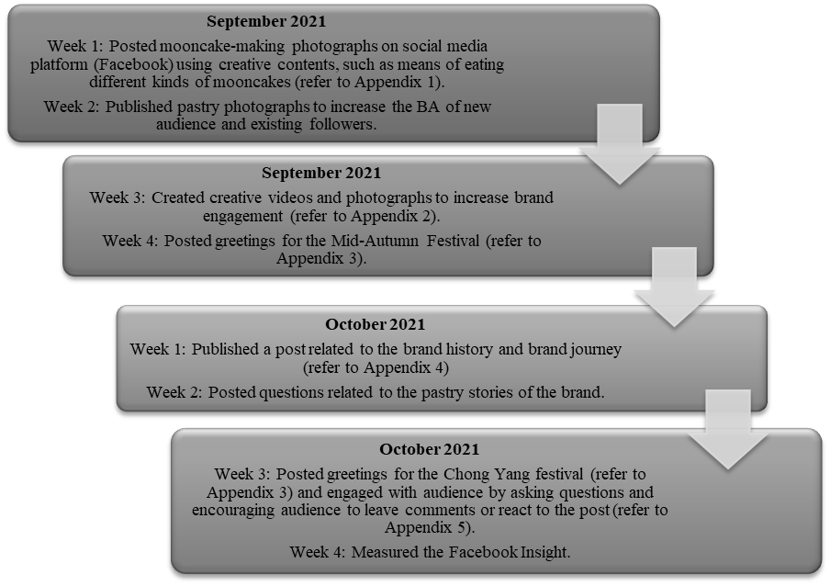
Figure 2. Marketing strategies on the Facebook page of the traditional Chinese pastry shop (source: authors)

4.8 Impact of Marketing Strategies on the Pastry Shop
Figure 3 illustrates the achievement of the marketing strategies implemented on the Facebook page of the traditional Chinese pastry shop within two months, where page followers, engagement, and reach were successfully increased. For example, the audience and followers actively participated in the social media of the pastry shop by commenting on its posts as demonstrated in Appendix 5. Thus, the company page engagement increased significantly from 693 interactions in September 2021 to 802 interactions in October 2021. Moreover, videos and attractive photographs boosted the page reach of the pastry shop from 16,752 views in September 2021 to 21,282 views in October 2021. Most of the audience and followers liked the informative content and shared it with others, hence helping the brand reach a wider audience at a lower cost. In addition, the sharing helped build the BI and BA of the pastry shop by reaching more Facebook users who were unfamiliar with the brand. Furthermore, page followers increased substantially from 695 in September 2021 to 777 in October 2021.
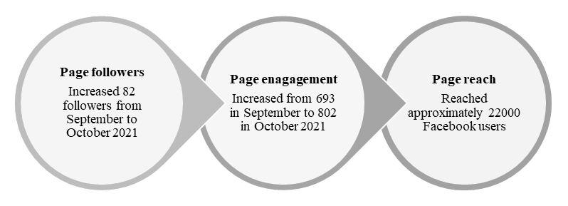
Figure 3. Impact of marketing intervention on the traditional Chinese pastry shop (source: authors)
5. DISCUSSION
5.1 What Factors Influenced the BA and BI of a Pastry Shop?
The findings indicated that SMI had a significant positive relationship with CBE and CBE was positively related to BA and BI. The three hypotheses were supported in this study as the p-value was < 0.05. The H1 was supported and agreed with previous studies [36, 37, 110]. Hanna et al. [110], Kietzmann et al. [111], and Leung et al. [112] reported that social media was essential for online interaction and engagement, which changed the communication method between brands and consumers. In this study, the pastry shop was encouraged to use Facebook as an important social medium to reach its target market by increasing interactions for brand engagement.
The findings also demonstrated that CBE was effective in increasing BA and BI. The results corresponded with those of Keller [43], Langaro et al. [13], Nurfitriana et al. [119], and Islam and Rahman [97]. In this study, it was vital for the shop to increase its brand engagement with its Facebook followers for brand-building, including BA and BI. Overall, traditional pastry shops displayed a higher degree of brand engagement by interacting with Facebook users and customers to build BA and BI during the COVID-19 crisis.
5.2 What SMM Strategies Increased the BA and BI of the Pastry Shop?
The SMM strategies of Facebook interactions and brand engagement were implemented to improve the BA and BI of the traditional Chinese pastry shop. The activities on a Facebook brand page can have a huge impact on engagement. For example, users who Like, comment, and share a brand post demonstrate two-way interaction between users and the brand. To engage customers, brands must post content that meets customers’ demands so that customers click the Like button or react to the brand message. A post that receives more Likes has more page marketing value [109]. Therefore, the pastry shop engaged Facebook users, such as by posting attractive photographs and videos of various pastries. Furthermore, users or customers were engaged via creative content that included videos of different mooncakes being eaten and conveying wishes for the Mid-Autumn Festival and Chong Yang Festival.
The social media strategy of publishing a post related to the brand history and journey of the pastry shop engaged the audience by asking questions and encouraging them to leave comments or react to the post. As demonstrated in Appendixes 1–5, the pastry shop successfully used SMM strategies with attractive weekly content to engage its audience during the pandemic. The findings aligned with those of Alhaddad [138], who reported that varied content, such as links, videos, and photographs, was significant for increasing BA and BI. Briefly, a brand may become memorable via abundant content and constant and regular posting.
5.3 Were the SMM strategies effective in increasing the pastry shop BA and BI?
The SMM strategies significantly increased the Facebook followers, reach, and engagement of the pastry shop from September to October 2021. Within the two months, followers of the pastry shop increased by 82, page engagement increased from 693 to 802 interactions, and the page reached approximately 22,000 Facebook users. The pastry shop had a wider audience reach and many Facebook users knew about the brand, which enhanced page interaction and engagement. Moreover, consistently publishing posts led to higher engagement between users and the brand. The greatest form of engagement the shop received was the numerous feedback, which could be used to improve its products and business. The increased number of followers enhanced the brand popularity of the pastry shop. Consequently, customer engagement on social media was valuable for enhancing more sharing about the brand with other users and potential customers. Therefore, the implemented marketing strategies were effective in increasing the BA and BI of the traditional Chinese pastry shop during the pandemic.
6. STUDY LIMITATIONS AND RECOMMENDATIONS FOR FUTURE STUDIES
The results demonstrated that there were positive significant relationships between SMI, CBE, BA, and BI. The study provided an opportunity for further empirical investigation of the effectiveness of social media strategies in increasing BA and BI. The findings add to the existing literature by confirming the relationships in the context of traditional Chinese pastry shops. The findings were supported by Cheung et al. [37] highlighting that SMI may aid the development of strong positive brand knowledge in customers’ minds.
The results demonstrated that SMI influenced CBE, which in turn increased BA and BI. The findings provided a guideline to marketers to post more attractive content to generate higher interactive relationships with consumers. Moreover, marketers may consider establishing and positioning their brand through highly interactive and active use of their social media brand pages. To improve brand page interactivity, marketers can engage with users by asking questions and encouraging them to leave comments or react to the brand post.
The implemented marketing strategies were effective of increasing the BA and BI of the pastry shop. Companies can increase their BA and BI by utilizing SMI for higher brand engagement. The SMI is significant for motivating consumers to interact for the growth of good brand engagement. Thus, social media aids the brand in reaching a larger audience at a lower cost.
This study had several limitations. First, the results had limited generalizability. Although the sample size met the minimum requirement of 165, the results were not generalized to the population as the small sample size was unable to represent all individuals who used social media platforms for interaction to buy pastry products in Malaysia. Therefore, it is recommended that future studies increase the sample size and use probability sampling approaches, such as simple random sampling, to achieve more generalized results. Second, the study was limited geographically, where data were collected from only Malaysian respondents. Hence, it is recommended that future studies collect data from several countries and compare countries as respondents from different countries might have different brand interactions and engagement.
Third, the study only focused on pastry shops, which limited the findings for other businesses. Therefore, future studies should involve several businesses, such as those in the fashion, beauty, and education industries, to investigate the relationships between SMI, CBE, BA, and BI for marketing interventions. Lastly, the survey was disseminated via Google Forms. Although it is easy to collect data via online surveys, the method has several drawbacks, such as low reliability, questions being misunderstood, and internet issues. Therefore, it is recommended that future studies use varied research methods, such as face-to-face interviews, for data collection and in-depth findings.
7. CONCLUSION
The findings demonstrated that SMI had a strong impact on CBE during the COVID-19 pandemic while CBE had a positive significant relationship with BA and BI. The results are significant where the implemented marketing strategies on the Facebook page of the traditional Chinese pastry shop increased the pastry shop BA and BI within two months. Furthermore, the findings can aid traditional Chinese pastry shops and other businesses in designing long-term social media and branding strategies to connect with their consumers for better BA and BI during the pandemic. The SMI was the best-implemented strategy for developing brand engagement, which built the BA and BI of the traditional Chinese pastry shop and other relevant businesses.
The findings support the current SMM strategies of meeting consumers’ preferences for online shopping and the preferences of those who prefer physical shopping but are required to adopt online channels as the possibility of visiting physical stores is limited due to COVID-19 restrictions. This study provided appropriate guidelines for marketers to adjust and implement the best social media strategies for their company. It is recommended that marketers and businesses social media to communicate information about their brand and build a relationship with their audience. These insights are also relevant for other stakeholders, such as influencers and governmental parties, as they can assist businesses in using the possibilities of social media optimally and benefiting from it.
The results demonstrated that social media is one of the most essential platforms for delivering brand information and building customer engagement for increased BA and BI. Therefore, future researchers could plan marketing interventions by actively interacting with their audiences and posting creative and attractive content for them to Like, comment, and share with others.
8. REFERENCES
[1] B. Berman, J. Evans, and P. Chatterjee, Retail Management: A Strategic Approach, 13th ed., Pearson Education Limited, 2017.
[2] L. Evans, and R. Kitchin, “A smart place to work? Big data systems, labour, control and modern retail stores,” New Technology, Work and Employment, vol. 33, no. 1, pp. 44–57, 2018.
[3] C. Jingyi. (2021, Nov. 11). Double 11 sales maintain momentum, as industry overhaul shows effect. Global Times [Online]. Available: https://www.globaltimes.cn/page/202111/1238773.shtml
[4] V. Arya, D. Sethi, and J. Paul, “Does digital footprint act as a digital asset? – Enhancing brand experience through remarketing,” International Journal of Information Management, vol. 49, no. December 2018, pp. 142–156, 2019.
[5] M. Nicola et al., “The socio-economic implications of the coronavirus pandemic (COVID-19): A review,” International Journal of Surgery, vol. 78, no. March, pp. 185–193, 2020.
[6] C. Bradbury-Jones, and L. Isham, “The pandemic paradox: The consequences of COVID-19 on domestic violence,” Journal of Clinical Nursing, vol. 29, no. 13–14, pp. 2047-2049, 2020.
[7] M. W. Hasanat, A. Hoque, F. A. Shikha, M. Anwar, A. B. A. Hamid, and H. H. Tat, “The impact of coronavirus (Covid-19) on e-business in Malaysia,” Asian Journal of Multidisciplinary Studies, vol. 3, no. 1, pp. 85–90, 2020.
[8] V. Ganesan. (2021, Oct. 20). Malaysia e-shopping king of the region, 9 out of 10 online by end-2021. The Edge Markets [Online]. Available: https://www.theedgemarkets.com/article/malaysia-eshopping-king-region-9-out-10-online-end2021
[9] A. J. Kim, and E. Ko, “Do social media marketing activities enhance customer equity? An empirical study of luxury fashion brand,” Journal of Business Research, vol. 65, no. 10, pp. 1480–1486, 2012.
[10] G. Tsimonis, and S. Dimitriadis, “Brand strategies in social media,” Marketing Intelligence & Planning, vol. 32, no. 3, pp. 328–344, 2014.
[11] B. A. A. Solem, and P. E. Pedersen, “The effects of regulatory fit on customer brand engagement: An experimental study of service brand activities in social media,” Journal of Marketing Management, vol. 32, no. 5–6, pp. 445–468, 2016.
[12] D. E. Schultz, and J. (J). Peltier, “Social media’s slippery slope: challenges, opportunities and future research directions,” Journal of Research in Interactive Marketing, vol. 7, no. 2, pp. 86–99, 2013.
[13] D. Langaro, P. Rita, and M. d. F. Salgueiro, “Do social networking sites contribute for building brands? Evaluating the impact of users’ participation on brand awareness and brand attitude,” Journal of Marketing Communications, vol. 24, no. 2, pp. 146–168, 2018.
[14] A. M. Stelzner. (2014, May). Social media marketing industry report (2014). Social Media Examiner [Online]. Available: http://www.socialmediaexaminer.com/report2014/
[15] E. Prunty. (2021, Nov. 1). Which social media platforms should you use for your business? Digital Marketing Institute [Online]. Available: https://digitalmarketinginstitute.com/blog/which-social-media-platforms-should-you-use-for-your-business.
[16] E. J. Seo, and J-W. Park, “A study on the effects of social media marketing activities on brand equity and customer response in the airline industry,” Journal of Air Transport Management, vol. 66, no. January 2018, pp. 36–41, 2018.
[17] F. Fortezza, and T. Pencarelli, “Potentialities of Web 2.0 and new challenges for destinations: Insights from Italy,” Anatolia, vol. 26, no. 4, pp. 563–573, 2015.
[18] Y. BİLGİN, “The effect of social media marketing activities on brand awareness, brand image and brand loyalty,” Business & Management Studies: An International Journal, vol. 6, no. 1, pp. 128–148, 2018.
[19] J. Sasmita, and N. M. Suki, “Young consumers’ insights on brand equity: Effects of brand association, brand loyalty, brand awareness, and brand image,” International Journal of Retail & Distribution Management, vol. 43, no. 3, pp. 276–292, 2015.
[20] N. d. Vries, and J. Carlson, “Examining the drivers and brand performance implications of customer engagement with brands in the social media environment,” Journal of Brand Management, vol. 21, no. 6, pp. 495–515, 2014.
[21] A. Thoring, “Corporate tweeting: Analysing the use of Twitter as a marketing tool by UK trade publishers,” Publishing Research Quarterly, vol. 27, no. 2, pp. 141–158, 2011.
[22] A. Vuong. (2016, Oct. 18). Customer satisfaction without engagement -- is it enough? Gallup.Com. [Online]. Available: https://news.gallup.com/businessjournal/196517/customer-satisfaction-without-engagement-enough.aspx.
[23] E. Myers. (2022, Dec. 13). Increaseing customer engagement and building brand awareness. WP Engine [Online]. Available: https://wpengine.com/resources/customer-engagement-brand-awareness/
[24] H. Chahal, J. Wirtz, and A. Verma, "Social media brand engagement: Dimensions, drivers and consequences," Journal of Consumer Marketing, vol. 37, no. 2, pp. 191–204, 2020.
[25] M. Jamali, and R. Khan, “The impact of consumer interaction on social media on brand awareness and purchase intention! Case study of Samsung,” Journal of Marketing & Logistics, vol. 1, no. August 2018, pp. 114–129, 2018.
[26] M. Yadav, and Z. Rahman, “Measuring consumer perception of social media marketing activities in e-commerce industry: Scale development & validation,” Telematics and Informatics, vol. 34, no. 7, pp. 1294–1307, 2017.
[27] J. Su, “Examining the relationships among the brand equity dimensions: Empirical evidence from fast fashion,” Asia Pacific Journal of Marketing and Logistics, vol. 28, no. 3, pp. 464–480, 2016.
[28] K. Melati, and F. STPBI, “The effect of social media on the brand awareness at hotels in Kuta area,” Journal of Business on Hospitality and Tourism, vol. 2, no. 1, pp. 474–482.
[29] L. Sanny, A. N. Arina, R. T. Maulidya, and R. P. Pertiwi, “Purchase intention on Indonesia male’s skin care by social media marketing effect towards brand image and brand trust,” Management Science Letters, vol. 10, pp. 2139–2146, 2020.
[30] L. Cui, H. Jiang, H. Deng, and T. Zhang, “The influence of the diffusion of food safety information through social media on consumers’ purchase intentions: An empirical study in China,” Data Technologies and Applications, vol. 53, no. 2, pp. 230–248, 2019.
[31] C. Valentini, S. Romenti, G. Murtarelli, and M. Pizzetti, “Digital visual engagement: Influencing purchase intentions on Instagram,” Journal of Communication Management, vol. 22, no. 4, pp. 362–381, 2018.
[32] U. Chakraborty, “The impact of source credible online reviews on purchase intention: The mediating roles of brand equity dimensions,” Journal of Research in Interactive Marketing, vol. 13, no. 2, pp. 142–161, 2019.
[33] K. Hutter, J. Hautz, S. Dennhardt, and J. Füller, “The impact of user interactions in social media on brand awareness and purchase intention: The case of MINI on Facebook,” Journal of Product & Brand Management, vol. 22, no. 5, pp. 342–351, 2013.
[34] S. Shojaee, and A. b. Azman, “An evaluation of factors affecting brand awareness in the context of social media in Malaysia,” Asian Social Science, vol. 9, no. 17, pp. 72–78, 2013.
[35] A. A. Razak, and M. F. Shamsudin, J. R. M. A. Aziz “The influence of atmospheric experience on theme park tourist’s satisfaction and loyalty in Malaysia,” International Journal of Innovation, Creativity and Change, vol. 6, no. 9, pp. 10–20, 2019.
[36] A. R. Ismail, “The influence of perceived social media marketing activities on brand loyalty: The mediation effect of brand and value consciousness,” Asia Pacific Journal of Marketing and Logistics, vol. 29, no. 1, pp. 129–144, 2017.
[37] M. L. Cheung, G. Pires, and P. J. Rosenberger, “The influence of perceived social media marketing elements on consumer–brand engagement and brand knowledge,” Asia Pacific Journal of Marketing and Logistics, vol. 32, no. 3, pp. 695–720, 2020.
[38] L. Dessart, C. Veloutsou, and A. Morgan-Thomas, “Capturing consumer engagement: Duality, dimensionality and measurement,” Journal of Marketing Management, vol. 32, no. 5–6, pp. 399–426, 2016.
[39] A. ekhveh, and Z. A. Darvishi, “The impact of brand awareness on re-purchase intention of customers with trilogy of emotions approach (case study for cell phones),” Applied Mathematics in Engineering, Management and Technology, vol. 3, no. 4, pp. 25–30, 2015.
[40] B. Bilgili, and E. Ozkul, “Brand awareness, brand personality, brand loyalty and consumer satisfaction relations in brand positioning strategies (a Torku brand sample),” Journal of Global Strategic Management, vol. 2, no. 9, pp. 89–89, 2015.
[41] Z. Shahid, T. Hussain, and F. aZafar, “The impact of brand awareness on the consumers’ purchase intention,” Journal of Marketing and Consumer Research, vol. 33, pp. 34–38, 2017.
[42] S. (S.) Kim, J. Y. (J.) Choe, and J. F. Petrick, “The effect of celebrity on brand awareness, perceived quality, brand image, brand loyalty, and destination attachment to a literary festival,” Journal of Destination Marketing & Management, vol. 9, pp. 320–329, 2018.
[43] K. L. Keller, Strategic Brand Management: Building, Measuring, and Managing Brand Equity, 4th ed., Prentice-Hall, London, 2013.
[44] H. Datta, K. L. Ailawadi, and H. J. v. Heerde, “How well does consumer-based brand equity align with sales-based brand equity and marketing mix response? Journal of Marketing, pp. 1–52, 2017.
[45] D. Aaker, Aaker on Branding, SAGE Publications, 2015.
[46] X. Zhang, “The influences of brand awareness on consumers’ cognitive process: An event-related potentials study,” Frontiers in Neuroscience, vol. 14, no. June, pp. 1–7, 2020.
[47] T. Nurhayati, and H. Hendar, “Personal intrinsic religiosity and product knowledge on halal product purchase intention: Role of halal product awareness,” Journal of Islamic Marketing, vol. 11, no. 3, pp. 603–620, 2020.
[48] P. Foroudi, S. Gupta, P. Kitchen, M. M. Foroudi, and B. Nguyen, “A framework of place branding, place image, and place reputation: Antecedents and moderators,” Qualitative Market Research: An International Journal, vol. 19, no. 2, pp. 241–264, 2016.
[49] R. G. Duffett, “Influence of social media marketing communications on young consumers’ attitudes,” Young Consumers, vol. 18, no. 1, pp. 19–39, 2017.
[50] I. Buil, L. de Chernatony, and E. Martínez, “Examining the role of advertising and sales promotions in brand equity creation,” Journal of Business Research, vol. 66, no. 1, pp. 115–122, 2013.
[51] N. Rubio, J. Oubiña, and N. Villaseñor, “Brand awareness-Brand quality inference and consumer’s risk perception in store brands of food products,” Food Quality and Preference, vol. 32, no. PC, pp. 289–298, 2014.
[52] C. Nguyen, and D. Nguyen, “A study of factors affecting brand awareness in the context of viral marketing in Vietnam,” International Journal of Advanced Science and Technology, vol. 29, no. 5, pp. 5401–5411, 2020.
[53] P. Foroudi, T. C. Melewar, and S. Gupta, “Linking corporate logo, corporate image, and reputation: An examination of consumer perceptions in the financial setting,” Journal of Business Research, vol. 67, no. 11, pp. 2269–2281, 2014.
[54] V. Rrustemi, and G. Baca, “The impact of social media activities on raising brand awareness during the Covid-19 pandemic: The case of fashion industry in Kosovo,” Journal of Contemporary Management Issue, vol. 26, no. 2, pp. 295–310, 2021.
[55] N. Wilson, and K. Keni, “Pengaruh website design quality dan kualitas jasa terhadap repurchase intention: Variabel trust sebagai variabel mediasi,” Jurnal Manajemen dan Pemasaran Jasa, vol. 11, no. 2, p. 291–310, 2018.
[56] N. Wilson, and S. T. Makmud, “Case study of the Indonesian smartphone industry,” Jurnal Muara Ilmu Sosial, Humaniora, dan Seni, vol. 2, no. 2, pp. 633–649, 2018.
[57] M. A. P. Ambolau, A. Kusumawati, and M. K. Mawardi, “The influence of brand awareness and brand image on purchase decision (Study on Aqua consumers in Administrative Science Faculty Brawijaya University class of 2013),” Jurnal Administrasi Bisnis, vol. 2, no. 2, pp. 1–8, 2015.
[58] H. Saleem, and N. S. Raja, “The impact of service quality on customer satisfaction, customer loyalty and brand image: Evidence from hotel industry of Pakistan,” Middle East Journal of Scientific Research, vol. 19, no. 5, pp. 706–711, 2014.
[59] Y. Zhang, “The impact of brand image on consumer behavior: a literature review,” Open Journal of Business and Management, vol 03, no. 01, pp 58–62, 2015.
[60] A. A. Barreda, A. Bilgihan, K. Nusair, and F. Okumus, “Generating brand awareness in online social networks,” Computers in Human Behavior, vol. 50, pp. 600–609, 2015.
[61] J. Egan, Marketing Communications, 2nd ed., SAGE Publications, 2015.
[62] S. Riyadi, “Influence between banking service quality and brand image against customer relationship and loyalty in sharia bank,” European Research Studies Journal, vol. 0(3), pp. 322–342, 2019.
[63] F. M. Arslan, and O. K. Altuna, “The effect of brand extensions on product brand image,” Journal of Product & Brand Management, vol. 19, no. 4, pp. 170–180, 2010.
[64] A. A. Barreda, K. Nusair, Y. Wang, F. Okumus, and A. Bilgihan, “The impact of social media activities on brand image and emotional attachment: A case in the travel context,” Journal of Hospitality and Tourism Technology, vol. 11, no. 1, pp. 109–135, 2020.
[65] I. G. A. W. Diputra, and N. N. Yasa, “The influence of product quality, brand image, brand trust on customer satisfaction and loyalty,” American International Journal of Business Management, vol. 4, no. 1, pp. 25–34, 2021.
[66] R. B. Kim, and Y. Chao, “Effects of brand experience, brand image and brand trust on brand building process: The case of Chinese millennial generation consumers,” Journal of International Studies, vol. 12, no. 3, pp. 9–21, 2019.
[67] H. Kaur, and K. Kaur, “Connecting the dots between brand logo and brand image,” Asia-Pacific Journal of Business Administration, vol. 11, no. 1, pp. 68–87, 2019.
[68] H. He, W. Zhu, D. Gouran, and O. Kolo, “Moral identity centrality and cause-related marketing: The moderating effects of brand social responsibility image and emotional brand attachment,” European Journal of Marketing, vol. 50, no. 1/2, pp. 236–259, 2016.
[69] H. Park, and S. Park, “The effect of emotional image on customer attitude,” The Journal of Asian Finance, Economics and Business, vol. 6, no. 3, pp. 259–268, 2019.
[70] H. O. ElAydi, “The effect of social media marketing on brand awareness through Facebook: An individual-based perspective of mobile services sector in Egypt,” Open Access Library Journal, vol. 5, no. 10, pp. 1-13, 2018.
[71] E. Erida, and A. S. Rangkuti, “The effect of brand image, product knowledge and product quality on purchase intention of notebook with discount price as moderating variable,” Journal of Business Studies and Management Review, vol. 1, no. 1, pp. 26–32, 2017.
[72] Q. Gao, and C. Feng, “Branding with social media: User gratifications, usage patterns, and brand message content strategies,” Computers in Human Behavior, vol. 63, pp. 868–890, 2016.
[73] I. N. Nurfarida, and S. Sudarmiatin, “Use of social media marketing in SMEs: Driving factors and impacts,” Management and Entrepreneurship: Trends of Development, vol. 2, no. 16, pp. 70–81, 2021.
[74] S. Nagpal, and G. Gupta, “Impact of pandemic communication on brand-specific outcomes: Testing the moderating role of brand attitude and product category,” Journal of Creative Communications, pp. 1-17, 2021.
[75] F. A. Buttle, and S. Maklan, Customer Relationship Management: Concepts and Technologies, 3rd ed., Routledge, 2015.
[76] D. Chaffey, Digital Business and E-Commerce Management: Strategy, Implementation and Practice, Pearson Education Limited, 2015.
[77] M. Magasic, “Touristic consumption as “sitesharing”: Unpacking the smart tourism paradigm from an internet studies perspective,” In book: Information and Communication Technologies in Tourism, 2016.
[78] S. V. Jin, A. Muqaddam, and E. Ryu, “Instafamous and social media influencer marketing,” Marketing Intelligence & Planning, vol. 37, no. 5, pp. 567–579, 2019.
[79] N. L. Chan, and B. D. Guillet, “Investigation of social media marketing: How does the hotel industry in Hong Kong perform in marketing on social media websites?” Journal of Travel & Tourism Marketing, vol. 28, no. 4, pp. 345–368, 2011.
[80] H. Wang, “Six P’s of youth social media from a young consumer’s perspective,” Young Consumers, vol. 13, no. 3, pp. 303–317, 2012.
[81] R. Masa’deh, S. AL-Haddad, D. A. Abed, H. Khalil, L. AlMomani, and T. Khirfan, “The impact of social media activities on brand equity,” Information, vol, 12, vol. 477, pp. 1–17, 2021.
[82] A. Sarner. (2013, Jan. 15). Social marketing in 2013. Gartner [Online]. Available: https://blogs.gartner.com/adam-sarner/2013/01/15/social-marketing-in-2013/
[83] L. Dessart, C. Veloutsou, and A. Morgan-Thomas, "Consumer engagement in online brand communities: A social media perspective", Journal of Product & Brand Management, vol. 24, no. 1, pp. 28–42, 2015.
[84] E. Fischer, and A. R. Reuber, “Social interaction via new social media: (How) can interactions on Twitter affect effectual thinking and behavior?” Journal of Business Venturing, vol. 26, no. 1, pp. 1–18, 2011.
[85] N. Hajli, “Social commerce constructs and consumer’s intention to buy,” International Journal of Information Management, vol. 35, no. 2, pp. 183–191, 2015.
[86] T. Vukasovič, “Building successful brand by using social networking media,” Journal of Media and Communication Studies, vol. 5, no. 6, pp. 56–63, 2013.
[87] S. I. Dubbelink, C. Herrando, and E. Constantinides, “Social media marketing as a branding strategy in extraordinary times: Lessons from the COVID-19 pandemic,” Sustainability, vol. 13, pp. 1–21, 2021.
[88] A. N. Mason, J. Narcum, and K. Mason, “Social media marketing gains importance after Covid-19,” Cogent Business & Management, vol. 8, no. 1, pp. 1–17.
[89] J. Yu, D. Moran, and L. C. Sanjaya, “Customer brand engagement as a new component of service value and supply chain in the social media age,” DEStech Transactions on Computer Science and Engineering, pp. 374–380, 2018.
[90] C. France, B. Merrilees, and D. Miller, “An integrated model of customer-brand engagement: Drivers and consequences,” Journal of Brand Management, vol. 23, no. 2, pp. 119–136, 2016.
[91] L. D. Hollebeek, M. S. Glynn, and R. J. Brodie, “Consumer brand engagement in social media: Conceptualization, scale development and validation,” Journal of Interactive Marketing, vol. 28, no. 2, pp. 149–165, 2014.
[92] V. Kumar, B. Rajan, S. Gupta, and I. D. Pozza, “Customer engagement in service,” Journal of the Academy of Marketing Science, vol. 47, no. 1, pp. 138–160, 2019.
[93] A. Dwivedi, “A higher-order model of consumer brand engagement and its impact on loyalty intentions,” Journal of Retailing and Consumer Services, vol. 24, no. C, pp. 100–109, 2015.
[94] C. Prentice, X. Wang, and S. M. C. Loureiro, “The influence of brand experience and service quality on customer engagement,” Journal of Retailing and Consumer Services, vol. 50, pp. 50–59, 2019.
[95] V. M. Lima, H. A. R. Irigaray, and C. Lourenco, “Consumer engagement on social media: Insights from a virtual brand community,” Qualitative Market Research, vol. 22, no. 1, pp. 14–32, 2019.
[96] C. Leckie, M. W. Nyadzayo, and L. W. Johnson, “Antecedents of consumer brand engagement and brand loyalty,” Journal of Marketing Management, vol. 32, no. 5–6, pp. 558–578, 2016.
[97] J. U. Islam, and Z. Rahman, “The transpiring journey of customer engagement research in marketing: A systematic review of the past decade,” Management Decision, vol. 54, no. 8, pp. 2008–2034, 2016.
[98] V. Kumar, and A. Pansari, “Competitive advantage through engagement,” Journal of Marketing Research, vol. 53, no. 4, pp. 497–514, 2016.
[99] A. S. Oertzen, G. Odekerken-Schröder, and B. Mager, “Driving users’ behaviours and engagement in co-creating services,” Journal of Services Marketing, vol. 34, no. 4, pp. 549–573, 2020.
[100] M. K. Clark, C. R. Lages, and L. D. Hollebeek, “Friend or foe? Customer engagement’s value-based effects on fellow customers and the firm,” Journal of Business Research, vol. 121, pp. 549-556, 2020.
[101] İ. Kırcova, Y. Yaman, and Ş. G. Köse, “Instagram, Facebook or Twitter: Which engages best? A comparative study of consumer brand engagement and social commerce purchase intention,” European Journal of Economics and Business Studies, vol. 10, pp. 279–289, 2018.
[102] K. P. W. D. R. Weerasinghe, “Impact of content marketing towards the customer online engagement,” International Journal of Business, Economics and Management, vol. 2, no. 3, pp. 217–224, 2019.
[103] I. Khan, Z. Rahman, and M. Fatma, “The role of customer brand engagement and brand experience in online banking,” International Journal of Bank Marketing, vol. 34, no. 7, pp. 1025–1041, 2016.
[104] W. Yuniari, N. N. K. Yasa, and K. Giantari, “The role of customer brand engagement and affective brand commitment in mediating the relationship between value congruity and brand loyalty,” Journal of Advanced Research in Dynamical and Control Systems, vol. 12, no. SP4, pp. 1963–1973, 2020.
[105] J. Hepola, H. Karjaluoto, and A. Hintikka, “The effect of sensory brand experience and involvement on brand equity directly and indirectly through consumer brand engagement,” Journal of Product & Brand Management, vol. 26, no. 3, pp. 282–293, 2017.
[106] S. B. M. Situmorang, and D. T. H. Aruan, “The role of customer brand engagement on brand loyalty in the usage of virtual hotel operator,” Proceedings of the International Conference on Business and Engineering Management (ICONBEM 2021), vol. 177, pp. 101–109, 2021.
[107] V. Barger, J. W. Peltier, and D. E. Schultz, “Social media and consumer engagement: a review and research agenda,” Journal of Research in Interactive Marketing, vol. 10, no. 4, pp. 268–287, 2016.
[108] S. Santos, P. E. Santo, and L. Augusto, “The role of customer engagement in the COVID-19 era,” Chapter 5: Insights, Innovation, and Analytics for Optimal Customer Engagement, pp.91–116, 2021.
[109] S. Jayasingh, and R. Venkatesh, “Customer engagement factors in Facebook brand pages,” Asian Social Science, vol. 11, no. 26, pp. 19–29, 2015.
[110] R. Hanna, A. Rohm, and V. L. Crittenden, “We’re all connected: The power of the social media ecosystem,” Business Horizons, vol. 54, no. 3, pp. 265–273, 2011.
[111] J. H. Kietzmann, K. Hermkens, I. P. McCarthy, and B. S. Silvestre, “Social media? Get serious! Understanding the functional building blocks of social media,” Business Horizons, vol. 54, no. 3, pp. 241–251, 2011.
[112] X. Y. Leung, B. Bai, and M. Erdem, “Hotel social media marketing: A study on message strategy and its effectiveness,” Journal of Hospitality and Tourism Technology, vol. 8, no. 2, pp. 239–255, 2017.
[113] S. Bitter, and S. Grabner-Kräuter, “Customer engagement behavior: Interacting with companies and brands on Facebook,” Advances in Advertising Research, vol. IV, pp. 3–17, 2013.
[114] B. Schivinski, and D. Dabrowski, “The impact of brand communication on brand equity through Facebook,” Journal of Research in Interactive Marketing, vol. 9, no. 1, pp. 31–53, 2015.
[115] N. Xi, and J. Hamari, “The relationship between gamification, brand engagement and brand equity,” The 52nd Hawaii International Conference on System Sciences, pp. 812–821, 2019.
[116] P. Vanitha, and S. Subramanian, “A study on brand awareness and customer engagement,” Indian Journal of Public Health Research & Development, vol. 11, no. 03, pp. 258–262, 2020.
[117] L. R. Men, and W-H. S. Tsai, “Public engagement with CEOs on social media: Motivations and relational outcomes,” Public Relations Review, vol. 42, no. 5, pp. 932–942, 2016.
[118] J. U. Islam, Z. Rahman, and L. D. Hollebeek, “Consumer engagement in online brand communities: A solicitation of congruity theory,” Internet Research, vol. 28, no. 1, pp. 23–45, 2018.
[119] R. Nurfitriana, S. Surachman, and A. S. Hussein, “The influence of brand image and brand love on customer loyalty mediated by customer engagement: Study on consumers of Wardah cosmetics,” Management and Economics Journal, vol. 4, no. 2, pp. 105–116, 2020.
[120] I. Akhtar, In book: Research in Social Science: Interdisciplinary Perspectives (pp.17), Research Design Publisher: Social research foundation, Kanpur, India, 2016.
[121] R. Ahuja, Research Methodology, New Delhi: Rawat Publication, 2010.
[122] N. Malhotra, J. Hall, M. Shaw, and P. Oppenheim, Marketing Research: An Applied Orientation, Pearson Education Australia, 2006.
[123] N. Malhotra, Basic Marketing Research: A Decision-Making Approach, 3rd. ed., New Jersey: Pearson Addison Wesley, 2009.
[124] N. Krieger, “Who and what is a ‘population’? Historical debates, current controversies, and implications for understanding ‘population health’ and rectifying health inequities,” Milbank Quarterly, vol. 90, no. 4, pp. 634–681, 2012.
[125] D. D. Suhr, Exploratory or Confirmatory Factor Analysis, SAS Institute Cary, 2006.
[126] H. Taherdoost, “Sampling methods in research methodology; how to choose a sampling technique for research,” International Journal of Academic Research in Management, vol. 5, no. 2, pp. 18–27, 2016.
[127] B. Thomas. (2020, Jul. 19). Outlier analysis: definition, techniques, how-to, and more. PESTLE Analysis [Online]. Available: https://pestleanalysis.com/outlier-analysis/
[128] D. J. Denis, SPSS Data Analysis for Univariate, Bivariate, and Multivariate Statistics, Wiley, 2018.
[129] F. ORCAN, “Parametric or non-parametric: Skewness to test normality for mean comparison,” International Journal of Assessment Tools in Education, vol. 7, no. 2, pp. 236–246, 2020.
[130] D. George, SPSS for Windows Step by Step: A Simple Study Guide and Reference, 17.0 update, 10 ed., Pearson Education India, 2011.
[131] F. Middleton. (2019, Jul. 3). Reliability vs validity: what’s the difference? Scribbr [Online]. Available: https://www.scribbr.com/methodology/reliability-vs-validity/
[132]K. S. Taber, “The use of Cronbach’s alpha when developing and reporting research instruments in science education,” Research in Science Education, vol. 48, no. 6, pp. 1273–1296, 2018.
[133]A. C. Rencher, and G. B. Schaalje, Linear Models in Statistics, 2nd ed., John Wiley & Sons, Inc., 2008.
[134] E. Marshall. (2020). Simple linear regression in SPSS. Statstutor Community Project [Online]. Available: https://www.statstutor.ac.uk/
[135] I. Hidayanti, L. E. Herman, and N. Farida, “Engaging customers through social media to improve industrial product development: the role of customer co-creation value,” Journal of Relationship Marketing, vol. 17, no. 1, pp. 17–28, 2018.
[136] K. French. (2021). How to Tell Your Brand Story (Plus Awesome Examples). Column FIVE [Online]. Available: https://www.columnfivemedia.com/how-to-tell-a-brand-story/
[137] P. Puro, “Content marketing and the significance of corporate branding,” Master Thesis, Lappeenranta: Lappeenranta University of Technology, 2013.
[138] A. A. Alhaddad, “The effect of advertising awareness on brand equity in social media,” International Journal of e-Education, e-Business, e-Management and e-Learning, vol. 5, no. 2, p. 73–84, 2015.
APPENDIX
Appendix 1 | 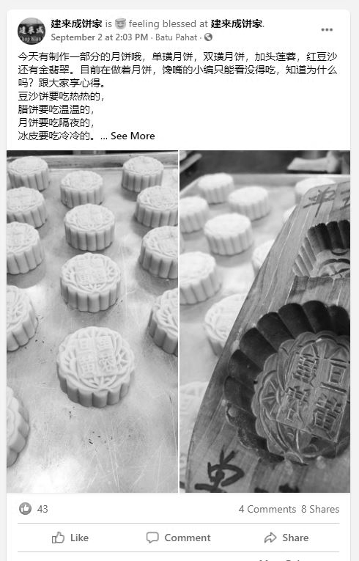 | 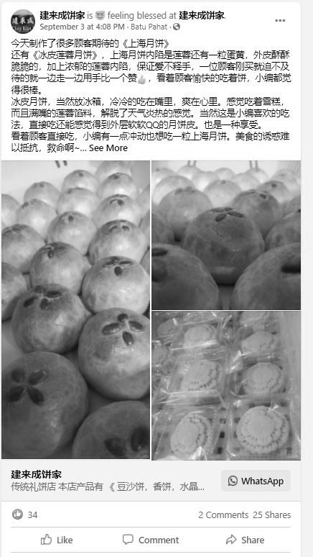
Appendix 2 | 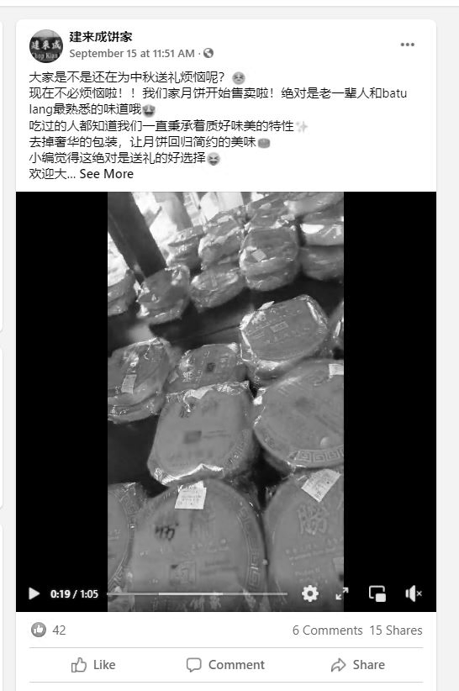 | 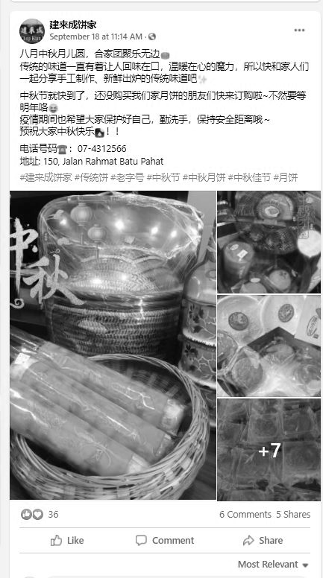

Appendix 3 | 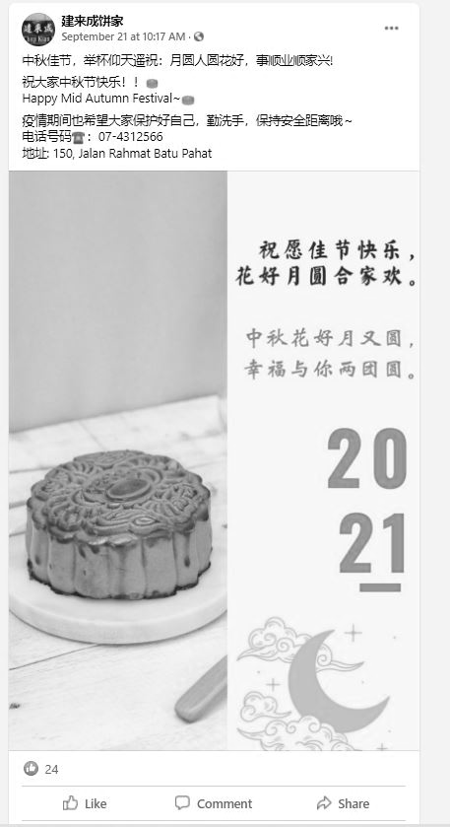 | 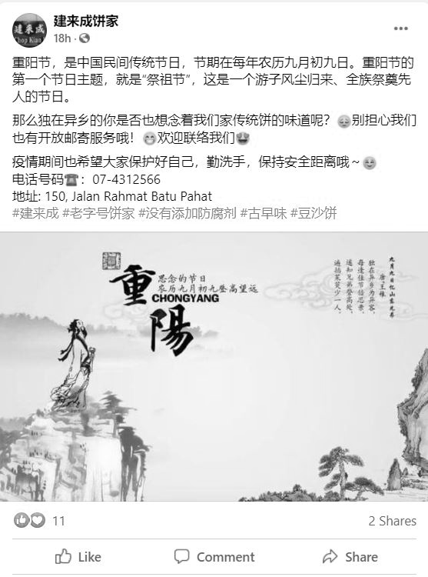
Appendix 4 | 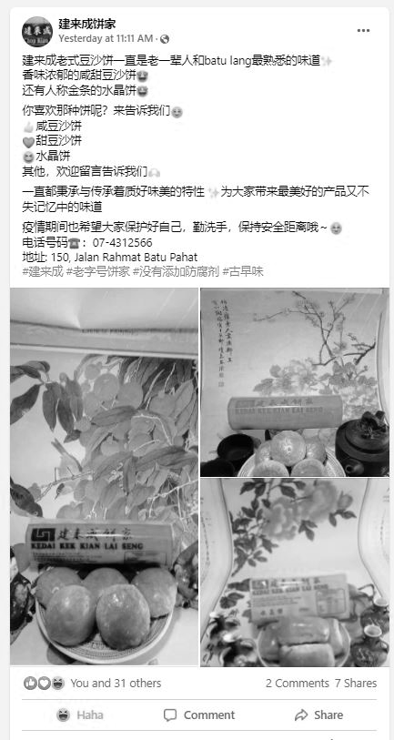 | 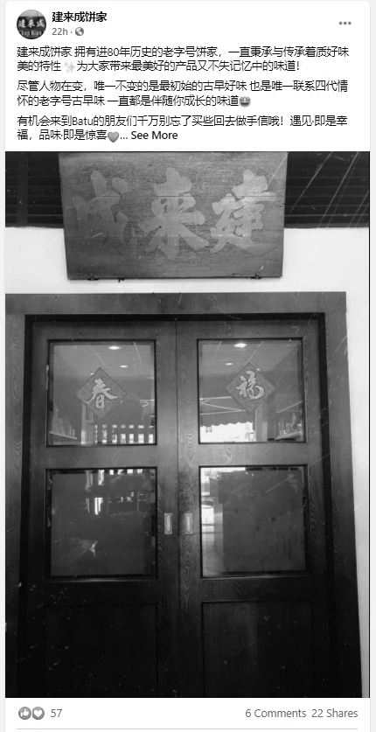

Appendix 5 | 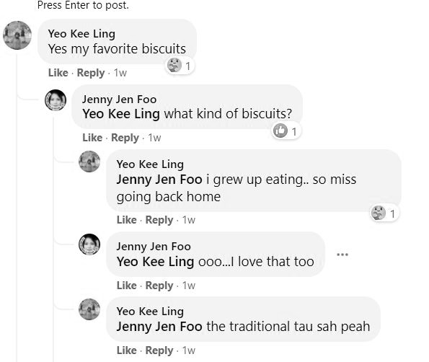 | 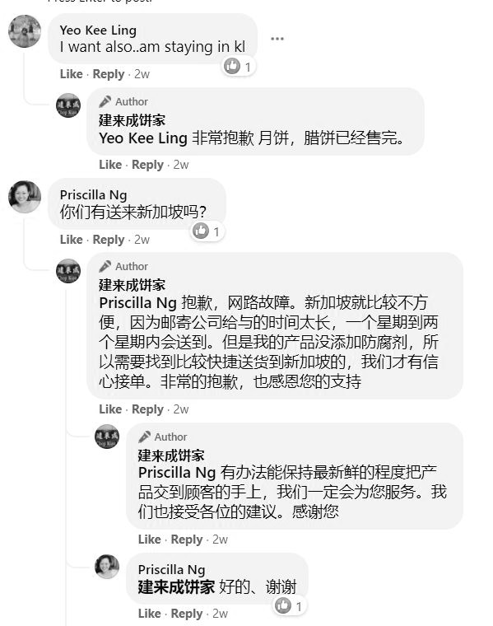
Appendix 5 | 

