The Identification and Prioritization of Success Factors for Online Egyptian Fashion Retailers Using the Analytic Hierarchy Process
Shereen Morsi
Arab Academy for Science, Technology & Maritime Transport
Shereen_morsi@aast.edu

ABSTRACT
The rapid changes in the behavior of Egyptian online consumers, influenced by the increasing adoption of e-commerce since the COVID-19 pandemic, especially shopping for apparel online, have made it essential for online fashion retailers to identify criteria that are crucial for their growth. This research attempts to discover the main factors and sub-factors that influence consumers' preference for online fashion e-stores. The analytic hierarchy process (AHP) methodology was used to determine the criteria along with their weights and priorities. The study began by conducting a thorough literature review in electronic retail to identify the significant elements (keys) mentioned in earlier studies. Based on these studies, as well as input from Egyptian experts in the online fashion field, five main factors, and twenty sub-factors were identified. The AHP results revealed that "website design" is the most influential factor on consumers, particularly in terms of navigation and responsiveness. Website facilities ranked second in priority, with multi-payment methods and search engine as sub-factors. The third most important factor was post-order services, including order tracking and customer support. These results provide significant insights that can be utilized by online fashion retailers to improve their e-store performance by effectively managing their resources based on the relative importance of these factors. Additionally, the findings contribute to the existing literature on factors that influence online consumer preferences, which is limited, particularly in the online fashion field in Egypt.
Keywords: E-Commerce, Online Fashion Retailers, Multi-Criterion Decision Making (MCDM), AHP.
1. INTRODUCTION
Electronic commerce (e-commerce) is defined as the usage of telecommunication networks for buying, selling, or exchanging information between organizations and their external stakeholders [1]. E-commerce takes various forms, including B2C (business to customer, also known as e-retail), B2B (e-commerce between businesses), C2B (e-commerce between customers and businesses), and C2C (e-commerce between customers) [2]. E-commerce is considered a cost-effective way for organizations to communicate with consumers. Consequently, its role has significantly increased in the consumer goods segment, especially in specialized retail [3-4]. Egyptian e-commerce sales have risen from US$3.6 billion in 2018 to US$5.2 billion in 2021. The total volume of the online retail sector was US$2.3 billion in 2020 [5]. Furthermore, internet retail is projected to grow at a compound annual growth rate (CAGR) of 15.7% annually over the next three years [6]. Egyptian e-commerce has experienced significant growth in various regions of the country, driven by improved infrastructure, increasing internet penetration, and a rising number of online shoppers [7-9]. The Coronavirus pandemic further accelerated this trend, as people embraced social distancing measures and increasingly turned to online shopping [10]. In fact, Egyptian online retail is projected to generate US$4.74 billion in 2025 [11].
The online Egyptian fashion retail industry is witnessing significant growth, driven by many factors such as increasing internet penetration and a rising number of online shoppers [7]. With more Egyptian consumers gaining access to the internet and using smartphones, the online fashion retail market has become a lucrative space for businesses to reach and engage with a larger consumer base [8]. In addition, the Coronavirus pandemic further accelerated this trend, as people turned to online shopping due to social distancing measures [10]. According to Statista report [11], the industry's revenue increased by 20% annually from 2017 to 2021. Additionally, during this period, the number of online fashion retailers in Egypt grew from approximately 300 to over 1,000, and it is expected that sales will account for US$2.98 billion in 2025.
Furthermore, the growth in internet penetration and smartphone usage in Egypt has also contributed to increased competition [7, 9]. The online fashion retail market has become a lucrative space for businesses to reach and engage with a larger consumer base, and competition within the industry has intensified as both local and international players recognize the market's potential [12]. Major global fashion e-commerce platforms have expanded their operations in Egypt, competing with well-established local players. This has led to a diverse range of online fashion retailers offering a wide selection of products, competitive prices, and innovative shopping experiences to attract customers.
The widespread acceptance and popularity of online fashion shopping among consumers is evident in the success of Egyptian online fashion retailers, such as Brantu, TFK, DressCode-DC, OPIO, RAFEYA, HK-fashion store, Mystic Evenings, Bespoke Egypt, and Style-Treasure. However, these retailers face fierce competition from international brands like Zara, H&M, Mango, as well as indirect competitors like Amazon, Jumia, and Noon. To stay ahead, online fashion retailers must ensure they provide a superior shopping experience and offer more value propositions than their rivals [12]. For achieving that, online fashion retailers need to identify and prioritize the success factors that align with consumer preferences to enhance customer satisfaction and drive sales. Where identifying and prioritizing these factors helps in tailoring online platforms, ensuring that websites are mobile-friendly, and providing a seamless shopping experience across various devices, product offerings, marketing strategies, and customer service to meet the specific needs and expectations of consumers. In addition, this allows online fashion retailers to stay relevant, attract new customers, and differentiate themselves in a rapidly evolving industry. Given the rapid growth and increasing significance of the online fashion retail sector, there is a need for more academic research to identify the most crucial factors for success and growth in this industry.
Previous research studies have examined various factors essential for the success of online retailers [13-15] and explored the acceptance of online stores [16-19], none have specifically focused on determining the priority of attributes that contribute to the growth and success of the online fashion segment, especially in the Egyptian market. Therefore, this research aims to address this gap. The research problem can be defined as follows: "To identify and prioritize the success factors for Egyptian online fashion retail." The online fashion retail industry presents unique challenges and complexities compared to other sectors of online retail. Customers face obstacles such as the inability to physically see, touch, and try on apparel, which can impede informed decision-making for online shoppers [20].
While previous studies have examined the significance of various attributes in online fashion websites, such as product attributes [21-22], hedonic aspects [23-24], product presentation [25-26], post-purchase service [27-30], aesthetics [31, 27], and web-store reputation [32-33], this current research aims to build upon this existing body of literature. The objective is to determine the attributes that will be prioritized by using the Analytic Hierarchy Process (AHP) method for Egyptian online fashion retailers, with the aim of establishing a successful business. Consequently, the study intends to investigate the entire online retail sector of fashion in Egypt and categorize all the identified factors in the literature based on their importance for developing a successful strategy for Egyptian online fashion retail. With the objective of the research in mind, two specific research questions are formulated for this study:
Q1: What are the success factors for online retailers of fashion in Egypt?
Q2: Which factors should online retailers of fashion prioritize?
The rest of the paper is formatted as follows: Section 2 provides a literature review related to research for identifying the criteria that may influence consumer behavior when interacting with online fashion websites. Section 3 explains the methodology and data analysis. Section 4 presents the results, while section 5 contains the discussion. The conclusion is presented in section 6.

2. LITERATURE REVIEW
The proliferation of e-commerce has drastically changed the retail market, transforming the dynamic business environment and the way organizations and individuals conduct their operations [1, 34]. The major challenges faced by Internet retail merchants today include providing an attractive and effective website design [34, 27], delivering a satisfactory customer service experience [28], mitigating perceived risks in online consumers' perceptions [21], and minimizing returns of items [35]. To overcome these challenges, a thorough examination of the existing literature has been conducted to identify the important factors and sub-factors that must be taken into consideration for online fashion retailers, as summarized in Table 1. The details of these factors will be explained in the following subsections.
2.1 Website design
The ability of accurately designing physical and aesthetic elements in traditional stores to meet consumer expectations is analogous to the ability of websites to carefully design screens and interfaces to attract and retain online consumers [27, 36]. Previous researchers suggest that in online shopping, the impact of website design on consumers is just as significant as the effects of low prices and excellent service in physical retail [27]. In online shopping, greater importance is placed on website design compared to the service provided in traditional stores. Customers experience and evaluate the quality of service based on the design interface of the site before proceeding with the purchasing process [37]. Furthermore, previous studies demonstrate that consumers are more likely to visit and make purchases from well-designed websites [38]. Thus, website design elements are crucial in shaping consumers' initial perceptions and future purchasing behavior [39-40], as well as conveying the benefits of products and vendors to customers [40]. Therefore, developing attractive and well-organized shopping websites is essential for enhancing consumer perceptions and attracting online shoppers [41, 42].
2.2 Product attributes
A product refers to something that a firm or firms can offer to consumers in both physical and digital markets, aiming to fulfill their needs [43]. It comprises two components: value in use and value, which can be either tangible or intangible [44]. In the context of this research, the product refers specifically to apparel that e-retailers aim to draw attention to and satisfy the needs of online consumers. Quality is regarded as a crucial product attribute, which can be defined as being free from faults. It encompasses eight key dimensions, namely product features, aesthetics, product performance, durability, reliability, serviceability, confirmation, and perception of quality [2].
Therefore, a high-quality product is capable of satisfying customers' needs [44]. The quality of a product is an intrinsic property that represents the expected standard of product excellence. Improving product quality has a significant impact on enhancing consumer satisfaction [45]. Furthermore, offering a variety of products is crucial for online merchants to attract and retain online customers. Providing more choices increases the opportunities for selling more products. According to [45], online retailers who offer a wide variety of products tend to be more successful. Additionally, a retailer's product quality and availability are key factors in establishing strong customer-based brand equity [20-21]. To assist online consumers in their decision-making process and create the impression of having an adequate selection of options, electronic stores need to offer a wide range of products and product categories [34, 46-47]. Another attribute of the product is price, which refers to the total monetary value that consumers have to pay to obtain the benefits of the product [44]. As customers often prefer to pay lower prices online, competitive pricing is also recognized as a significant factor in improving positioning among online retailers [2, 22].
2.3 Website facilities
Website facilities encompass numerous attributes that have been emphasized in research. According to [48-49], a retailer's website features can influence consumers' purchasing decisions. For example, offering a variety of payment options is crucial for online fashion merchants as it simplifies the checkout process for customers. Similarly, internet sellers should provide a range of delivery options. Customers prefer online stores that offer various delivery alternatives, such as standard delivery, express delivery, location-specific delivery, and instant delivery [50]. Additionally, online shoppers appreciate e-stores that have lower shipping charges [28]. Moreover, offering an effective search tool, such as a search engine with advanced features, allows customers to easily find desired products by using keywords. This tool is considered one of their favorite features [29, 51].
2.4 Tactical Information
Due to the inability to physically touch a product when shopping online, tactile information plays a vital role in assisting customers in visualizing the product and enhancing their sensory experience [52-53]. There are various ways to enhance tactile information, and one effective approach is to include multiple enlarged images on the website [54-55]. Incorporating an image enlargement tool for garment images can help reduce perceived risk for users in online shopping by providing them with a closer and more detailed look at the item [33]. Enlarged images are necessary for customers when viewing products online as they allow for a thorough examination of the quality and fabric structure [33]. Moreover, according to studies by [25, 34, 39], enhancing tactile information can also be achieved by providing additional details about the manufacturing processes, washing instructions, style, fabric, precautions, and other characteristics of the products.
Karimov et al. [39] emphasize the significance of information content and recommend that online retail shops provide comprehensive and detailed product information, including high-quality photos and product details, to assist consumers in making easier purchasing decisions. In fact, [25] explain that when a product includes both an image and text, buyers tend to remember more details about it. The presentation of product information plays a crucial role in eliciting significant responses from users [25, 34]. Moreover, many online merchants incorporate product videos on their websites to capture attention and engagement. Product videos can provide details about the product's design, color, and materials, thereby increasing consumer confidence [56] and enhancing trust in both the products and online fashion vendors [39]. Additionally, contact information is considered a valuable attribute of tactile information. By including contact information on the website, customers can reach out to the retailer for any inquiries or problems they may have. Furthermore, the inclusion of a frequently asked questions (FAQs) section is essential as it provides valuable information about online fashion retail and answers common questions about specific items [57].
2.5 Post-order service
Online retailers must provide adequate support once the purchasing transaction has taken place on their website to cater to the needs of online consumers [50]. Customer support can be enhanced by offering an online link or a toll-free number where all inquiries can be addressed [34]. Furthermore, the availability of order tracking services has emerged as an important factor in online shopping, influencing repurchase intentions and satisfaction [34, 50, 58]. Additionally, delivery time is a crucial factor impacting customer satisfaction and loyalty [28]. Customers prefer online stores that offer a variety of delivery options, including standard delivery, fast delivery, location-specific delivery, and instant delivery [50], along with affordable shipping costs [31]. Moreover, having a flexible return policy is considered a performance-enhancing strategy as it provides easy returns and contributes to building customer trust and encouraging repeat purchases [35].
Based on the review presented above, 20 sub-criteria have been identified to determine the priority criteria for running a successful online fashion retail business. These sub-criteria are categorized into five main criteria, as illustrated in Table 1. The significance of this study is two-fold. Firstly, it will provide managers and decision-makers with valuable insights into the Egyptian fashion retail sector by classifying the identified factors based on their importance in enhancing services, website attributes, and implementing a successful strategy. Secondly, developers can utilize the study's findings as a guide when creating e-fashion stores in Egypt.

Table 1: Attributes of an online fashion retailer
Criteria | Sub-criteria |  | References
Website design | Visual design Navigation Information design Responsive |  | [27, 36-37]  [38, 40]  [41-42]
Product attributes | Product quality Product availability Product variety Price | [44-45]  [20-21]  [46-47]  [2, 22]
Tactile information | Extensive product details Visual merchandise FAQs  Contact information | [52-55]  [38]  [55, 38]
Website facilities | Multi-payment methods Delivery options Low-cost shipping  Search option | [48-49]  [28,50]  [29, 51]  [29, 51]
Post-order- services | Customer support Order tracking Flexible return  On-time delivery | [50, 58]  [35]  [50]
2.6 Techniques of MCDM Approaches in Online Retail
In the context of e-commerce, various methodologies and techniques have been employed in research studies. Many of these studies have examined online retail through decision-making approaches to comprehensively analyze and rank electronic retail platforms. For instance, [59] investigated several criteria in Taiwanese online shopping platforms and found that the most successful platform had no shop fees, annual fees, transaction costs, publication costs, low shop constraints, and a high level of security. Kahraman et al. [17] developed a multi-criteria model to prioritize B2C firms and compare alternative options. Ghatak et al. [14] constructed a multi-criteria evaluation model to prioritize attributes for online retail patronage, thereby improving store performance. However, previous research has primarily focused on assessing B2C e-commerce, neglecting individual sub-sectors that require equal attention. There is a lack of research understanding consumer behavior in specific sectors of online retailers, such as entertainment, music, electronics, fashion, and others. Therefore, further investigation and better understanding of these types of studies, especially in the context of Egypt, are warranted. Additionally, the multi-criteria decision-making (MCDM) approach, particularly the Analytic Hierarchy Process (AHP) method, is widely used due to its flexibility in addressing problems in online retailing, such as analyzing the prioritization of critical factors in B2C e-commerce, as depicted in Table 2. Thus, this study focuses specifically on the online fashion retail sector in Egypt.
Table 2: Multi-criteria studies by using MCDM techniques for assessment of online retail
Title 1 | Title 2 | Title 3
Comparison for some of  online shopping platforms in Taiwan | AHP | [59]
Applying AHP method to select among criteria and  sub-criteria for best B2C firm | Fuzzy Linguistic AHP | [17]
Applying AHP method for  evaluating online retail patronage in India | AHP | [14]
Understanding the dynamics  of the most important factors in Indian online shops | AHP | [15]
Evaluating the performance  among five alternatives | AHP-TOPSIS | [19]
Ranking Indian e-commerce  websites | AHP | [13]
3. RESEARCH METHODOLOGY
Quantitatively solving decision problems with multiple facets can be challenging. In such cases, the use of the Multi-Criteria Decision Making (MCDM) method is preferable over other methods due to its ability to handle multidimensional decision-making problems [60, 57]. However, when solving these problems qualitatively, decision-makers and managers often rely on imprecise knowledge rather than precise knowledge [57]. Therefore, this study utilized the Analytic Hierarchy Process (AHP) to identify the important criteria and sub-criteria that influence consumer preferences in the online fashion retail sector in Egypt. The AHP was employed to determine the weights of the factors, and the ranking was performed using the aggregated weighted scores approach.
The research aimed to determine the critical factors for assessing online fashion retail by conducting a literature review and obtaining opinions from field experts. The factors were then evaluated and prioritized by assessing their relative weights. For this purpose, the Analytic Hierarchy Process (AHP) methodology was employed to identify and rank the factors of online fashion retail.
3.1 Analytic Hierarchy Process (AHP)
The AHP method was developed by [61] Saaty (1980) and is widely recognized as one of the most commonly used Multi-Criteria Decision Making (MCDM) techniques [62]. AHP provides a systematic procedure for solving MCDM problems [63] and is particularly suitable for decision-making situations involving subjectivity and hierarchical criteria structure [64]. The prioritization process in AHP involves assigning numerical values from a comparison scale, as shown in Table 5, to represent the relative importance of factors, which are then used to select among available alternatives. This is achieved by performing pairwise comparisons to determine the importance of the selected variables [57, 60]. AHP is based on three fundamental principles: the model structure, comparative judgments of criteria and sub-criteria, alternatives, and the synthesis of priorities.
Step One: Identification of factors and building the problem's structure
The primary objective of this step is to establish a comprehensive list of criteria that are crucial for online fashion retail. To accomplish this, a thorough literature review was conducted to identify relevant factors and sub-factors. Additionally, expert opinions were sought to evaluate the selected factors. As a result, 5 main factors and 20 sub-factors were identified based on the findings from the literature review and input from the experts.
At that point, the problem was structured in a hierarchical manner [65]. The Analytic Hierarchy Process (AHP) initially divides a complex multi-criteria decision-making problem into interrelated decision elements within a hierarchical structure, including factors, sub-factors, and decision alternatives [66]. In the AHP, the objectives, factors, sub-factors, and alternatives are organized in a tree-like hierarchy. Typically, there are three levels: the top level represents the problem goal, the middle level includes the main criteria along with their sub-factors (if applicable), and the bottom level consists of decision alternatives [66].
In this study, the goal is to identify and prioritize the factors that influence online fashion retail consumers. In the hierarchical structure, the study goal is located at level one. Level two comprises the main criteria, and level three includes the sub-criteria that may impact consumers' intentions when interacting with e-fashion stores [65]. The hierarchical structure is visually presented in Figure 1.
Step Two: Data Collection from Field Experts
In this step, data related to the criteria and sub-criteria for pairwise comparisons were collected from field experts [65]. Five experienced field experts were approached to gather their opinions on all the factors and sub-factors that influence consumers when engaging with Egyptian online fashion stores (the expert details are presented in Table 3). To facilitate the pairwise comparisons among different criteria, a nine-point scale [62] was utilized to assign relative scores, as depicted in Table 4.
Step Three: Determination of Normalized Priority Weights
In this step, the priority weights for each criterion and sub-criterion are determined through the following process:
1.Construction of Pairwise Comparison Matrices: Pairwise comparisons are conducted to assess the relative dominance of one factor over another. These judgments are expressed as integers. In the AHP method, a set of criteria can be assumed as a matrix, where each element represents the preference of one criterion over another.

Following pairwise comparison among “n” (n= number of factors being compared) factors, a (n × n) dimension matrix A is formed in which each component, A= [ ], represents the factors' weight given by the experts.
2.Construction of the Aggregate Comparison Matrix: The data collected from the experts for pairwise comparisons of all criteria and sub-criteria are aggregated using the geometric mean method, resulting in the construction of the aggregated matrix A [65]. This matrix combines the judgments obtained from the experts and provides a comprehensive view of the relative importance of each criterion and sub-criterion.
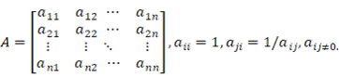 (1)
3. Calculation of Relative Weights: To determine the priorities of each criterion and sub-criterion, a normalized matrix N is constructed using equation 2. This matrix allows for the calculation of the relative weights of the criteria and sub-criteria, indicating their importance in the decision-making process.
Equation 2. 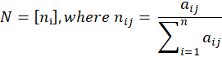 (2)
Next, the corresponding weights for all criteria and sub-criteria are calculated by averaging the elements of each row of N. This step provides the relative importance or weightage of each criterion and sub-criterion in the decision-making process.
Calculating the priority vector
wᵢ = 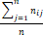 (3)
4.Checking consistency: It is well-known that people can sometimes exhibit inconsistency when answering questions. Therefore, it is important to determine the consistency levels for the comparison matrices [65]. The consistency ratio (CR) is used to measure the level of pairwise comparison consistency [65]. The acceptance limit for CR is set to be less than or equal to 0.1. If the final consistency ratio exceeds 0.1, the evaluation process needs to be reviewed by the decision maker in order to improve consistency [62]. Matrix A is considered consistent if:
(4)
The eigenvalue problem arises in equation 3, where it is assumed that the largest eigenvalue is greater than or equal to n [62, 65]. The closer the value of max is to n, the more consistent matrix A is considered. The next step involves calculating the consistency ratio (CR) for the comparison matrix A to check its consistency.
(5)
5. The calculation of CR as follows:
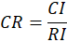 (6)
Matrix A has rank 1 and = n if the pairwise comparisons are entirely consistent. In this case, normalizing any of the matrix's rows or columns can be done to obtain the weights [53, 57]. It should be emphasized that the output quality of AHP is rigidly related to pairwise comparison consistency judgments [65]. The relationship between the entries of matrix A is defined as consistency, which can be calculated by the consistency index (CI):
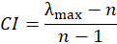 (7)
The final consistency ratio (CR) is applied to determine if the assessments are sufficiently consistent. It can be computed using the (CI) ratio and the random index (RI), as shown in Equation (6).
6. Calculation of global weights: Local weights for criteria and sub-criteria are obtained from equation 3. Then, the overall or global weights for sub-criteria are computed using equation 8, while the global weights for the main criteria remain the same as their local weights.
Global weight of sub-criteria = Local weight of the sub-criteria x Global weight of the corresponding main criteria (8)
Table 3: The nine-point intensity of importance scale and its description
Definition | Intensity of importance
Equally important | 1
Moderately more important | 3
Strongly more important | 5
Very strongly more important | 7
Extremely more important | 9
Intermediate values | 2,4,6,8

Table 4: Random consistency index table [62]
N | 1 | 2 | 3 | 4 | 5 | 6 | 7 | 8 | 9 | 10 | 11 | 12 | 13
RI | 0 | 0 | 0.58 | 0.9 | 1.12 | 1.24 | 1.32 | 1.41 | 1.45 | 1.49 | 1.51 | 1.58 | 1.56
4. THE PROPOSED RESEARCH FRAMEWORK FOR PRIORITIZING ONLINE FASHION RETAILERS
4.1 The finalization of factors that determine the selection of online fashion retail
The objective of the study is to focus on online fashion retailers in Egypt and emphasize the factors that are crucial for the selection of online stores. The study draws on an extensive literature review and incorporates the opinions of experts, including managers and enterprise managers. These experts, who are considered experienced in the study, can make informed decisions based on customer reviews and feedback, indirectly reflecting the voice of the customers [56].
To begin, a decision group was formed comprising of five experts from case companies of online fashion stores (Table 5 for detailed profiles) and two experts from academia with expertise in fashion and technology. The opinions of the experts were gathered through face-to-face interviews, during which details such as the establishment year of the online fashion retailers and their respective positions were also obtained. These interviews included matrix comparisons to obtain insights into the factors under consideration. The purpose of gathering these details was to gain a comprehensive understanding of the status of the online fashion retailers from which the experts were selected.
Table 5: The experts' detail who working in online fashion companies
Affiliation | Domain | Title/designation Experience
Brantu.com | Fashion and accessories | Vendor Manager 7
OPIO.com | Fashion and accessories | Sales Manager 5
Dresscodeme.com | Women’s Fashion | Category Manager 7
Mystic evening | Fashion | Product Manager 9
TFK.me | Fashion | Retail Planner 8
The selected experts from both industry and academia possess expertise in decision-making within the online and fashion retail domains, making them qualified contributors to the study. Their insights, along with the findings from the literature review, were synthesized to develop a framework consisting of five criteria and twenty sub-criteria. The aim was to prioritize five alternatives for Online Fashion Retail. The structural hierarchy for the problem is illustrated in Figure 2. It comprises four levels:
Level 1 represents the overall goal of the study.
Level 2 outlines the main criteria considered in the research agenda.
Level 3 delineates the exhaustive factors or sub-criteria that were examined.
Level 4 presents the available alternatives under consideration.
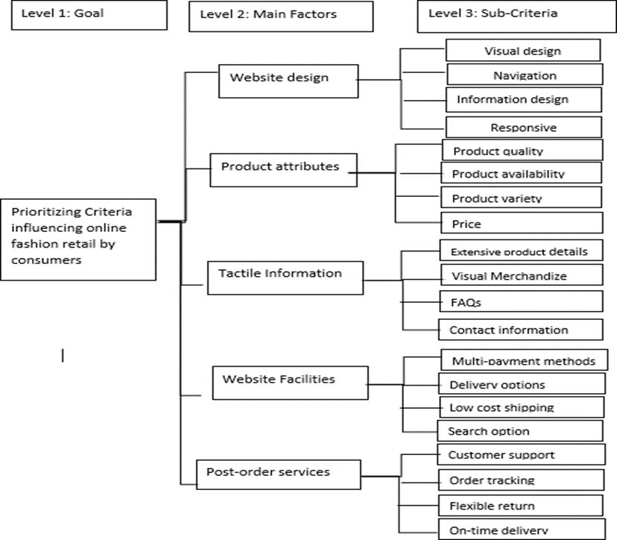
Figure 1 Factors and sub-factors in tree structure

4.2 The application of the analytic hierarchy process (ahp) to calculate the local weight and global weight of factors
The weight of factors and categories identified in this study has been computed using the Analytic Hierarchy Process (AHP). A pairwise comparison of the main categories for selecting online fashion retailers was conducted with the participation of seven experts. The matrix format in Table 6 displays the average value of all five opinions provided by the experts for each pairwise comparison.
Following the pairwise comparison, the categories website design, website facilities, and post-order service were determined to be the top three priorities. While all the main criteria hold significance in the selection of online fashion retailers, having a ranking of their importance can assist retailers in prioritizing their focus on the most preferred criteria. Moreover, the five individual categories were compared pairwise based on their factors. The ratings provided by all five experts were averaged and recorded in the pairwise comparison matrix, as shown.

Table 6. Main‐Factors Pairwise matrix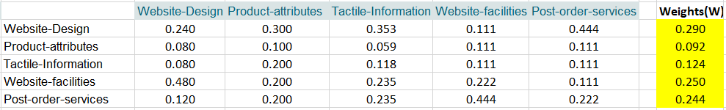
CR = 0.087561 (Consistent)
Table 6.1. Pairwise matrix of Sub‐criteria (website design)
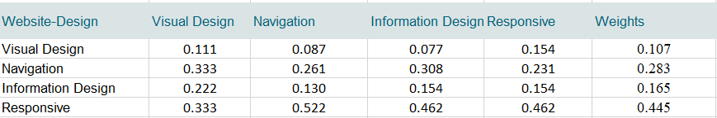
CR = 0.026379 (Consistent)
Table 6.2. Pairwise matrix of Sub‐criteria (product attributes).
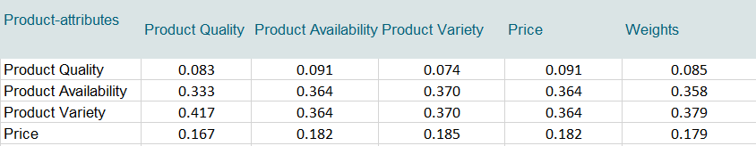
CR = 0.002309 (Consistent)
Table 6.3. Pairwise matrix of Sub‐criteria (tactile information).
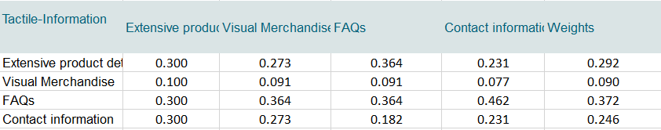
CR = 0.016959 (Consistent)

Table 6.4. Pairwise matrix of Sub‐criteria (website facilities).
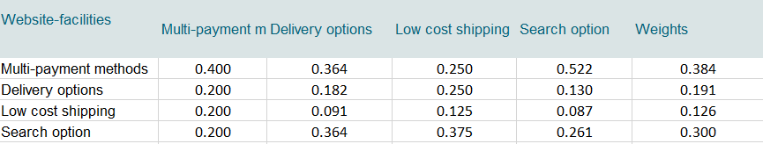
CR = 0.052972 (Consistent)
Table 6.5. Pairwise matrix of Sub‐criteria (post-order service).
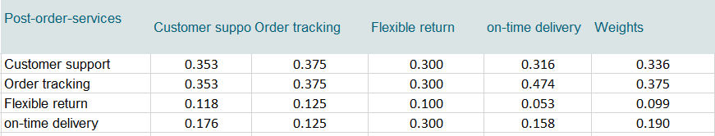
CR = 0.044188 (Consistent)
5. AHP RESULTS
All the gathered data was analyzed using MS Excel software. The experts' responses were collected in pairwise comparisons, and the criteria and sub-criteria were aggregated using the geometric mean method. The calculations for the comparison matrices, weights, and consistency tests for each main criterion and sub-criterion of the hierarchical model are presented in table 6 (Tables 6.0-6.5). The results indicate that all the consistency ratio (CR) values are less than 0.10, suggesting consistency in the comparison matrices. Therefore, the obtained weights can be accepted.
5.1 Main-Factors Weights
Following the transformation of the problem into a hierarchical structure, the weights of the main factors (website design, product attributes, website facilities, tactile information, and post-order services) were computed. The main criteria weights were obtained by calculating the pairwise matrix, as shown in Figure 2. It can be observed that among the five main criteria, the website design criterion (weight = 29%) is the most critical success factor in influencing consumers when interacting with Egyptian online fashion websites. This outcome is consistent with previous studies [27, 31, 38, 42] which suggest that consumers form their initial impressions based on the website interface of the e-store. Therefore, the elements of website design have a significant impact on consumers' beliefs and attitudes [27]. A more attractive website leads to the increased time spent by consumers, higher purchase rates, and a positive influence on customers' intention to continue using fashion applications. The second highest weight is given to website facilities (weight = 25%), which accounts for less than 4% of the weight of the website design criterion. The third factor in the hierarchy is post-order services, with a weight of 24.4%, followed by tactile information (12.4%), and product attributes (9.2%).
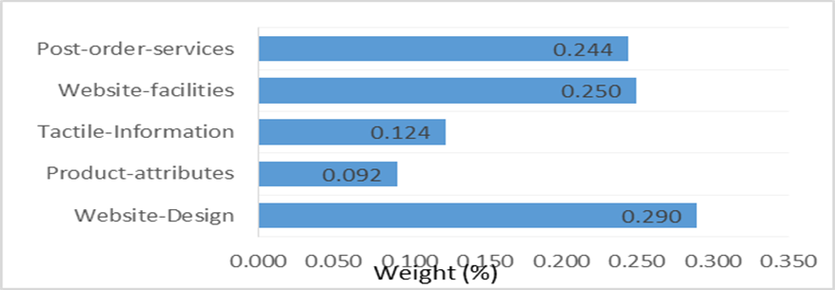
Figure 2 The results of online fashion website' factors with respect to the goal.
5.2 Website Design Weights
Additionally, after computing the weights of the main criteria, the weights of the sub-criteria were also calculated using similar steps as in the computation of the main criteria weights. For each main criterion, five pairwise matrices were constructed, which are presented in table 6.1. Solving these matrices resulted in obtaining the weights of the sub-criteria relative to their respective main criteria. The pairwise comparison of each sub-criterion within the "website design" factor revealed that the sub-factor "responsiveness" has the highest weight of 44%, followed by "navigation" with 28.3%, "information design" with 16.5%, and "visual design" with 10.7%.
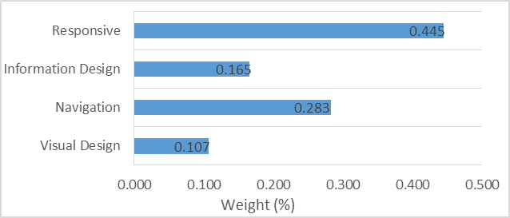
Figure 3 The sub-criteria result with respect to the website design
5.3 Product Attributes Website
Figure 4 displays the weights of the sub-criteria in relation to the product attributes criterion. It is evident that the sub-criterion "product variety" has the highest weight of 37.9%. Following closely, the sub-criterion "product availability" holds the second highest weight of 35.8%. Conversely, the sub-criteria "price" and "product quality" obtained the lowest weights of 17.9% and 8.5% respectively.
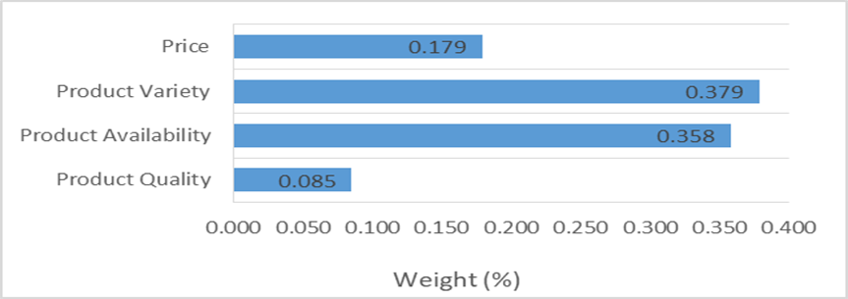
Figure 4 The sub-criteria result with respect to the product attributes
5.4 Tactical Information Weights
The AHP technique determined the top three sub-criteria for the main factor "tactile information" to be FAQs, Extensive product details, and Contact information. Figure 5 illustrates the weights of the sub-criteria in relation to the tactile information factor. The FAQ sub-criteria received the highest weight of 37.2% among the tactile information factor. The extensive product details sub-criteria received a weight of 29.2%, while visual merchandise obtained the lowest weight of 9%.
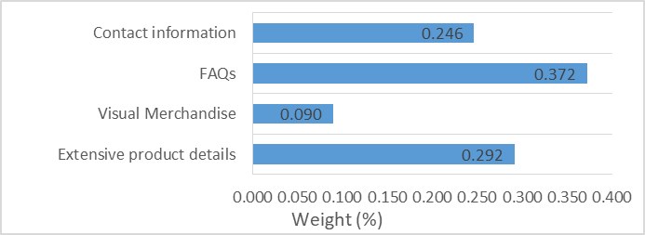
Figure 5 The sub-criteria result with respect to the tactile information
5.5 Website Facilities Weights
The main category "Website Facilities" consists of four sub-factors: search, low-cost shipping, delivery options, and multi-payment methods. Based on the pairwise comparison results presented in Figure 6, the multi-payment methods obtained the highest weight of 38.4% under the website facilities criterion. The search option sub-criterion achieved a weight of 30%, while low-cost shipping received the lowest weight at 12.6%.
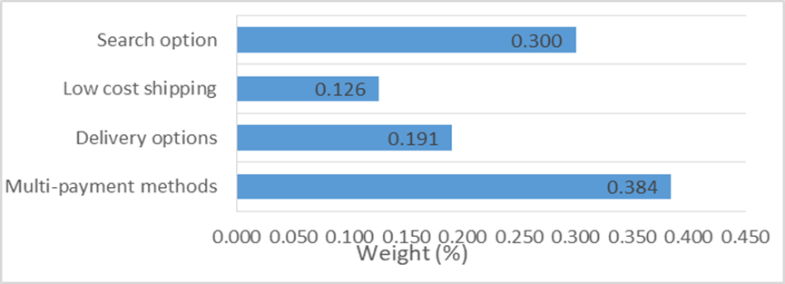
Figure 6 The sub-criteria result with respect to the website facilities
5.6 Post-Order Service Weights
Finally, the comparison matrix result for the main factor "Post-order services" is presented in Figure 7. Among the sub-criteria, the weight of "order tracking" received the highest weight of 37.5%, followed by "customer support" at 33.6% and "on-time delivery" at 19%.
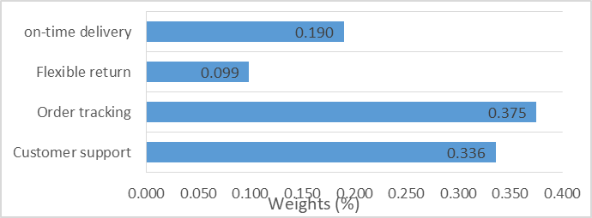
Figure 7: The sub-criteria result with respect to the post-order services
5.7 Final Ranking of Overall Factors
In the last step, after calculating the weights of the main criteria and sub-criteria (with respect to the main factor), we calculated the final weights of the sub-criteria. These calculations were performed by multiplying the initial sub-criteria weights with their respective weights of the main criteria. The final weights of the sub-criteria and their overall rankings are shown in Table 6. The sub-criterion "responsive" is ranked as very important among the 20 sub-criteria. In contrast, the sub-criterion "product quality" is considered the least significant factor. The rationale behind the low ranking of the "product quality" sub-criterion may be that customers prefer shopping through mobile applications rather than accessing websites. It is worth noting that many online fashion retailers already have dedicated mobile applications.

Table 6 Final weights of overall online fashion website factors
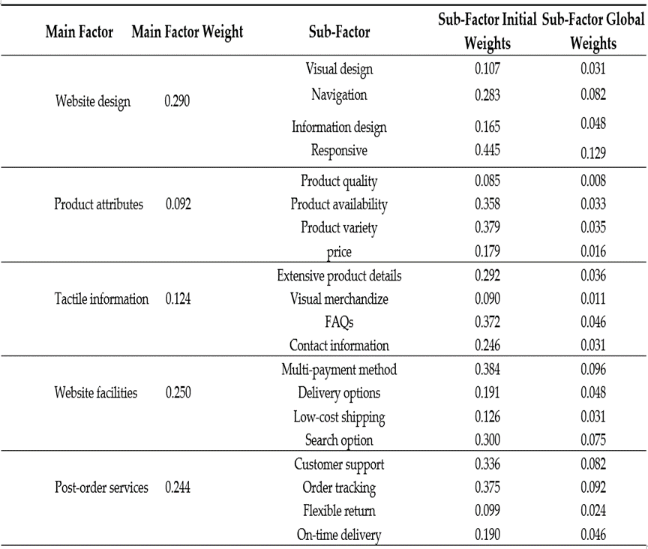
6. DISCUSSION
The current research has several key implications. It focuses on selecting attributes that are relevant to online retail and compares them based on previous studies [12, 14-15, 53]. This research draws on the findings of these literature reviews and applies them to the context of online fashion retailing in Egypt to identify any unique characteristics of this market. Additionally, the research categorizes and prioritizes various aspects of online fashion retailing to identify the most critical factors that should be prioritized when developing an online strategy.
From a theoretical perspective, the study began by identifying factors related to online fashion retail. The most significant factors that influence consumers' reactions to Egyptian online fashion websites were selected. These factors were validated through a literature review conducted by the author and consultation with industry experts. A decision methodology, specifically the Analytic Hierarchy Process (AHP), was employed to address the decision problem. The AHP results revealed that website design is the primary factor that influences consumers' interactions with fashion e-stores, followed by website facilities, post-order services, tactile information, and product attributes. These findings can be valuable for practitioners and academics in further investigating the impact of these factors on online consumers and effectively managing this type of business.
From a practical standpoint, the findings of this research can be utilized by fashion retailers to enhance the online shopping experience for consumers. By improving their services and product attributes based on the identified factors, retailers can increase customer satisfaction and retention. Additionally, online fashion store managers can enhance the website attributes according to the prioritized factor weights. Entrepreneurs interested in entering the online fashion retail sector can also benefit from the prioritization of factors to efficiently cater to customer needs. Furthermore, market researchers can rely on these results for their analysis and market forecasting activities.
7. CONCLUSION
Previous studies have explored various aspects of e-stores and consumer buying behavior [26, 38], assessed and ranked the performance of online retail [15], and evaluated and ranked e-stores [12]. Building upon this existing literature, the current study extends the understanding by introducing the most influential criteria that impact online fashion retail. These criteria include website design, product attributes, tactile information, website facilities, and post-order services. Furthermore, this research is the first to identify and prioritize a specific sector within the B2C e-commerce domain, specifically the Egyptian online market, based on the author's knowledge and expertise.
The rapid growth of online fashion retail in Egypt over the past five years has brought about significant changes. These changes have underscored the importance of identifying the factors crucial for the growth and success of online fashion retail. This research focuses on the Egyptian online fashion sector and aims to determine the website factors and sub-factors that influence consumer preferences. By applying the Analytic Hierarchy Process (AHP), the study determines the weights of these factors and constructs an evaluative model.
Initially, five main factors and twenty sub-factors were identified based on previous research in online retail and insights from industry experts. The analysis revealed that "website design" is the most influential factor on online consumers, particularly the sub-factors of navigation and responsiveness. The second most important category is web facilities, followed by post-order services and tactile information, respectively. These findings shed light on the factors specifically crucial for Egyptian online fashion retailers, enabling e-store managers to prioritize and improve their e-stores' performance based on their relative importance. Furthermore, effective resource management can be achieved by implementing cost-effective e-fashion applications.

8. LIMITATIONS AND FUTURE WORK
The study has certain constraints. It focuses solely on the fashion industry, specifically apparel, which means the conclusions may not apply to other product categories like electronics, books, and automobiles. Additionally, while the study has identified 20 factors, it is conceivable that other significant factors might not have been taken into account. Moreover, the cases analyzed in the study are specifically derived from Egypt, indicating that the findings may have limited applicability to the Egyptian market. It would be beneficial for future research to explore and compare these findings across different countries and cultures. In future research, alternative Multi-Criteria Decision Making (MCDM) techniques such as ISM (Interpretive Structural Modeling) and DEMATEL (Decision-Making Trial and Evaluation Laboratory) could be employed to examine the interrelationships, strength of relationships, and direction among the factors. Additionally, TOPSIS (Technique for Order of Preference by Similarity to Ideal Solution) could be utilized to assist in the selection and prioritization of online fashion retail options.
In addition, the study did not take into account the fuzzy factor, which suggests that a fuzzy-based approach could be employed in future research. Furthermore, in order to reduce the number of factors, those that are similar could be consolidated through Exploratory Factor Analysis. Additionally, the model established in the study could be validated using statistical modeling techniques such as Structural Equation Modeling.
9. REFERENCES
- D. Chaffey, E-business and E-commerce Management: Strategy, Implementation and Practice. Pearson Education, 2007.
- M. Neger and B. Uddin., “Factors Affecting Consumers’ Internet Shopping Behavior During the COVID-19 Pandemic: Evidence from Bangladesh,” Chinese Business Review, vol. 19, no. 3, 2020.
- B. Knezevic, P. Skrobot, and E. Pavic., "Differentiation of e-commerce consumer approach by product categories," Journal of Logistics, Informatics and Service Science, Vol.8, No.1, pp. 1-19, 2021.
- D. Yang, & S. Grice, S., “Research on the Design of E-commerce Recommendation System,” International Journal of Smart Business and Technology, Vol.6, No. 1, pp. 15-30, 2018.
- Research and Markets. (2021, Oct. 1). Online Retail in Egypt-Market Summary, Competitive Analysis and Forecast to 2025[Online]. Available: https://www.researchandmarkets.com/reports/5322688/online-retail-in-egypt-market-summary.
- Statista. (2021). Market Insights - Digital – E-commerce – Egypt [Online]. Available: https://www.statista.com/outlook/dmo/ecommerce/egypt.
- S. Kamel. "Electronic commerce challenges and opportunities for emerging economies: Case of Egypt," in conf. International Conference on Information Resources Management (CONF-IRM), 2015.
- P. El Ahmar, G. Oatley, and P. Tantawi., "Government regulations and online shopping behavior: An exploratory study on Egyptian online consumers," The Business and Management Review, Vol. 7, No. 2, pp. 134-144, 2016.
- S. Morsi, and M. Tarek., “Using System Dynamics Approach to Analyze Factors restraining E-Commerce Growth in Egyptian firms,” Journal of business Studies, Faculty of Commerce, Banha University, Vol. 31, No. 1, 2011.
- H. Lokman, H. Amy, and G. Hui-Ngo., “Click Analysis: How E-commerce Companies Benefit from Exploratory and Association Rule Mining,” Journal of System and Management Sciences, Vol. 12, No. 5, pp. 36-56, 2022.
- Statista. (2022). Market Insights – Digital – e-Commerce -Fashion–Egypt [Online]. Avilable: https://www.statista.com/outlook/dmo/ecommerce/fashion/egypt.
- L. Cao., "Business model transformation in moving to a cross-channel retail strategy: A case study," International Journal of Electronic Commerce, Vol. 18, No. 4, pp. 69-96, 2014.
- K. P. Gupta, and SK. Dubey. "Adaptability evaluation of E-commerce websites in Indian perspective," in conf. Intelligent Communication, Control and Devices: Proceedings of ICICCD, Springer Singapore, 2018.
- R. R. Ghatak, R. Singhi, and S. Bansal., "Online store selection attributes and patronage intentions: an empirical analysis of the indian E-retailing industry,” Indian Journal of Science and Technology, Vol.9, No. 4, pp. 200-222, 2016.
- G. R. Kalelkar, G. Kumbhare, V. Mehta, and A. K. Kar. "Evaluating E-Commerce portals from the perspective of the end user–A group decision support approach," in conf. Advances in Signal Processing and Intelligent Recognition Systems. Springer International Publishing, 2014.
- B.D. Rouyendegh, K. Topuz, A. Dag, A. Oztekin., "An AHP-IFT integrated model for performance evaluation of E-commerce websites," Information Systems Frontiers Vol. 21, pp. 1345-1355, 2019.
- C. Kahraman, SÇ Onar, and B Öztayşi., "B2C marketplace prioritization using hesitant fuzzy linguistic AHP," International Journal of Fuzzy Systems, Vol. 20, pp. 2202-2215, 2018.
- H. Liu, HW Xuan, X Cui., "Determine weights of evaluation indices for E-commerce websites ranking based on fuzzy AHP," Electronic engineering and information science, pp. 271-274, 2015.
- G. Kabir, M. Ahsan, and A. Hasin., "Framework for benchmarking online retailing performance using fuzzy AHP and TOPSIS method," International Journal of Industrial Engineering Computations, Vol. 3, No. 4, pp. 561-576, 2012.
- Y. Ha, W. S. Kwon, and S. J. Lennon., "Online visual merchandising (VMD) of apparel web sites," Journal of Fashion Marketing and Management: An International Journal, Vol. 11, No. 4, pp. 477-493, 2007.
- A. J. Flanagin, MJ. Metzger, R. Pure, and A. Markov., "Mitigating risk in ecommerce transactions: perceptions of information credibility and the role of user-generated ratings in product quality and purchase intention," Electronic Commerce Research, Vol. 14, pp. 1-23, 2014.
- H. M. Chen, C. H. Wu, S. B. Tsai, J. Yu, J. Wang, and Y. Zheng., "Exploring key factors in online shopping with a hybrid model," SpringerPlus, Vol.5, No. 2046, pp. 1-19, 2016.
- C.J. Parker, and H. Wang., "Examining hedonic and utilitarian motivations for m-commerce fashion retail app engagement," An International Journal of Fashion Marketing and Management, 2016.
- A. Ahmad, O. Rahman, and MN. Khan., "Exploring the role of website quality and hedonism in the formation of e-satisfaction and e-loyalty: Evidence from internet users in India," Journal of Research in Interactive Marketing, 2017.
- C. F. Blanco, R. G. Sarasa, and C. O. Sanclemente., "Effects of visual and textual information in online product presentations: looking for the best combination in website design," European Journal of information systems, Vol. 19, No. 6, pp. 668-686, 2010.
- R. Boardman, and H. Mccormick., "The impact of product presentation on decision-making and purchasing," Qualitative Market Research: An International Journal, 2019.
- B. Hasan., "Perceived irritation in online shopping: The impact of website design characteristics," Computers in Human Behavior, Vol. 54, pp. 224-230, 2016.
- Y. Cao, H. Ajjan, and P. Hong., "Post-purchase shipping and customer service experiences in online shopping and their impact on customer satisfaction: An empirical study with comparison," Asia Pacific Journal of Marketing and Logistics, 2018.
- B. Özkan, E. Özceylan, M. Kabak., "Evaluating the websites of academic departments through SEO criteria: a hesitant fuzzy linguistic MCDM approach," Artificial intelligence review, Vol. 53, pp. 875-905, 2020.
- A. Harrison, and S. Kortuem., "Optimized Analysis based on the Characteristics of Cross-Border E-Commerce Logistics Business," International journal of Smart Business and Technology, Vol. 6, No. 2, pp. 1-10, 2018.
- J. Luo, S. Ba, and H. Zhang., "The effectiveness of online shopping characteristics and well-designed websites on satisfaction," Mis Quarterly, Vol. 36, No. 4, pp. 1131-1144, 2012.
- S. Utz, P. Kerkhof, and J.Van Den Bos., “Consumers rule: how consumer reviews influence perceived trustworthiness of online stores,” Electronic commerce Research Application, Vol. 11, No. 1, pp. 49–58, 2012.
- H. Kim, and S.J. Lennon., "E‐atmosphere, emotional, cognitive, and behavioral responses," An International Journal of Fashion Marketing and Management, Vol.14, No. 3, pp. 412-428, 2010.
- V. Kaushik, A. Khare, R. Boardman, and M. B. Cano., “Why do online retailers succeed? The identification and prioritization of success factors for Indian fashion retailers,” Electronic Commerce Research and Applications, Vol. 39, No. 1, 2020.
- P. Oghazi, S. Karlsson, D. Hellström, and K. Hjort., "Online purchase return policy leniency and purchase decision: Mediating role of consumer trust," Journal of Retailing and Consumer Services, Vol. 41, pp. 190-200, 2018.
- D. E. Rosen, and E. Purinton., "Website design: Viewing the web as a cognitive landscape," Journal of Business Research, Vol. 57, No. 7, pp. 787-794, 2004.
- G. M. Ping Zhang., "User expectations and rankings of quality factors in different web site domains," International journal of electronic commerce, Vol. 6, No. 2, pp. 9-33, 2001.
- S. Mithas, N. Ramasubbu, M. S. Krishnan, and C. Fornell., “Designing web sites for Customer loyalty across business domains: a multilevel analysis,” Journal of Management Information Systems, Vol. 23, No. 3, pp. 97-127, 2007.
- F. P. Karimov, M. Brengman, L. Van Hove, and L. Van., “The effect of website design dimensions on initial trust: a synthesis of the empirical literature,” Journal of Electronic Commerce Research, Vol. 12, No. 4, pp. 272-301, 2011.
- J. D. Wells, J. S. Valacich, and T. J. Hess., "What signal are you sending? How website quality influences perceptions of product quality and purchase intentions," MIS quarterly, pp. 373-396, 2011.
- T. Ahn, S. Ryu, and I. Han., "The impact of Web quality and playfulness on user acceptance of online retailing," Information & management, Vol. 44, No. 3, pp. 263-275, 2007.
- H. H. Chang, and S. W. Chen. Chang., "Consumer perception of interface quality, security, and loyalty in electronic commerce," Information & management, Vol. 46, No.7, pp. 411-417, 2009.
- A. J. S. Nugroho, J. J. O. I. Ihalauw, and N. A. N. A. Kristian., "The Moderating Effect of Trust and Product Involvement on Antecedents of Halal Brands to Purchase Intention towards the Competitiveness of the Sharia Economic System in Indonesia," Journal of System and Management Sciences, Vol. 12, No. 5, pp. 374-396, 2022.
- P. Kotler, and G. Armstrong, Principles of Marketing, 14th ed. Labor and Social Publishing House: HCMC, 2012.
- I. Amerta, M. J. I. M. P. A. A. M. M. I. M. S., "The marketing mix affect on the consumer buying decision (case study of sausage products at PT. Aroma Denpasar)," International Journal of Social Sciences and Humanities, Vol. 1, No. 2, pp. 65-74, 2017.
- H. Cho, S. S. Fiorito., "Acceptance of online customization for apparel shopping," International Journal of Retail & Distribution Management, Vol. 37 No. 5, pp. 389-407, 2009.
- H. Cho, “Consumer Perceptions of Online Apparel Customization: An Exploratory Study," in Fashion Supply Chain Management: Industry and Business Analysis: IGI Global, 2012, pp. 286-302.
- M. Noh, K. Lee, S. Kim, G. Garrison., “Effects of collectivism on actual s- commerce use and the moderating effect of price consciousness,” Journal of Electronic Commerce Research, Vol. 14, No. 3, pp. 244, 2013.
- S.M.C. Loureiro, M. Breazeale., “Pressing the buy button: generation Y’s online clothing shopping orientation and its impact on purchase,” Clothing and Textiles Research Journal, Vol. 34, No. 3, pp. 163–178, 2016.
- R. Roy Dholakia, M. Zhao., “Effects of online store attributes on customer satisfaction and repurchase intentions,” International journal of retail & distribution management, Vol. 38, No. 7, pp. 482–496, 2010.
- R. Liang, J. Wang, H. Zhang., “Evaluation of E‐Commerce Websites: An Integrated Approach under a Single‐Valued Trapezoidal Neutrosophic Environment,” Knowledge Based Systems, Vol. 135, No. 1, pp. 44–59, 2017.
- F. Morton, “The use of written descriptions and 2D images as cues for tactile information in online shopping,” in Research Anthology on E-Commerce Adoption, Models, and Applications for Modern Business: IGI Global, 2018, pp.18–37.
- W. Liu, R. Batra, and H. Wang., “Product touch and consumers’ online and offline buying: the role of mental representation,” Journal of Retail, Vol. 93, No. 3, pp. 369-381, 2017a.
- S. S. Song, M. Kim., “Does more mean better? An examination of visual product presentation in e-retailing,” Journal of Electronic Commerce Research, Vol. 13, No. 4, 2012.
- T. Verhagen, C. C. Vonkeman, J. F. M. Feldberg, and P. Verhagen, “Making online products more tangible and likeable: the role of local presence as product presentation mechanism,” Faculty of Economics and Business Administration, VU University Amsterdam, Rep. 3, 2013.
- P. Xu, L. Chen, and R. Santhanam., “Will video be the next generation of e- commerce product reviews? Presentation format and the role of product type,” Decision Support System, Vol. 73, pp. 85–96, 2015.
- R. Li, T. Sun., “Assessing factors for designing a successful B2C E-Commerce website using fuzzy AHP and TOPSIS-Grey methodology,” Symmetry, Vol. 12, No. 3, 2020.
- Y. K. Cho., “Creating customer repurchase intention in Internet retailing: The effects of multiple service events and product type,” Journal of retailing and consumer services, Vol. 22, No. 1, 2015.
- C. H. Hsu, C. M. Yang, T. C. Chen, and C. Y. Chen. “Applying AHP method select online shopping platform,” in conf. 7th International Conference on Service Systems and Service Management, IEEE, 2010, Jun 28, pp. 1-5.
- C. N. Wang, N. A. Nguyen, T. T. Dang, C. M. Lu., “A compromised decision- making approach to third-party logistics selection in sustainable supply chain using fuzzy AHP and fuzzy VIKOR methods,” Mathematics, Vol. 9, No. 8, 2021.
- T. L. Saaty., “What is the analytic hierarchy process?,” Mathematical Models for Decision Support, Springer, Berlin, Heidelberg, pp. 109–121, 1988.
- T. L. Saaty., “Analytic hierarchy process,” Encyclopedia of Operations Research and Management Science, Springer, Boston, MA, pp. 52–64, 2013.
- F. Torfi, R.Z. Farahani, S. Rezapour., “Fuzzy AHP to determine the relative weights of evaluation criteria and Fuzzy TOPSIS to rank the alternatives,” Applied soft computing, Vol. 10, No. 2, 2010.
- A. Ishizaka, A. Labib., “Review of the main developments in the analytic hierarchy process,” Expert systems with applications, Vol. 38, No. 11, pp. 14336-14345, 2011.
- K. P. Gupta, P. Bhaskar, S. Singh, "Prioritization of factors influencing employee adoption of e-government using the analytic hierarchy process," Journal of Systems and Information Technology, Vol. 19, Vo. 1, pp.116-137, 2017.
- E. Albayrak, Y. C. Erensal., “Using analytic hierarchy process (AHP) to improve human performance: An application of multiple criteria decision-making problem,” Journal of intelligent manufacturing, Vol. 15, No. 4, pp. 491-503, 2004.

