The Effect of Social Media Usage and Electronic Word of Mouth on Conviction and Its Impact on Purchase Intention and Customer Loyalty: The Role of Brand Reputation as A Moderator
Elvin,
Bina Nusantara University
elvin003@binus.ac.id

Aussie Dian Hidayat
Bina Nusantara University
aussie.hidayat@binus.ac.id

Patricia Hilda Tanti
Bina Nusantara University
patricia.tanti@binus.ac.id

Yuniarty
Bina Nusantara University
yuniarty@binus.ac.id

ABSTRACT
This study aimed to introduce the concept of conviction to the digital space. It also investigated the crucial role of conviction and brand reputation, as well as explored the relationship between social media usage, E-WOM, and purchase intention on e-commerce platforms. Data were collected from 181 respondents in Jakarta, Indonesia, using convenience sampling and questionnaires. The data were subsequently analyzed using Structural Equation Modeling (SEM) and empirically tested using Partial Least Square (PLS). The results showed that E-WOM and conviction positively affected purchase intention and customers' loyalty, while social media usage had no positive effect on purchase intention. Furthermore, perceived brand reputation moderated the relationship between E-WOM and purchase intention. This relationship was significantly stronger with higher positive brand reputation. The study offered valuable insights into marketing using e-commerce platforms as a medium and product distribution.
Keywords: Market Intelligence, Marketing Strategy, Brand Reputation, Social Media, Electronic Word Of Mouth (E-WOM), Confidence, Purchase intention, and Customer Loyalty.

INTRODUCTION
The increase in online shopping activities in society is attributed to the development of information technology [1]. Moreover, the development of online activities has significantly transformed shopping behavior in society. Individuals who previously engaged in traditional shopping activities have increasingly shifted toward online [2] , an action that has evolved from merely filling leisure time or spending money [3]. This transformation has changed people's habits from manual shopping to interactions mediated by technology. Traditional shopping includes interactions between humans, while online shopping predominantly features interactions between humans and technology, giving rise to various e-commerce applications [4]. Many companies use e-commerce as a medium for online sales due to the potential to boost product sales and access global markets [5].
Social media currently plays a crucial role in the publication and advertising activities carried out by e-commerce in Indonesia. As e-commerce continues to grow, social media has become an important communication channel between business actors and customers. The types of social media used by e-commerce businesses vary alongside development in information technology [6]. Social media offers a space for all parties to communicate and provide information without distance and time barriers. It has also become a popular platform for sharing product reviews and experiences. This activity is a form of marketing communication commonly referred to as word-of-mouth (WOM). Traditionally, WOM entails face-to-face communication of product or service with a limited audience comprising acquaintances. However, there has been a paradigm shift in WOM communication, extending to the cyberspace with a broader scope, known as electronic WOM (E-WOM) [7].
Studies have shown that E-WOM is the most influential factor influencing brand reputation and shopping interest [8]. Its impact on customers' confidence can foster loyalty. Confidence, in this context, refers to the willingness to rely on a trusted company. Long-term relationships between customers and company can be created through confidence [9], [10]. Customers' loyalty is the possibility of making repeat purchases and willingness to remain loyal and partner with a company.
Loyal customers tend to show specific behaviors, such as sharing positive feedback, encouraging others to transact, and consistently choosing brand for future purchases [11]. here are five key indicators for measuring loyalty, namely repeat purchases, strong brand preference, brand fixation, belief in the superiority of a particular brand, and brand recommendations [12].
The current study aimed to investigate the effects of social media usage, E-WOM, and conviction on purchase intention, loyalty, with brand reputation as a moderator for product or brand purchases on e-commerce platforms. To continually increase purchase intention rates, both e-commerce platforms and sellers using these platforms for marketing should prioritize satisfaction and loyalty. These factors can significantly influence purchasing decision and behavior. Consequently, study experts are motivated to explore purchase intention and loyalty, as well as underlying factors such as social media usage and E-WOM.

2. LITERATURE REVIEW

2.1 Social Media Usage
Social media is a new phenomenon that has transformed business environments by offering access to previously unavailable resources. It also helps company facilitate confidence, cultivate strategic partnerships, and improve interactions with both customers and suppliers. For business owners and marketers, understanding the essence of social media as a communication and marketing tool is crucial for significant business growth [13]. Advertisements featured on social media have several fundamental characteristics, namely providing information through images and sounds to captivate and influence customers' attention. Therefore, the content on social media can build confidence and encourage interest in purchasing an item or product [14]. Social media also influences purchase behavior, specifically purchase decisions with online processes. It offers a swift avenue for customers to gather and assimilate information [15], [16]. Majority of online shoppers use this platform to find information about products and brands, showing the impact on purchase interest. Based on these observations, the following hypotheses were formulated:
H1: Social Media Usage significantly affects conviction on e-commerce platforms.
H3: Social Media Usage significantly affects Purchase Intention on e-commerce platforms.
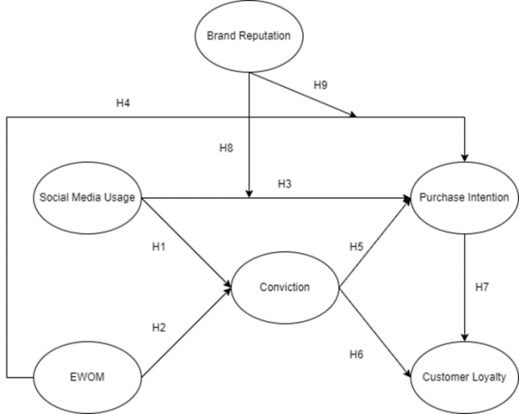
Figure 1. Conceptual Framework

2.2 Electronic Word Of Mouth
E-WOM is often referred to as "free marketing” due to reviews or testimonials by previously satisfied buyers of online businesses. Information quality plays an essential role in the success of information systems [17]. Therefore, a more in-depth analysis of the most basic communication skills between online buyers and sellers is essential. This analysis can be viewed as a fundamental determinant in building trust within online business units and fostering buyer confidence [18]. When referring to WOM shared across various social media channels, both the quality and quantity of E-WOM influence purchase decision [8]. Studies have shown that a stronger perception of the credibility of online reviews correlates with higher purchase value. Furthermore, reviews supported by trust in online retailers, can positively influence purchase intention [19]. Based on these observations, the following hypotheses were formulated:
H2: E-WOM significantly affects conviction on e-commerce platforms.
H4: E-WOM significantly influences Purchase Intention on e-commerce platforms.

2.3 Conviction
Among various factors influencing transactions through e-commerce, trust factor essentially instills confidence. Therefore, only customers who trust a platform can feel comfortable conducting online transactions. E-commerce transactions may not be feasible without this form of trust [20]. According to the Theory of Reasoned Action, beliefs shape an individual's attitude, and subsequently influence intention and behavior. The trust in e-commerce platforms directly impacts usage intensity [20]. Conviction plays a crucial role in bolstering trust, specifically when relevant parties have not previously interacted and are unfamiliar with each other [21]. Both customers' trust in a product and company's credibility are crucial factors in fostering loyalty. Building trust and confidence significantly enriches buying and selling relationship as well as loyalty [22]. The higher the confidence in a product or service, the higher the level of loyalty [23]. Based on these observations, the following hypotheses were formulated:
H5: Conviction significantly affects Purchase Intention on e-commerce platforms.
H6: Conviction significantly affects Customer Loyalty on e-commerce platforms.

2.4 Purchase Intention and Customer Loyalty
In online shopping, purchase interest is an essential predictor of actual purchasing behavior. It refers to customers assessments regarding information search, product quality, and product evaluation, which subsequently result in increased purchase interest and potentially drive purchase decision for a product [24]. Loyalty is an important strategic objective for all online vendors and can be classified into intentional and behavioral components. Despite conceptual differences, both constructs are intrinsically interconnected [25]. The relationship between purchase intention and loyalty is supported by previous studies, stating that repurchase intention and WOM are regularly measured to understand the possibility of loyalty to specific vendors [26], [27]. Based on these observations, the following hypothesis was formulated:
H7: Purchase Intention significantly affects Customer Loyalty on e-commerce platforms.

2.5 Brand Reputation
Brand reputation refers to perception that a particular brand is reliable and can be developed through advertising, public relations, and quality improvement efforts. This has a significant effect, hence, customers are less likely to patronize a brand when unfamiliar with a product [28]. In the online buying and selling system, reputation can be associated with sellers with a positive track record. Feedback and testimonials on social media can easily attract customers to a specific product, specifically when compared to online shops lacking a good reputation or track record in the online world. Sellers with good reputations can reduce anxiety about purchasing online by increasing interest [29]. E-WOM can be very profitable with numerous benefits for companies when effectively integrated into a marketing strategy. It also has the potential to strengthen purchase interest, as well as support and improve company's brand reputation in order to be more appealing and convincing to customers [30]. Online reviews on the Internet and social media by family, relatives, or others can significantly influence perceptions of brand's reputation [31]. T Based on these observations, the following hypotheses were formulated:
H8: Brand reputation moderates the relationship between social media usage and purchase intention, so this relationship is significantly stronger if there is a more positive brand reputation.
H9: Brand reputation moderates the relationship between electronic word of mouth and purchase intention, so this relationship is significantly stronger if there is a more positive brand reputation.

3. METHODS

3.1 Procedure
This study used quantitative and associative methods to analyze the relationship or influence between two or more variables. It specifically explored how social media usage and E-WOM influenced conviction, subsequently impacting purchase intention and customers' loyalty, with brand reputation as a moderator. This was particularly relevant for people residing in Jakarta and transacting through e-commerce platforms. An indirect survey method was adopted by using a questionnaire featuring closed questions. Respondents answered questions by selecting from a series of clearly described alternatives and limited choices. Furthermore, a cross-sectional design was adopted, which entailed the collection of data at a single point in time to address study questions. The unit of analysis comprised customers who had shopped once or more on an e-commerce platform.
The questionnaire included questions related to each variable and corresponding indicator. Social Media Usage (SMU) with indicators SMU1, SMU2, SMU3, SMU4 [32]. E-WOM with indicators E-WOM1, E-WOM2, E-WOM3, E-WOM4, E-WOM5 [21]. Conviction (CON) with indicators CON1, CON2, CON3, CON4. Purchase Intention (PI) with indicators PI1, PI2, PI3, PI4, PI5, PI6, PI7. Customers' Loyalty (CL) with indicators CL1, CL2. CL3, CL4. Brand Reputation (BR) with indicators BR1, BR2, BR3, BR4, BR5 [21].
SEM analysis method combines with PLS path modeling method in data analysis to form PLS-SEM. This PLS-SEM is a causal-predictive approach to SEM that prioritizes prediction in estimating statistical models. Its structure is designed to provide causal explanations, bridging the perceived gap between explanation-typically prioritized in academic study and prediction, which is the basis for developing managerial implications. PLS path modeling was specifically chosen due to its capability to estimate complex models featuring several constructs, indicator variables, and structural paths without imposing distributional assumptions on data. Smart PLS software version 3.3.5 was used for data analysis.

3.2 Measures
Descriptive statistical analysis is a method used for analyzing and describing collected data, without intending to make generalizations [33]. In the current study, the results from the questionnaire were categorized based on specific demographic variables, namely gender, age, education, occupation, and income. Several questions related to the investigated variables used a semantic differential scale, with responses tabulated for further analysis.
Several parameters were considered to measure the reliability of latent variable constructs and assess the reliability of all indicators in the model. These included Composite Reliability (CR), Cronbach's alpha, and convergent validity of a construct with reflective indicators evaluated by Average Variance Extracted (AVE). Construct reliability is synonymous with Cronbach's alpha. CR is considered superior for estimating the internal consistency of a construct. Each latent variable should account for 50% of variance for each indicator. Accordingly, the recommended criteria for measuring reliability are as follows: CR of ≥ 0.7 is considered reliable, with 0.8 being ideal, and 0.6 still acceptable. Cronbach's alpha value of ≥ 0.50 is considered fair. The absolute correlation between latent variables and indicators is > 0.70 (outer loading). AVE value of ≥ 0.5 is required to explain 50% or more of the variance of the item. Reflective indicators with an outer loading value below 0.4 should be excluded from the measurement model.
All previous tests culminated in hypothesis testing, where the acceptance or rejection of hypothesis is determined using the Sig. (probability significance). A regression coefficient of the independent variable is considered to have a significant effect on the dependent variable when the Sig. is less than 0.05 and the path coefficient value is positive. When these conditions are met, the hypothesis is accepted, showing a significant influence between the independent and dependent variables. Meanwhile, the hypothesis is rejected when the criteria are not met. The estimated values for the path relationships in the structural model should be evaluated based on the strength and significance of the effect.

3.3 Participants
The population serving as a source of information for this study comprised residents of Jakarta who had e-commerce accounts and made transactions through the platforms. Data were collected from November 2022 to January 2023, producing 275 respondents. A total of 181 respondents passed the final screening after applying the study's criteria. The success rate of sample collection exceeded minimum sample size calculation, with 189% of the required 96 respondents.

4. RESULTS

4.1 Respondent Characteristics
Table 1 presents the study participants, with a few numbers residing in Jakarta out of the total 275.
Table 1. Respondents Characteristics
Characteristics | Frequency | Percentage (%)
Gender
Female | 147 | 53.5%
Male | 128 | 46.5%
Age
17 – 25 years old | 205 | 74.5%
26 – 35 years old | 52 | 18.9%
36 – 45 years old | 13 | 4.7%
46 – 55 years old | 5 | 1.8%
Education
High School | 131 | 47.6%
Diploma | 16 | 5.8%
Bachelor Degree | 122 | 44.4%
Master Degree | 6 | 2.2%
Occupation
Student | 87 | 31.6%
Private Employee | 114 | 41.5%
Teacher / Lecturer | 3 | 1.1%
Bureucrat | 2 | 0.7%
Freelancer | 10 | 3.6%
Entrepreneur | 23 | 8.4%
Housewife | 5 | 1.8%
Others | 31 | 11.3%
Income
< IDR 2,500,000 | 63 | 22.9%
IDR 2,500,001 - Rp 5,000,000 | 60 | 21.8%
IDR 5,000,001 - Rp 7,500,000 | 62 | 22.5%
IDR 7,500,001 - Rp 10,000,000 | 40 | 14.5%
> IDR 10,000,000 | 50 | 18.2%

4.2 Outer Model Test Results
Tables 2, 3, 4, and 5 present the evaluation of the outer model. The loading factor values for each variable were > 0.5, showing that all indicators had a high level of validity.
Table 2. Mean Indicator and Loading Factor
Variable | Indicators | Mean | Loading Factors | t-Stat | Note
Social Media Usage | SMU1 | 3.807 | 0.847 | 36.176 | Valid
Social Media Usage | SMU2 | 3.818 | 0.829 | 29.272 | Valid
Social Media Usage | SMU3 | 3.950 | 0.796 | 26.939 | Valid
Social Media Usage | SMU4 | 4.116 | 0.769 | 20.627 | Valid
Electronic Word Of Mouth | EWOM1 | 3.840 | 0.752 | 17.458 | Valid
Electronic Word Of Mouth | EWOM2 | 4.155 | 0.748 | 16.879 | Valid
Electronic Word Of Mouth | EWOM3 | 3.989 | 0.702 | 13.430 | Valid
Electronic Word Of Mouth | EWOM4 | 3.740 | 0.718 | 14.684 | Valid
Electronic Word Of Mouth | EWOM5 | 3.691 | 0.746 | 15.456 | Valid
Conviction | CON1 | 4.116 | 0.844 | 30.313 | Valid
Conviction | CON2 | 4.188 | 0.822 | 26.898 | Valid
Conviction | CON3 | 4.144 | 0.815 | 15.667 | Valid
Conviction | CON4 | 4.177 | 0.852 | 35.032 | Valid
Purchase Intention | PI1 | 4.099 | 0.733 | 14.992 | Valid
Purchase Intention | PI2 | 4.072 | 0.771 | 13.231 | Valid
Purchase Intention | PI3 | 4.039 | 0.773 | 17.575 | Valid
Purchase Intention | PI4 | 4.144 | 0.705 | 9.174 | Valid
Purchase Intention | PI5 | 4.116 | 0.811 | 25.631 | Valid
Purchase Intention | PI6 | 4.022 | 0.831 | 30.250 | Valid
Purchase Intention | PI7 | 4.017 | 0.717 | 16.859 | Valid
Customer Loyalty | CL1 | 4.039 | 0.684 | 14.032 | Valid
Customer Loyalty | CL2 | 4.182 | 0.822 | 26.195 | Valid
Customer Loyalty | CL3 | 4.050 | 0.826 | 24.094 | Valid
Customer Loyalty | CL4 | 4.099 | 0.767 | 19.529 | Valid
Brand Reputation | BR1 | 4.160 | 0.809 | 25.993 | Valid
Brand Reputation | BR2 | 4.265 | 0.788 | 19.699 | Valid
Brand Reputation | BR3 | 4.177 | 0.842 | 30.609 | Valid
Brand Reputation | BR4 | 4.215 | 0.802 | 24.789 | Valid
Brand Reputation | BR5 | 4.083 | 0.706 | 17.061 | Valid

Table 3 shows that all indicators had a significant correlation value. The developed instrument or questionnaire had good discriminant validity, as evidenced by the higher loading values between each indicator and its respective latent variable compared to others [34].

Table 3. Discriminant Validity
 | SMU | EWOM | CON | PI | CL | BR
SMU1 | 0.847 | 0.544 | 0.505 | 0.537 | 0.473 | 0.474
SMU2 | 0.829 | 0.552 | 0.426 | 0.467 | 0.485 | 0.516
SMU3 | 0.796 | 0.403 | 0.440 | 0.377 | 0.466 | 0.417
SMU4 | 0.769 | 0.559 | 0.498 | 0.534 | 0.475 | 0.478
EWOM1 | 0.587 | 0.752 | 0.419 | 0.551 | 0.427 | 0.353
EWOM2 | 0.478 | 0.748 | 0.372 | 0.413 | 0.337 | 0.310
EWOM3 | 0.325 | 0.702 | 0.379 | 0.405 | 0.291 | 0.265
EWOM4 | 0.480 | 0.718 | 0.374 | 0.401 | 0.463 | 0.308
EWOM5 | 0.455 | 0.746 | 0.433 | 0.384 | 0.344 | 0.413
CON1 | 0.526 | 0.447 | 0.844 | 0.596 | 0.466 | 0.517
CON2 | 0.492 | 0.466 | 0.822 | 0.592 | 0.511 | 0.541
CON3 | 0.441 | 0.419 | 0.815 | 0.600 | 0.506 | 0.501
CON4 | 0.477 | 0.468 | 0.852 | 0.697 | 0.583 | 0.622
PI1 | 0.422 | 0.401 | 0.640 | 0.733 | 0.439 | 0.533
PI2 | 0.441 | 0.453 | 0.549 | 0.771 | 0.530 | 0.595
PI3 | 0.563 | 0.516 | 0.521 | 0.773 | 0.507 | 0.538
PI4 | 0.430 | 0.473 | 0.556 | 0.705 | 0.431 | 0.424
PI5 | 0.396 | 0.434 | 0.598 | 0.811 | 0.529 | 0.527
PI6 | 0.465 | 0.462 | 0.566 | 0.831 | 0.567 | 0.559
PI7 | 0.481 | 0.440 | 0.572 | 0.717 | 0.605 | 0.566
CL1 | 0.415 | 0.291 | 0.450 | 0.457 | 0.684 | 0.539
CL2 | 0.502 | 0.442 | 0.544 | 0.608 | 0.822 | 0.561
CL3 | 0.480 | 0.437 | 0.499 | 0.588 | 0.826 | 0.503
CL4 | 0.412 | 0.402 | 0.427 | 0.426 | 0.767 | 0.525
BR1 | 0.397 | 0.305 | 0.582 | 0.608 | 0.525 | 0.809
BR2 | 0.407 | 0.267 | 0.470 | 0.530 | 0.580 | 0.788
BR3 | 0.468 | 0.339 | 0.522 | 0.550 | 0.518 | 0.842
BR4 | 0.505 | 0.389 | 0.523 | 0.550 | 0.590 | 0.802
BR5 | 0.532 | 0.504 | 0.487 | 0.532 | 0.483 | 0.706

Table 4 shows that all dimensions were reliable. This was confirmed by Cronbach's alpha of ≥ 0.50, CR of > 0.70, and AVE of ≥ 0.50 [35]. Specifically, 0.658 AVE value was obtained for social media usage variable, 0.538 for E-WOM, 0.695 for conviction, 0.584 for purchase intention, 0.604 for customers' loyalty, and 0.625 for brand reputation [35], [36].

Table 4. Reliability Tests
 | AVE | Cronbach’s Alpha | Composite Reliability
Social Media Usage | 0.658 | 0.827 | 0.885
Electronic Word Of Mouth | 0.538 | 0.786 | 0.853
Conviction | 0.695 | 0.853 | 0.901
Purchase Intention | 0.584 | 0.880 | 0.907
Customer Loyalty | 0.604 | 0.780 | 0.858
Brand Reputation | 0.625 | 0.849 | 0.892

Based on Table 5, The Path Coefficient of SMU --> CON was 0.397. Calculations were based on standardized variables. The path coefficient value of 0.397 showed that, in linear analysis, an increase of 1 standard deviation variation in SMU could result in 0.397 standard deviation increase in CON. The P-value for SMU --> CON was 0.000, which was less than the Sig. 0.05, showing a significant relationship between SMU and CON.
The Path Coefficient of E-WOM --> CON was 0.286. Calculations were based on standardized variables. A path coefficient value of 0.286 showed that, in linear analysis, an increase of 1 standard deviation variation in E-WOM could result in 0.286 standard deviation increase in CON. The P-value of E-WOM --> CON was 0.004, which was less than the 0.05 Sig, showing a significant relationship between E-WOM and CON.
The Path Coefficient of SMU --> PI was 0.076. Calculations were based on standardized variables. A path coefficient value of 0.076 showed that, in linear analysis, an increase of 1 standard deviation variation in SMU could result in 0.076 standard deviation increase in PI. The P-value of SMU --> PI was 0.240, which was greater than the Sig. 0.05, showing no significant relationship between SMU and PI.
The Path Coefficient of E-WOM --> PI was 0.207. Calculations were based on standardized variables. A path coefficient value of 0.207 showed that, in linear analysis, an increase of 1 standard deviation variation in E-WOM could result in 0.207 standard deviation increase in PI. The P-value of ES --> RI was 0.002, which was less than the Sig. 0.05, showing a significant relationship between E-WOM and PI.
The Path Coefficient for CON --> PI was 0.361. Calculations were based on standardized variables. A path coefficient value of 0.361 showed that, in linear analysis, an increase of 1 standard deviation variation in CON could result in 0.361 standard deviation increase in PI. The P-value of CON --> PI was 0.000, which was less than the Sig. 0.05, showing a significant relationship between CON and PI.
The Path Coefficient for CON --> CL was 0.259. Calculations were based on standardized variables. A path coefficient value of 0.259 showed that, in linear analysis, an increase of 1 standard deviation variation in CON could result in 0.259 standard deviation increase in CL. The P-value of CON --> CL was 0.008, which was less than the Sig. 0.05, showing a significant relationship between CON and CL.
The Path Coefficient for PI --> CL was 0.485. Calculations were based on standardized variables. A path coefficient value of 0.485 showed that, in linear analysis, an increase of 1 standard deviation variation in PI could result in 0.485 standard deviation increase in CL. The P-value of PI --> CL was 0.000, which was less than the Sig. 0.05, showing a significant relationship between PI and CL.
The Path Coefficient for BR --> PI was 0.344. Calculations were based on standardized variables. A path coefficient value of 0.344 showed that, in linear analysis, an increase of 1 standard deviation variation in BR could result in 0.344 standard deviation increase in PI. The P-value of BR --> PI was 0.000, which was less than the Sig. 0.05, showing a significant relationship between BR and PI.

Table 5. Hypothesis Tests & F Square Tests
Path |  | Path | Coefficient (Standardized) | t-  Value | Conclusion | F Square (F²) | F Square Result
 | 1 | SMU -> CON | 0.397 | 4.424 | Significant | 0.151 | Strong Effect
 | 2 | EWOM -> CON | 0.286 | 2.866 | Significant | 0.078 | Medium Effect
 | 3 | SMU -> PI | 0.076 | 1.176 | Not Significant | 0.009 | Weak Effect
 | 4 | EWOM -> PI | 0.207 | 3.080 | Significant | 0.073 | Medium Effect
 | 5 | CON -> PI | 0.361 | 4.483 | Significant | 0.188 | Strong Effect
 | 6 | CON -> CL | 0.259 | 2.684 | Significant | 0.058 | Medium Effect
 | 7 | BR -> PI | 0.344 | 4.945 | Significant | 0.165 | Strong Effect

Table 5 also shows the effect sizes (F2), investigating whether the effect on the path coefficients was small, medium, or large, as showed by bootstrapping procedure. For the initial assessment, a small number of bootstrap subsamples (500) were selected, while for the final results, a larger number of bootstrap subsamples (5,000) were used. The recommended F2 values were 0.02, 0.15, and 0.35 [35]. The values showed the influence of weak or strong latent predictor variables (exogenous latent variables) at the structural level, with the following criteria: Effect Sizes for Path Coefficients < 0.02 = weak; 0.02 – 0.15 = medium; 0.15 – 0.35 = strong; > 0.35 = very strong.

4.3 Inner Model Test Results
Figure 2 describes the full SEM model of the study results, showing the parameter values for observed variable (indicator), exogenous latent variable, and endogenous variable. The effects of each dimension on the variables were shown in detail, as evidenced by path coefficients and p-values. Variables in the columns served as predictor latent variables, while those in the rows represented criteria.
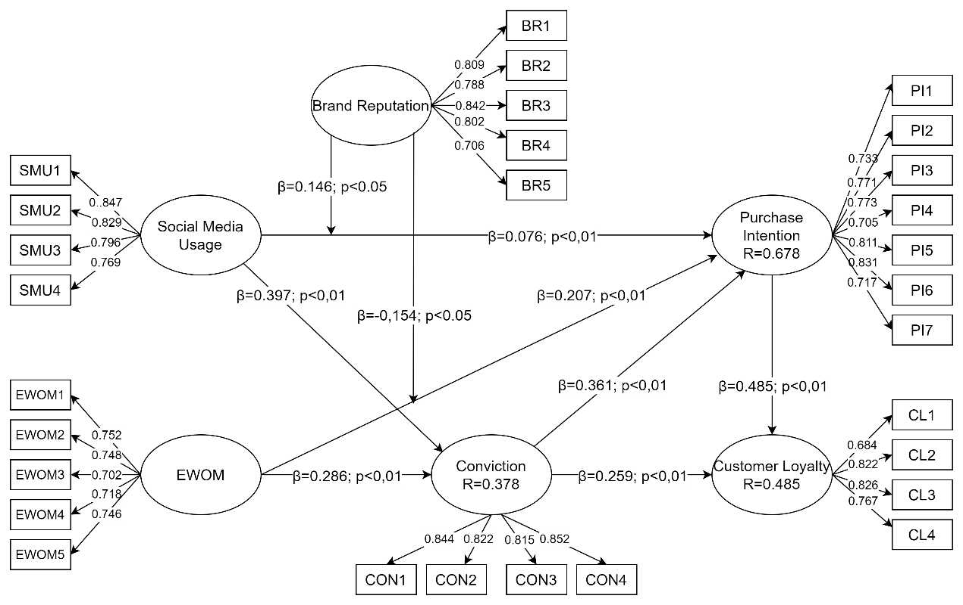
Figure 2. SEM Model Path Coefficient and Inner Model P-Value

The coefficient of determination (R²) is used to assess the extent independent variable construct can explain the dependent variable construct. Table 6 shows that R² values ranged between 0 and 1, with values between 0.25 – 0.49 considered weak, 0.50 – 0.74 moderate, and greater than 0.75 strong [35] (see Table 6).
Table 6. R Square Tests
 | R Square | R Square Adjusted
CL | 0.491 | 0.485
CON | 0.385 | 0.378
PI | 0.689 | 0.678

Predictive relevance can also be determined using a formula with a value above 0. Predictive relevance value was obtained using the formula:
Q2 = 1 – (1 – R1) (1 – R2) (1 – R3)
Q2 = 1 – (1 – 0.485) (1 – 0.378) (1 – 0.678)
Q2 = 1 – (0.515) (0.622) (0.322)
Q2 = 1 – 0.103
Q2 = 0.897

The resulting Q2 values of 0.897 exceeded 0, showing that the model had predictive relevance.

4.4 Moderation Tests
Table 6 shows variables influencing (either strengthening or weakening) the relationship between independent and dependent variables, leading to moderation.

Table 6. Moderation Testing
 | Original Sample (O) | Sample Mean (M) | Standard Deviation (STDEV) | T Statistics (|O/STDEV|) | P Values
BR*SMU -> PI | 0,146 | 0,141 | 0,062 | 2,.345 | 0,019
BR*EWOM -> PI | -0,154 | -0,140 | 0,066 | 2,336 | 0,020

Figure 3 shows that brand reputation strengthened and significantly moderated the effect of social media usage on purchase intention. A brand with a strong reputation tends to have several benefits, specifically loyalty. Customers who consistently prioritize brand offerings tend to remain loyal, find it challenging to switch to alternatives, and easily recommend brand to friends and family.
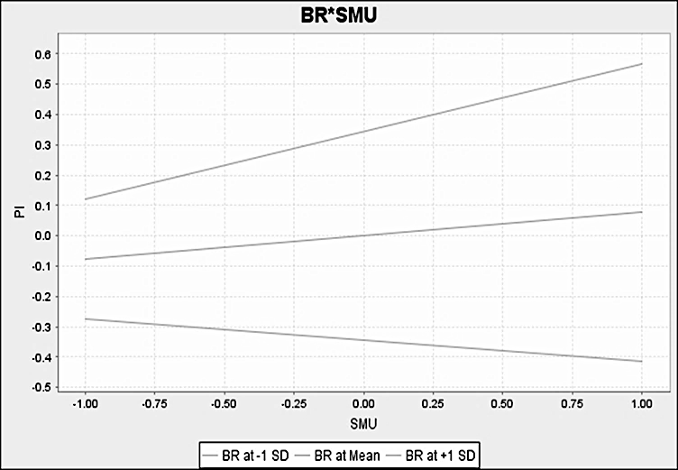
Figure 3. The role of BR moderates the effect of SMU on PI

Figure 4 shows that brand reputation weakened and significantly moderated the impact of E-WOM on purchase intention. With the ease of accessing and disseminating both positive and negative information through social media, customer's consumption habits had evolved. Customers inclination to read unfavorable news related to products or companies increased the probability of the news spreading rapidly and shaping public opinion. Once the information influences public perception, its reversal could be challenging. Managing brand reputation was crucial to prevent unwanted events. Events, such as lost sales and lack of loyalty allowed individuals to freely express different perspectives on the homepage or in the public space on social media, which was still a dynamic platform. Therefore, it was not uncommon to find issues that could tarnish brand's reputation. This necessitated the implementation of a robust reputation management strategy.

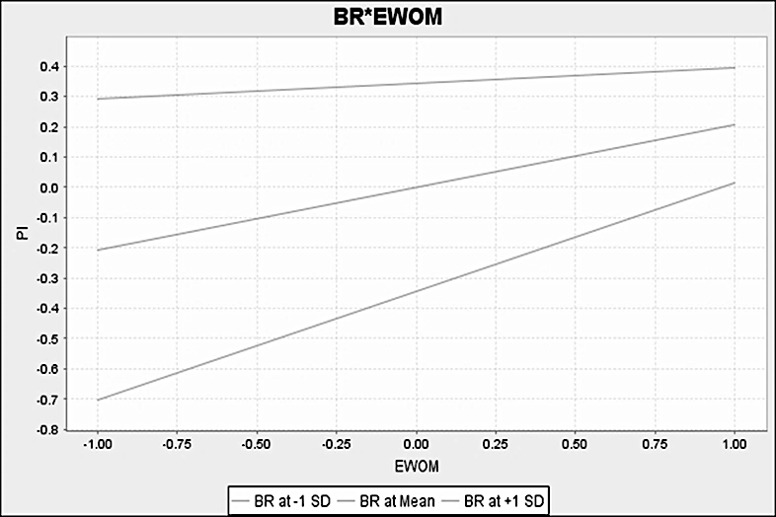
Figure 4. The role of BR moderates the effect of EWOM on PI

5. CONCLUSIONS

5.1 Discussion
This study aimed to investigate the effect of social media usage and E-WOM on conviction. It also explored the subsequent impact on purchase intention and loyalty, with brand reputation serving as a moderator. To achieve this objective, a model based on the Theory of Customers Behavior extension was developed. Other variables were sourced from previous literature to construct the conceptual framework. This study also introduced a new framework to identify the main factors related to the attributes of social media usage and E-WOM on conviction, the impact on purchase intention and loyalty, and the role of brand reputation as a moderator.
Based on a sample of 181 respondents from Jakarta, the study empirically validated that social media broadened opportunities to strengthen relationships with customers, facilitating the engagement in interactive communication. Social media has transformed E-WOM into a pervasive source of information about products or services. This transformation showed the importance of information and necessitated a more in-depth analysis of the most basic communication skills between online buyers and sellers. These skills are fundamental determinants in building trust in online business units and fostering purchase confidence.
The results also showed that social media was a support channel for businesses to build awareness, consideration, and initial purchase intention. Purchase interest relates to the enthusiasm and determination to make purchase decisions and determine the quantity of products required at a particular time. While social media played a significant role in shaping purchase interest, it was not a major determinant, as customers' needs influenced purchase intention. In addition, the volume of E-WOM impacted purchase decisions. The stronger the perceived credibility of online reviews among potential buyers, the higher purchase value.
Analysis showed the importance of trust factor in creating a sense of conviction. E-commerce transactions were dependent on trust, which was the basis of belief. Establishing and maintaining long-term relationships were contingent on trust, serving as a potent driver of repeat purchases, a key indicator of loyalty.
Measuring repurchase intention and WOM could offer insights into the potential loyalty to a particular vendor. In this context, brand reputation refers to customer's perception that brand is reliable and could be developed through advertising, public relations, and quality improvement efforts.
This study showed social media usage and E-WOM were significant factors shaping purchase intention and loyalty, with brand reputation playing a crucial role on e-commerce products. It also contributed to existing literature by describing and understanding customers' interests as well as purchase decision influenced by purchase intention and loyalty through social media and E-WOM.

5.2 Practical implications
The results showed that social media usage positively influenced conviction but negatively affected purchase intention on e-commerce platforms. The highest value was observed for the SMU1 indicator (I use social media to improve my relationship with various e-commerce platforms). Social media served as a communication tool for users to interact and share insights on a wide scale. The e-commerce system facilitated digital transactions for various organizations and individuals, reaching both customers and the broader community and presenting opportunity for market growth. Implementing promotional strategies through social media could improve marketing performance and buying interest. However, the presence of reviews and content containing destructive criticism about an e-commerce platform could deter potential customers due to reliability concerns.
E-WOM positively influenced both conviction and purchase intention on e-commerce platforms. The highest value was recorded for the E-WOM1 indicator (I am proud to tell others on social networks that I use a particular e-commerce platform). E-WOM allowed customers to present opinions and was considered more effective than WOM due to its broader accessibility and reach. Purchase interest represented a phase customer underwent before making purchase decision.
Conviction positively influenced purchase intention and loyalty on e-commerce platforms. The highest value was observed for the CON4 indicator (I get satisfaction by using an e-commerce platform for product or brand purchase). Depending on perceived persuasiveness and informativeness, customers typically searched for and obtained relevant information through product reviews, pricing details, recommendations, and references. Arguments perceived as high-quality, strong, and convincing facilitated customers to gather information during purchase process as well as make decisions based on the belief to buy a particular product. Customers' loyalty is a deep-seated commitment to consistently re-subscribe or repurchase selected products or services in the future, even when situational factors and marketing efforts could potentially induce behavioral changes. Having loyal customers offered several benefits to company, as customers who repeatedly bought a product often transitioned from being merely interested to making actual purchase.
Purchase intention positively influenced loyalty on e-commerce platforms. The highest value was observed for the PI6 indicator (I hope to make more purchase transactions for specific products or brands I buy on the e-commerce platform). Loyalty fostered by e-commerce was decisive for customers to repurchase products. Products offered on e-commerce platforms should meet the expectations of potential buyers to incentivize purchase. Furthermore, excellent and satisfactory service influenced loyalty.
Brand reputation, as a moderator, had a positive and significant effect on the relationship between social media usage, E-WOM, and purchase intention on e-commerce platforms. The highest value was observed for BR3 indicator (the e-commerce platform where I transact makes legitimate claims). A brand with a strong reputation tended to enjoy several benefits, including increased loyalty. Customers who consistently appreciated brand's offerings tended to remain loyal, less likely to switch to competitors, and could recommend brand to friends and family. Social media also served as a platform where both positive and negative information could be easily disseminated. As information consumption habits change, customers inclined to read negative news regarding products or company could increase the rapid spread of information, thereby influencing public opinion. This impact could make subsequent alteration challenging. Therefore, managing brand reputation was crucial to prevent unwanted events. Events, such as lost sales and lack of loyalty allowed individuals to freely express different perspectives on the homepage or in the public space on social media, which was still a dynamic medium.
This study only focused on Jakarta, the capital of Indonesia. Therefore, future investigations were recommended to compare customers behavior across several countries. Investigations in developing countries, where customers might have limited information technology capabilities, could offer avenues for exploring switching costs, inertia, and neuroticism in the future.

6. REFERENCES
[1] S. H. Hsieh, C. T. Lee, and T. H. Tseng, “Psychological empowerment and user satisfaction: Investigating the influences of online brand community participation,” Inf Manag, vol. 59, no. 1, p. 103570, Jan. 2022.
[2] M. Carmona, “The existential crisis of traditional shopping streets: the sun model and the place attraction paradigm,” J Urban Des, vol. 27, no. 1, pp. 1–35, Jan. 2022.
[3] P. K. Kannan and G. Kulkarni, “The impact of Covid-19 on customer journeys: implications for interactive marketing,” J Res Interact Mark, vol. 16, no. 1, pp. 22–36, Feb. 2022.
[4] M. Palmié, L. Miehé, P. Oghazi, V. Parida, and J. Wincent, “The evolution of the digital service ecosystem and digital business model innovation in retail: The emergence of meta-ecosystems and the value of physical interactions,” Technol Forecast Soc Change, vol. 177, p. 121496, Apr. 2022.
[5] D. Tolstoy, E. R. Nordman, S. M. Hånell, and N. Özbek, “The development of international e-commerce in retail SMEs: An effectuation perspective,” J World Bus, vol. 56, no. 3, p. 101165, Apr. 2021.
[6] H. Guven, “Industry 4.0 and Marketing 4.0: In Perspective of Digitalization and E-Commerce,” in Agile Business Leadership Methods for Industry 4.0, Emerald Publishing Limited, 2020, pp. 25–46.
[7] L. Zhou, H. Zhang, and X. Zhang, “Reshaping the central place hierarchy of the urban hotel industry through O2O e-commerce,” Int J Hosp Manag, vol. 109, p. 103389, Feb. 2023.
[8] Y. Zhao, L. Wang, H. Tang, and Y. Zhang, “Electronic word-of-mouth and consumer purchase intentions in social e-commerce,” Electron Commer Res Appl, vol. 41, no. May 2019, p. 100980, 2020.
[9] S. F. Salem, “Do Relationship Marketing Constructs Enhance Consumer Retention? An Empirical Study Within the Hotel Industry,” SAGE Open, vol. 11, no. 2, 2021.
[10] A. Ghahtarani, M. Sheikhmohammady, and M. Rostami, “The impact of social capital and social interaction on customers’ purchase intention, considering knowledge sharing in social commerce context,” J Innov Knowl, vol. 5, no. 3, pp. 191–199, Jul. 2020.
[11] H. N. K. Giao, B. N. Vuong, and T. N. Quan, “The influence of website quality on consumer’s e-loyalty through the mediating role of e-trust and e-satisfaction: An evidence from online shopping in Vietnam,” Uncertain Supply Chain Manag, pp. 351–370, 2020.
[12] S. Champlin, Y. Sterbenk, K. Windels, and M. Poteet, “How brand-cause fit shapes real world advertising messages: a qualitative exploration of ‘femvertising,’” Int J Advert, vol. 38, no. 8, pp. 1240–1263, Nov. 2019.
[13] N. Obermayer, E. Kővári, J. Leinonen, G. Bak, and M. Valeri, “How social media practices shape family business performance: The wine industry case study,” Eur Manag J, vol. 40, no. 3, pp. 360–371, Jun. 2022.
[14] S.-H. Liao, R. Widowati, and Y.-C. Hsieh, “Investigating online social media users’ behaviors for social commerce recommendations,” Technol Soc, vol. 66, p. 101655, Aug. 2021.
[15] A. Ali, W. Bahadur, N. Wang, A. Luqman, and A. N. Khan, “Improving team innovation performance: Role of social media and team knowledge management capabilities,” Technol Soc, vol. 61, p. 101259, 2020.
[16] I. Erkan and C. Evans, “The influence of eWOM in social media on consumers’ purchase intentions: An extended approach to information adoption,” Comput Human Behav, vol. 61, pp. 47–55, 2016.
[17] A. Tandon, A. Aakash, and A. G. Aggarwal, “Impact of EWOM, website quality, and product satisfaction on customer satisfaction and repurchase intention: moderating role of shipping and handling,” Int J Syst Assur Eng Manag, vol. 11, pp. 349–356, 2020.
[18] L.-Y. Leong, T.-S. Hew, K.-B. Ooi, and A. Y.-L. Chong, “Predicting the antecedents of trust in social commerce – A hybrid structural equation modeling with neural network approach,” J Bus Res, vol. 110, pp. 24–40, Mar. 2020.
[19] C. Jiang, R. M. Rashid, and J. Wang, “Investigating the role of social presence dimensions and information support on consumers’ trust and shopping intentions,” J Retail Consum Serv, vol. 51, pp. 263–270, Nov. 2019.
[20] C. P. Furner, J. R. Drake, R. Zinko, and E. Kisling, “Online Review Antecedents of Trust, Purchase, and Recommendation Intention: A Simulation-Based Experiment for Hotels and AirBnBs,” J Internet Commer, vol. 21, no. 1, pp. 79–103, Jan. 2022.
[21] S. Prasad, A. Garg, and S. Prasad, “Purchase decision of generation Y in an online environment,” Mark Intell Plan, vol. 37, no. 4, pp. 372–385, 2019
[22] B. Ahmad and M. I. ud D. Akbar, “Validating a multidimensional perspective of relationship marketing on brand attachment, customer loyalty and purchase intentions: a serial mediation model,” J Strateg Mark, vol. 31, no. 3, pp. 669–692, Apr. 2023.
[23] W. Aslam, A. Hussain, K. Farhat, and I. Arif, “Underlying Factors Influencing Consumers’ Trust and Loyalty in E-commerce,” Bus Perspect Res, vol. 8, no. 2, pp. 186–204, Jul. 2020.
[24] L. Zhu, H. Li, F.-K. Wang, W. He, and Z. Tian, “How online reviews affect purchase intention: a new model based on the stimulus-organism-response ( S - O - R ) framework,” Aslib J Inf Manag, vol. 72, no. 4, pp. 463–488, Jun. 2020.
[25] L. Jiang, T. Eck, and S. An, “A Study on the Effect of Emotional Solidarity on Memorable Tourism Experience and Destination Loyalty in Volunteer Tourism,” SAGE Open, vol. 12, no. 1, p. 215824402210872, Jan. 2022.
[26] A. O. Dandis and M. B. Al Haj Eid, “Customer lifetime value: investigating the factors affecting attitudinal and behavioural brand loyalty,” TQM J, Jun. 2021.
[27] A. Belhadi, S. Kamble, I. Benkhati, S. Gupta, and S. K. Mangla, “Does strategic management of digital technologies influence electronic word-of-mouth (eWOM) and customer loyalty? Empirical insights from B2B platform economy,” J Bus Res, vol. 156, p. 113548, Feb. 2023.
[28] M. T. Febriyantoro, “Exploring YouTube Marketing Communication: Brand awareness, brand image and purchase intention in the millennial generation,” Cogent Bus Manag, vol. 7, no. 1, 2020.
[29] M. S. Nasiri and S. Shokouhyar, “Actual consumers’ response to purchase refurbished smartphones: Exploring perceived value from product reviews in online retailing,” J Retail Consum Serv, vol. 62, p. 102652, Sep. 2021.
[30] W.-L. Lee, C.-H. Liu, and T.-W. Tseng, “The multiple effects of service innovation and quality on transitional and electronic word-of-mouth in predicting customer behaviour,” J Retail Consum Serv, vol. 64, p. 102791, Jan. 2022.
[31] M. S. Siddiqui, U. A. Siddiqui, M. A. Khan, I. G. Alkandi, A. K. Saxena, and J. H. Siddiqui, “Creating Electronic Word of Mouth Credibility through Social Networking Sites and Determining Its Impact on Brand Image and Online Purchase Intentions in India,” J Theor Appl Electron Commer Res, vol. 16, no. 4, pp. 1008–1024, Mar. 2021.
[32] P. et Al., “Purchase decision of generation Y in an online environment. Marketing Intelligence & Planning,” vol. 37, no. 4, pp. 372-385., 2019.
[33] N. K. Malhotra, D. Nunan, and D. F. Birks, Marketing Research: An Applied Approach. 2017.
[34] G. Kock, N., & Lynn, “Lateral Collinearity and Misleading Results in Variance-Based SEM: An Illustration and Recommendations.,” J Assoc Inf Syst, 2012.
[35] J. F. Hair, W. C. Black, B. J. Babin, and R. E. Anderson, “Multivariate Data Analysis,” Hampshire, United Kingdom, 2019.
[36] Kock, “Advanced Mediating Effects Tests, Multi-Group Analyses, and Measurement Model Assessments in PLS-Based SEM,” Int J e-Collaboration, 2014.

