Usability Evaluation of an Eye-Tracking in Batik E-commerce Web-Based Systems
Nova Suparmanto
Gadjah Mada University
novasuparmanto@mail.ugm.ac.id
Anna Maria Sri Asih
Gadjah Mada University
amsriasih@ugm.ac.id
Andi Sudiarso
Gadjah Mada University
a.sudiarso@ugm.ac.id
Titis Wijayanto
Gadjah Mada University
twijaya@ugm.ac.id
Paulus Insap Santoso
Gadjah Mada University
insap@ugm.ac.id

ABSTRACT
Online developments are promoting various store businesses to establish online stores or E-commerce, including the buying and selling of batik products. Batik, a globally recognized masterpiece of Indonesian cultural heritage, is still crafted by Small-Medium Industries (SMIs). Despite the considerable enthusiasm for batik, SMIs in this field face technological constraints. The application of eye-tracking methodology and usability testing has not been explored in the context of batik e-commerce. Therefore, this study aimed to explore the world of batik E-commerce websites. Usability assessments were conducted using methods comprising users, evaluators, and Webcam Eye-Tracking software. A total of two batik E-commerce websites were selected for this exploration, of which one is already established, while the other is still recent, both offering ready-to-sell products. The results of usability testing, based on performance metrics, indicated that Danar Hadi and Butimo showed similar performance in terms of time-on-task, efficiency, and errors. Moreover, both websites achieved an "Acceptable" rating in satisfaction tests. Statistical analysis showed no significant gender-based differences in the usability aspects tested. Proposed enhancements, informed by performance analysis, heatmaps, and gaze replay data, consisted of improvements to the main menu section and the payment platform icon section. Furthermore, it was recommended to optimize advertisement placement on batik E-commerce website using an Area of Interest (AOI) analysis.
Keywords: E-commerce, Batik, Usability, Webcam, Eye-tracking, Behavior of Users

1. INTRODUCTION
Batik is one of the masterpieces of art worldwide, recognized as part of Indonesian cultural heritage. In addition, it significantly influences the growing demand for batik products and the proliferation of industry. The development of batik industry has witnessed substantial growth and its impact, combined with the movement towards the digital era, certainly presents a challenge for the industry to compete on the global stage. The integration of technology into various sectors, namely E-commerce, offers numerous advantages and conveniences. Entrepreneurs can leverage the opportunities presented by this digital era to connect with potential customers more effectively. However, the quality of E-commerce implementations in several Small and Medium Industries (SMIs) remains very low due to various factors, including usability concerns.
The most critical factor determining the value of a website is usability [1]. In recent years, many E-commerce websites have placed a strong emphasis on usability [2], which measures the ease of use. Usability assessments can be conducted by users, evaluators, or software tools [3]. When an E-commerce website lacks good usability, users may require an extended period to learn its functionality. It is crucial to acknowledge that low usability often drives users away from the platform [4] E-commerce websites should empower users to efficiently, effectively, and adequately achieve their objectives. In the course of E-commerce development, a usability evaluation becomes imperative to identify issues in product usage and ensure that the design and features of the E-commerce website meet users' needs when purchasing batik products.
Usability evaluation plays a crucial role in detecting users’ problems, constraints, and glitches when interacting with a system, in accordance with ISO 9241-11 [5]. This directly impacts the number of customers who decide to shop through an E-commerce website. This study aims to conduct usability testing, using eye-tracking technology, on both existing and forthcoming batik E-commerce products. The reference to existing platforms includes renowned Indonesian batik brands such as Danar Hadi, which enjoy widespread popularity.
Eye-tracking functions as a valuable method for enhancing usability [6]. This method has been recognized in decision and behavioral science due to its ability to provide detailed insight into the decision-making process [7, 8]. Its application extends to various areas, including the examination of new product development, product presented in retail settings [9-12], analysis of YouTube visitors' fixation patterns on ad banners [13], evaluation of website landing pages [14], assessment of college website [15], observation of facial expressions during face-to-face conversations [16], and exploration of multiple disciplines.
Cruyssen et al. [17] emphasized that online eye-tracking studies, focusing on relatively significant effects and did not demand exceedingly high precision (such as studies comprising four or fewer major AOI), could be conducted using respondents' webcams. Schröter et al. [12] investigated the suitability of webcam eye-tracking in understanding the impact of external factors on the visual attention of customers visiting online clothing shops. Since the various stages leading to customers’ purchase necessitate visual attention, gaze behavior could be considered critical in this context [18]. Advancements in online study methodology suggest that webcam eye-tracking systems can yield data quality comparable to those obtained in traditional lab settings [19]. Online eye-tracking reduces barriers for studies seeking to incorporate eye-tracking when carrying out investigations [20].
Several advantages of online eye-tracking over in-lab eye-tracking are stated by Hausfeld et al. [21]. In comparing online webcam and laboratory-based eye-tracking, Banki et al. [22] proposed that online eye-tracking was very good for assessing infants' gaze behavior but necessitates vigilant data quality control, affirming its feasibility in behavioral study.
In the domain of computer science, web-based eye-tracking, such as GazeRecorder [23] and WebGazer (Papoutsaki et al. [24]) have been developed. However, the use in behavioral studies remains constrained by challenges related to calibration, inconsistent temporal resolution (Semmelmann and Weigelt [19]), and integration into experimental software. Additional concerns with online eye-tracking relate to user/subject requirements. In a laboratory setting, individuals can control factors such as computer and camera quality, lighting, and subject positioning. This is different from online scenario leading to limited control over these variables. Consequently, efforts have been put together to improve the algorithms for gaze location determination in the aspect of computer science (Valliappan et al. [25]).
To address the previous challenges, the objective is to establish fundamental prerequisites and clear procedures for subjects to follow, ensuring optimal data quality. Subjects need to understand that they are not under surveillance, thereby safeguarding privacy, as individual images and videos remain confined to each respective computer. The goal is to assess the suitability of webcam eye-tracking in examining the simultaneous impact of various design elements within an online store on the visual attention of potential buyers, particularly within the context of online batik e-commerce. A limited study attempted to comprehend the behavior of users in E-commerce batik website through the use of webcam eye-tracking. However, this paper contributes to the body of knowledge in the domain of E-commerce and webcam eye-tracking. Recommendations are also provided to enhance the experience of users on batik platforms.

2. LITERATURE REVIEW
This literature review serves as a valuable reference for conducting other studies. It comprises scientific journals that form a framework (mapping), aiding in the identification of novelties or gaps in prior explorations relevant to current studies.
  - E-commerce Website
E-commerce, as defined by Turban et al., is the process of buying, selling, or exchanging products, services, and information through computer information networks, specifically the Internet. Also, Business to Customers (B2C) is an online sales targeting individual customers [26]. Laudon and Laudon [27] defined E-commerce as the use of the Internet or website for transactions, accompanied by the use of other electronic devices. Combining these two definitions, it can be concluded that E-commerce consists of transaction activities conducted by customers using electronic devices connected to the Internet. Batik E-commerce website facilitates transactions including ready-to-sell batik products.
  - Usability Evaluation
In accordance with ISO 9241–11:2018 [28], usability relates to the outcomes of interactions with systems, products, or services and is not merely an attribute of a product. Usability extends beyond the commonly understood concepts of "ease-of-use" or "user-friendliness." In addition, this concept plays a crucial role in detecting users’ problems, constraints, and frustrations during interactions with a system, necessitating usability evaluation. Nielsen defined usability as a quality attribute that reflects how easy an interface is to use. It is also considered a method for enhancing interface usability during the design process.
However, Cato [29] viewed usability as the capability for users to perform desired actions and not imposed tasks. Usability, derived from the term "usable," implies that customers can effectively use a product or service [30]. This phenomenon can be considered effective when it minimizes usage failure, offers benefits, and satisfies users. Products or services are considered usable when users can perform tasks without obstacles, doubts, or questions. The purpose of usability testing is to verify whether an application is in line with users' needs.
Schneiderman and Plaisant [31] identified five quality components of usability, namely Learnability, Efficiency, Memorability, Error Reduction and Security, and Satisfaction, assessed using the System Usability Scale (SUS) method [32]. SUS uses a ten-item questionnaire with five response options, ranging from strongly agree to strongly disagree, to evaluate the usability of various software and hardware devices. With a history of approximately 30 years, SUS is a reliable and extensively referenced tool for assessing diverse products and systems [33, 34]. Usability remains a significant challenge for E-commerce websites due to failure to meet established standards [35]. Understanding the design elements contributing to effective web design still relies heavily on managerial intuition or, at best, ad hoc A/B testing [36]. Usability challenge faced by websites may result from task-related factors affecting end users, including response time, presentation quality, and navigability [37]. This aspect has proven to be a critical factor in the success of E-commerce ventures.
  - Webcam Eye-Tracking
Eye-tracking requires recording the position and movement of the eye in an environment by tracking corneal reflections, enabling the assessment of visual attention. The Human-Computer Interaction (HCI) study focuses on how computers are used and designed, as well as their interaction with people. From laptops and tablets to smartphones and beyond, technology usage can be evaluated by measuring individuals’ visual attention to these devices [38]. The field of usability and users’ experience testing, which is rapidly expanding, uses eye-tracking as an evaluation approach. Eye-tracking for website testing is a common strategy for understanding how a website is viewed and used. This type of investigation is increasingly integrated into both commercial and academic usability testing practices [39].
Eye-tracking offers a unique method to observe how human attention is distributed externally. By identifying where a person looks, scientists can determine what guides human visual attention [19]. This observation is facilitated through gaze replays, gaze plots, heat maps, and Area of Interest (AOI). According to Pernice and Nielsen [40], gaze replays allow for reviewing eye movements during tests to understand what users are observing. Gaze plots show the sequence of movements, fixation points, and eye transitions between fixations within the observed image. Heat maps describe the areas in an image where users’ visual attention is most concentrated. According to Holmqvist et al. [41], AOI identifies the regions with the highest visual concentration and allows for an objective analysis of the display.
Traditional eye-tracking studies require in-person interaction between the person conducting the research and the respondents. However, webcam eye-tracking offers an alternative to infrared eye-tracking for examining how product presentation aspects affect customers' visual attention [12]. This approach can address logistical, economic, and organizational challenges. The facility needed for this technology to function is a webcam and software, which assists in reaching a larger pool of potential volunteers who might otherwise be too geographically distant [42]. Recently, many computers or laptops have come equipped with built-in webcams, enabling respondents to engage in webcam eye-tracking studies from the comfort of their homes, using personal equipment and without the need for in-person interaction with an expert. This approach also eliminates health risks associated with infrared light and reduces infection risks, specifically in times of a pandemic.
  - Eye-Tracking Software
Using online webcam eye-tracking requires the support of specialized software. Eye-tracking software is a technology that empowers computers and machines to determine where a person is directing their gaze using cameras or sensors. These cameras and sensors detect changes in the distance between persons’ pupils and calculate movements including their eyelids, corneas, and related components. With this data, it is easy to observe and analyze patterns of visual attention, including where individuals look and how long they focus on specific objects. Various studies used WebGazer ([19], [20], [42], [43]), an eye-tracking library tool highly regarded among behavioral scientists.
Conducting various scientific experiments can be fulfilling, but achieving the desired result will not be possible without the appropriate equipment. Moreover, due to the growing interest in technology, there is currently a range of software options available to simplify this task, including GazeRecorder. Eye-tracking technology enables individuals to observe how individuals view web pages, advertisements, or images. As opposed to traditional eye-tracking, which necessitates specialized equipment and inviting respondents to laboratories, GazeRecorder can track the eye movement of individuals using their personal computers at home. This application features a user-friendly interface and several useful functions, making it accessible to a broad audience.
GazeRecorder software is one of the tools capable of providing metric analysis based on data collected from eye-tracking tests, achieved by creating AOI on available media [44]. GazeRecorder is a free eye-tracking software compatible with Windows and operates by tracking the eyes and faces of the users while recording the movements on the screen. It functions effectively in varying lighting conditions and even when users’ face is partially obscured. Additionally, it serves as a cloud-based eye-tracking resourceful platform for remote behavioral investigations [23]. This cloud-based system allows for testing individuals from anywhere, at any time. Test respondents only need to share their webcam and view the provided content, with the rest being handled by the platform. The eye-tracking model uses self-calibrates by observing web visitors interact with web pages and establishes a mapping between eye features and screen positions. The key features of this platform include:
- Real-time gaze prediction on most commonly used web browsers.
- There is no need for special hardware, as WebGazer.js uses users’ webcam.
- Self-calibration, based on clicks and cursor movements of users.
3. METHOD
  - Study Methodology
This study focused on SMIs Butimo batik e-commerce, one of the developing batik industries in the Yogyakarta Special Region of Indonesia. Yogyakarta is known as a hub for the batik industry, thereby earning the title of the "world batik city." Butimo featured comprehensive production facilities and abundant resources that supported this study. Batik Danar Hadi was used as a reference for the existing products, a well-known brand in Indonesia. Two usability methods were used, namely users testing and webcam eye-tracking. The objective behind these two usability methods was to extract benefits for improvement, development, and product design, while gathering valuable user feedback. The study workflow could be seen in Figure 1.
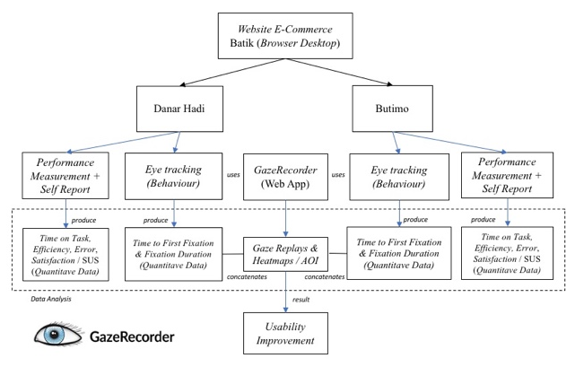
- Study Methodology
This study used GazeRecorder software with the webcam function to monitor respondents' eye movements. Respondents were required to use a computer and webcam for this study, which made it accessible from any location through a stable Internet connection. The web portal facilitated access to results and enabled evaluation at the investigator's convenience. Usability test for batik E-commerce website began with an explanation of eye-tracking. Subsequently, respondents were presented with a task scenario to evaluate website usability.
The online webcam eye-tracking experiment commenced with a calibration procedure provided by the GazeRecorder software. Respondents then performed tasks within the system and completed the SUS questionnaire to evaluate the batik E-commerce website. After the test, an interview was performed regarding the experience of using the website. This was achieved through the playback of video gaze replays and the recording of Zoom sessions. This process allowed for identifying usability issues and necessary system performance enhancements [45]. GazeRecorder experiment consisted of three stages, as shown in Figure 2.

- Experimental Stages
Before commencing data collection, it was imperative to establish the dedicated setups for webcam eye-tracking. Obtaining eye-tracking results comprised three stages, adapted from GazeRecorder [23] and Khosravi et al. [43].
- Setup Study: Selection of ready-to-use solutions from the library and integration into the method. GazeRecorder was designed to handle various types of content, including banners, videos, and live web pages (Figure 3).
- Launch Experiment: Collection of customers’ perspectives online using the provided link, allowing engagement with testers worldwide. Testers only required a computer with a webcam (Figure 3).
- Analyze Results: Review individual and aggregated visualizations to measure customers’ attention and engagement. This approach facilitated UX study for both desktop and mobile platforms, performed remotely. High-quality session recordings were obtained, providing a firsthand perspective of users' experiences.
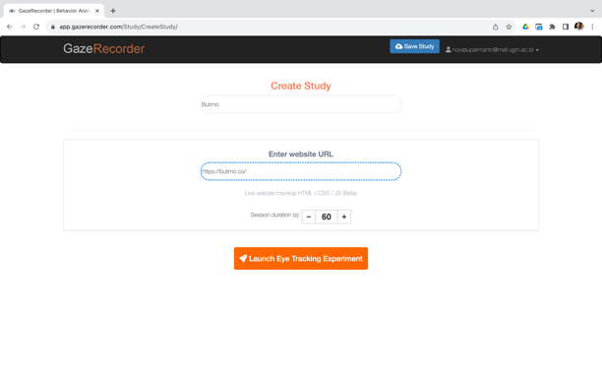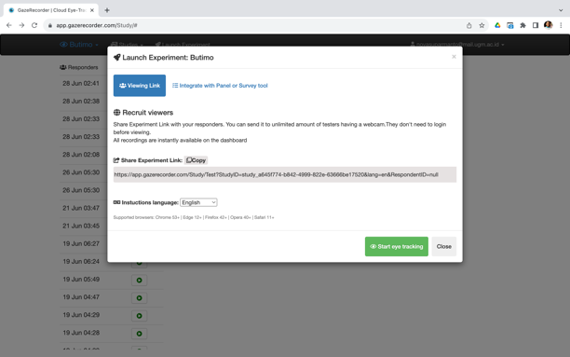
- Setup Study & Launch Experiment GazeRecorder
This study comprised 20 respondents, which is consistent with the guidelines from "Eye-Tracking Web Usability" by Nielsen and Pernice [46]. This respondent number enabled an in-depth analysis of eye movement heat map and the data was shown in Table 1.
Table 1. Study Data
No | Section | Description
1. | Object | Danar Hadi & Butimo E-commerce Website (Browser Desktop)
2. | Method | - Webcam Eye-Tracking (Quantitative)
2. | Method | - Performance Measurement & Self Report/SUS Questionnaire (Quantitative) [47]
3. | Variable | Website developed (Butimo) & Popular/Existing (Danar Hadi), Gender (Men & Women)
4. | Respondent | 20 people, 10 men & 10 women
4. | Criteria | Accustomed to using computers and the Internet, as well as conducting transactions in E-commerce at least once a month
  - Usability Attributes
The method for measuring performance, known as users testing, comprises evaluating usability by directly testing product users to gather documentation or evidence of a product's acceptability. This process also collected input on how users interacted with the product. This testing was guided by usability principles and test metrics, as shown in "Eye-Tracking Web Usability" by Nielsen and Pernice [46], shown in Table 2.
Table 2. Usability Attributes
No | Section |  |  | Description
1. | Metrics
a. | Eye-tracking (Behavior)
 | gaze replay |  |  | It is possible to repeat eye movements during the test.
 | time to the first fixation |  |  | Measuring the length of time, it takes for respondents to fixate on AOI for the first time.
 | fixation duration |  |  | Measures the duration for each fixation that occurs in AOI, dwell time.
b. | Performance
 | time on task |  |  | Measure how much time it takes to complete a task.
 | efficiency |  |  | Time required to meet the needs of users. Efficiency is calculated by comparing the number of respondents who complete the task under the standard time with the number of respondents who complete the task.
 | error |  |  | The number of errors using the product and how users can correct the errors.
c. | Self-report |  |  | SUS questionnaire to measure the level of satisfaction (Users’ Subjective Satisfaction) [32], [47]
2. |  | Task | - Task I: browse web pages for 20 seconds.  - Task II: read the title of the batik product that has the lowest price.  - Task III: search for batik product titles with black/brown color  - Task IV: look for payment info and social media use.
3. |  | Tools & Materials | GazeRecorder, Computer/Laptop min 11" with Webcam, resolution of at least 1,080 × 720px. Internet Connection, Zoom.
  - Eye-Tracking Metrics
Eye-tracking offered a unique ability to quantify visual attention, objectively tracking where, when, and what people focused on [38]. According to Zhu and Lv [48] eye-tracking metrics included:

Physiological Indicators and Visualization
- Trajectory map and heat map
A trajectory map is a visual form of eye-tracking. Furthermore, it generated a gaze sequence by recording the position and duration of eye fixation, providing a visual representation of the gaze position and corresponding time in an observation [48]. Heat maps divided the scene into grids and assigned a numerical value to the length of eye fixation time on each grid, with warmer colors indicating higher values (yellow, reddish) and cooler colors indicating lower values (green, blue). The maps were essential as they revealed a subject's attraction to specific stimuli. Heat maps provided rich information for analyzing thought processes when presented with images, videos, objects, or environments in comparison to other stimuli during the dynamic gaze process. The maps could be either static or dynamic aggregations of gaze points and fixations, showing the distribution of visual attention [38].
- AOI and sequence analysis
Specific target areas were selected to use AOI statistics as a functional indicator in eye-tracking systems, and eye-tracking indicators were extracted for analysis. By designating one or more specific areas within the stimulus as objects, it became possible to assess the performance of multiple areas within the same scene. This was done by conducting AOI data statistics and visual analysis of individual gaze time and frequency indicators for each area.
When individuals interacted with stimuli, such as web pages or HCI interfaces, AOI sequence analysis primarily examined how the eyes focused on different AOIs. For example, when studying users' browsing habits on waterfall flow website, the page was divided into four AOI, namely image display area, text area, view information, and comments. Analyzing the corresponding AOI sequences could visually represent and statistically analyze the attention order data of multiple subjects. AOI analysis was particularly useful for understanding the behavior of users concerning the order in which they focused on AOI, such as the text area, image display area, and detailed view area.

Data Indicators and the Significance
- Time to First Fixation (TTFF)
TTFF is the duration needed to focus on a specific AOI after the stimulus has been initiated. This phenomenon exposes the significance and attraction of spatial features and indicates both attention and stimulus-driven search with bottom-up cognitive inertia. Despite being a fundamental eye-tracking indicator, TTFF offers substantial value as it shows the prioritization of specific elements within the visual scene.
- First Fixation Duration (FFD)
During the exploration of a visual scene, attention is directed to a particular image area through fixation. FFD quantifies the seconds taken for the initial fixation on AOI, reflecting the distinguishability of spatial elements within the scene [49]. When combined with TTFF, FFD enhances information conveyance, marking a scene's initial point of attention. Brief TTFF and extended FFD suggest the unique attention-grabbing quality of the area.
- Average Fixation Duration
Provides an understanding of the typical length of attention allocated to an area. A significant comparison in average fixation duration between two images may signal areas worthy of deeper investigation. Furthermore, by comparing AOIs, this metric discerns which areas hold superior importance to others [50].
- Dwell Time
Dwell Time quantifies the cumulative attention duration directed toward AOI by respondents. This phenomenon reflects the appeal of elements to viewers and signifies the total time dedicated to engaging with an element after it captures attention.
  - Calibration and Validation
Clear instructions on positioning were furnished before the commencement of the calibration validation process. For example, respondents were directed and positioned to face the webcam, ensuring the full visibility of the faces. Specific directives as seen in Figure 4., included:
- Positioning light sources in front of them, not behind, for optimal visibility.
- Avoiding seating with a window behind them.
- Exclusively using eye movements to gaze at the screen.
After following these instructions, test respondents granted the camera access to GazeRecorder. Subsequently, individuals encountered a screen displaying live video from a webcam, allowing the adjustment of their positions accordingly. After being positioned suitably, respondents progressed to the calibration and validation phase, which comprised the subsequent steps, as shown in Figure 4.
- An initial video stream appeared in the upper center of the screen. Respondents used this feedback to center their faces within a green box at the video center.
- Progressing to the next stage was facilitated by pressing the space bar.
- Calibration included the presentation of 16 calibration dots on the screen, each displayed for three seconds. Respondents simply focused on each dot until it vanished.
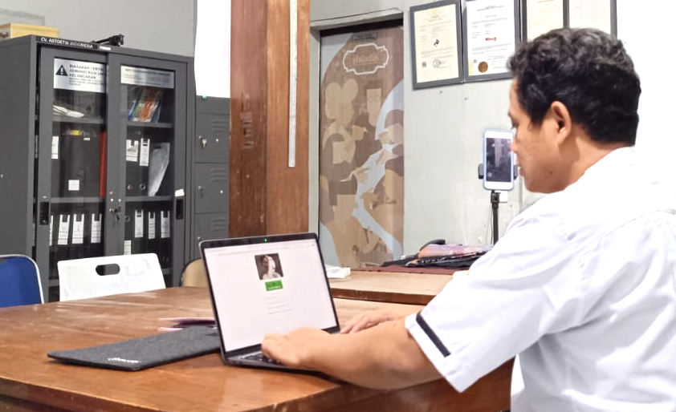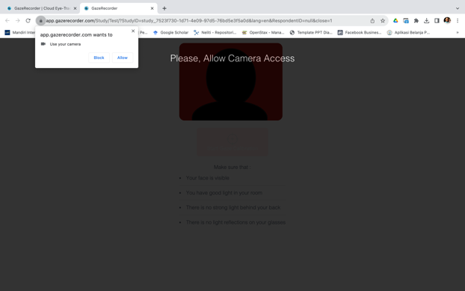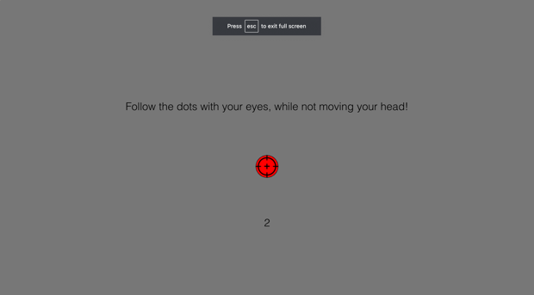
- GazeRecorder Calibration and Validation Process
Respondents then entered the validation procedure, mirroring the calibration process with the following distinctions:
- Each validation dot remained visible for two seconds.
- GazeRecorder recorded 100 measurements within this two-second interval (one measurement every 20 ms). The initial 500 ms measurements were excluded to account for gaze transitions.
- Any measurement within X pixels of the dot center was categorized as a successful hit (X increased with each unsuccessful calibration/ validation attempt, as elaborated below).
- A dot turned green when at least 80% of the measurements were hit, indicating validity. Otherwise, it turned yellow (respondents were instructed to strive in order to turn every dot green).
- The experiment proceeded from the 16 validation dots when the proportion of valid dots reached at least Y.
- Respondents had three opportunities to pass the initial calibration + validation task.
In this study, the adopted method granted patients who are poorly calibrated the opportunity to reposition and make another attempt. This is based on the fact that some respondents could make significant adjustments to their setups in order to meet strict requirements. The method facilitated an assessment of whether the initial calibration attempt influenced subsequent outcomes. To establish context, the following briefly outlines a typical eye-tracking procedure used in a traditional laboratory setting. For example, an eye-tracking camera was positioned between the subject and the computer screen, either above or below. Subjects were seated, often with their heads immobilized in a chinrest to minimize head movements during the experiment.
4. RESULTS AND DISCUSSION
  - Analysis of Performance Measurement

Time on Task
Table 3. shows the average task completion times for both batik E-commerce website and the results of gender comparison.
Table 3. Task Completion Time
No | Task | Batik E-commerce |  | Gender
No | Task | Danar Hadi (s) | Butimo (s) | Men (s) | Women (s)
1 | Task 1 | 19,91 | 20 | 20,31 | 19,41
2 | Task 2 | 7,71 | 9 | 8,61 | 8,04
3 | Task 3 | 6,80 | 7 | 7,54 | 5,88
4 | Task 4 | 9,37 | 8 | 8,56 | 9,57
 | Average | 10.95 | 11.03 | 11,25 | 10,72
The average task completion time (10.95 seconds) proposed by Danar Hadi slightly exceeded Butimo (11.03 seconds). Meanwhile, concerning gender disparities, women required less time on average (10.72 seconds) compared to men (11.25 seconds).

Efficiency
Table 4. shows the results of the time required to fulfill users’ needs and the corresponding efficiency percentages for Batik Danar Hadi.
Table 4. Efficiency (Danar Hadi)
No | Task | Completion Rate | Task Time (minute) | Efficiency
1 | Task 1 | 100% | 3,32 | 30%
2 | Task 2 | 80% | 1,29 | 62%
3 | Task 3 | 100% | 1,13 | 88%
4 | Task 4 | 95% | 1,56 | 61%
Table 5. showed the outcomes for Batik Butimo and the data indicated that Batik Danar Hadi recorded slightly higher efficiency values than Butimo for Tasks 2 and 3. However, for Task 4, Butimo slightly outperformed Danar Hadi. In Task 1, the average time required and the efficiency value were nearly identical, at 30%.

Table 5. Efficiency (Butimo)
No | Task | Completion Rate | Task Time (minute) | Efficiency
1 | Task 1 | 100% | 3,29 | 30%
2 | Task 2 | 95% | 1,55 | 61%
3 | Task 3 | 95% | 1,11 | 86%
4 | Task 4 | 90% | 1,41 | 64%

Error
Table 6. showed the results of calculations regarding the number of respondents encountering errors during the tasks. The most prevalent error occurred in Task 2 due to the image display being too small, rendering it illegible. In Task 4, errors originated from exhausting the allotted time, and the average error rate for Danar Hadi (6.25%) was marginally higher than Butimo (5%).
Table 6. Number of Errors
Task | Number of Error Respondents
Task | Danar Hadi | Butimo
1 | 0 | 0
2 | 4 | 1
3 | 0 | 1
4 | 1 | 2
Error rate | 5 of 80 = 0,0625 (6,25%) | 4 of 80 = 0,05 (5%)

Satisfaction
The evaluation of satisfaction was conducted using the SUS questionnaire, consisting of 10 questions. The results, shown in Table 7., indicated that the average SUS score for both Danar Hadi and Butimo respondents fell within the "Acceptable" category, based on Brooke [35], with scores surpassing 70 or receiving a "Good" grade in category C.
Table 7. Satisfaction Test Result
Respondent | SUS Score Average | Category
Danar Hadi | 76,25 | Acceptable
Butimo | 76,125 | Acceptable
  - Analysis of Eye-Tracking Results

Area of Interest (AOI)
AOI analysis was conducted to assess ad placement on the homepage. Matrices, specifically the "time to first fixation" and "fixation duration," were used during the implementation of Task I. The "time to first fixation" matrix served to measure the effectiveness of advertisement, promo, essential information, and primary product placement by monitoring the number of views in each area.
The "fixation duration" matrix was used for the examination of AOI content. Given the brief fixation duration on an area, it was imperative to design displays with concise, engaging, and uncluttered information.
Eye-tracking results were described as heat maps generated by GazeRecorder, exemplified in Figure 5. In Danar Hadi heat map shown in Figure 5(a), three areas showed the highest frequency of fixation:
Area 1: The section menu logo & header.
Area 2: The section navigation category.
Area 3: The product list section.
During Task I, respondents were allotted time to explore the website and discover products of interest within the category section (Area 2). Transitioning to Butimo heat map shown in Figure 5(b), three areas with the most fixation were identified:
Area 1: The section logo and top menu (header).
Area 2: The product list section.
Area 3: The section bottom menu (footer).
In Task I for Batik Butimo, respondents explored the website to find products of interest by examining the category section (Area 1). The figure below provided valuable explanations through a color-coded scheme in heat maps. These visual representations showed elements that drew respondents’ attention. Red areas signified a high number of gaze points, indicative of heightened interest, while yellow and green areas suggested fewer gaze points, reflecting lower engagement. It was also observed that areas lacking coloring went unnoticed completely.
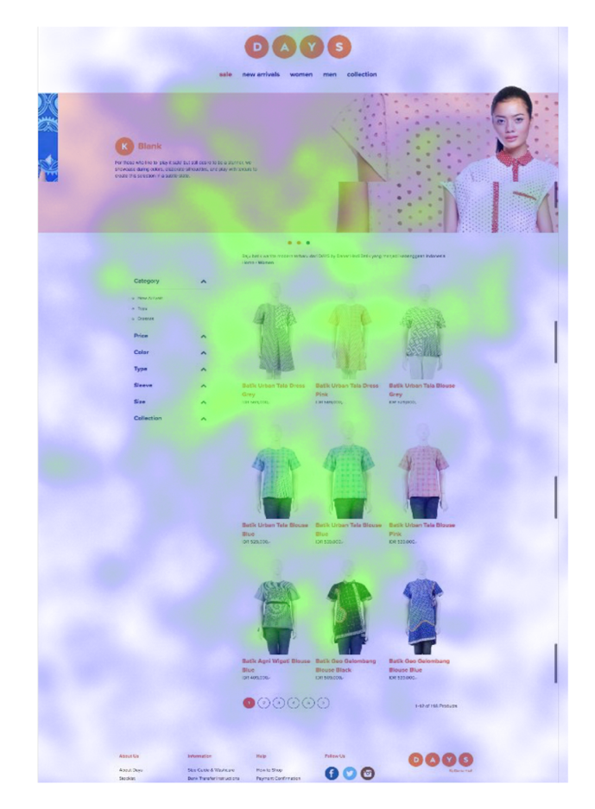  Area 1  Area 2  Area 3  (a) | 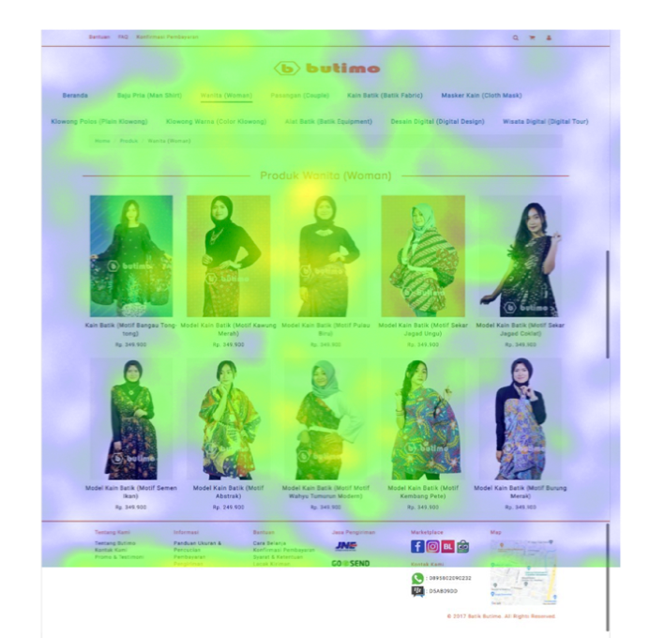  Area 1  Area 2  Area 3  (b)
- (a) Batik Danar Hadi Heat Map, (b) Batik Butimo Heat Map
According to Figure 5., E-commerce websites needed to consider integrating human models in order to capture increased customer attention. Human models should be chosen over torso mannequins for product display to enhance the sales of specific products. In cases where no product required emphasis, a uniform presentation was maintained. Displaying all clothing items on models provided a competitive advantage over other online stores, simplifying buyers' assessments of fit and purchase decisions.

GazeReplay
The analysis of eye-tracking results comprised the examination of gaze replays, providing information regarding the visual patterns of respondents. A gaze plot, exemplified by an individual respondent, showed eye movements. GazeRecorder software facilitated the replay of eye movements during the test for all respondents, as shown in Figure 6.
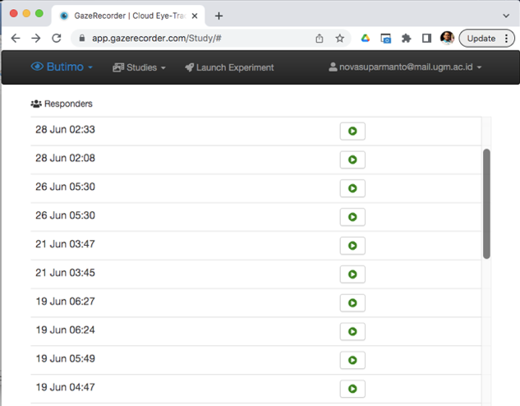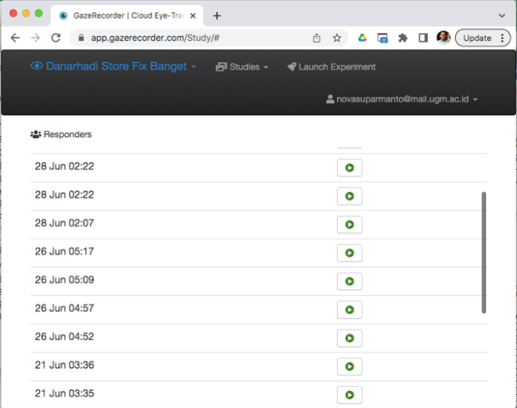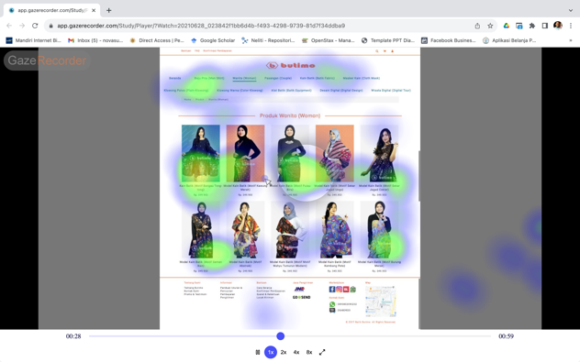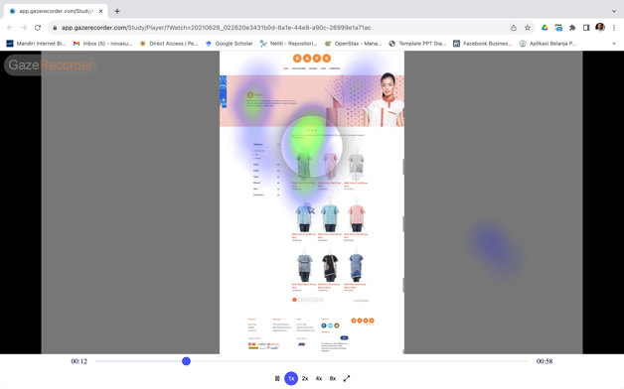
- GazeReplay Data (GazeRecorder)

The gaze replay video analysis results were summarized in Table 8 below.
Table 8. GazeReplay Data Results
No. | GazeReplay of Danar Hadi
1. | The writing on the title and product price is not clear
2. | The list of products shown on 1 page is enormous
3. | Respondents have difficulty distinguishing colors and price numbers on products
4. | Respondents are not interested in seeing shopping information at the bottom (footer)
 | GazeReplay of Butimo
1. | Respondents have difficulty finding information about product payments and business info
2. | The writing for the payment method is less clear
3. | Respondents have difficulty distinguishing colors and price numbers on products
4. | Respondents are not interested in seeing the main menu at the top (header)
The results of the gaze plot calculations using GazeRecorder were shown in Figure 7. A gaze plot provided several pieces of data, including "time to first fixation" (measuring how long it took for respondents to fixate on an AOI for the first time), "fixation duration" (measuring the duration of each fixation that occurred in an AOI, also known as dwell time), and the number of respondents who observed each area.
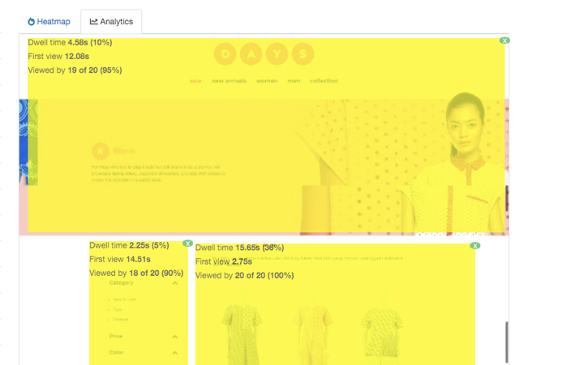  2  1  3  4  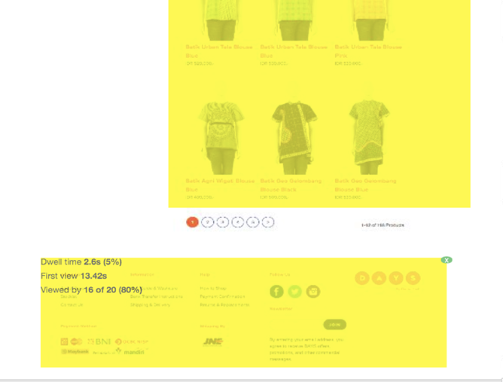  (a) | 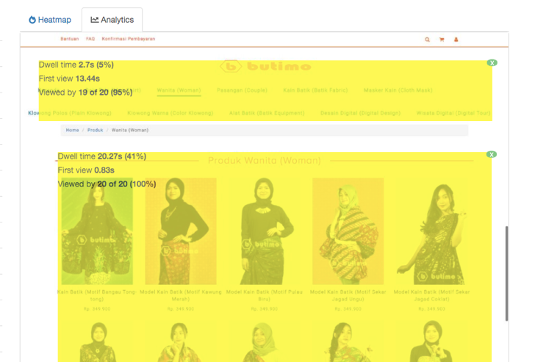  1  2  3  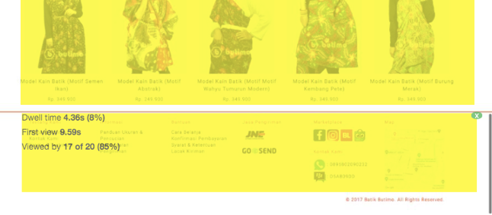  (b)
- (a) Batik Danar Hadi Gaze Plot, (b) Batik Butimo Gaze Plot

The analysis of the gaze replay results on Danar Hadi resulted in the following:
- According to the results, most respondents first focused on Area 2.
- The fixation duration matrix showed the number of times fixation occurred in each AOI and the average duration of each fixation in AOI. Area 3 attracted the longest attention because of its size and central position on the homepage, while Area 2 received the least attention from users.
The gaze plot time calculation results were shown in Table 9 below.
Table 9. GazeReplay Time Results
Area | Metric | Danar Hadi | Butimo
Time to First Fixation
Area 1 | Total (respondent) | 19 | 19
 | Average (seconds) | 12,08 | 13,44
Area 2 | Total (respondent) | 18 | 18
 | Average (seconds) | 14,51 | 0,83
Area 3 | Total (respondent) | 20 | 17
 | Average (seconds) | 2,75 | 9,59
Area 4 | Total (respondent) | 16 | -
 | Average (seconds) | 13,42 | -
Fixation Duration
Area 1 | Average/dwell time (seconds) | 4,58 | 2,7
Area 2 | Average/dwell time (seconds) | 2,25 | 20,27
Area 3 | Average/dwell time (seconds) | 15,65 | 4,36
Area 4 | Average/dwell time (seconds) | 2,6 | -
Based on the analysis of the gaze replay results on Butimo, the following were recorded:
- The results indicated that most respondents initially focused on Area 1.
- The fixation duration matrix showed the number of times fixation occurred in each AOI and the average duration of each fixation in AOI. Area 2 captured viewers' attention for a very long time due to its size and central location on the homepage, while Area 1 received the least attention from users.
  - Statistics Test Based on Gender
- Descriptive Test
The descriptive test results are shown in Table 10. Based on Table 10, the Men Completion Rate was higher (98.75) than the Women Completion Rate (90.00). Men also achieved a higher SUS Score of 76.25 compared to women, who achieved 76.125. In terms of Efficiency, Men scored 61.50, which was higher than Women (60.25), and Men also recorded a higher Time of 1.8750 compared to Women with a value of 1.7850.

Table 10. Descriptive Test Results
 | N | Min | Max | Mean | Std. Dev
Time (Men) | 4 | 1.26 | 3.38 | 1.8750 | 1.00653
Time (Women) | 4 | .98 | 3.23 | 1.7850 | .99534
Completion Rate (Men) | 4 | 95 | 100 | 98.75 | 2.500
Completion Rate (Women) | 4 | 80 | 100 | 90.00 | 9.129
Efficiency (Men) | 4 | 30 | 80 | 61.50 | 21.810
Efficiency (Women) | 4 | 31 | 97 | 60.25 | 27.439
SUS Score (Men) | 1 | 76.250 | 76.250 | 76.25000 | .
SUS Score (Women) | 1 | 76.125 | 76.125 | 76.12500 | .
- Wilcoxon Difference Test
Different tests were conducted in this study using Wilcoxon because the data did not follow a normal distribution. The objective was to determine whether there were any differences between various aspects within each group. The test results were shown in Table 11.
Table 11. Wilcoxon Differential Test Results
Aspect | Group | Sig. | Limit | Description
Time | Men | 0.465 | < 0.05 | There is no difference
Time | Women | 0.465 | < 0.05 | There is no difference
Completion Rate | Men | 0.102 | < 0.05 | There is no difference
Completion Rate | Women | 0.102 | < 0.05 | There is no difference
Efficiency | Men | 0.854 | < 0.05 | There is no difference
Efficiency | Women | 0.854 | < 0.05 | There is no difference
Based on the test results, it was evident that "There was no difference between Men and Women" in terms of Time, Completion Rate, and Efficiency. This conclusion was drawn because the significance values were > 0.05.
  - Proposed Improvements
Valuable data was gathered after conducting a usability study, which included both users’ testing for performance enhancement and eye-tracking, alongside users’ feedback. This dataset led to the development of several proposed enhancements for Butimo E-commerce website. These improvements originated from the outcomes of users’ testing and the analysis of eye-tracking:
- Main Menu (Header) Enhancements:
- Alphabetical menu organization was implemented.
- Essential information and captivating promotions were introduced.
- Payment Platform Icon Improvements:
- A logo was integrated for a more appealing and legible appearance.
- Product Filter Features:
- Functionalities similar to those on the Danar Hadi website were included.
- Pagination was introduced for scenarios comprising a substantial product quantity.
- Advertisement and Promotion Placement:
- Ad and promotion positioning was optimized based on AOI analysis, with priority given to areas in the following sequence, namely Areas 1, 2, and 3.
This strategy showed its effectiveness in influencing viewers' visual attention, particularly regarding the placement of product representations and the use of human models to showcase apparel products. Considering the data on "time to the first fixation," Area 1 became the most viewed and initially observed region in comparison to others. Area 2, characterized by extended fixation durations, as opposed to other regions, offered an avenue for presenting comprehensive information and product images featuring models accompanied by engaging descriptions. Moreover, Areas 1 and 3, due to their smaller dimensions and receiving less frequent and shorter fixations, were better suited for the display of advertisements or essential information, such as discounts, sales, and promotions.
5. CONCLUSION
In conclusion, this study suggested that webcam eye-tracking could serve as a viable alternative to traditional infrared eye-tracking in examining the impact of external factors on visual attention within the context of batik E-commerce and online shopping. Consequently, a study on batik e-commerce, with a focus on the behavior of customers through online webcam eye-tracking and usability evaluations, held significant theoretical and practical implications.
The exploration consisted of methods used by users, evaluators, and webcam eye-tracking using GazeRecorder. Specifically, GazeRecorder software was used to calibrate the online webcam eye-tracking experiment. Respondents completed various system tasks, and the batik E-commerce website went through evaluation using SUS questionnaire. After the assessment, respondents were interviewed through Zoom and video replays to obtain information regarding their experiences with the website. This process aided in identifying usability issues, paving the way for potential system performance enhancements.
Based on usability testing with a performance measurement matrix, both Danar Hadi and Butimo yielded similar results in terms of time on task, efficiency, and error rates. SUS questionnaire placed both websites in the "Acceptable" category, with scores exceeding 70 or achieving a "Good" grade, denoted as grade C. Due to GazeRecorder limitations, challenges encountered during eye-tracking did not significantly impact the usability test results for the batik E-commerce website. After analyzing the results, there was no substantial difference between men and women concerning usability metrics such as Time, Completion Rate, and Efficiency. This conclusion was supported by significance values greater than 0.05.
The proposed improvements, informed by performance analysis, heat maps, and gaze replay data, consisted of two key areas, namely the main menu section and the payment platform icon section. Additionally, suggestions were made to enhance the placement of advertisements and promotions within the batik E-commerce website based on AOI analysis. The proposed improvements for Butimo E-commerce website had not yet been implemented, requiring further investigation to evaluate their effectiveness in addressing relevant issues. Furthermore, the results needed to be corroborated through additional studies. Future exploration should explicitly incorporate both technologies for a comprehensive analysis of the advantages and disadvantages of webcam eye monitoring compared to traditional infrared eye-tracking.
Theoretical Implications
The study investigated how the placement of advertisements and promotions on the batik E-commerce website influenced consumers’ purchasing decisions through webcam eye-tracking. The results contributed to understanding consumers’ behavior and had practical implications for e-business market growth. This study presented several theoretical contributions. First, it added to the online shopping layout design literature by examining how consumers gathered visual information driving purchasing decisions. Previous investigations focused on the impact of online review sentiment, but the mechanisms behind these effects received limited attention.
Secondly, this study offered a deeper understanding of the relationships between layout design and gender differences, showing the moderating role of gender. While previous explorations had identified review sentiment effects on online consumers’ behavior, the current study was the first to show the influence of gender and explain it from an attention-biased perspective.
Lastly, this study investigated the impact of layout design and placement of advertisements on consumers’ behavior through behavioral webcam eye-tracking, usability assessments, and self-reports. Consistency across these methods enhanced the credibility of the results, providing robust evidence of layout design influence.
Practical Implications
In the practical context, this study suggested that online merchants needed to consider layout design and advertisement placement while taking into account consumers’ characteristics, including gender. Advances in webcams, cameras, and processing systems continued, reducing constraints associated with online webcam eye-tracking. This facilitated wider adoption of the approach with fewer prerequisites for high-quality data collection.

6. REFERENCES
[1] S. Kaur, K. Kaur, and P. Kaur, “Analysis of website usability evaluation methods,” Proceedings of the 10th INDIACom; 2016 3rd International Conference on Computing for Sustainable Global Development, INDIACom 2016, pp. 1043–1046, 2016.
[2] M. Shi and H. Yuan, “Impact of e-commerce website usability on user satisfaction,” Journal of Advanced Computational Intelligence and Intelligent Informatics, pp. 91–96, Jan. 2019.
[3] S. A. El Rahman and N. F. Soliman, “Evaluation of E-Commerce Web-Based Systems,” International Journal of Computing and Digital Systems, vol. 5, no. 6, pp. 465–472, 2016.
[4] P. K. Tharindu and R. Koggalage, “Usability of E-Commerce Websites: State of the Art and Future Directions,” International Research Journal of Modernization in Engineering Technology and Science, vol. 3, no. 2, pp. 2582–5208, 2021.
[5] N. Bevan, J. Carter, J. Earthy, T. Geis, and S. Harker, “New ISO standards for usability, usability reports and usability measures,” Lecture Notes in Computer Science, vol. 9731, no. July, pp. 268–278, 2016.
[6] L. Cooke, “Improving usability through eye tracking research,” IEEE International Professional Communication Conference, pp. 195–198, 2004.
[7] M. Wedel, R. Pieters, and R. van der Lans, “Modeling Eye Movements During Decision Making: A Review,” Psychometrika, vol. 88, no. 2, pp. 697–729, Jun. 2023.
[8] M. Mormann et al., “Time to pay attention to attention: using attention-based process traces to better understand consumer decision-making,” Mark Lett, vol. 31, no. 4, pp. 381–392, Dec. 2020.
[9] T. Chen, P. Samaranayake, X. Y. Cen, M. Qi, and Y. C. Lan, “The Impact of Online Reviews on Consumers’ Purchasing Decisions: Evidence From an Eye-Tracking Study,” Front Psychol, vol. 13, Jun. 2022.
[10] M. Ni, N. Ni, H. Liu, L. Jiang, and W. Mo, “Design Optimization for the Coating of Machine Tools Based on Eye-Tracking Experiments and Virtual Reality Technology,” Applied Sciences (Switzerland), vol. 12, no. 20, 2022.
[11] A. Mustikawan, W. Swasty, and F. E. Naufalina, “Utilization of Eye Tracking Technology in Design and Marketing Decision Making,” ASEAN Marketing Journal, vol. 13, no. 2, 2021.
[12] I. Schröter et al., “Webcam eye tracking for monitoring visual attention in hypothetical online shopping tasks,” Applied Sciences (Switzerland), vol. 11, no. 19, 2021.
[13] C. Tangmanee, “Fixation and recall of YouTube ad banners: An eye-tracking study,” International Journal of Electronic Commerce Studies, vol. 7, no. 1, pp. 49–76, 2016.
[14] M. Țichindelean, M. T. Țichindelean, I. Cetină, and G. Orzan, “A comparative eye tracking study of usability—towards sustainable web design,” Sustainability, vol. 13, no. 18, 2021.
[15] H. M. Šola, F. H. Qureshi, and S. Khawaja, “Eye-tracking Analysis : College Website Visual Impact on Emotional Responses Reflected on Subconscious Preferences,” International Journal of Advanced Computer Science and Applications, vol. 14, no. 1, pp. 1–11, 2023.
[16] A. Vehlen, I. Spenthof, D. Tönsing, M. Heinrichs, and G. Domes, “Evaluation of an eye tracking setup for studying visual attention in face-to-face conversations,” Nature Publishing Group UK, 2021.
[17] I. Van der Cruyssen et al., “The validation of online webcam-based eye-tracking: The replication of the cascade effect, the novelty preference, and the visual world paradigm,” Behav Res Methods, 2023.
[18] K. Gidlöf, A. Anikin, M. Lingonblad, and A. Wallin, “Looking is buying. How visual attention and choice are affected by consumer preferences and properties of the supermarket shelf,” Appetite, vol. 116, pp. 29–38, Sep. 2017.
[19] K. Semmelmann and S. Weigelt, “Online webcam-based eye tracking in cognitive science: A first look,” Behav Res Methods, vol. 50, no. 2, pp. 451–465, 2018.
[20] X. Yang and I. Krajbich, “Webcam-based online eye-tracking for behavioral,” Judgm Decis Mak, vol. 16, no. 6, pp. 1485–1505, 2021.
[21] J. Hausfeld, K. von Hesler, and S. Goldlücke, “Strategic gaze: an interactive eye-tracking study,” Exp Econ, vol. 24, no. 1, pp. 177–205, Mar. 2021.
[22] A. Bánki, M. de Eccher, L. Falschlehner, S. Hoehl, and G. Markova, “Comparing Online Webcam- and Laboratory-Based Eye-Tracking for the Assessment of Infants’ Audio-Visual Synchrony Perception,” Front Psychol, vol. 12, no. January, pp. 1–19, 2022.
[23] GazeRecorder, “Webcam Eyetracking.”
[24] A. Papoutsaki, N. Daskalova, P. Sangkloy, J. Huang, J. Laskey, and J. Hays, “WebGazer: Scalable Webcam Eye Tracking Using User Interactions,” 2016. [Online]. Available: https://webgazer.cs.brown.edu
[25] N. Valliappan et al., “Accelerating eye movement research via accurate and affordable smartphone eye tracking,” Nat Commun, vol. 11, no. 1, Dec. 2020.
[26] E. Turban, D. King, J. K. Lee, T.-P. Liang, and D. C. Turban, Electronic Commerce: A Managerial and Social Networks Perspective. 2015.
[27] K. C. Laudon and J. P. Laudon, Manajemen Information System: Managing the Digital Firm. 2010.
[28] ISO, “Human-centred design for interactive systems. Ergonomics of human system interaction Part 210 (ISO 9241-210),” ISO 9241-210, vol. 40, no. 4, pp. 759–68, 2010.
[29] J. Cato, Ucer-Centered Web Design. London: Pearson Education Limited, 2001.
[30] J. Rubin and D. Chisnell, Handbook of Usability Testing : How to Plan, Design, and Conduct Effective Tests (Second Edition). Indiana: Wiley Publishing, Inc., 2008.
[31] B. Shneiderman and C. Plaisant, Designing the User Interface, 4th Editio., vol. 1, no. 2. United States: Pearson, 2005.
[32] J. Brooke, “SUS - A quick and dirty usability scale,” Usability Evaluation in Industry, 1996.
[33] B. Klug, “An Overview of the System Usability Scale in Library Website and System Usability Testing,” Weave: Journal of Library User Experience, vol. 1, no. 6, Apr. 2017.
[34] M. R. Drew, B. Falcone, and W. L. Baccus, “What does the system usability scale (SUS) measure?: Validation using think aloud verbalization and behavioral metrics,” in Lecture Notes in Computer Science (including subseries Lecture Notes in Artificial Intelligence and Lecture Notes in Bioinformatics), Springer Verlag, 2018, pp. 356–366.
[35] Y. Purwati, “Standard Features of E-Commerce User Interface,” Journal of Arts, Science & Commerce, vol. II, no. July 2011, pp. 77–87, 2011.
[36] A. Bleier, C. M. Harmeling, and R. W. Palmatier, “Creating effective online customer experiences,” J Mark, vol. 83, no. 2, pp. 98–119, 2019.
[37] U. Konradt, L. Lückel, and T. Ellwart, “The Role of Usability in Business-to-Business E-Commerce Systems: Predictors and Its Impact on Users Strain and Commercial Transactions,” Advances in Human-Computer Interaction, vol. 2012, pp. 1–11.
[38] “Eye Tracking The Complete Pocket Guide iMotions-Biometric Research, Simplified.”
[39] C. Ehmke and S. Wilson, “Identifying Web Usability Problems from Eye-Tracking Data,” in HCI 2007, British Computer Society, 2007, pp. 119–128.
[40] J. Nielsen and K. Pernice, “Eyetracking Web Usability,” p. 456, 2010.
[41] K. Holmqvist, M. Nyström, R. Andersson, R. Dewhurst, H. Jarodzka, and J. Van De Weijer, “Eye Tracking: A comprehensive guide to methods and measures,” no. January, p. 560, 2011.
[42] M. Vos, S. Minor, and G. C. Ramchand, “Comparing infrared and webcam eye tracking in the Visual World Paradigm,” Glossa Psycholinguistics, vol. 1, no. 1, Aug. 2022.
[43] S. Khosravi, A. R. Khan, A. Zoha, and R. Ghannam, “Self-Directed Learning using Eye-Tracking: A Comparison between Wearable Head-worn and Webcam-based Technologies,” in IEEE Global Engineering Education Conference, EDUCON, IEEE Computer Society, 2022, pp. 640–643.
[44] A. Quimbita, A. Pupiales, and G. Guerrero, “Proposal to improve the usability of social networks using eye tracking : A study to optimize internal communication in the university context,” Iberian Conference on Information Systems and Technologies, CISTI, vol. 2020-June, pp. 3–8, 2020.
[45] J. Nielsen, Usability Engineering. California: Morgan Kaufmann, 1993.
[46] J. Nielsen and K. Pernice, “Eyetracking Web Usability,” p. 456, 2010.
[47] Z. Sharfina, H. B. Santoso, and A. Usability, “An Indonesian Adaptation of the System Usability Scale (SUS),” in International Conference on Advanced Computer Science and Information Systems (ICACSIS), Faculty of Computer Science, Universitas Indonesia, 2016, pp. 145–148.
[48] L. Zhu and J. Lv, “Review of Studies on User Research Based on EEG and Eye Tracking,” Applied Sciences (Switzerland), vol. 13, no. 11. MDPI, Jun. 01, 2023.
[49] B. Banire, D. Al Thani, M. Qaraqe, B. Mansoor, and M. Makki, “Impact of mainstream classroom setting on attention of children with autism spectrum disorder: an eye-tracking study,” Univers Access Inf Soc, vol. 20, no. 4, pp. 785–795, Nov. 2021.
[50] R. Boardman, H. McCormick, and C. E. Henninger, “Exploring attention on a retailer’s homepage: an eye-tracking & qualitative research study,” Behaviour and Information Technology, vol. 42, no. 8, pp. 1064–1080, 2023.

ACKNOWLEDGEMENTS
The authors are grateful to the Batik 4.0 research team at IKM Batik Butimo, all management at IKM Batik Butimo, and related parties, including all respondents who have participated in the investigation. The authors are also grateful to Mr. Dr. Eng. Ir. Titis Wijayanto, S.T., M.Des., IPM., ASEAN Eng. and Prof. Ir. Paulus Insap Santosa, M.Sc., Ph.D., IPU has guided learning about Ergonomics, Usability, and writing this article. Research funding came from the RTA Program with Grant Number 5722/UN1.P.III/Dit-Lit/PT.01.05/2022.

