Factors Influencing the Adoption of Augmented Reality on Consumers’ Online Shopping Purchase Intentions
Lianna Wijaya
Bina Nusantara University
lianna.wijaya@binus.ac.id
Jesslyn Valerie
University of Minnesota
valer066@umn.edu
Cheng Kin Meng (Corresponding author)
Universiti Tunku Abdul Rahman
chengkm@utar.edu.my
Ridho Bramulya Ikhsan
Bina Nusantara University
ridho.bramulya.i@binus.ac.id

ABSTRACT
The current upsurge in e-commerce, especially amid the worldwide pandemic, underscores the imperative for organizations to comprehend the impact of technology on consumer behavior. This study investigates the determinants of augmented reality (AR) adoption in online shopping and its effect on purchase intentions. We analyze the relationship between virtual presence, device usability, and customer decision-making based on enjoyment. Analyzed through the use of Structural Equation Modeling (PLS-SEM), data collected from 103 Indonesian e-commerce consumers during the epidemic provides valuable and significant insights. The findings indicate that the experience of being virtually there and the convenience of using the gadget greatly contribute to the satisfaction of online buying. Surprisingly, enjoyment does not have a direct impact on purchase intention or play a role in moderating the connection between virtual presence, device usability, and the desire to make a purchase. This unexpected outcome questions traditional ideas on the significance of pleasure in online buying and indicates the need for a more intricate comprehension. This study elucidates the intricate determinants underlying the adoption of augmented reality (AR) and the intention to purchase. The findings underscore the crucial significance of developing immersive virtual experiences and user-friendly interfaces to stimulate purchase decisions for e-commerce enterprises. Moreover, the study suggests a need to reassess the significance of pleasure in the process of online buying, which could potentially lead to new areas of investigation aimed at enhancing consumer experiences.
Keywords: Augmented Reality, Online Shopping, Virtual Presence, Devices, Enjoyment, Purchase Intention

1. INTRODUCTION
Industry 4.0, propelled by the Industrial Internet of Things (IoT), is causing a significant transformation in industries worldwide [1]. This revolution significantly changes the way we engage with products and services. The transition from depending on physical interactions, such as renting movies from a store or borrowing books from a library, to the ease of online alternatives, underscores the influence of the Internet of Things (IoT) in enhancing efficiency and simplifying access [1, 2, 3]. The COVID-19 pandemic expedited this pattern, since extensive lockdowns and social distancing measures contributed to a significant increase in the utilization of e-commerce [4]. Indonesia experienced a notable 23% surge in e-commerce enterprises in the first quarter of 2022 [5]. E-commerce platforms provide benefits such as ease, competitive pricing, and user-friendly interfaces. However, these platforms also encounter inherent constraints and customer apprehensions, including the risk of potential fraud, the absence of direct product interaction, and the chance of disparities between promoted and actual products [6, 7].
In order to overcome these difficulties and close the divide between in-person and online buying, companies are progressively investigating the possibilities of augmented reality (AR). Augmented reality (AR) technology overlays digital information onto the physical environment, enabling buyers to engage with virtual representations of products. This presents the possibility of a more engaging 'test before you purchase' encounter, potentially boosting consumer trust and impacting buying choices [8]. E-commerce companies are currently conducting extensive trials to incorporate augmented reality (AR) into different items, with the goal of generating captivating and customized experiences that can ultimately lead to higher sales. Nevertheless, there is a requirement for additional targeted empirical investigation that particularly examines the direct impact of augmented reality (AR) adoption in online shopping applications on consumer purchase intentions [9].
Prior research has investigated the uses of augmented reality (AR) in diverse domains, yielding encouraging outcomes. Research indicates that in the field of e-commerce, augmented reality (AR) has the potential to greatly improve consumer experiences and have a beneficial effect on sales [4, 8, 9]. Similarly, Augmented Reality (AR) has demonstrated its advantages in other fields such as education [10], museums [11], healthcare [12, 13], retail malls [14], and the service industry [15]. These findings emphasize the extensive capacity of augmented reality (AR) to fundamentally transform our interactions with products and services.

2. LITERATURE REVIEW
2.1 Augmented Reality
It was in 1990 that Boeing aircraft researchers Tom Caudell and David Mizell coined the term augmented reality. They developed a head mount display AR technology, specifically designed to aid aircraft electricians with cable assembly [16]. Interestingly, this was also the time when augmented reality started acquiring popularity in everyday scenarios. AR technology serves different purposes in various domains. For instance, the study by Bajura et al. (1992) discusses its implementation in a surgical training program [17]. The study by Feiner et al. (1993) explored the application of AR for laser printer maintenance [18]. In 1997, the first comprehensive paper on AR, titled: A Survey of Augmented Reality, was published [19]. In the initial stage of AR development, many researchers used technologies such as the head mount display related devices to run AR simulations [17-19]. However, in an attempt to avoid limiting AR to a specific technology, the study by Azuma (2017) identified three characteristics of AR technology: (1) the combination of real and virtual environments, (2) experiences that are interactive in real time, and (3) experiences that are presented in a three-dimensional manner. By taking these three characteristics into consideration, this paper defines augmented reality as a three-dimensional technology that combines real and virtual worlds to enhance its user’s sensory perceptions through computer generated information in a real time interaction [19].
Despite the fact that augmented reality (AR) has the potential to enhance the e-commerce experience, there are certain obstacles that may hinder its widespread adoption. These obstacles include device compatibility, long download time, and the requirement for advanced technology. Therefore, e-commerce platforms must take these factors into careful consideration when incorporating AR features into their systems. Augmented reality provides a unique opportunity for e-commerce platforms to enhance user engagement and satisfaction by creating enjoyable and interactive experiences. By leveraging this technology, businesses can foster brand loyalty and open up exciting possibilities for both consumers and themselves in the dynamic world of online purchasing.
2.2 Virtual Presence
In recent years, many large companies such as Snap, Amazon, and eBay have been incorporating the use of augmented reality to improve their consumer experience [20]. Augmented reality is a more interesting and enriching tool for e-commerce compared to virtual reality because AR allows the user to see the product that they are interested in purchasing in their actual environment [21]. While there is still a lack of empirical studies that show the effectiveness of AR implementation in increasing consumer satisfaction, AR seems to offer many affordances that potentially look promising and beneficial for online businesses and retailers [22]. For example, AR applications allow its user to mimic an in-store shopping experience regardless of their location [23]. AR also provides three-dimensional augmented avatars of the selected object in which the consumers could interact with, such as moving the augmented object around their space, changing the colors of the product, and their sizes. These affordances are very appealing to consumers as they are able to gain a better understanding of the product while also saving transportation and shopping time [24].
Furthermore, the incorporation of augmented reality can offer a solution to the problem of ambiguity surrounding product attributes and fit, leading to a more enjoyable decision-making process. AR technology provides the added benefit of personalization and customization, empowering users to modify product features and appearances to their liking. This not only enhances the overall purchasing experience but also makes it more enjoyable for the consumers.
2.3 Use of Devices
Technology has revolutionized the way we shop, leading to a notable shift in our shopping habits. In addition to transforming the purchasing process, the internet has also been accompanied by the emergence of new technologies such as desktops, laptops, and smartphones, which further shape consumer behavior. In today’s technologically advanced era, smartphones have transformed into an affordable and ubiquitous tool that serves various purposes. One of its key functionalities is providing access to e-commerce applications and websites, which further facilitate the utilization of augmented reality (AR) technology. In order to enhance their understanding of consumer habits, the E-commerce operator may find it beneficial to collect data regarding the devices utilized by buyers during online transactions. According to the study by Štefko et al. (2019) the most widely used shopping platforms among consumers are smartphones [25].
2.4 Enjoyment
In this section, we will delve into the topic of online window shopping, meaning that consumers visit the online shopping platform without the intention of making a purchase. Enjoyment plays a crucial role in the realm of e-commerce and augmented reality (AR) experiences. In addition to searching for information and performing transactions, users of e-commerce platforms also visit these platforms for the purpose of enjoyment and entertainment (online window shopping). When e-commerce platforms integrate augmented reality (AR) technologies and provide users with a pleasant and satisfying purchasing experience, it can result in multiple positive repercussions for both customers and businesses. The inclusion of augmented reality in the shopping process adds a completely new dimension to the experience, enabling users to virtually place and view products in real-life environments. This interactive feature greatly enhances the level of enjoyment for shoppers.
Moreover, when e-commerce businesses incorporate augmented reality (AR) technology into their platforms, it gives them the opportunity to differentiate themselves from their competitors. This can be achieved by providing distinctive and entertaining AR features that not only attract tech-savvy customers but also contribute to gaining a competitive edge in the market. Customers who strongly associate a brand with innovation and user-friendliness are not only more likely to be satisfied with their experience, but are also more inclined to return in the future and develop a positive perception of the brand. Additionally, the joy and excitement of augmented reality experiences can serve as a powerful incentive for consumers to share their experiences on various social media platforms. This, in turn, can lead to a significant increase in exposure and the potential for viral content, ultimately resulting in a substantial boost in traffic to the e-commerce platform.
2.5 Purchase Intention
In order to fully grasp consumers’ inclination to purchase, it is essential to consider purchase intent in the context of e-commerce and augmented reality (AR). Purchase intention is a term used to describe the probability of a consumer successfully making a transaction on an online platform. In the traditional model of e-commerce, the intention to make a purchase is shaped by several factors, such as the availability of product information, competitive pricing, the user-friendliness of the website, and feedback from other customers.
When it comes to AR-enhanced e-commerce, incorporating augmented reality features can be a powerful way to boost purchase intent for multiple reasons. First, with the utilization of augmented reality (AR), users are presented with an exceptional opportunity to view products within their actual environments, thereby introducing a truly immersive and interactive aspect to the overall purchasing experience. By utilizing this enhanced visualization, individuals can experience a reduction in uncertainty when it comes to understanding the characteristics and suitability of a product, ultimately leading to more confident and informed purchase decisions. The use of AR to investigate products not only enhances consumers’ enjoyment but also has a significant influence on their purchase intent. This is due to the fact that enjoyable experiences are highly correlated with a higher propensity to make a purchase.
Second, Augmented Reality (AR) has the potential to overcome the drawbacks of conventional e-commerce, as it allows customers to have a tangible interaction with products before making a purchase. The integration of augmented reality (AR) into online shopping experiences has revolutionized the way customers make purchases by offering them the opportunity to virtually try on clothing, test furniture in their homes, and assess how specific items fit into their living spaces, thus bridging the gap between online and offline shopping and ultimately increasing purchase intent. Utilizing AR in e-commerce can result in a boost in purchase intention due to the enhanced shopping experience it offers, the reduced uncertainty it provides, and the unique chance it gives consumers to virtually engage with products.
However, it is vital to recognize and confront potential hurdles that may affect AR-driven purchase intention, including technological barriers, compatibility problems with devices, and the necessity for users to be well-versed in AR interfaces. These challenges need to be overcome in order to fully utilize the potential of augmented reality in boosting e-commerce purchase intent. By effectively implementing and leveraging augmented reality (AR) capabilities, businesses can effectively tackle technological barriers and improve consumers’ inclination to buy, which in turn will drive up sales in the dynamic realm of online shopping.
2.6 Research Framework
This research investigates the framework for understanding factors influencing purchase intentions within AR-enhanced online shopping. The researchers propose several hypotheses (H1-H5) to explore these relationships.
H1 and H2 focus on the initial experience with AR features. H1 proposes that a strong sense of virtual presence (feeling "present" in the virtual environment) leads to greater enjoyment of the shopping experience. H2 investigates if user-friendly devices with AR features contribute to a more enjoyable interaction.
The framework then delves into how enjoyment translates into purchase decisions. H3 posits that higher enjoyment directly influences the likelihood of buying. H4 and H5 explore a potential mediating role of enjoyment. H4 proposes that enjoyment might partially explain the influence of virtual presence on purchase intention, while H5 explores the same concept for device ease of use.
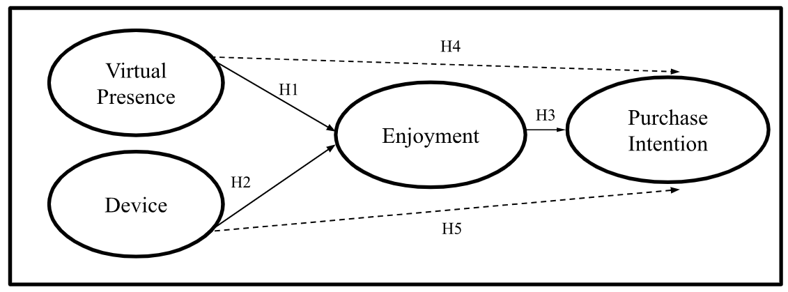
Figure 1. Research Framework
3. RESEARCH METHODOLOGY
3.1 Samples and Data Collection
In the study, the researchers examined individual online shoppers residing in Greater Jakarta who had prior experience using online shopping applications. This study utilized a purposive sampling strategy to specifically target a demographic of interest: individuals who reside in the Greater Jakarta region and have previous experience using online shopping applications. This strategy was considered appropriate since it enabled the researchers to concentrate on individuals who were most likely to offer insights that were pertinent to the study's objectives. The sample was selected based on specific criteria, which included: (1) having prior experience using online purchasing applications, (2) being 18 years of age or older, and (3) residing within the Greater Jakarta area. The emphasis on the Greater Jakarta area corresponds to the objective of comprehending the adoption of augmented reality (AR) and the purchasing behavior within this particular and economically vibrant region of Indonesia. A digital survey was administered using Google Forms between May and July 2022, resulting in 103 valid replies that were considered suitable for subsequent research. Although purposive sampling allows for the targeting of a specific demographic, it is crucial to recognize that the findings may not be directly applicable to larger groups of online customers who are located outside the targeted area or who do not have prior experience with online purchasing.
3.2 Survey Instrument
This research adopts a quantitative methodology, employing an online questionnaire as the primary tool for data collection from online shoppers in the Greater Jakarta region. The questionnaire consists of 12 carefully designed questions aimed at exploring diverse elements related to AR adoption and purchase intentions. A 5-point Likert scale, ranging from "totally disagree" (1) to "totally agree" (5), is used to structure respondent answers. This approach provides a nuanced way to measure attitudes and opinions, enabling the researchers to gather quantifiable data. The choice of Structural Equation Modeling - Partial Least Square (SEM-PLS) for analysis is well-suited to this design, as it effectively handles complex models and reveals relationships between the various factors under investigation.
Table 1. Operational Variables and Indicators
Construct | Items | Indicators | Scale
Virtual Presence  [16] | VP1  VP2 | AR helps to visualize the products become visible  AR provide information about virtual products | Ordinal  5-Likert  Scale
Device  [10], [15] | DV1  DV2  DV3  DV4 | I use augmented reality through smartphone or tablet.  The best way to use augmented reality is by smartphone or tablet.  Applications with augmented reality can be used through variety of gadgets.  Augmented reality can be accessed easily with mobile devices | Ordinal  5-Likert  Scale
Enjoyment  [17] | EJ1  EJ2  EJ3 | The online shopping application that used augmented reality are more interesting  Augmented reality in the e-commerce application more interactive  The online shopping application that used augmented reality are more impressive and special | Ordinal  5-Likert  Scale
Purchase Intention  [11] | PI1  PI2  PI3 | I intent to purchase in online shopping that use augmented reality  I prefer to use online shopping website that use augmented reality  I choose to look for the products in online shopping websites that use augmented reality | Ordinal  5-Likert  Scale

3.3 Data Analysis
The Structural Equation Modeling–Partial Least Square (SEM-PLS) method used to estimate and test the hypotheses. The SEM-PLS method involves a two-step process. To establish the validity and reliability of the items, the initial step involves employing measurement models to assess the quality of the constructs. The assessment’s measurement model requires certain parameters to be met. These parameters include loading factors that are greater than 0.70, Cronbach’s Alpha and Composite Reliability that are greater than 0.70, and Average Variance Extracted that is greater than 0.50 [28].
The focus of the second step in this research is on the development of a structural model, which will help to evaluate the inter-relationship between the constructs. The assessment of the structural model includes several components. Firstly, hypothesis testing, which involves evaluating the t-statistic and considering it significant if it exceeds the value of 1.96 at a 95% confidence level. Secondly, the R-square (R2) is examined to gauge the proportion of variance explained by the model. Additionally, the effect size (f2) and Stone-Geisser (Q2) statistics are also considered within the range of references 18 to 30. The R2 value measures 0.75, 0.50, and 0.25 for all endogenous structures in the research, considered substantial, moderate, and weak.
4. Results
4.1 Demographic Respondents
The demographic data from the respondents indicates that there was a nearly equal ratio of male respondents (48 individuals, 46.6%) and female respondents (55 individuals, 53.4%). In summary, the majority of the respondents were women. Among the respondents, the largest group (66.1%) consisted of 68 individuals aged between 20 and 29. This was followed by 22 respondents (21.3%) in the age range of 30-39, and 13 individuals (12.6%) in the age range of 40-49. These results suggest that the majority of online shopping app users belong to the younger age groups. Out of the respondents, 57 individuals (55.3%) were employed in the private sector. The majority of the participants’ income was around 5-10 million Indonesian Rupiah (Approximately US$300-600), 47 persons (45.6%). A significant majority of respondents, comprising 63 individuals (61.2%), opted to use the Shopee online shopping application. The respondents’ demographic information is present on Table 2.

Table 2. Demographic Respondents
Demographic | Frequency | Percentage
Gender  Men  Women | 48  55 | 46.6%  53.4%
Age  20 – 29 years old  30 – 39 years old  40 – 49 years old | 68  22  13 | 66.1%  21.3%  12.6%
Status/ Job  Private Employee  Government Employee  Self-Employee  Housewife  Students | 57  6  7  3  30 | 55.4%  5.8%  6.8%  2.9%  29.1%
Income  < Rp. 5 million  Rp 5 – Rp. 10 million  Rp. 10 – Rp. 15 million  > Rp. 15 million | 21  47  7  28 | 20.4%  45.6%  6.8%  27.2%
Online Shopping Apps  Shopee  Tokopedia | 63  40 | 61.2%  38.8%
4.2 Measurement Model
The first test in the measurement model assessment aims to evaluate the loading factors of the items within each construct in the study. A study by Hair et al. (2019) states that the Loading Factors (LF) must be greater than 0.70 in order to be deemed valid [28]. With the exception of one item DV (DV1: 0.511), all loading factors in the research are considered valid and accepted. To gauge the individual reliability of each construct, we evaluated Cronbach Alpha (CA), Composite Reliability (CR), and Dijkstra-Henseler’s rho (ρA). The CA and CR values for all composites are above 0.7, indicating reliability. Additionally, Dijkstra-Henseler rho (ρA) also exceeds 0.7 in all constructs. Once we assessed reliability, the subsequent step involved evaluating convergent validity using Average Variance Extracted (AVE), which should exceed 0.5. The results indicate that the AVE values are all higher than 0.50, with a range of 0.666 to 0.825. Table 3 displays the findings of the measurement model assessment.

Table 3. Measurement Model Evaluation
Construct/ Item | LF | CA | ρA | CR | AVE
Virtual Presence (VP)  VP1  VP2 | 0.904  0.913 | 0.788 | 0.789 | 0.904 | 0.825
Device (DV)  DV1  DV2  DV3  DV4 | 0.511  0.776  0.847  0.824 | 0.749 | 0.751 | 0.857 | 0.666
Enjoyment (EJ)  EJ1  EJ2  EJ3 | 0.915  0.900  0.890 | 0.885 | 0.885 | 0.929 | 0.813
Purchase Intention (PI)  PI1  PI2  PI3 | 0.892  0.924  0.900 | 0.892 | 0.908 | 0.932 | 0.820
The following step involved assessing the discriminant validity by applying the Fornell–Larcker criterion. The square root of the AVE construct value must exceed the construct correlation with other latent variables [29]. The result shows that the AVE construct value is higher (see Table 4). Figure 2 displays the path diagram for the measurement model.
Table 4. Fornell-Larcker Criterion
Construct | DV | EJ | PI | VP
DV | 0.816
EJ | 0.398 | 0.901
PI | 0.361 | 0.681 | 0.906
VP | 0.235 | 0.788 | 0.597 | 0.908
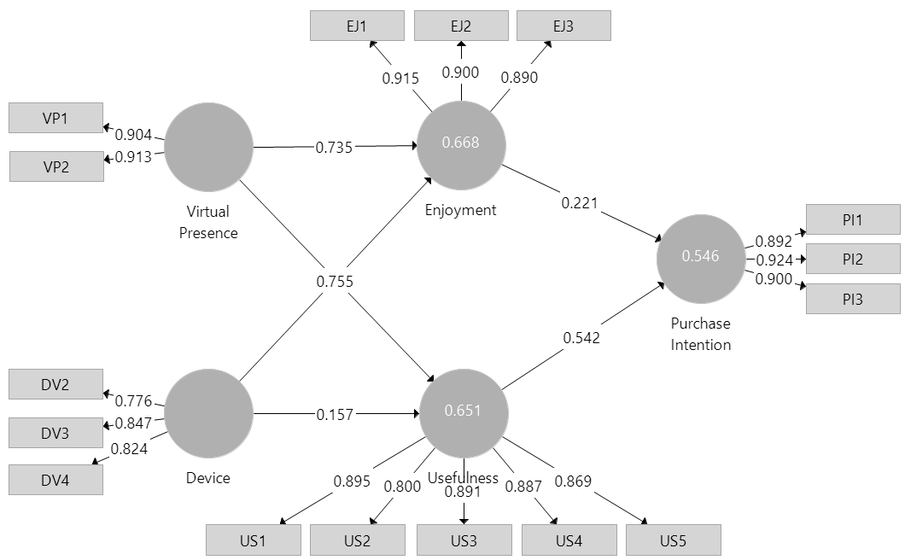
Figure 2. Measurement Model Path Diagram
Given that the data were obtained from a single survey, the researchers investigated the potential presence of common method bias. In PLS-SEM, common method bias (CMB) is identified by conducting a comprehensive assessment of collinearity. A useful tool for identifying common method bias is described based on variance inflation factors (VIF). When the VIF value reaches 5 or exceeds it, it indicates a significant collinearity problem among the formatively measured constructs’ indicators [28]. Table 5 shows that the VIF value is below 5, indicating low collinearity.
Table 5. Collinearity Statistics (VIF)
Items | VIF
DV2 | 1,397
DV3 | 1,693
DV4 | 1,524
EJ1 | 2,869
EJ2 | 2,454
EJ3 | 2,363
PI1 | 2,077
PI2 | 3,695
PI3 | 3,323
US1 | 3,229
US2 | 2,161
US3 | 3,195
US4 | 3,126
US5 | 2,889
VP1 | 1,732
VP2 | 1,732
4.3 Structural Model
The evaluation of the structural model was conducted prior to hypothesis testing. The coefficient of determination (R2) for enjoyment is 0.668 and the R2 for Purchase Intention is 0.546. The results show that endogenous constructs are influenced by exogenous constructs with moderate criteria (see Table 6).
The effect size f2 for each path model was evaluated based on the criteria of 0.02 (small), 0.15 (medium), and 0.35 (large) [30]. On the effect of Enjoyment, only Virtual Presence (1.537) has a strong effect and Device (0.144) has a small effect size. On the effect of Purchase Intention, Enjoyment (0.030) has a small effect size (see Table 6).
Lastly, the current study also assesses the predictive significance of the model using Stone–Geisser’s Q2. According to the results presented in Table 7, all Q2 values (0.511 and 0.424) are greater than zero, indicating that the model possesses adequate predictive ability. Furthermore, in order to ensure a good fit of the model to the data, the SRMR value must be less than 0.08 [18]. The path diagram displayed in Figure 3 represents the Structural Model.

Table 6. Effect Size f-square
Path Model | Effect Size | Result
Virtual Presence → Enjoyment  Device → Enjoyment | 1.537  0.144 | Large  Small
Enjoyment → Purchase Intention | 0.030 | Small
Table 7. Coefficient of Determination (R2), Stone–Geisser’s (Q2), and SRMR
SRMR
Construct | R-Square | R-Square Adjusted | Q2
Enjoyment | 0.668 | 0.662 | 0.511
Purchase Intention | 0.546 | 0.537 | 0.424
Model Fit | SRMR | 0.075
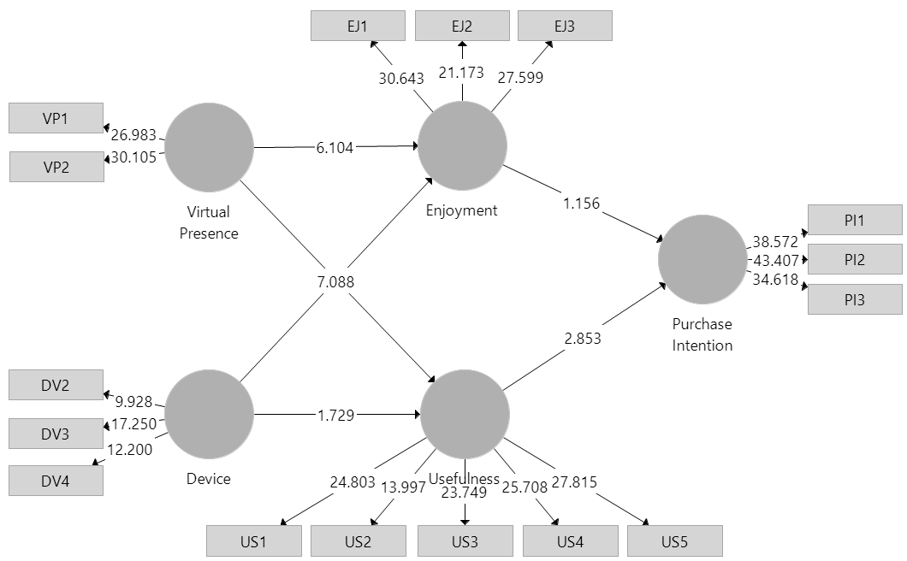
Figure 3. Structural Model Path Diagram
4.4 Hypotheses Testing
Table 8 presents the hypotheses testing using one-tailed testing. If we assume that the coefficient is either positive or negative, it is recommended to employ one-tailed testing.
Table 8. Results of Hypotheses Testing
Hypotheses | β | T-Statistic | p-value | Result
H1: VP → EJ | 0.735 | 6.104 | 0.000 | Supported
H2: DV → EJ | 0.225 | 2.152 | 0.016 | Supported
H3: EJ → PI | 0.221 | 1.156 | 0.124 | Not Supported
H4: VP → EJ→ PI | 0.163 | 1.166 | 0.122 | Not Supported
H5: DV → EJ → PI | 0.050 | 0.876 | 0.190 | Not Supported
Virtual Presence has a positive effect on Enjoyment (β = 0.735;
Virtual Presence has a positive effect on Enjoyment (β = 0.735; t = 6.104), therefore H1 is accepted, and this result is supported by previous research [30]. The device has a positive effect on enjoyment (β = 0.225; t = 2.152), therefore H2 is accepted, and this result is supported by previous research [30]. Enjoyment has no effect on Purchase Intention (β = 0.221; t = 1.156), therefore H3 is rejected and is supported by previous research [30]. Enjoyment has not partially and fully mediated between Virtual Presence (β = 0.163; t = 1.166) and Device (β = 0.050; t = 0.876) on Purchase Intention, therefore H4 and H5 are rejected. These results are supported by previous research [30].
5. DISCUSSION and IMPLICATION
The analysis shows that Virtual Presence has a positive influence on the level of enjoyment experienced during online shopping. Virtual reality technology has the capability to enhance the e-commerce shopping journey through the establishment of a virtual presence. This achievement can be facilitated by employing artificial intelligence, enabling the creation of tailored engagements for customers within the virtual environment. Through the utilization of artificial intelligence, e-commerce entities can customize their virtual reality offerings to cater to individual preferences and needs, ultimately providing a more individualized, interactive, and intuitive shopping encounter. The utilization of virtual reality technology permits users to engage deeply within a computer-simulated environment, instilling a sense of presence that transcends conventional online shopping encounters. By integrating artificial intelligence, virtual reality encounters can be personalized to meet the distinct requirements and desires of each consumer. This customization may encompass suggestions derived from previous purchases, interactive product demonstrations, and virtual trials for apparel and accessories. When artificial intelligence is utilized in virtual reality applications, online merchants have the opportunity to revolutionize the manner in which customers interact with their merchandise and brand, providing a shopping experience that is more immersive, customized, and pleasurable. The integration of artificial intelligence and virtual reality in e-commerce able to enhance the online shopping journey, offering customers a sense of immersion and interaction reminiscent of traditional retail spaces.
Devices have a positive influence on the level of enjoyment experienced during online shopping. These devices have a significant impact on our satisfaction levels when engaging in online shopping. The ubiquity of smartphones, tablets, and laptops has extended consumers' reach to online shopping platforms. Consequently, the convenience and simplicity of browsing and conducting transactions from any location at any time have contributed to the pleasure derived from online shopping. Moreover, the advent of intelligent household appliances and the Internet of Things has further enriched the online shopping experience. Consumers are now able to easily add products to their virtual carts through voice commands or by scanning product codes using their interconnected devices. This seamless integration of devices within the online shopping process not only enhances convenience but also instills a feeling of pleasure and thrill. The impact of devices on the enjoyment of online shopping transcends mere accessibility and convenience.
However, it was found that enjoyment does not significantly impact the intention to make a purchase. The enjoyment factor also does not act as a mediator between virtual presence, the device, and the intention to make a purchase. By enhancing comprehension of consumer attitudes and behaviors, businesses have the ability to customize their approaches to enhance the online shopping experience and ultimately stimulate purchase intentions.
With the rapid advancement of technology, augmented reality has emerged as a groundbreaking tool across various sectors, particularly in online shopping. Particularly in developing nations, the incorporation of augmented reality in online shopping stands offers significant advantages. The utilization of augmented reality within an online shopping environment can enable emerging economies to surmount some of the obstacles encountered in conventional e-commerce, such as the absence of direct product interaction and challenges in assessing fit and size. Augmented reality presents a viable remedy to these impediments by enabling customers to virtually test products, visualize furniture placement in their living spaces, or preview the fit of apparel items, all within the confines of their residences. Through the integration of augmented reality in online shopping, emerging economies have the potential to enrich the overall customer experience, elevate customer contentment, and potentially amplify sales volumes. Developing nations frequently encounter obstacles related to infrastructure and accessibility, which can constrain the scope of traditional retail encounters for numerous consumers. Augmented reality technology alleviates these limitations by bringing the shopping experience directly to the consumers' fingertips. Apart from addressing challenges associated with distance and accessibility, augmented reality also enriches the bond between consumers and online merchants by offering an immersive and interactive shopping experience.
While the findings suggest that virtual presence and device ease of use positively impact enjoyment, the lack of a direct relationship between enjoyment and purchase decision warrants further exploration. To obtain a more comprehensive understanding, future research should calculate effect sizes to quantify the strength of these relationships and employ larger sample sizes to increase the generalizability of results. Additionally, addressing potential limitations such as geographic restrictions and the potential for self-reporting bias would enhance the robustness of the findings.The findings of the current study offer valuable insights into the complex interplay of factors that influence the experiences and intentions of individuals engaged in online shopping. First, the research findings strongly indicate that familiarizing consumers with the use and benefits of Augmented Reality (AR) is of utmost importance. By effectively introducing consumers to augmented reality (AR) on online shopping platforms, it will assist them in making informed purchasing decisions. This tactic will ultimately lead to an increase in consumers’ willingness to make purchases. Second, by incorporating the features of virtual presence, customers will have the opportunity to preview or pretest products virtually, which will greatly enhance their enjoyment and satisfaction. Third, to ensure the successful adoption of AR, e-commerce businesses must ensure that customers have the appropriate device that can run the software that will support the use of AR. E-commerce businesses must prioritize the convenience of online shoppers to successfully integrate AR. It would also be critical for e-commerce businesses to create an enjoyable environment for online shoppers, ensuring their satisfaction. With the use of this technology, online retailers have the capability to adapt their service and product offerings, resulting in augmented reality (AR) enhanced online purchasing experiences that cater to a wide array of potential customers.
Augmented reality (AR) purchasing platforms have become increasingly popular among online shoppers due to the fact that it greatly enhance their enjoyment of the shopping experience. However, in this study, enjoyment did not fulfill its expected role as a mediator between Virtual Presence and Device on the purchase intention. In other words, AR-enhanced online purchasing brings pleasure to consumers, but it does not significantly affect their intention to make a purchase. The preference for physically interacting with products before making a purchasing decision is still prevalent among online consumers, which explains why this is the case.
6. LIMITATION AND FUTURE RESEARCH
This study elucidates crucial aspects that influence the adoption of augmented reality (AR) in online purchasing and examines their impact on purchase intentions. The results indicate that the experience of being virtually present and the level of user-friendliness have a notable impact on increasing satisfaction. However, it is uncertain whether these factors directly lead to making purchasing decisions. This emphasizes the necessity for e-commerce enterprises to investigate supplementary factors that influence consumer buying patterns while incorporating augmented reality (AR) technologies. Future research should take into account and resolve certain constraints. By broadening the study's geographical reach outside Jakarta, we can gain useful insights into how regional variations may affect the adoption of augmented reality (AR) and its consequences. By including supplementary elements like as perceived usefulness, simplicity of use, risk, and the impact of promotions, a more comprehensive comprehension of consumer decision-making can be achieved. Moreover, doing a thorough examination of the possible advantages of augmented reality in other sectors will expand the practicality of the results.
Although there are limits, this research provides valuable insights into consumer behavior in AR-enhanced online buying settings. For e-commerce enterprises, the findings underscore the need of not only developing captivating virtual experiences and user-friendly platforms but also exploring additional factors that impact buying choices.
7. REFERENCES
- F. Yu and T. Schweisfurth, “Industry 4.0 technology implementation in SMEs – A survey in the Danish-German border region,” International Journal of Innovation Studies, vol. 4, no. 3, pp. 76–84, 2020.
- G. Li, Y. Hou, and A. Wu, “Fourth Industrial Revolution: technological drivers, impacts and coping methods,” Chinese Geographical Science, vol. 27, no. 4, pp. 626–637, 2017.
- H. Lasi, P. Fettke, H. G. Kemper, T. Feld, and M. Hoffmann, “Industry 4.0,” Business and Information System Engineering, vol. 6, no. 4, pp. 239–242, 2014.
- S. R. Billewar et al., “The rise of 3D E-Commerce: the online shopping gets real with virtual reality and augmented reality during COVID-19,” World Journal of Engineering, vol. 19, no. 2, pp. 244–253, 2022.
- Liputan6. (2022, Aug. 03). Transaksi E-Commerce Indonesia Rp 108,54 Triliun di Kuartal I-2022 [Online]. Available: https://www.liputan6.com/bisnis/read/5032523.
- R. Rathee and P. Rajain, “Online shopping environments and consumer’s Need for Touch,” Journal of Advances in Management Research, vol. 16, no. 5, pp. 814–826, 2019.
- R. S. D. Al-Tayyar, A. R. B. Abdullah, A. Abd Rahman, and M. H. Ali, “Challenges and obstacles facing SMEs in the adoption of e-commerce in developing countries; A case of Saudi Arabia,” Studies of Applied Economics, vol. 39, no. 4, pp. 1–11, 2021.
- J. Stoyanova, P. Q. Brito, P. Georgieva, and M. Milanova, “Comparison of consumer purchase intention between interactive and augmented reality shopping platforms through statistical analyses,” In 2015 International Symposium on Innovations in Intelligent SysTems and Applications (INISTA), Madrid, Spain, pp. 1-8, 2015.
- H. L. Siek, K. M. Cheng, and D. C. De. Wong, “The Effectiveness of Incorporating Augmented Reality in Print Design Course,” Journal of e-Learning & Higher Education, 661787, pp. 1-9, 2022.
- D. Nincarean, M. B. Alia, N. D. A. Halim, and M. H. A. Rahman, “Mobile Augmented Reality: The Potential for Education,” Procedia – Social and Behavioral Sciences, vol. 103, pp. 657–664, 2013.
- Z. He, L. Wu, and X. Robert Li, “When art meets tech: The role of augmented reality in enhancing museum experiences and purchase intentions,” Tourism Management, vol. 68, pp. 127–139, 2018.
- R. M. Viglialoro, S. Condino, G. Turini, M. Carbone, V. Ferrari, and M. Gesi, “Augmented reality, mixed reality, and hybrid approach in healthcare simulation: A systematic review,” Applied Sciences, vol. 11, no. 5, pp. 1–20, 2021.
- J. Ara, F. B. Karim, M. S. A. Alsubaie, Y. A. Bhuiyan, M. I. Bhuiyan, S. B. Bhyan, and H. J. Bhuiyan, “Comprehensive Analysis of Augmented Reality Technology in Modern Healthcare System,” International Journal of Advanced Computer Science and Applications, vol. 12, no. 6, pp. 845–854, 2021.
- V. Saprikis, G. Avlogiaris, and A. Katarachia, “Determinants of the intention to adopt mobile augmented reality apps in shopping malls among university students,” Journal of Theoretical and Applied Electronic Commerce Research, vol. 16, no. 3, pp. 491–512, 2021.
- M. Rapaccini, I. Porcelli, D. B. Espíndola, and C. E. Pereira, “Evaluating the use of mobile collaborative augmented reality within field service networks: the case of Océ Italia – Canon Group,” Production and Manufacturing Research, vol. 2, no. 1, pp. 738–755, 2014.
- T.P. Caudell and D.W. Mizell, “Augmented reality: An application of heads-up display technology to manual manufacturing processes.” In Proceedings of the Twenty-Fifth Hawaii International Conference on System Sciences, Kauai, HI, United States of America, vol. 2, pp. 659-669, 1992.
- M. Bajura, H. Fuchs, and R. Ohbuchi, “Merging virtual objects with the real world: Seeing ultrasound imagery within the patient.” ACM SIGGRAPH Computer Graphics, vol. 26, no. 2, pp: 203-210, 1992.
- S. Feiner, Steven, B. MacIntyre, and D. Seligmann. “Knowledge-based augmented reality.” Communications of the ACM, vol. 36, no. 7, pp: 53-62, 1993.
- R. T. Azuma, “A survey of augmented reality.” Presence: Teleoperators & Virtual Environments, vol. 6, no. 4, pp: 355-385, 1997.
- Z. Du, J. Liu, and T. Wang, “Augmented reality marketing: A systematic literature review and an agenda for future inquiry.” Frontiers in Psychology, vol. 13, pp: 925-963, 2022.
- T. Verhagen, C. Vonkeman, F. Feldberg, and P. Verhagen, “Present It Like It Is Here: Creating Local Presence to Improve Online Product Experiences,” Computers in Human Behavior, Vol. 39, pp: 270–80, 2014.
- R. K. Pallasena, M. Sharma, and V. Krishnaswamy, “A Study of Interaction, Visual Canvas, and Immersion in AR Design: A DSR Approach,” AIS Transactions on Human-Computer Interaction, vol. 14, no. 3, pp. 390-425, 2022.
- S. Chandra, and K. N. Kumar, “Exploring Factors Influencing Organizational Adoption of Augmented Reality in E-commerce Empirical Analysis Using Technology-organization-environment model,” Journal of Electronic Commerce Research, vol. 19, no. 3, pp. 237-265, 2018.
- E. Pantano, and R. Servidio, “Modeling Innovative Points of Sales Through Virtual and Immersive Technologies,” Journal of Retailing and Consumer Services, vol. 19, no. 3, pp. 279–86, 2012.
- R. Stefko, R. Bacík, R. Fedorko, M. Olearova, and M. Rigelsky, “Analysis of consumer preferences related to the use of digital devices in the e-commerce dimension,” Entrepreneurship and Sustainability Issues, vol. 7, no. 1, pp. 25-33, 2019.
- M. Y. C. Yim, S. C. Chu, and P. L. Sauer, “Is Augmented Reality Technology an Effective Tool for E-commerce? An Interactivity and Vividness Perspective,” Journal of Interactive Marketing, vol. 39, no. 1, pp. 89–103, 2017.
- S. C. Chang, C. C. Sun, L. Y. Pan, and M. Y. Wang, “An Extended TAM to Explore Behavioural Intention of Consumers to Use M-Commerce,” Journal of Information and Knowledge Management, vol. 14, no. 2, pp. 1–16, 2015.
- J. F. Hair, J. J. Risher, M. Sarstedt, and C. M. Ringle, “When to use and how to report the results of PLS-SEM,” European Business Review, vol. 31, no. 1, pp. 2–24, 2019.
- D. F. Fornell, C., and Larcker, “Evaluating structural equation models with unobservable variables and measurement error,” Journal of Marketing Research, vol. 18, no. 1, pp. 39–50, 1981.
- L. Leonnard, A. S. Paramita, and J. J. Maulidiani, “The Effect of Augmented Reality Shopping Applications on Purchase Intention,” Esensi: Jurnal Bisnis dan Manajemen, vol. 9, no. 2, pp. 131–142, 2019.

